 **Air University Multan Campus**

**Department of Computer Science and Engineering**

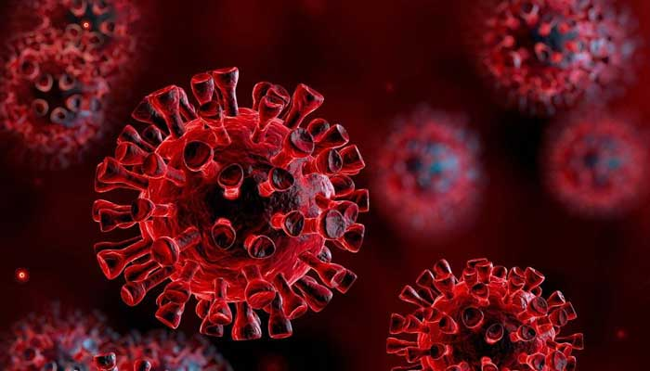

**<Covid-19 Updates>**

**Project Proposal**

Prepared by

|  |  |
| --- | --- |
| Group#: | Grade: |
| Group Email: [183158@students.au.edu.pk](mailto:183158@students.au.edu.pk), [183209@students.au.edu.pk](mailto:183209@students.au.edu.pk), [183220@students.au.edu.pk](mailto:183220@students.au.edu.pk) | |
| Group members: 3 | |
| *<Student1, ID ,Role>* | 183158 |
| *<Student2, ID, Role>* | 183209 |
| *<Student3, ID, Role>* | 183220 |

**Supervised by**

Mam Atka Ali

<6th> Semester <1442>

<Summer> <2021>

**Revision Table**

|  |  |  |  |
| --- | --- | --- | --- |
| **Page#** | **Section#** | **Reviewer** | **Corrected by (Reviewer, Author)** |
|  |  |  |  |
|  |  |  |  |
|  |  |  |  |
|  |  |  |  |
|  |  |  |  |
|  |  |  |  |
|  |  |  |  |

**Contents**

1. Introduction 4

2. The Problem 4

3. Project Goals and Objectives 5

4. The Solution 5

5. Project Scope 6

6. Software Tools 6

6.1. Software 6

6.2. Languages 6

7. Timeline 6

8. Roles and Responsibilities 7

9. Risk Management 7

Reference 8

# **Introduction**

Coronavirus disease (COVID-19) is an infectious disease caused by a newly discovered coronavirus.

**Context:**

On 31st December 2019, in the city of Wuhan (CHINA), a cluster of cases of pneumonia of unknown cause was reported to World Health organization. In January 2020, a previously unknown new virus was identified, subsequently named 2019 novel corona virus. WHO has declared the COVID-19 as a pandemic. A pandemic is defined as disease spread over a wide range of geographical area and that has affected high proportion of the population.

As the time passes, number of coronavirus cases are increasing day by day due to the negligence of people. COVID-19 is mainly transmitted through droplets generated when an infected person coughs, sneezes, or exhales. These droplets are too heavy to stay in the air, and quickly fall on floors or surfaces. People can be infected by breathing in the virus if they are within close proximity of someone who has COVID-19, or by touching a contaminated surface and then your eyes, nose or mouth.

**Problem:**

If people will not follow SOPS, they will likely to have coronavirus and their immunity will slow down and chances of death increases. We can see as the people are not following SOPs, number of corona virus cases is increasing day by day and number of deaths too is increasing day by day. With the passage of time, virus is mutating and becoming severe. If people will show the same behavior, It will be difficult to handle this mutated corona virus and vaccine will not function properly.

**Response:**

People will surely be safe from Corona virus if they properly follow SOPs and strict Lockdown will not be implemented. Unemployment rate will get decrease which is high these days due to rise in Covid-19 cases.

# **The Problem**

The pandemic has already taken grip over peoples’ life. Since the start of the pandemic, some countries are facing problem of ever-increasing cases. Through the data analysis of cases one can analyze how countries all over the world are doing in terms of controlling the pandemic. Analyzing data leads to adapt the prevention model of the countries that are doing great in terms of lowering the graph. Predictions are made with the dataset available to the country, thus helping them to decide how far they are able to control the pandemic or up to how much extent they should guide preventive measures. Through this project, a step towards helping people to understand the spread and predict the cases in their country is done. This project also gives an insight of how a country is doing in terms of limiting the spread.

# **3. Project Goals and Objectives**

This project have the following goals and objectives:

* **Origin of coronavirus**: From where it has started.
* **Effect of corona virus**: How corona virus will affect our lives and routines.
* **Symptoms of coronavirus**: How people will come to know whether they have corona or not by sharing their symptoms.
* **Advantages and disadvantages of lockdown**: How lockdown has affected people’s life. How lockdown has saved people from being affected by corona virus.
* **Unemployment rate in Covid**-19: How lockdown and Covid has affected businesses of people.
* **Seasonal effects of Covid 19**: How season is affecting corona virus cases
* **Precautions and SOPS**: What will be the effect of SOPS if followed in offices and educational institutes?
* **Vaccine:** Speeding up the development of safe and effective vaccines against Covid-19.
* **Confirmed cases:** How the number of confirmed cases increasing day by day, month wise and per year.
* **Recovered cases:** How the number of recovered cases increasing day by day, month wise and per year.
* **Death Cases**: How the number of death cases increasing day by day, month wise and per year
* **Active cases**: How many number of cases are currently active?
* **Complaint form**: User can enter complaint against positive corona patients.
* **Predictions**: What will be the future of corona virus?

# **The Solution**

* **Data Analyzation**: To analyze the data and information, correlation between attributes, size of data etc.
* **Data Preprocessing**: Removal of null, missing values and outliers to remove inappropriate data.
* **Data Visualization**: Graphical representation of data.
* **Data Modeling**: To predict future outcomes by training algorithms.

# **Project Scope**

From this project, people will come to know about the Corona virus history, their effect on people, reasons of increase in corona virus cases, Corona Virus symptoms, Daily cases of corona virus, future predictions of corona virus and even people can complaint against the positive patients if they see them not following the SOPs. People will get awareness from this application by getting all information related to corona virus from one platform.

# **6. Software Tools**

## **6.1. Software**

* VS Code

# **6.2. Languages**

* Django
* Python
* React
* HTML
* CSS
* JAVASCRIPT
* Bootstrap

# **Timeline**

|  |  |
| --- | --- |
| Task | May-June |
| Do the Literature Survey | 2 days |
| Design Data Crawling Techniques | 2 days |
| Design the database | 2 days |
| Design data mining algorithms | 3 days |
| Design the user interface | 3 days |
| Build the database | 2 days |
| Develop the data mining algorithms | 3 days |
| Build the user interface | 3 days |
| Test the Database | 1 day |
| Test the Data Mining Algorithms | 1 day |
| Test the User Interface | 1 day |
| Perform Integration Testing | 1 day |
| Write the Final Report | 3 days |
| Prepare for the Presentation | 3 days |

# **8. Roles and Responsibilities**

|  |  |  |
| --- | --- | --- |
| **Role** | **Responsibilities** | **Participant(s)** |
| Project Leader | To make sure everyone is performing her task, nobody has any issue. | 183158 |
| Analysis | To do analysis at assigned time | 183158,183209,183220 |
| Design | To design at assigned time | 183158,183209,183220 |
| Implementation | To implement at assigned time | 183158,183209,183220 |
| Testing | To test at assigned time | 183158,183209,183220 |

# **9. Risk Management**

|  |  |
| --- | --- |
| **Risk** | **Strategy** |
| Laptop damages | If one member’s laptop is not working, she will do her task by collaborating with her group member |
| Any member may get ill or may be busy. | Other members will help her in completing her assigned task by dividing her task. |
| Stuck at some point | Group will arrange a meeting with supervisor to sort out that problem. |

# **Reference**

*COVID-19*. (n.d.). Retrieved from en.wikipedia.org: https://en.wikipedia.org/wiki/COVID-19