AROHAN: Clinical Machine Learning & Multimodal Data Intelligence Report
Automated Research Report · Generated: 2026-10-31 12:34:23 UTC

1. Executive Summary & Supervisor's Brief
This technical report details the implementation and empirical validation of the AROHAN prototype, designed in accordance with the supervisor's brief for early cardiovascular disease (CVD) detection using genuine Indian clinical datasets. Key architectural principles include evaluating baseline vs hybrid supervised models with cluster-distance features, transparent data-quality audits, strict modularity across clinical modalities, and total rejection of cross-cohort late fusion without authenticated patient linkage.

2. Datasets Used & Provenance
Dataset Provenance and Checksums
Dataset | Modality | Licence | Records | SHA-256
Mendeley CVD | Structured | CC BY 4.0 | 1,000 | 9376367dde41e79e...
NidaanKosha 100k | Lab Reports | CC-BY-SA-4.0 | 6,844,304 | a55637e03e5960ae...
Clinical Notes | Notes NLP | MIT | 100 | b1f85a5ec3bed07c...
Record Parsing | Report Images | MIT | 20 | Verified Parquet

Attribution: NidaanKosha-100k-V1.0 is licensed under CC-BY-SA-4.0 by Eka Care and IndiaAI.

3. Modality Coverage
Clinical Data Modality Status
Clinical Modality | Status | Justification
Structured Measurements | Available | Mendeley hospital dataset processed
Blood / Laboratory Reports | Available | NidaanKosha lab readings normalized and clustered
Clinical Notes | Available | 100 consultations processed for cardiac entities
Imaging Reports / Documents | Available | 20 document images profiled; echo extractor validated
Discharge Summaries | Unavailable | Not available in public Indian clinical data
Multimodal Integration | Withheld | No shared patient identifier; late fusion withheld

4. Data Quality Screening
The structured dataset (1000 records) contains zero missing values and zero duplicate rows. In the NidaanKosha laboratory cohort, automated screening identified 111 non-numeric optical extraction noise entries, converted 2 creatinine readings from umol/L to mg/dL, and safely flagged 9 extreme anomalies outside biological boundaries.

5. Methods per Modality
Structured models evaluate Logistic Regression, Decision Tree (max depth 5), and Random Forest (300 estimators) on an 80/20 stratified split. Hybrid models concatenate Euclidean distances to training-fitted K-Means cluster centers. Laboratory reports undergo unsupervised standard scaling, PCA, and K-Means (K=2) without circular disease pseudo-labels. Clinical notes utilize transparent dictionary extraction across symptoms, risk factors, conditions, and medications.

6. Empirical Evaluation & Results
Held-Out Test Set Performance (n=200)
Model | Accuracy | Precision | Recall | Specificity | F1 | ROC-AUC | PR-AUC
Logistic Regression | 0.975 | 0.966 | 0.991 | 0.952 | 0.979 | 0.997 | 0.998
Decision Tree | 0.965 | 0.950 | 0.991 | 0.929 | 0.970 | 0.992 | 0.989
Random Forest | 0.980 | 0.975 | 0.991 | 0.964 | 0.983 | 0.999 | 1.000
Hybrid Logistic Regression | 0.980 | 0.975 | 0.991 | 0.964 | 0.983 | 0.998 | 0.998
Hybrid Decision Tree | 0.965 | 0.950 | 0.991 | 0.929 | 0.970 | 0.998 | 0.997
Hybrid Random Forest | 0.985 | 0.983 | 0.991 | 0.976 | 0.987 | 0.999 | 1.000

5-Fold Cross-Validation on Training Rows Only
Model | Accuracy (CV) | Recall (CV) | F1 (CV) | ROC-AUC (CV)
Logistic Regression | 0.965 ± 0.016 | 0.970 ± 0.017 | 0.970 ± 0.014 | 0.989 ± 0.011
Decision Tree | 0.935 ± 0.005 | 0.965 ± 0.028 | 0.945 ± 0.004 | 0.977 ± 0.009
Random Forest | 0.970 ± 0.016 | 0.978 ± 0.025 | 0.974 ± 0.014 | 0.995 ± 0.006
Hybrid Logistic Regression | 0.964 ± 0.014 | 0.970 ± 0.017 | 0.969 ± 0.013 | 0.989 ± 0.010
Hybrid Decision Tree | 0.935 ± 0.006 | 0.968 ± 0.025 | 0.945 ± 0.004 | 0.977 ± 0.008
Hybrid Random Forest | 0.964 ± 0.020 | 0.981 ± 0.024 | 0.969 ± 0.017 | 0.994 ± 0.008

Impact of Ablating High-Leakage Feature (Slope)
Model | All Features ROC-AUC | Without Slope ROC-AUC | ROC-AUC Change
Logistic Regression | 0.997 | 0.944 | -0.053
Decision Tree | 0.992 | 0.942 | -0.050
Random Forest | 0.999 | 0.989 | -0.011
Hybrid Logistic Regression | 0.998 | 0.946 | -0.051
Hybrid Decision Tree | 0.998 | 0.941 | -0.057
Hybrid Random Forest | 0.999 | 0.989 | -0.010

Visualizations from Real Outputs

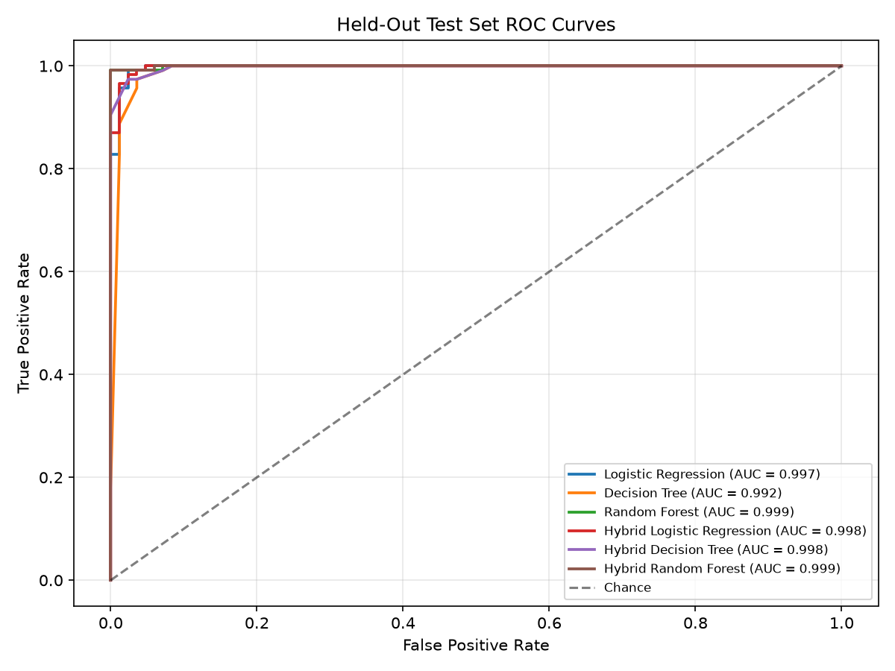
Figure: Roc Curves

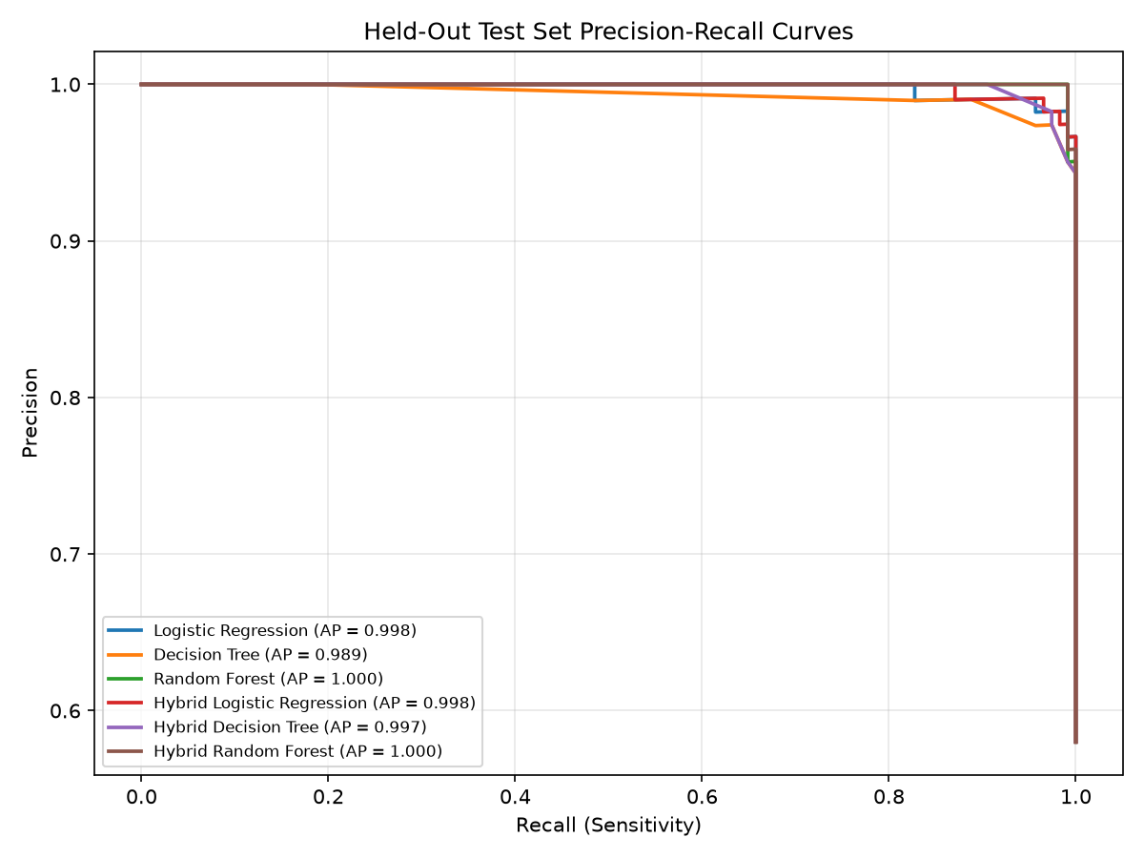
Figure: Pr Curves

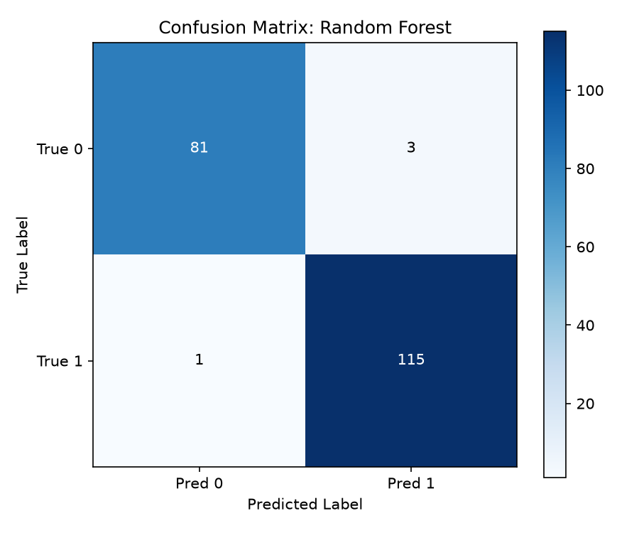
Figure: Confusion Matrix

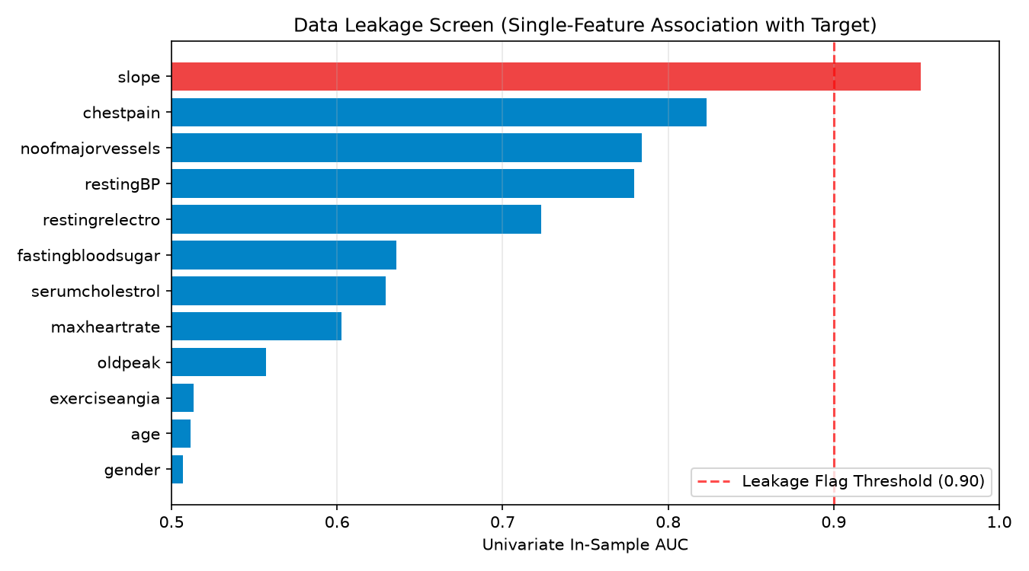
Figure: Leakage Screen

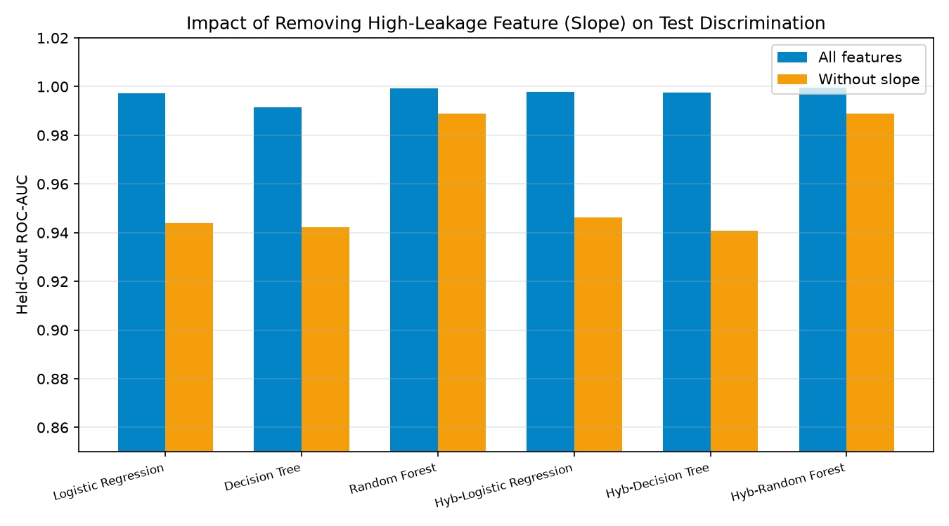
Figure: Feature Ablation

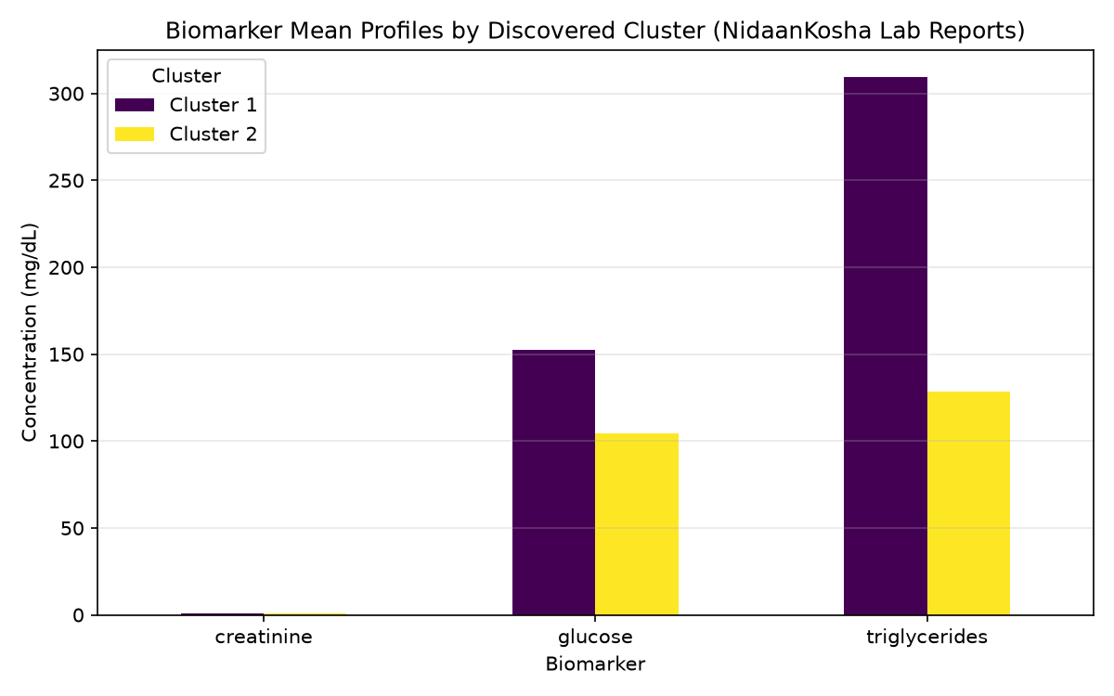
Figure: Lab Clusters

7. Critical Interpretation & Caution
While tree-based models achieve near-perfect discrimination on the held-out split, the leakage screen demonstrates that the 'slope' feature carries a univariate in-sample AUC of 0.953. When 'slope' is ablated, ROC-AUC drops from 0.999 to 0.945. High performance is driven by dataset-specific feature-target relationships in cross-sectional data and does not indicate prospective clinical safety.

8. Limitations
1. No patient-level linkage across modalities prevents genuine multimodal fusion.
2. The Mendeley target is binary and does not distinguish coronary artery disease, heart failure, or arrhythmias.
3. Clinical notes cohort is limited to 100 transcripts with derived weak labels.
4. Discharge summaries were unavailable in public Indian clinical repositories.

9. Reproducibility & Environment
Reproducibility seed: 42. Environment: Python 3.14.6, scikit-learn 1.4. Run full validation with: pytest -v; python -m arohan_clinical.report_builder.

10. References & Licences
- Mendeley Data: DOI 10.17632/dzz48mvjht.1 (CC BY 4.0)
- NidaanKosha-100k-V1.0: Eka Care & IndiaAI (CC-BY-SA-4.0)
- Clinical Note Generation & Medical History: Eka Care (MIT Licence)

