No:1

Date:

Program 1

**Aim:** Write an html program to display table as follows.

|  |  |  |
| --- | --- | --- |
|  | average | |
| height | weight |
| males | height | 0.003 |
| females | 1.9 | 0.002 |

Program:

<html>

<body>

<table border="1">

<tr>

<td rowspan="2"></td>

<td colspan="2">average</td>

</tr>

<tr>

<td>height</td>

<td>weight</td>

</tr>

<tr>

<td>males</td>

<td>height</td>

<td>0.003</td>

</tr>

<tr>

<td>females</td>

<td>1.9</td>

<td>0.002</td>

</tr>

</table>

</body>

</html>

Output:

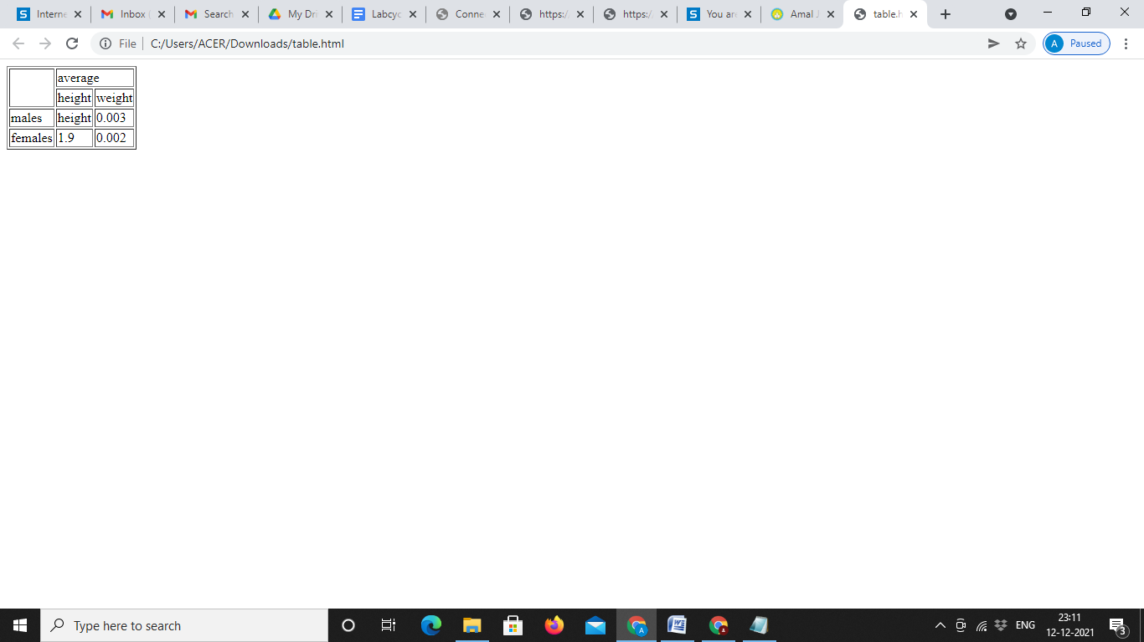

No 2:

Date

Program 2

**Aim:** Write a program to create list as follows.

Ordered List

1. Appetizer
2. Main Course
3. Salad

Unordered List

* Cold Drinks
* Hot Drinks
* Ice-Cream

Program :

<html>

<body>

<h3>Ordered List</h3>

<ol>

<li>Appetizer</li>

<li>Main Course</li>

<li>Salad</li>

</ol>

<h3>Unordered List</h3>

<ul>

<li>Cold Drinks</li>

<li>Hot Drinks</li>

<li>Ice-Cream</li>

</ul>

</body>

</html>

Output:

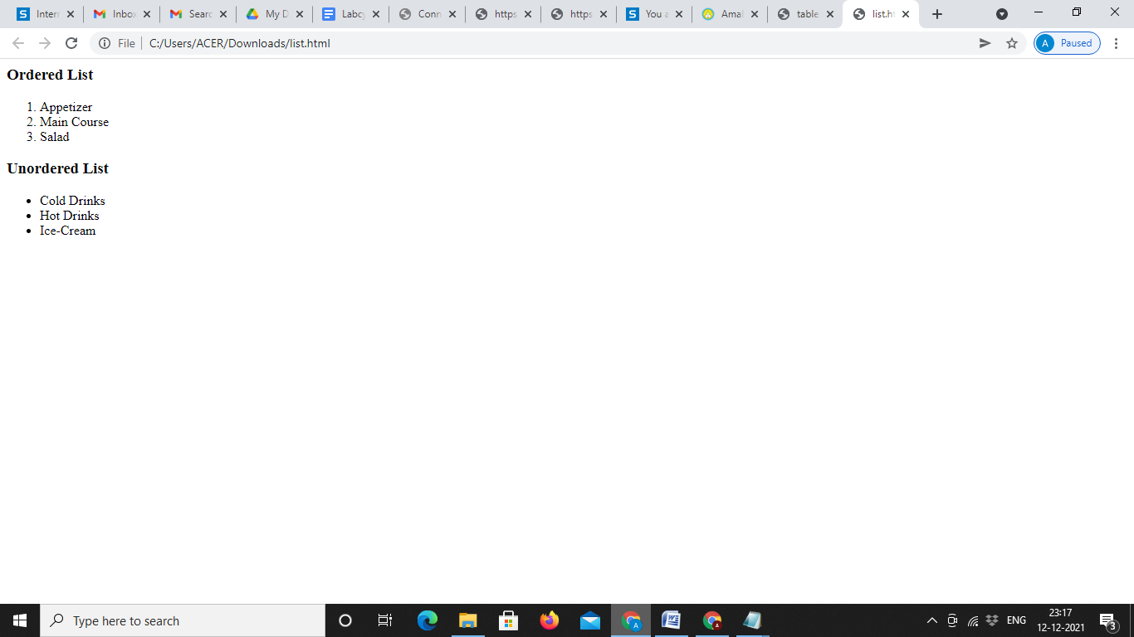

No 3:

Date:

Program 3

**Aim:** Design a website of your college which contain home page, department and about us using html (use image, tables and links)

Program

Website.html

<html>

<head><title>Amal Jyothi Engineering College</title></head>

<body >

<image src="b.jpg">

<br>

<a href="abouts.html">About us</a>

<a href="dept.html">Departments</a>

</body>

</html>

About.html

<html>

<body>

<h3>About Us</h3>

<p>Amal Jyothi College of Engineering, Kottayam established in 2001 under Diocese Educational Trust, Kanjirappally. It is affiliated to APJ Abdul Kalam Technological University (KTU), Kottayam. It is approved by All India Council for Technical Education (AICTE), New Delhi and accredited by National Board of Accreditation (NBA), New Delhi.</p>

<p>The vision of the institute is to be a centre of excellence in technical higher education, research and support services, capable of making a significant contribution to individual and societal empowerment.

The mission of the institute is to create technically qualified world-class professionals with social commitment through career-oriented courses conducted by high profile faculties, complemented with globally interactive learning processes and leading edge technology.

It is situated at Koovappally near Kanjirappally alongside the Kottayam-Erumeli-Sabarimala state highway. It’s sprawling campus spread over 60 acres of scenic landscape at the foothills of the Western Ghats, has been laid out to create a unique learning environment. Lawns and wide vistas of luxuriant luscious green provide an enchanting ambience.</p>

</body>

</html>

Dept.html

<html>

<body>

<h3>Departments</h3>

<ul>

<li>Department of Computer Science & Engineering</li>

<li>Department of Electronics & Communication Engineering</li>

<li>Department of Electrical & Electronics Engineering</li>

<li>Department of Mechanical Engineering</li>

<li>Department of Civil Engineering</li>

<li>Department of Chemical Engineering</li>

<li>Department of Automobile Engineering</li>

<li>Department of Computer Applications</li>

</ul>

<h3>Collaboration</h3>

<ul>

<li>University of Ontario Institute of Technology (UOIT), Canada</li>

<li>Deakin University, Australia</li>

<li>Dr. MGR University, Chennai</li>

<li>SRM University, Chennai</li>

<table border="1">

<tr>

<th colspan="2">Facilities</th>

</tr>

<tr>

<td>lab</td>

<td>5</td>

</tr>

<tr>

<td>Faculties</td>

<td>35</td>

</tr>

<tr>

<td>Total stu</td>

<td>160</td>

</tr>

</table>

</body>

</html>

Output:

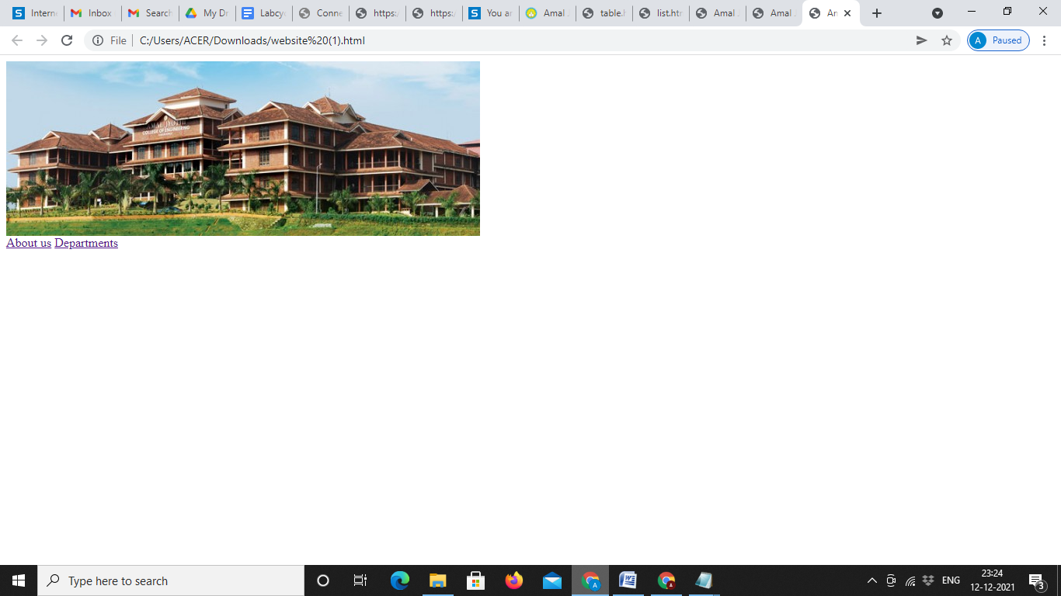

No 4:

Date:

Program 4

**Aim**: Create a HTML page with different types of frames such as floating frame(iframe), navigation frame & mixed frame (horizontal and vertical).

Program

Frame.html

<head>

<title>Frame</title>

</head>

<frameset cols="20%,80%">

<frame src="navigation.html">

<frameset rows="40%,40%">

<frame src="iframe.html"/>

<frame src="a.JPG" width="100%"/>

</frameset>

</frameset>

</html>

Iframe.html

<html>

<body>

<h1>IFrame</h1>

<iframe src="https://www.javatpoint.com/" width="50%" height="70%"></iframe>

</body>

</html>

Mixed.html

<html>

<frameset cols="30%,*">

<frame src="1.html"></frame>

<frameset rows="50%,*">

<frame src="2.html" autostart="true">

<frame src="3.html" >

</frameset>

</frameset>

</html>

Navigation.html

<html>

<body>

<a href="1.html">navigation</a><br>

<a href="2.html">floating frame</a><br>

<a href="01.html">mixed frame</a><br>

<body>

</html>

Output:

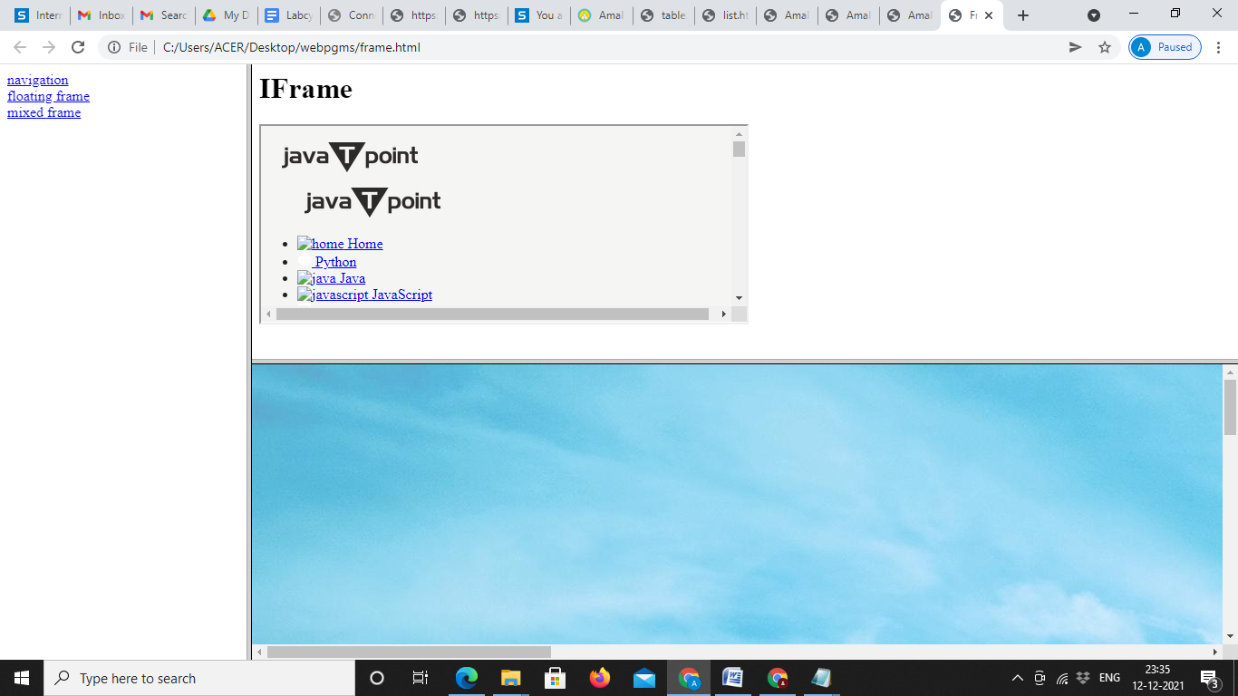

No 5:

Date:

Program 5

**Aim:** Demonstrate a registration form using HTML.

Program

<html>

<head>

<title>Registration form</title>

</head>

<body>

<h2 align="center">Registration Form</h2>

<table border="0" align="center">

<tr>

<td><label name="fname">First Name&nbsp :</label>

<input type="text"></input></td></tr>

<tr>

<td><label name="lname">Last Name&nbsp&nbsp&nbsp:</label>

<input type="text"></input></td></tr>

<tr>

<td><label name="address">Address&nbsp&nbsp&nbsp&nbsp &nbsp :</label>

<textarea rows="2" name="textarea"></textarea></td></tr>

<tr>

<td><label name="nationality">Nationality&nbsp :</label>

<select>

<option value="India">India</option>

<option value="Pakisthan">Pakisthan</option>

<option value="SriLanka">Sri Lanka</option>

<option value="Uae">UAE</option

</select></td>

</tr>

<tr>

<td><label name="gender">Gender &nbsp&nbsp&nbsp&nbsp&nbsp&nbsp&nbsp:</label>

<input type="radio">Female</input>

<input type="radio">Male</input>

</td></tr>

<tr><td>

<label name="Qualifications">Qualifications:</label>

<input type="checkbox">SSLC</input>

<input type="checkbox">Plus Two</input>

<input type="checkbox">Degree</input>

<input type="checkbox">Post Degree</input></td></tr>

<tr><td><label name="email">e-mail&nbsp&nbsp&nbsp&nbsp&nbsp&nbsp&nbsp&nbsp&nbsp&nbsp:</label>

<input type="text"></input></td></tr>

<tr><td><label name="password">Password&nbsp&nbsp&nbsp&nbsp&nbsp:</label>

<input type="password"></input></td></tr>

<tr><td colspan="2">

<input type="submit"></input></td></tr>

</table>

</body>

</html>

Output:

