Essential table in Database

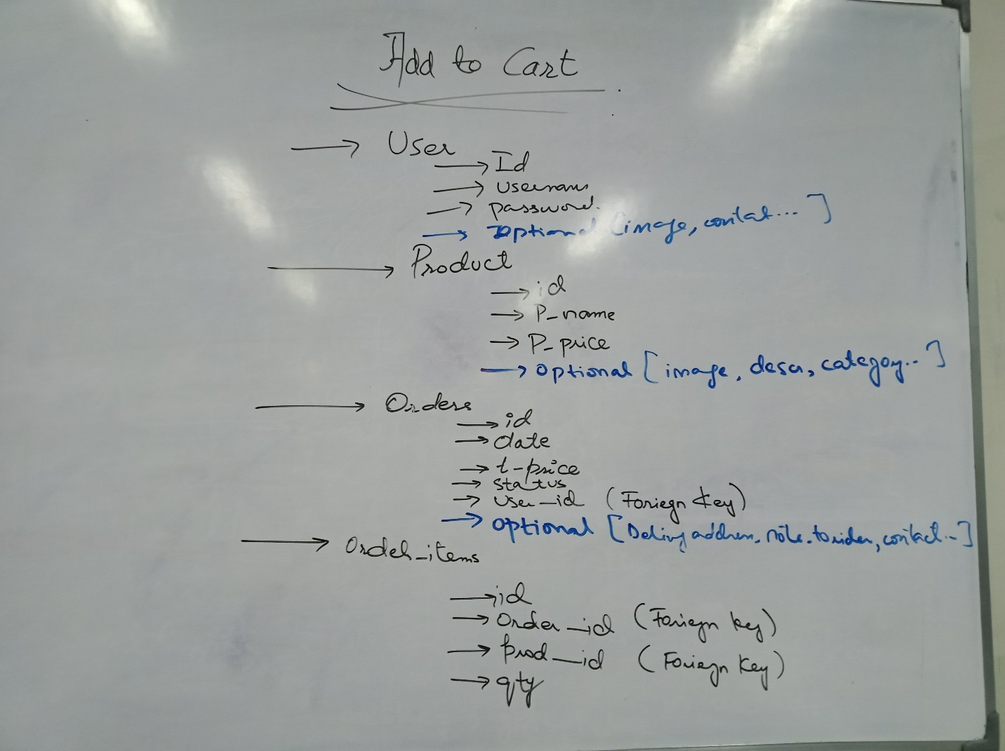

First of all create a getter setter class for your cart

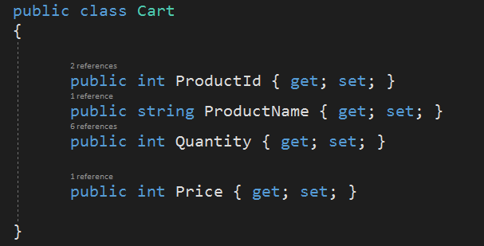

Also, create session extension class beforehand

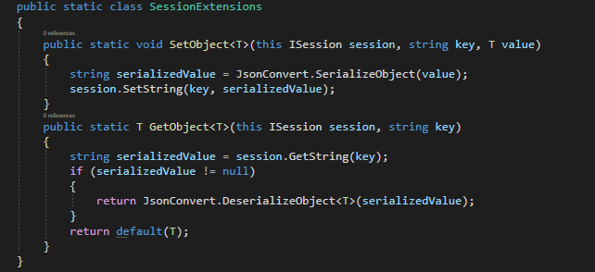

To use session in your program.cs file





In main page 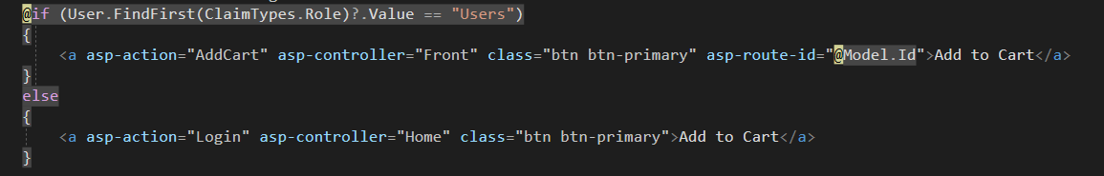

In AddCart action method

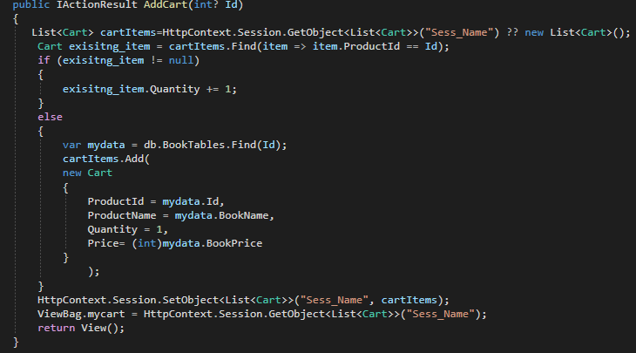

In AddCart View:

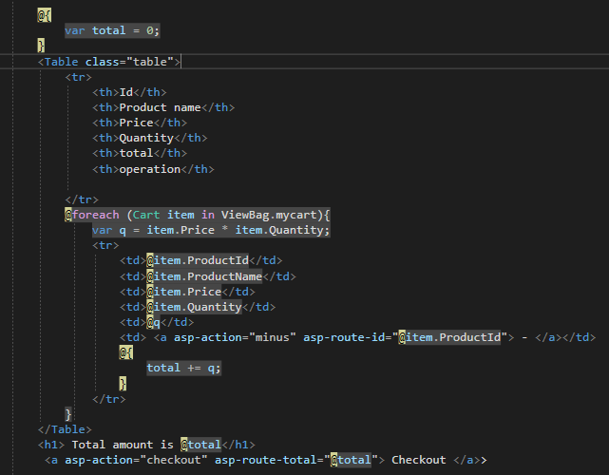

In Controller, **minus** action method

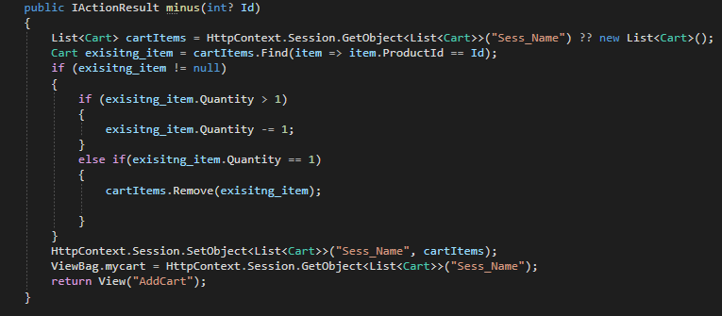

In Controller, Checkout action method. (GET METHOD)

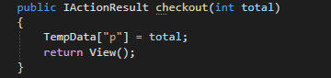

In **CHECKOUT** View

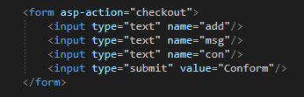

In Controller, Checkout action method. (POST METHOD)

