Data Analysis and Visualization

(Lab Sessional)


Group Members:
Aleesha javed - 23i5055
Wajeeha Khalid - 23i2610
Ayesha Bint Imran - 22i1942

Importing the dataset:
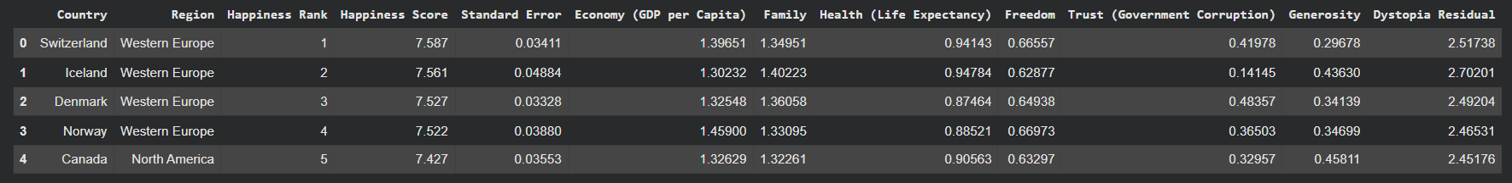
Interpretation:
This dataset has 158 countries and 12 columns. It shows each country’s happiness rank and score, along with factors like economy, family, health, freedom, trust, generosity, and a dystopia residual.

Statistical Summary:
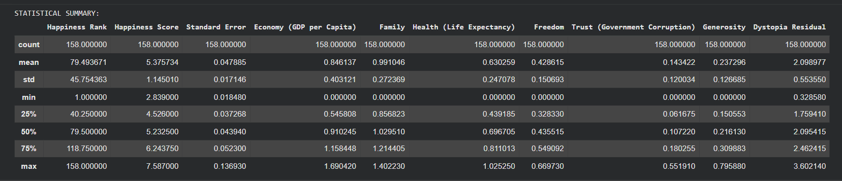

Outlier detection:
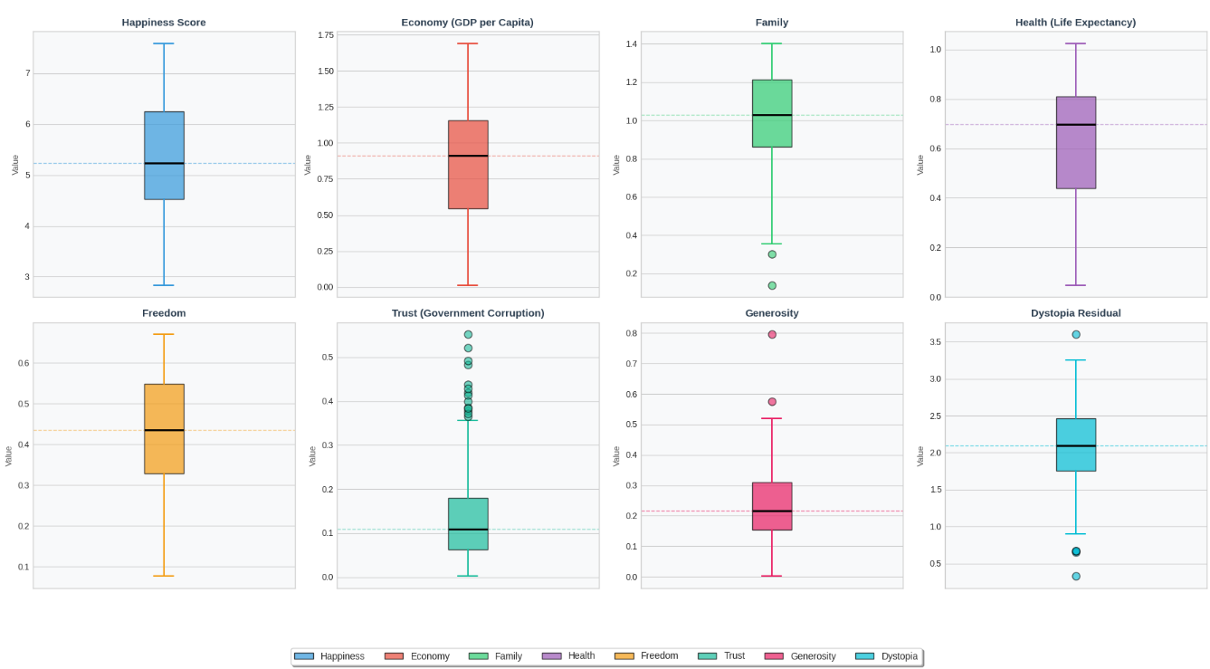
Economic Dependency Percentages:
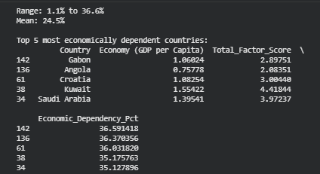
Interpretation:
The Economic Dependency Percentage shows how much of a country’s overall happiness comes from its economy (GDP per capita).

Higher values (~35–36%) mean happiness relies heavily on wealth, these countries are more vulnerable to economic changes.
Lower values (~1–2%) mean happiness depends more on other factors like family, health, freedom, or social support.
Mean: 24.5%, showing that on average, about a quarter of happiness comes from economic factors.
Top economically dependent countries: Gabon, Angola, Croatia, Kuwait, and Saudi Arabia.
Correlation Matrix:

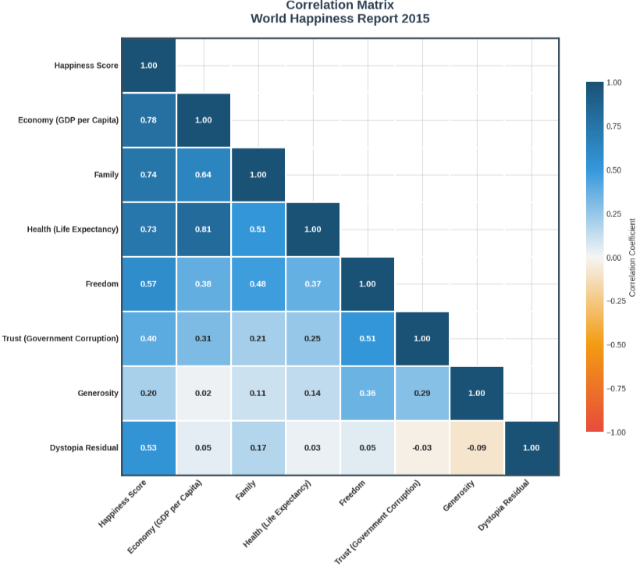
Interpretation:

Overall, money, health, and family matter most for happiness. For example, Economy correlates with Happiness at 0.78, Family at 0.74, and Health at 0.73, showing that richer countries with longer life expectancy and stronger family support are generally happier. Meanwhile, Freedom (0.57) and Trust in government (0.40) also contribute, but their effect is moderate. In contrast, Generosity has a very weak link (0.20) and barely impacts happiness. Furthermore, the Dystopia Residual (0.53) suggests that some happiness cannot be explained by these factors alone, meaning other elements also play a role.
Horizontal Bar Chart:
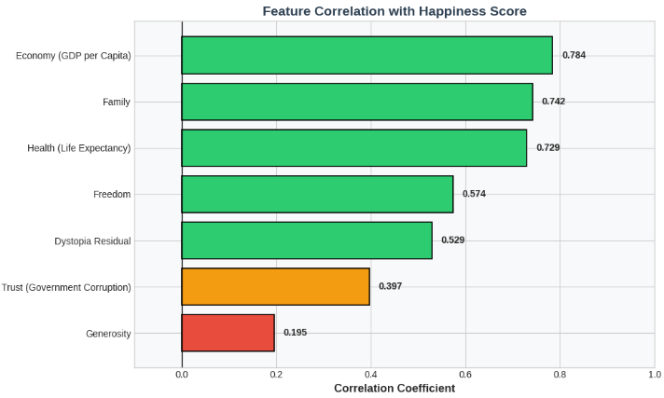
Interpretation:
This shows that the main drivers of national happiness are Economy (0.78), Family (0.74), and Health (0.73). Wealthier countries with strong family support and higher life expectancy tend to be much happier. Freedom (0.57) and Dystopia Residual (0.53) also contribute moderately, reflecting personal liberty and unexplained happiness, while Trust (0.40) has a smaller effect, showing that low corruption helps but isn’t a major factor. Finally, Generosity (0.20) has very little impact on overall happiness. In short, money, health, and family matter most, while generosity plays almost no role at the national level.
Missing Value Analysis:
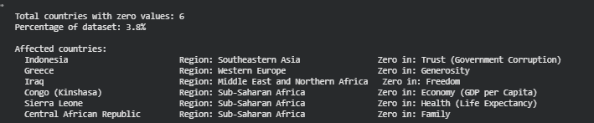
Interpretation:
6 countries have zero values, which is about 3.8% of the dataset.
Affected countries and factors:
Indonesia: zero in Trust (Government Corruption)
Greece: zero in Generosity
Iraq: zero in Freedom
Congo (Kinshasa): zero in Economy (GDP per Capita)
Sierra Leone: zero in Health (Life Expectancy)
Central African Republic: zero in Family

Checking For Duplicates: 0
Range Value Analysis:
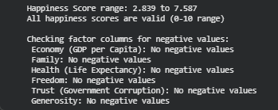
Interpretation:
Happiness scores range from 2.839 to 7.587, all within the valid 0–10 scale.
All factor columns like Economy, Family, Health, Freedom, Trust, Generosity have no negative value
Sample Data From Each Region:
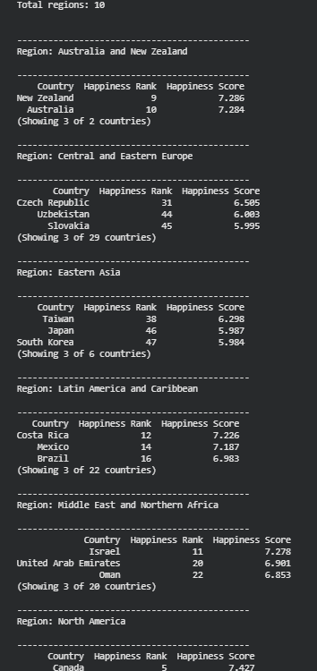
Interpretation:
The dataset has 10 regions with varying numbers of countries.
Western Europe and Australia and New Zealand have the highest happiness scores (7+).
North America also scores high, while Southern Asia and Sub-Saharan Africa show lower scores (around 4.7–5.5).
Central and Eastern Europe, Eastern Asia, and Southeastern Asia fall in the mid-range (around 5.9–6.8).
This shows that happiness differs by region, reflecting differences in wealth, health, social support, and freedom.

- Ridgeline Plot:

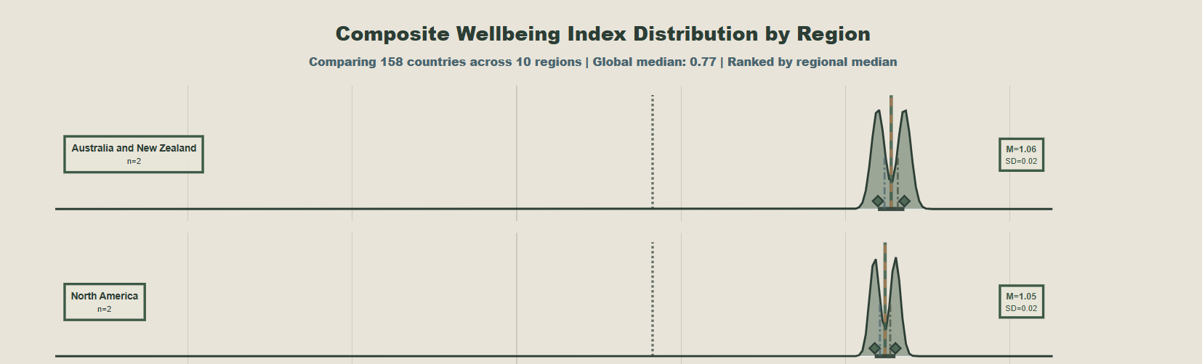
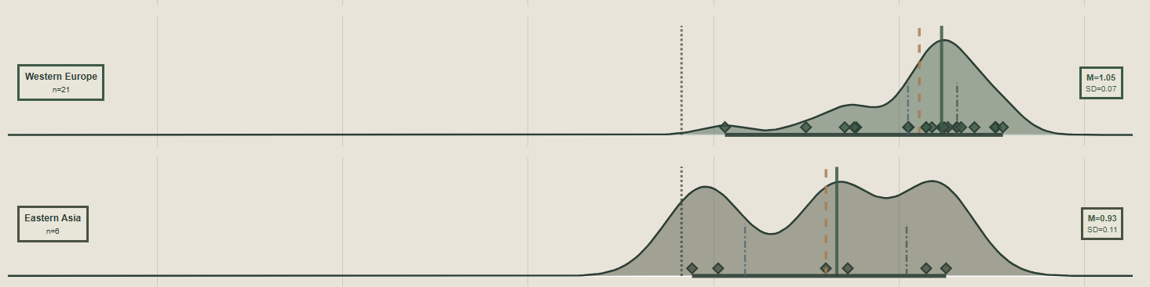
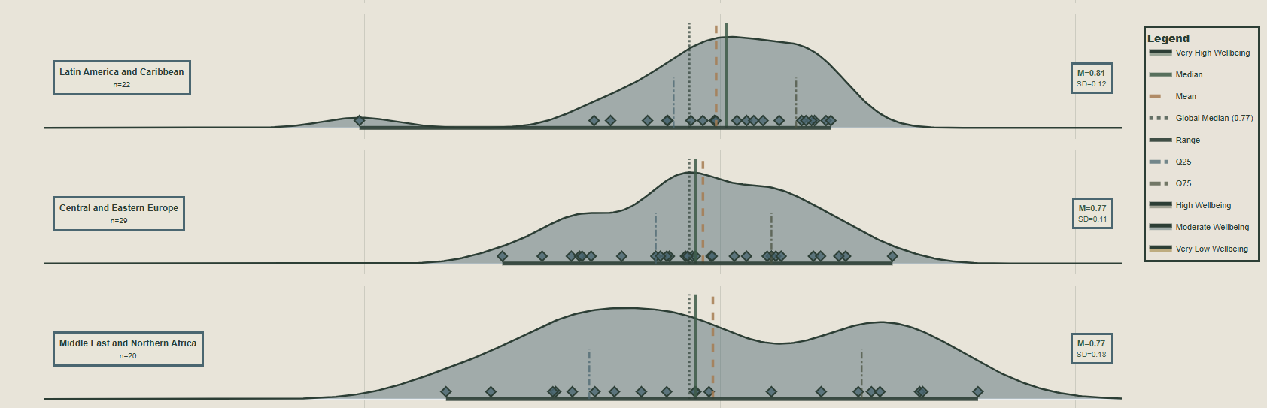
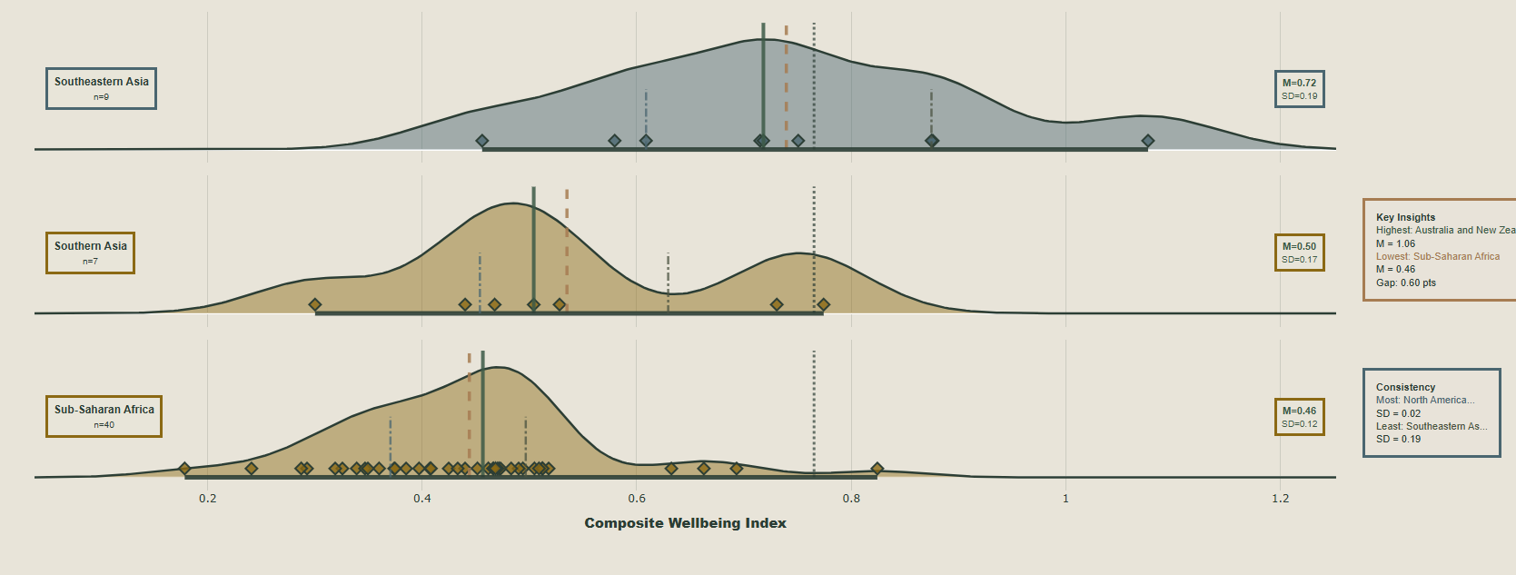
Interpretation:
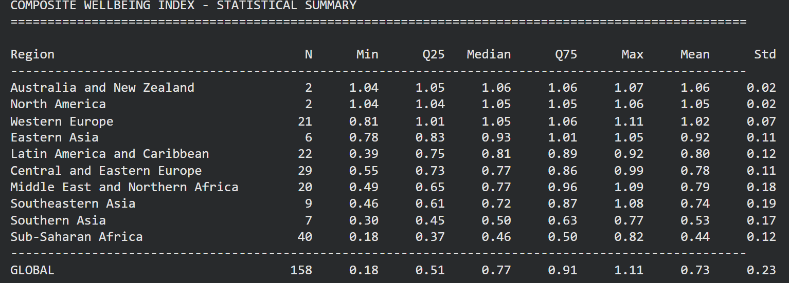

Interpretation of the Composite Wellbeing Index Visualization

1. Regional Wellbeing Patterns
- The chart clearly shows the distribution of wellbeing scores for each region.
- Regions at the top of the plot (larger median values, darker green) are performing better in terms of overall wellbeing, while regions at the bottom (lower median, bronze/brown colors) are lagging behind.
- The median line (dark green) and mean line (bronze dashed) highlight central tendencies, allowing us to quickly see if a region’s distribution is symmetric or skewed.

2. Spread and Variability
- The width of the density curves indicates how concentrated or spread out scores are within a region.
  - Narrow peaks suggest consistency (countries in that region have similar wellbeing).
  - Broad or flat curves indicate high variability, meaning countries’ wellbeing differs widely within the region.
- The 25th (teal dash-dot) and 75th (olive dash-dot) percentiles further show the internal range of wellbeing, highlighting outliers or extreme performers.

3. Country-Level Details
- Each diamond marker shows an individual country’s wellbeing score within the region, providing a clear link between the aggregate regional statistics and individual data points.
- Hovering over markers shows additional factor breakdowns (Material Score, Social Score, Democratic Index, etc.), offering insights into what drives each country’s wellbeing.

4. Global Context
- The global median (dotted line) allows comparison of each region’s performance relative to the world as a whole.
- This contextualizes regional rankings and identifies which regions are above or below the global average.

5. Key Insights
- The highest wellbeing is concentrated in the top-ranked region (likely Western Europe or similar), with a high median and relatively narrow spread, indicating both high and consistent scores.
- The lowest wellbeing is in regions with smaller medians and sometimes wider distributions, indicating lower and more variable wellbeing.
- The gap between top and bottom regions quantifies global disparities in wellbeing.

6. Consistency Analysis
- Regions with the lowest standard deviation (narrow curves) have countries with very similar wellbeing, indicating homogeneity in outcomes.
- Regions with the highest standard deviation show heterogeneity, where some countries perform well while others lag significantly.

2. Lollipop Chart:
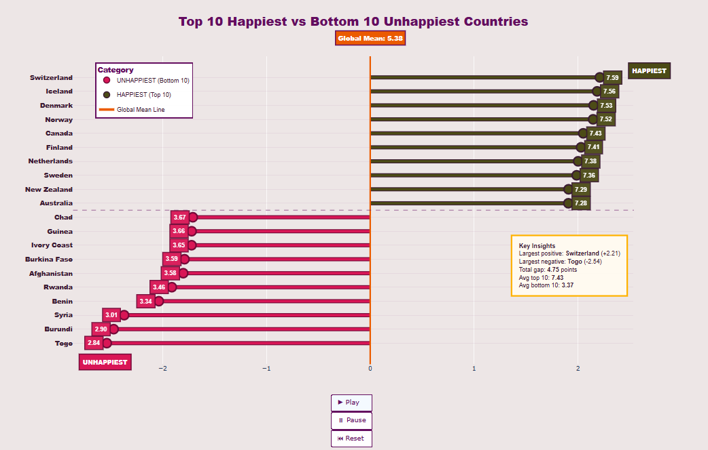
This visualization is also known as a Dumbbell Chart or Diverging Bar Chart
Why this visualization?
The Diverging Bar Chart was essential for the final, impactful conclusion of your data analysis project. While the previous charts focused on factors, regions and correlations, this chart provides the summary and contrast.
- Narrative and Impact: After plots like the pair and 3D plot, this chart simply communicates the sheer scale of global happiness inequality.
- Benchmark Comparison: It effectively uses the Global Mean (5.38) as a crucial benchmark. By plotting everything relative to this zero line, it instantly answers the question: "How happy are the happiest, and how unhappy are the unhappiest, compared to the average human experience?"
- Data Simplification and Accessibility: It takes the complex, multi-factor analysis and condenses the finding into a single, intuitive metric (Happiness Score). This makes the results accessible to a wider audience.
- Completion of Extremes Analysis: The previous charts focused on the distribution and correlations. This chart specifically highlights the extreme ends of the data, which are often the most socially significant findings in any global report.
Interpretation of the Diverging Bar Chart
This chart directly compares the Top 10 Happiest Countries with the Bottom 10 Unhappiest Countries relative to the Global Mean Happiness Score.

- Central Axis (Zero Line): This is strategically set at the Global Mean Score (5.38).
- Top Half (Happiest): Countries are plotted to the right of the central axis, showing their score above the global mean.
- Bottom Half (Unhappiest): Countries are plotted to the left of the central axis, showing their score below the global mean.
- Color and Length: The length of the bar and its color intensity (dark brown for happiest, dark pink/red for unhappiest) clearly convey the magnitude of the score and its distance from the mean.
Key Insights:
- Extreme Spread: The chart visualizes the massive disparity in global happiness. The difference between the highest score (Switzerland, 7.59) and the lowest score (Togo, 2.84) is over 4.75 points, demonstrating a clear polarization in global wellbeing.
- Relative Positioning to the Mean:
  - The bars for the Top 10 are consistently long and dark brown, showing that the happiest countries are far above the global average.
  - The bars for the Bottom 10 are consistently long and dark red, showing that the unhappiest countries are far below the global average.
- Regional Confirmation: This visualization provides a summary confirmation of the regional findings: the Top 10 are dominated by developed Western nations (Switzerland, Iceland, Norway, Canada, etc.), while the Bottom 10 are dominated by regions facing extreme challenges (Togo, Burundi, Syria, Chad, Guinea, etc.).
- Summary Statistics: The "Key Insights" box provides the numerical summary required for final reporting:
  - The largest positive deviation (Switzerland, +2.21 from the mean).
  - The largest negative deviation (Togo, -2.54 from the mean).
  - The large average difference between the groups (Avg Top 10−Avg Bottom 10=7.43−3.37=4.06 points).

3. 3D Scatterplot
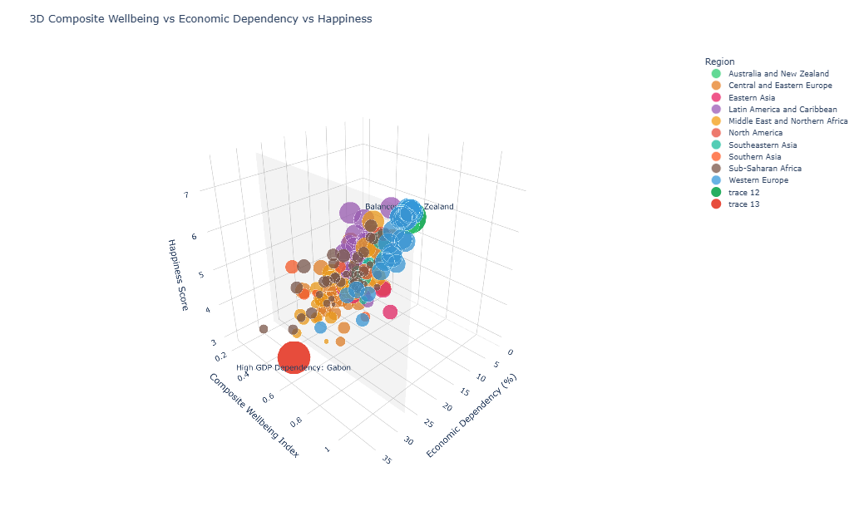

Why This Chart Was Critically Needed
- Testing Composite and Counter-Intuitive Variables: The chart was needed to test two concepts that simpler plots couldn't handle simultaneously:
  - The Power of a Composite Index: It validates the success of combining internal factors into one Composite Wellbeing Index. By showing its strong correlation with Happiness, it proves that the analyst can simplify the seven factors into one powerful predictor.
  - External Risk Assessment: It introduces Economic Dependency, an external risk factor, to see if it predicts Happiness. The finding that it does not strongly correlate but creates important outliers (like Gabon and New Zealand) is a crucial, non-obvious insight.
- Highlighting the Vague/Non-Linear: For a dataset criticized as "vague," the 3D plot excels at showing non-linear relationships and interaction effects. The value of this chart lies not in finding a straight line, but in identifying regions of stability (high Wellbeing, low Dependency) and regions of risk (low Wellbeing, high Dependency).
- Creative Synthesis (4-Dimensional View): Using a 3D scatter plot is highly creative and necessary for visually synthesizing four quantitative variables (X, Y, Z, and Size/Color) into a single, comprehensive model. This presentation demonstrates a maximum effort to extract complex, contextual meaning from the data.
- Outlier and Policy Focus: The chart provides a powerful visual framework for policy recommendations. It was needed to instantly flag high-risk outliers (like Gabon) and resilient high-performers (like New Zealand), prompting further investigation into why these countries defy the general trends.

Interpretation:
This visualization maps four dimensions onto a three-dimensional space to explore the relationships between a country's internal strength, external reliance, and final happiness:
- X-axis (Economic Dependency (%)): Measures the degree to which a country relies on external factors (like trade, remittances, or foreign aid). Higher percentages mean greater dependency.
- Y-axis (Composite Wellbeing Index): Represents a single metric summarizing several internal factors of wellbeing (likely combining Health, Family, Freedom, etc.). Higher values mean better internal wellbeing.
- Z-axis (Happiness Score): The overall outcome score. Higher positions mean higher happiness.
- Bubble Size (Implicit Value): Proportional to the Happiness Score.
- Color: Categorized by Region.

Key Relationships and Patterns Observed:
- Composite Wellbeing vs. Happiness (Y-Z Plane):
  - The primary trend shows a strong positive relationship between the Composite Wellbeing Index and the Happiness Score. The highest-ranking bubbles (Western Europe, Australia/New Zealand) are consistently located high up on the Z-axis (high Happiness) and far out on the Y-axis (high Composite Wellbeing). This confirms that improving internal, structural factors is the most direct path to happiness.
- Economic Dependency vs. Happiness (X-Z Plane):
  - There is no clear linear correlation between Economic Dependency and Happiness. High-dependency countries (right side of the X-axis) and low-dependency countries (left side) are spread across the entire range of the Z-axis.
  - The highest happiness scores (Z-axis top) are generally achieved by countries with low to moderate Economic Dependency (around 0% to 15% on the X-axis).
- The "High GDP Dependency: Gabon" Outlier:
  - The code labels a significant outlier on the far right (high Economic Dependency) and low on the Y and Z axes (low Wellbeing, low Happiness). This point (labeled "Gabon" in the image) demonstrates a critical weakness: High external reliance combined with low internal wellbeing leads to low happiness.
- The "Zealand" Outlier/High Performer:
  - This country (likely New Zealand) sits high on the Y-Z plane (High Wellbeing, High Happiness) but occupies a unique position on the X-axis (high dependency). It represents a nation that achieves high happiness despite high economic dependency, suggesting its high Composite Wellbeing Index is robust enough to mitigate external risks.

4. Pairplot:
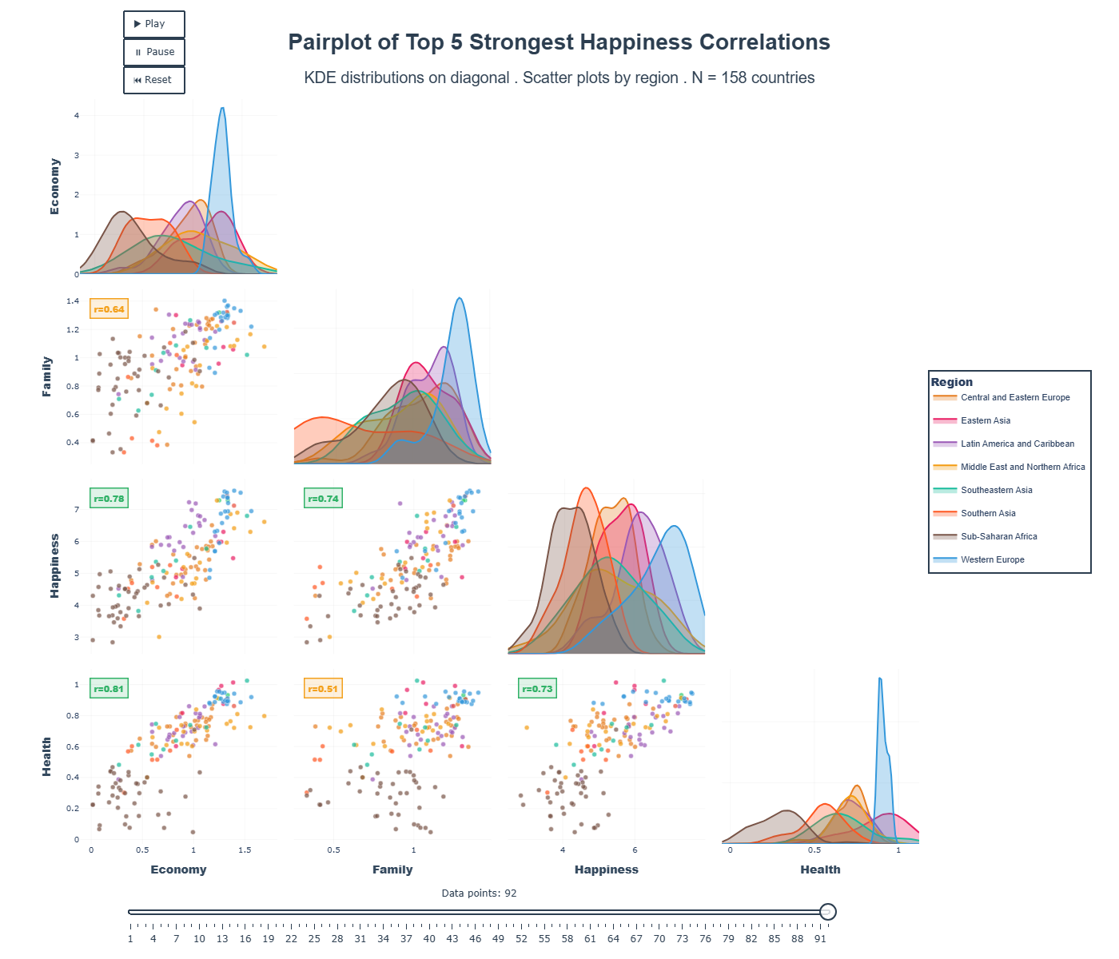

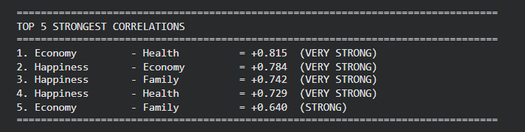
Why this was needed
After the initial exploratory analysis (Bubble Plot and Radial Heatmap), the Pair Plot was essential for validation, completeness, and rigor in a project dealing with potentially "vague" data.
- Validation and Rigor: The Pair Plot is the gold standard for checking multi-variate correlations. It allows you to numerically validate the visual trends seen in the previous charts by providing the correlation coefficient (r). For example, the visual strength of the Economy vs. Happiness relationship is confirmed by r=0.78. This moves the analysis from visual inference to statistical proof.
- Comprehensive Relationship Mapping: The chart provides an exhaustive, one-stop reference for every single interaction between the four chosen variables. You don't have to generate four separate scatter plots; the matrix displays unique comparisons (where n=4) in a clean layout. This ensures you haven't missed a surprising relationship between two secondary factors (like Family and Health, r=0.74).
- Understanding Factor Interdependence (UMulticollinearity): This is perhaps the most advanced necessity. The plot clearly shows that Economy and Health are highly correlated (r=0.81). This phenomenon, known as multicollinearity, is a critical finding: it means that high scores in one almost guarantee high scores in the other. This explains why the Happiness Score is so predictable and helps the analyst understand that these two factors should often be considered as a single, combined "Development" variable.
- Distributional Context: The diagonal KDE plots were necessary to show the variance and central tendency of each factor across different regions. It visually confirms that the observed correlations are largely driven by the difference between the high-performing Western Europe cluster and the low-performing Sub-Saharan Africa cluster, providing crucial context for the entire dataset's structure.

Interpretation:
The Pair Plot shows the relationships between four key quantitative variables from the World Happiness Report: Economy, Family, Happiness, and Health.
The structure is a matrix where:
- Off-Diagonal Panels: Show the scatter plot between the variable on the row and the variable on the column (e.g., the plot in the second row, third column shows Family vs. Happiness).
- Diagonal Panels: Show the univariate distribution (Kernel Density Estimate or KDE) for the single variable (e.g., the plot in the second row, second column shows the distribution of the Family factor).
- Color/Region: Every point and density curve is colored by Region, allowing for regional comparison within each relationship.
- Correlation Coefficient (r): The correlation coefficient is displayed on the off-diagonal plots to numerically quantify the linear strength between the two variables.

Key Insights from the Matrix:
- Core Predictors Confirmed (Strong r values):
  - Economy vs. Happiness (r = 0.78): A strong positive linear relationship is confirmed. As GDP increases, Happiness Score increases.
  - Health vs. Happiness (r = 0.73): A strong positive linear relationship is confirmed. As Life Expectancy increases, Happiness Score increases.
  - Economy vs. Health (r = 0.81): This is the strongest relationship in the matrix, indicating that a nation's high GDP and high Life Expectancy are deeply intertwined.
- Secondary Factor Impact (Moderate r values):
  - Family vs. Happiness (r = 0.74): Family support also shows a strong positive relationship with happiness, similar in magnitude to Health. This highlights that a key social factor is nearly as important as the primary economic and health factors.
  - Family vs. Economy (r = 0.64): There is a moderate positive correlation here, suggesting that high economic standing often coincides with higher scores in the Family factor.
- Regional Distribution (KDE Plots): The diagonal plots clearly show how each factor is distributed by region:
  - Economy and Health: The density curves for Western Europe and North America are clearly positioned far to the right, showing these regions have the highest median values for these factors.
  - Family and Happiness: The distributions are tighter and slightly more overlapped across regions, suggesting that while Western Europe is often highest, other regions (like Latin America) may have strong performance in specific social factors, even if their Economy/Health is lower.

5. Choropleth

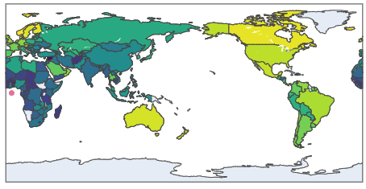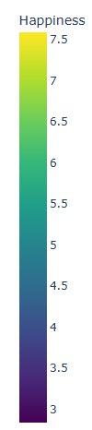
6. Bubble Chart
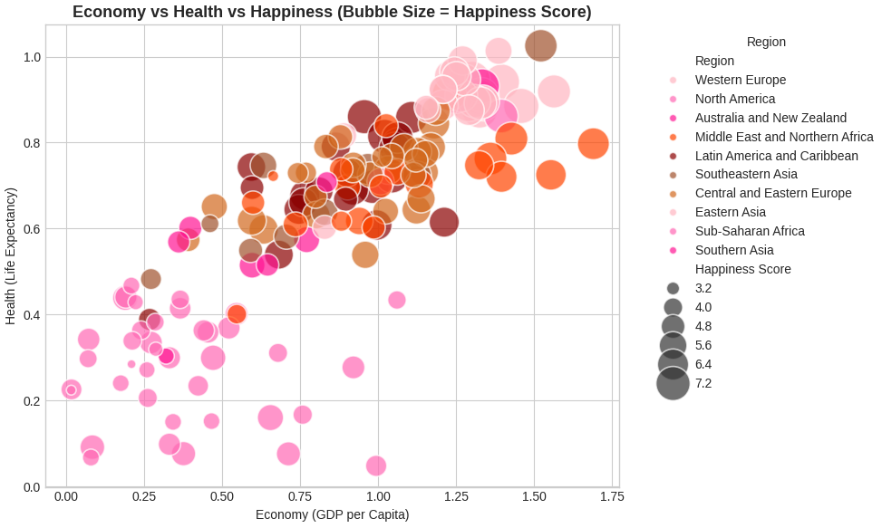
Why the bubble chart:

Necessity
- The bubble scatter plot confirms whether the two foundational pillars of wellbeing—economic strength (GDP) and social health—actually influence national happiness.
- It provides a clear, unified view of how these three major variables interact before moving to more complex analyses.
How the Bubble Scatter Plot Achieves It
- It makes the core hypothesis testable by displaying GDP, Health, and Happiness simultaneously.
- The diagonal trend reveals that GDP and Health function as the primary “engine” driving the Happiness Score.

Identifying Predictors
- The plot visually isolates the two strongest predictors of happiness.
- The clear clustering pattern demonstrates how countries move along the happiness scale based on GDP and Health alone.

Highlighting Nuance and Outliers
- The structure is ideal for spotting exceptions—countries that defy the main pattern.
- Large bubbles in low-GDP regions or small bubbles in high-GDP regions immediately stand out as candidates for deeper exploration.

Four-Dimensional Comparison
- The chart combines four dimensions in a single frame:
  - X-axis: GDP
  - Y-axis: Health
  - Bubble Size: Happiness Score
  - Color: Region
- This allows for a comprehensive and efficient comparison of the main outcome (Happiness) against its most important inputs.

Interpretation:
This visualization displays the relationship between the two most fundamental economic and social factors—Economy (GDP per Capita) and Health (Life Expectancy)—while encoding the overall Happiness Score into the size of the bubble and the Region into the color.

- Axes:
  - X-axis (Economy/GDP): Represents the country's economic strength.
  - Y-axis (Health/Life Expectancy): Represents the country's social/health strength.
- Bubble Size: Proportional to the country's Happiness Score.
- Color: Categorized by Region
Key relationships and Patterns:
- Strong Positive Correlation (The Main Trend): There is a clear, strong positive correlation running diagonally from the bottom-left to the top-right corner.
  - Countries with low GDP and low Life Expectancy tend to have small bubbles (low Happiness Score) and cluster in the bottom-left.
  - Countries with high GDP and high Life Expectancy tend to have large bubbles (high Happiness Score) and cluster in the top-right.
  - Conclusion: This visually confirms the primary hypothesis that Economic prosperity and good Public Health are the strongest predictors of overall Happiness.
- Regional Clustering: The chart effectively segregates the world into distinct clusters:
  - Top-Right Cluster (Darker Colors): Dominated by Western Europe and North America (Pink/Magenta shades) and Australia/New Zealand (Dark Orange). These countries exhibit peak performance across all three metrics (GDP, Health, Happiness).
  - Mid-to-Low Cluster (Light/Pink Colors): Countries in Sub-Saharan Africa and Southern Asia (bottom-left) show low scores across all three metrics.
  - Outliers (Points of Interest):
    - Look for bubbles that are large in size (high happiness) but are not in the top-right corner. These points represent countries that achieve high happiness despite moderate-to-low GDP or Life Expectancy, suggesting that other factors (like Family, Freedom, or Trust) play a significantly larger role for them.
    - Look for bubbles that are small in size (low happiness) but are high on the axes (high GDP/Health). These countries are unhappy despite having economic and health advantages, potentially due to poor scores in factors like Trust or Freedom

7. World Icicle Chart
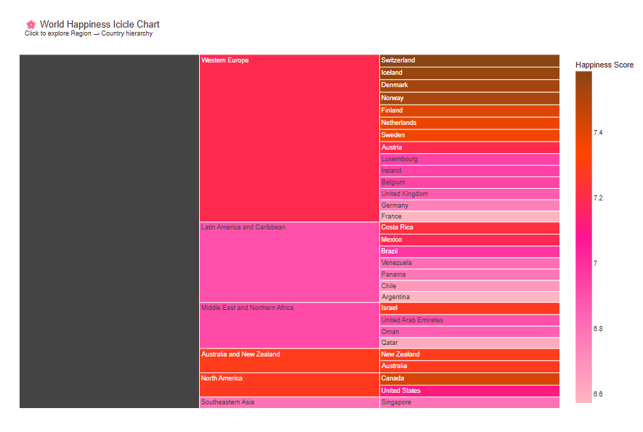
The Icicle Chart is a way to tackle the hierarchical structure hidden within the World Happiness data (Region-> Country ->Score)

Why This Chart Was Necessary and Creative
The Icicle Chart was chosen to provide a hierarchical summary:
where the size and color of each segment are mapped to a quantitative value. It's essentially a space-filling visualization, like a Treemap, but presented from top-to-bottom (hence the "icicle" shape).

Interpretation of the Chart
The Icicle Chart provides a clear, top-down view of how happiness is distributed regionally and nationally.
- Regional Dominance: The Western Europe region is the largest and most dominant block at the top. This signifies that, collectively, the countries in this region have a very high total Happiness Score, making it the primary hub of happiness in the dataset.
- Score Consistency (Western Europe): The country blocks within the Western Europe segment are overwhelmingly colored in dark brown and orange-red (e.g., Switzerland, Iceland, Denmark, Norway). This shows that not only is the region collectively happy, but the individual countries within it exhibit very high and consistent Happiness Scores.
- Regional Comparison: By looking across the regional blocks, it is easy to compare regional characteristics:
  - Latin America and Caribbean is a large region with a generally high score (bright pink/magenta colors), but the scores are less intense than Western Europe, suggesting a slightly lower average score or greater variance.
  - The Middle East and Northern Africa show more variability, with some countries showing bright colors and others showing darker colors, indicating a less uniform distribution of happiness.
- Ranking Clarity: Since the Icicle chart defaults to sorting based on the values (Happiness Score) when displaying the lowest level (Country), the bars within each region are implicitly ordered by score. This provides a clear, visible ranking within each region.

8. Radial/Circular Heatmap
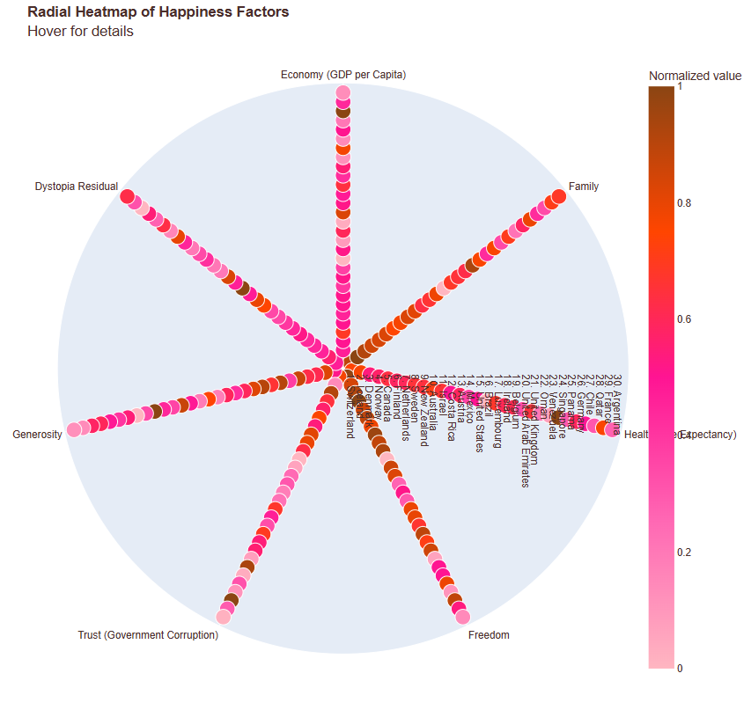
Why we chose a radial heatmap:
High-Density Comparison:
It allows the viewer to immediately compare 30 countries across 7 factors in a single view. By fixing the factors on the angular axis and the countries on the radial axis, you can quickly:
- Compare Factors for one Country: Look along one concentric circle to see the varying colors (strengths) of all factors for a single country.
- Compare Countries for one Factor: Look along one radial line ($\theta$) to see how different countries stack up (color gradient) on a specific factor (e.g., Freedom).
Clear Pattern Recognition (Heatmap Effect): The color gradient acts as a heatmap. Darker colors (brown) signify a country is performing exceptionally well on that specific factor (relative to the other top 30 countries). This helps identify:
- Strengths: Dark dots clustered in one factor's column show a shared strength (e.g., Economy).
- Outliers: A single very dark or very light dot quickly identifies a country that is an exceptional performer or underperformer on a given factor, even within the Top 30.
Novelty and Engagement: Radial plots are inherently less common than standard Cartesian plots. This novelty draws the viewer in and visually communicates the complex, multi-factor nature of the Happiness Score, fulfilling the need to be "creative" with a vague dataset.

Interpretation of the Chart:
The Radial Heatmap visualizes the relative performance of the Top 30 Happiest Countries across the seven main contributing factors: Economy, Family, Health, Freedom, Trust, Generosity, and Dystopia Residual.
- Factors (Axes): The seven factors are spread out along the angular axis
- Country Rank (Radius): The radial axis (r) lists the countries by rank (the inner-most ring is Rank 1).
- Performance (Color/Heat): The color of each dot indicates the normalized score (0 to 1) for that factor in that country.
  - Light Pink/Magenta (Low Normalized Value): The country is performing relatively less well on that factor compared to the maximum value found within the Top 30 countries.
  - Dark Red/Brown (High Normalized Value): The country is performing exceptionally well on that factor compared to the maximum value found within the Top 30 countries.

Key Patterns Observable from the Chart:
- Uniformity in Core Factors: For the highest-ranking countries (inner rings), the factors like Economy (GDP per Capita) and Health (Life Expectancy) show consistently darker colors (more brown/red). This suggests that high performance in these fundamental economic and social pillars is a prerequisite for achieving a high overall Happiness Score.
- Variability in Societal Factors: Factors like Generosity and Trust (Government Corruption) often show a wider range of colors, even among the Top 30. This highlights that these societal and cultural factors are less uniformly high among the top-ranking nations and may represent areas of subtle difference or unique strengths for specific countries.
- Country Profiles: By looking along a single radial ring (e.g., the outermost ring), a complete "profile" of a specific country's performance can be quickly assessed. A country might have very dark dots for Economy and Health but lighter dots for Generosity and Freedom.
- Feature Strengths/Weaknesses: By looking along a single angular line (e.g., the line for Generosity), it's easy to spot which countries (dot colors) excel or lag behind the others in that specific factor.

9. Sankey Diagram
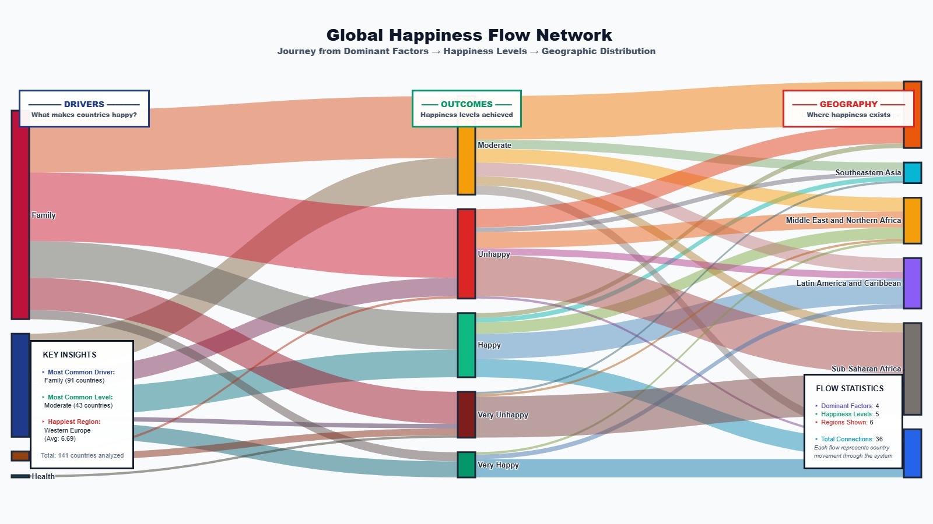
It illustrates the relationships between Drivers (factors that make countries happy), Outcomes (happiness levels achieved), and Geography (where happiness exists).
Why this visualization
- Showcasing Multi-Stage, Many-to-Many Relationships
The main goal of the visualization is to link three distinct stages of data (Drivers -> Outcomes -> Geography).
- A standard bar chart could show the number of countries in each 'Outcome' or 'Region,' but it could not show where they came from or where they went next.
- The Sankey diagram excels at showing the many-to-many mapping. It connects:
  - Drivers (e.g., Family) to multiple Outcomes (e.g., Happy, Moderate).
  - Outcomes (e.g., Happy) to multiple Geographic Regions (e.g., Western Europe, Latin America).

2. Visually Representing Magnitude (The "Flow")
The width of the links (the colored bands) is proportional to the quantity they represent—in this case, the number of countries (Total: 141).
- This immediately highlights the most dominant flows. For example, you can see at a glance that the flow into the Moderate outcome is the largest, and you can trace that flow back to its primary drivers.
- It allows the viewer to instantly grasp the relative importance of different pathways (e.g., is Family a stronger predictor of Very Happy or Moderate?), which is much harder to do by looking at a table of 36 connections.

3. Tracing Causality and Contribution
The directed flow, from left to right (Driver -> Outcome ->Geography), helps researchers and policymakers answer key questions:
- Which factors contribute most to the desired outcomes (like "Happy" or "Very Happy")?
- Which pathways lead to negative outcomes (like "Unhappy" or "Very Unhappy") and in which regions are they concentrated? (e.g., tracing the flow to "Sub-Saharan Africa").

Key Insights and Statistics
- Total Countries Analyzed: 141
- Most Common Driver: Family (51 countries).
- Most Common Level: Moderate (42 countries).
- Happiest Region: Western Europe (Avg 6.68).

Flow Statistics:
- Dominant Factors: 4
- Happiness Levels: 5
- Regions Shown: 6
- Total Connections: 36 (Each flow represents a country)

Major Flow Observations
The diagram uses the width of the colored bands (flows) to represent the quantity of countries moving from a Driver to an Outcome, and then to a Geographic Region.
- The largest number of countries flow into the Moderate happiness level, confirming the "Most Common Level" insight.
- Family is a significant driver, with its flow lines connecting to almost all happiness levels and geographical regions.
- The flow lines from the Happy and Very Happy outcomes predominantly connect to a region (implied to be Western Europe by the key insights, which is the unlabelled region at the top right).
- Sub-Saharan Africa appears to receive the largest flow from the Unhappy and Very Unhappy outcomes.

