AeroNet Lite
Autonomous Drone Delivery Simulation
BS Data Science — AI Semester Project SP2026
Technical Report

May 2026

1. Project Overview
AeroNet Lite is an autonomous drone delivery simulator built as a BS Data Science AI semester project. The system models a city as a 10×10 grid where each cell carries a zone type, population density, facility flags, and a no-fly status. Five tightly integrated AI modules — a Constraint Satisfaction Problem (CSP) validator, a Genetic Algorithm fleet selector, an A* path planner, a real-time disruption handler, and a machine learning pipeline — work together across a 20-step simulation that assigns drones to deliveries, responds to mid-flight obstacles, forecasts demand, and detects flight anomalies.
The project intentionally replaces a full city-scale autonomous fleet (which would require ACO, GA, CSP, A*, clustering, regression, and classification at production scale) with a simplified but technically complete demonstration system. The trade-off keeps every algorithm explainable from first principles while still covering the full AI curriculum: search, constraint reasoning, optimisation, regression, and classification.

Grid size: 10 × 10 cells | Simulation length: 20 steps | Interface: Streamlit multi-page app
AI techniques: CSP · Genetic Algorithm (Brute Force alternative) · A* Search · Random Forest · Decision Tree · KNN · Naive Bayes
Dataset: Bike Sharing Demand (regression) · Synthetic drone telemetry (classification)

System Architecture
All modules share a single flat grid model (grid_data.py). Each module reads from and writes to this shared state — the CSP validator reports violations, the fleet selector deposits a drone list, the path planner writes routes, the disruption handler updates no-fly flags, and the ML pipeline stores demand forecasts and anomaly alerts. The Streamlit interface then reads that shared state on every page without any module needing to know the implementation details of another.
Module | Function
CSP Validator | Checks 4 layout rules; reports violating cells
Fleet Selector | Picks light/heavy drone mix under budget via GA
Path Planner | Finds Hub→Pickup→Drop-off→Hub routes using A*
Disruption Handler | Activates no-fly zones; triggers A* rerouting
ML Pipeline | Demand regression + flight anomaly classification
Simulation | 20-step integration run; event log + final summary

2. CSP Validator
Module 1 treats the city layout as a Constraint Satisfaction Problem. The grid is defined once and the validator runs four hard constraints against it. Violations are collected into a list rather than stopping after the first failure, so the entire layout can be audited in a single pass. Each failed rule reports the exact cell coordinates and a suggested corrective action.

Constraints
Rule | Constraint
R1 — Industrial Safety | Industrial cells must not be directly adjacent (4-directional) to Schools or Hospitals
R2 — Residential Coverage | Every Residential cell must be within Manhattan distance 3 of at least one Hub
R3 — Hub Charging Access | Every Hub must have a Charging Pad within Manhattan distance 2
R4 — Medical Emergency Access | At least one Hospital must have a Medical Pickup point within distance 1

Implementation
The validator is implemented in csp_validator.py. Four standalone functions — check_R1_industrial_safety, check_R2_residential_coverage, check_R3_hub_charging, and check_R4_medical_access — each return a list of violating cell coordinates. A fifth function run_all_constraints calls all four and returns a combined results dictionary used by the Streamlit page and the simulation runner.
R1 loops over every Industrial cell and inspects its four Manhattan neighbors. R2 computes the minimum Manhattan distance from each Residential cell to every hub and flags cells where that minimum exceeds 3. R3 mirrors R2 but measures hubs against charging pads with a threshold of 2. R4 checks whether at least one Hospital has a Medical Pickup cell at distance exactly 1; the rule is satisfied even if some hospitals are uncovered, as long as one is covered.

Results on the Sample Grid
Running the validator on the project's default 10×10 grid produced 9 total violations: R1 flagged 1 Industrial cell adjacent to a sensitive zone; R2 flagged 8 Residential cells too far from any hub. R3 and R4 both passed — every hub has a charging pad within 2 cells, and at least one hospital has Medical Pickup access. The Streamlit page displays each constraint as a colour-coded card (green for PASS, red for FAIL) along with a violations table and a constraint graph overlaid on the city grid.

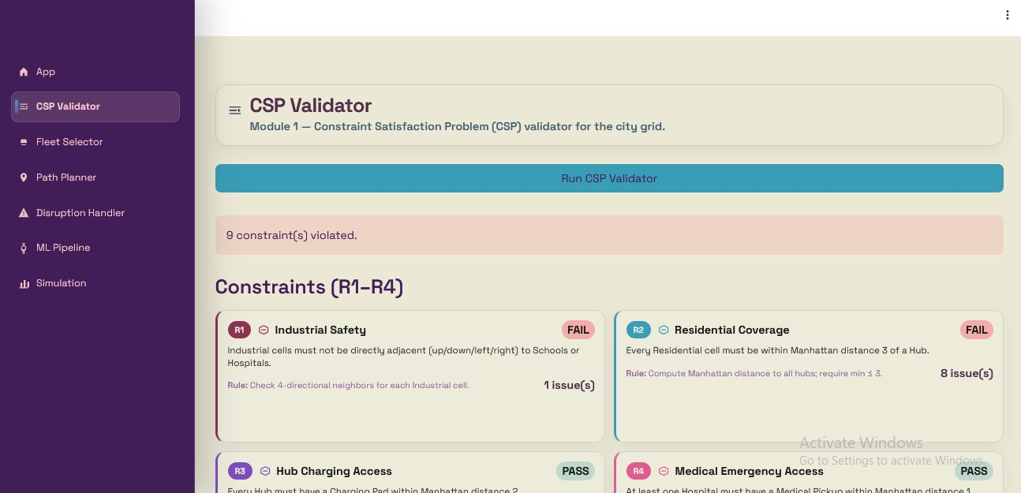
Figure 1 — CSP Validator page: R1 and R2 fail, R3 and R4 pass
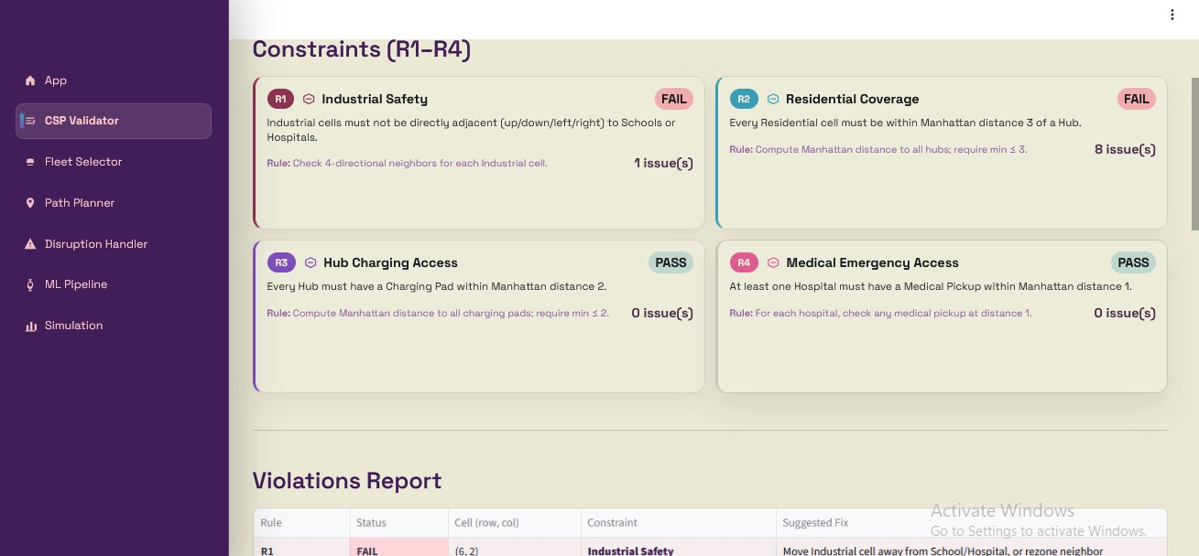
Figure 2 — Full constraint cards and violations report table
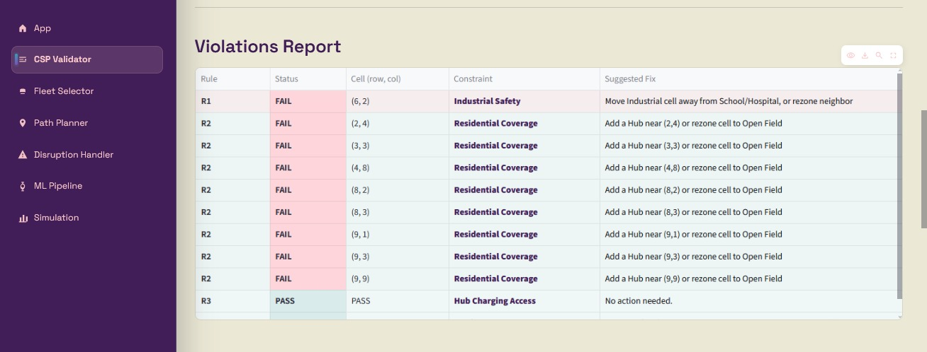
Figure 3 — Violations report listing cell coordinates and suggested fixes
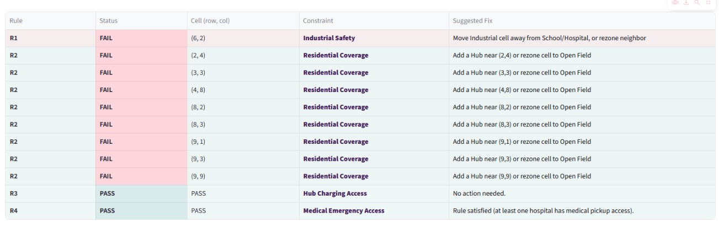
Figure 4 — Suggested fixes panel with actionable recommendations
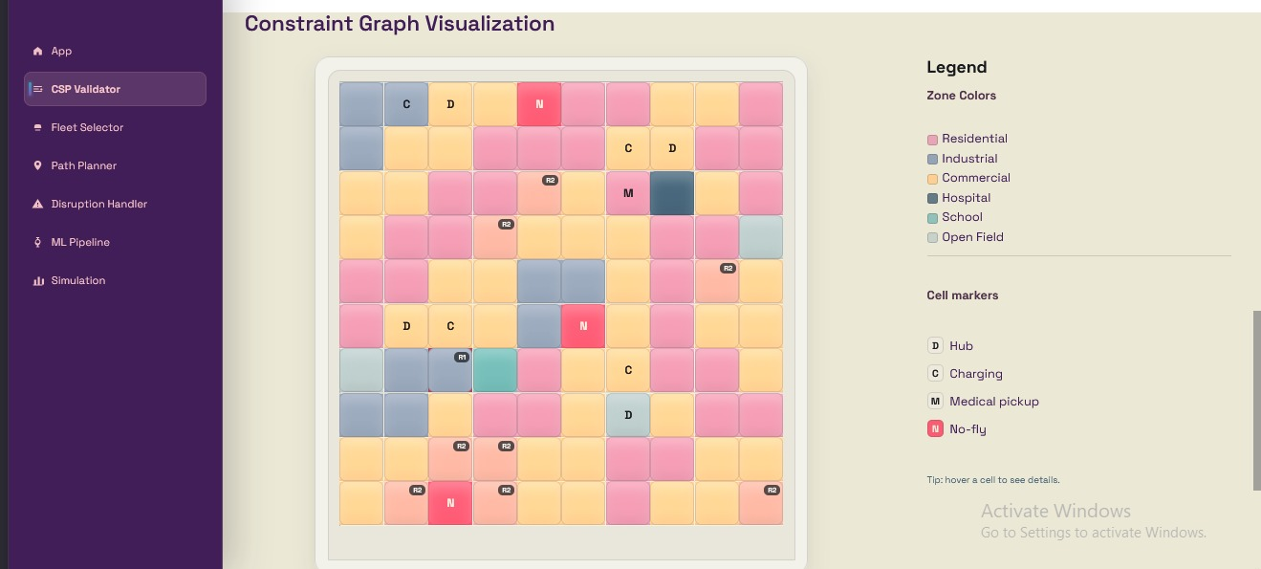
Figure 5 — Constraint graph overlay on the 10×10 city grid
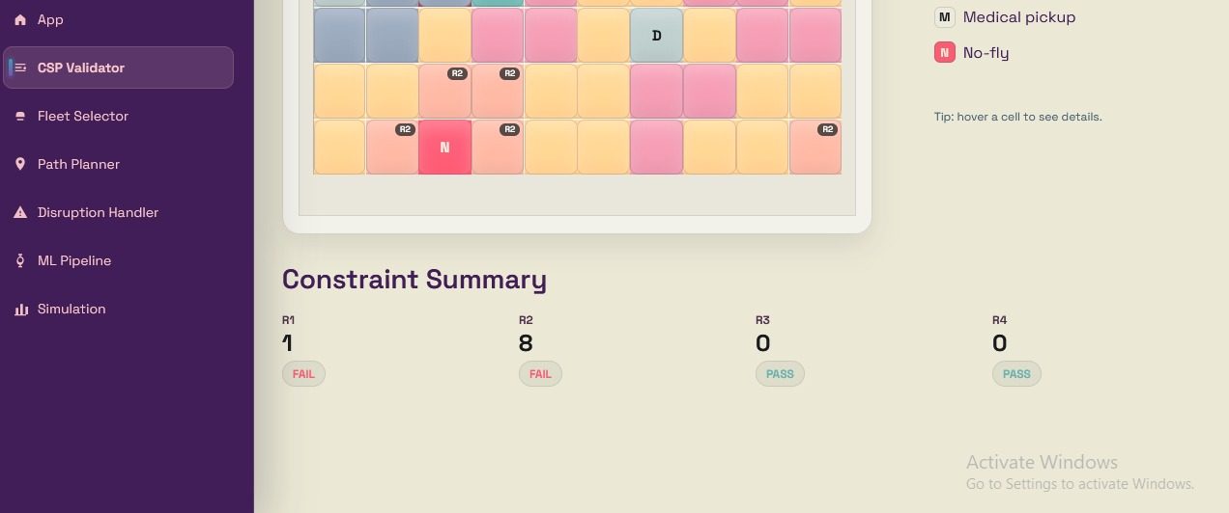
Figure 6 — Zoom on R2 violation badges overlaid on residential cells

3. Fleet Selector
Module 2 selects the optimal combination of light and heavy drones that maximises delivery coverage under a fixed budget. Two drone types are available: a Light Drone (₹1,000, 2 kg payload, 12-cell range) and a Heavy Drone (₹1,800, 5 kg payload, 20-cell range). Both a brute-force exhaustive search and a Genetic Algorithm are implemented so the results can be compared directly.

Fitness Function
The shared fitness formula is: score = (0.75 × coverage_percentage) − (0.25 × budget_used_percentage). Coverage is computed as the total cells reachable by the fleet (light_count × 12 + heavy_count × 20), capped at 100 (the grid size) and further capped by the ML demand estimate. Any fleet that exceeds the budget receives a score of −∞ and is automatically eliminated.

Genetic Algorithm
Each chromosome is a two-element list [light_count, heavy_count]. An initial population of 20 random individuals is evolved over 50 generations. Each generation scores all individuals, retains the top 50% as survivors (elitism), fills the remainder with children via single-point crossover (light from parent A, heavy from parent B), and applies random mutation at a 10% rate. The best individual across all generations is returned as the selected fleet.

Result on the Sample Grid
With a budget of ₹10,000 and the GA method, the selector chose 7 light drones and 1 heavy drone for a total cost of ₹8,800 (₹1,200 remaining). This fleet reaches 100 out of 100 grid cells with a fitness score of 53.0. Total payload capacity is 14 kg light and 5 kg heavy. Average effective range is 13.0 cells, covering all 97 flyable cells across the 4 available hubs. The fitness landscape heatmap shows the score surface across every valid combination, confirming the GA converged near the global optimum.

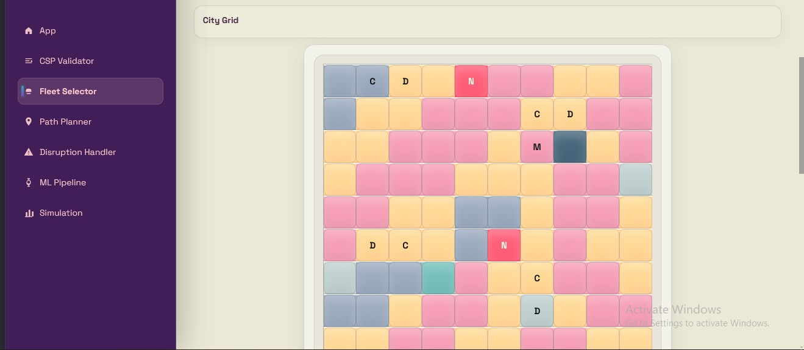
Figure 7 — Fleet Selector: city grid and stats summary (4 hubs, 5 charging, 3 no-fly)
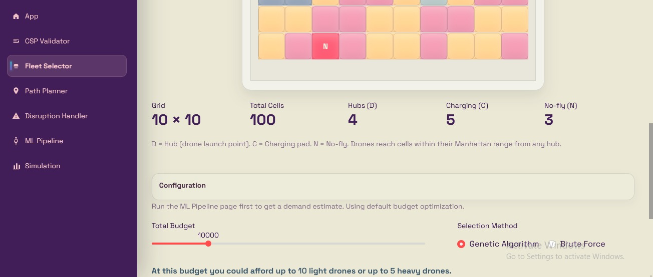
Figure 8 — Configuration panel: budget slider ₹10,000 and GA / Brute Force toggle
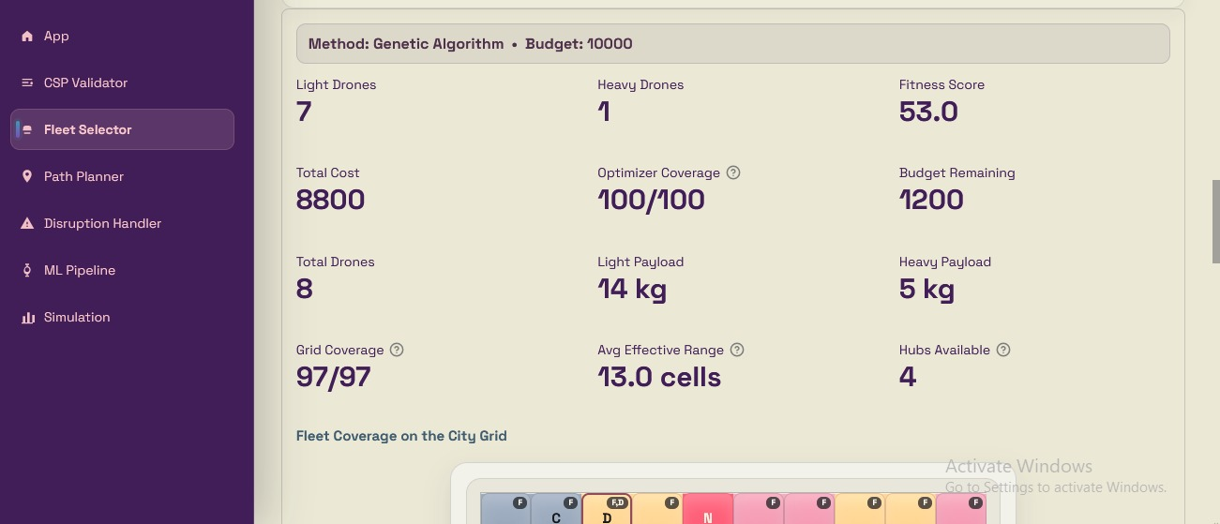
Figure 9 — Fleet result: 7 light + 1 heavy drones, fitness 53.0, coverage 100/100
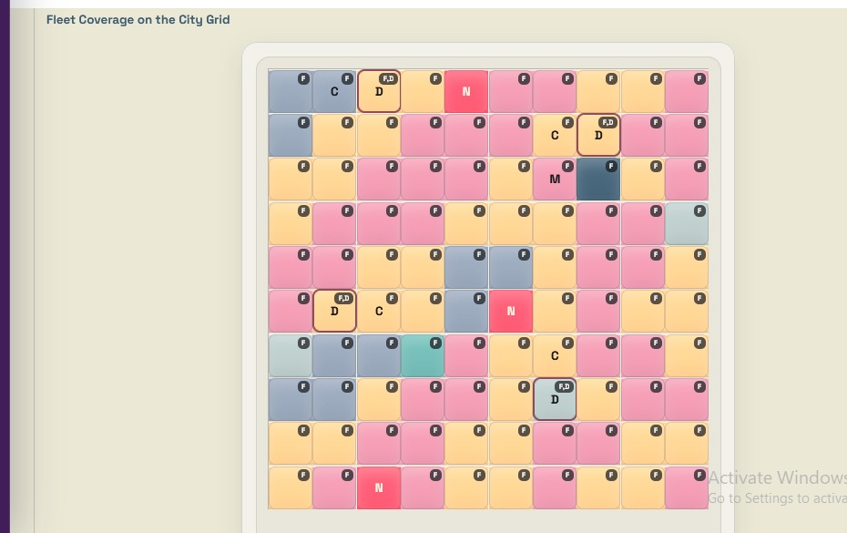
Figure 10 — Fleet at a glance: drone icons and budget utilisation summary
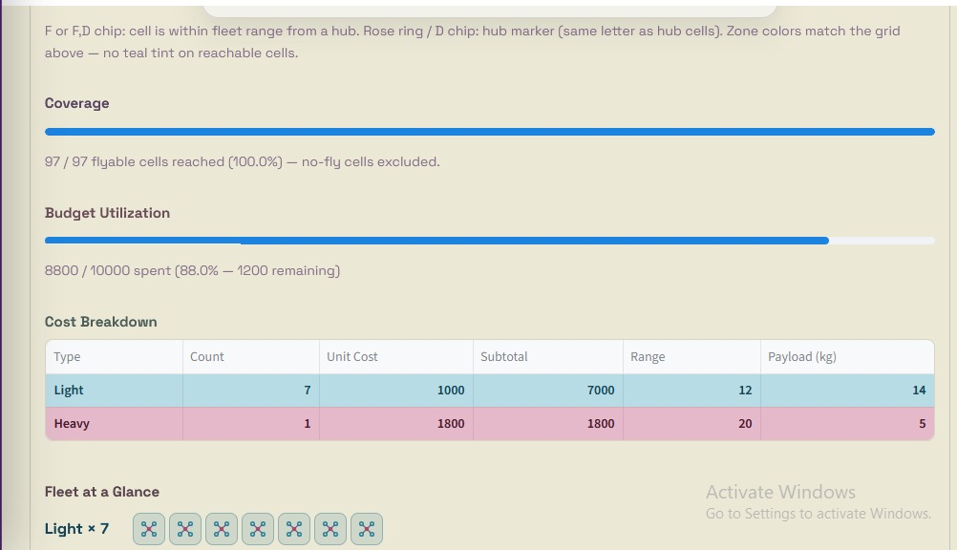
Figure 11 — Fleet coverage overlay on the city grid with hub reachability markers
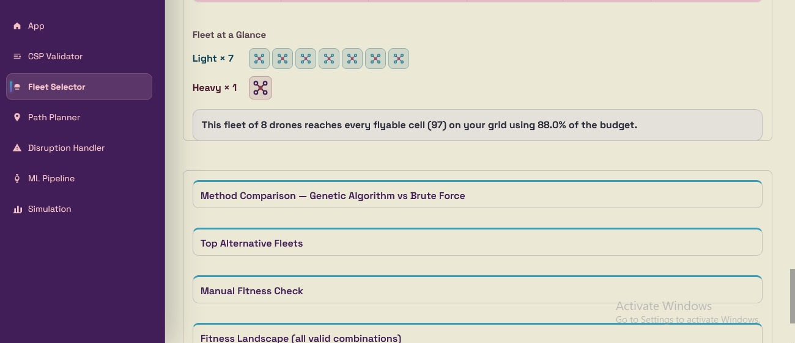
Figure 12 — Method comparison: GA vs Brute Force with alternative fleet options
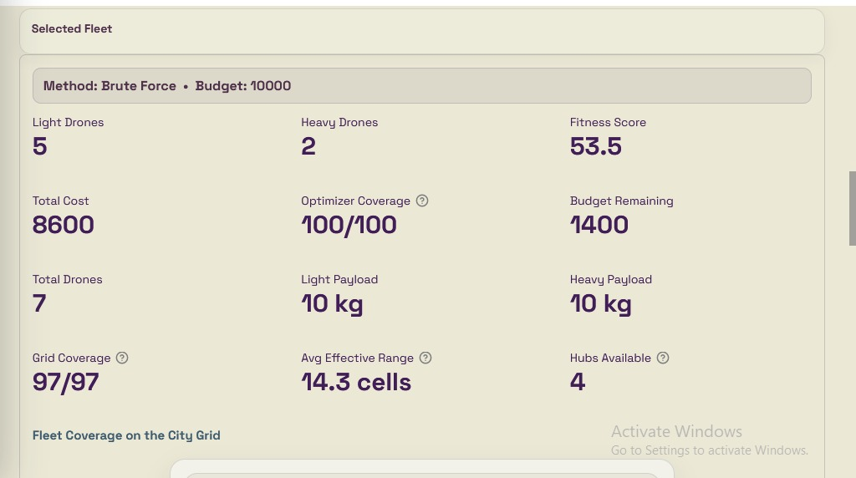
Figure 13 — Top alternative fleets and manual fitness check table
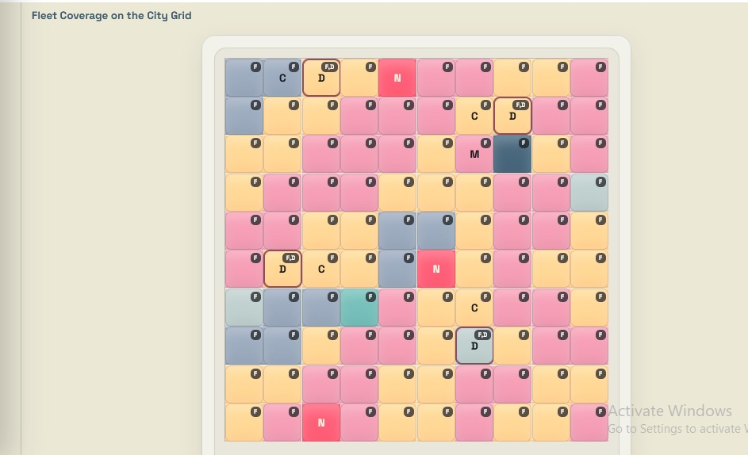
Figure 14 — Fitness landscape heatmap: all valid light/heavy combinations

4. Path Planner
Module 3 plans a safe delivery route through the grid using A* search. Each delivery follows the sequence Hub → Pickup → Drop-off → Hub, solved as three independent A* segments joined without repeating junction cells. The planner respects no-fly cells, reduces movement cost through commercial corridors, and handles blocked goals gracefully by returning a failure message with the reason.

A* Design
Item | Choice
State | (row, col) coordinate on the 10×10 grid
Actions | Up, Down, Left, Right — 4-directional movement
Path cost | 1.0 per normal move; 0.8 for commercial corridor cells
Blocked nodes | Cells where no_fly = True are skipped entirely
Heuristic | Manhattan distance — admissible for 4-direction grids
Data structure | Min-heap priority queue (heapq); parent dict for path reconstruction

Implementation
The core astar(start, goal, grid) function pushes (f_cost, g_cost, node) tuples onto a min-heap. It skips any neighbour where no_fly is True, computes move cost via get_move_cost() to handle commercial corridors, and tracks the best known g_cost to each node to avoid revisiting. When the goal is popped, it walks back through the parent dictionary to reconstruct the path.
plan_delivery_route() calls astar() three times for the three segments and joins the results. If any segment fails, the entire delivery is marked failed and an empty path is returned. The Streamlit page lets the user pick any hub, set pickup and drop-off coordinates, and optionally block extra cells to test how the planner routes around obstacles.

Sample Result
On the default grid with Hub (0,2), Pickup (0,0), Drop-off (9,9), A* found a 37-step route traversing 23 commercial corridor cells and 14 other-zone cells. The commercial corridor discount saved approximately 4.6 cost units compared to a naive shortest-hop count. The path is rendered on the grid with colour-coded segments for each of the three legs.

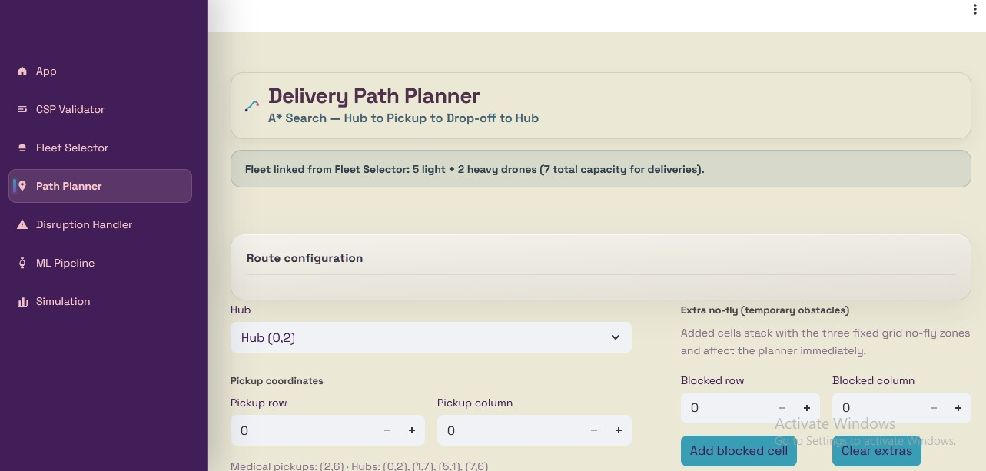
Figure 15 — Path Planner: route configuration, hub selector and extra no-fly controls
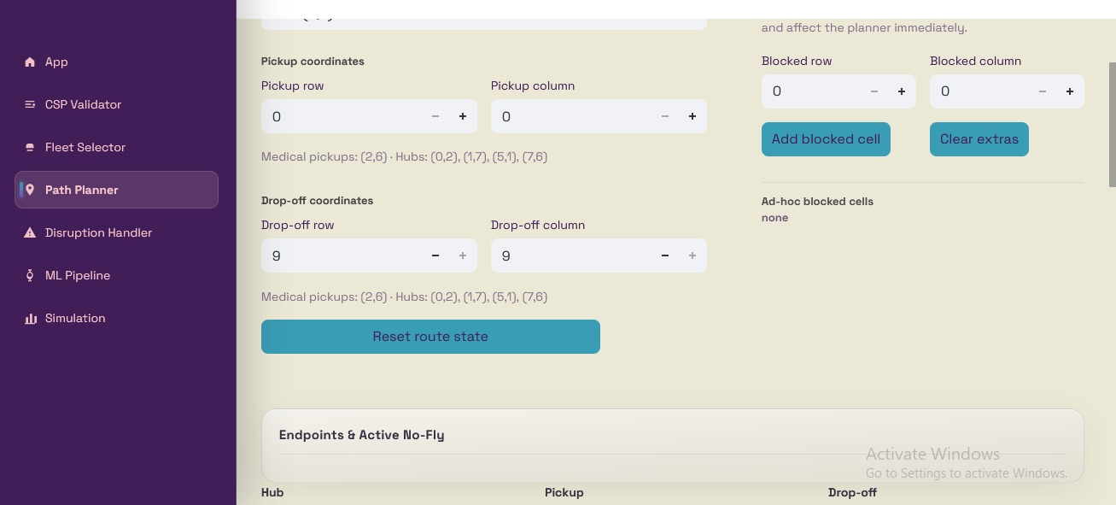
Figure 16 — A* route result: segments Hub→Pickup, Pickup→Drop-off, Drop-off→Hub
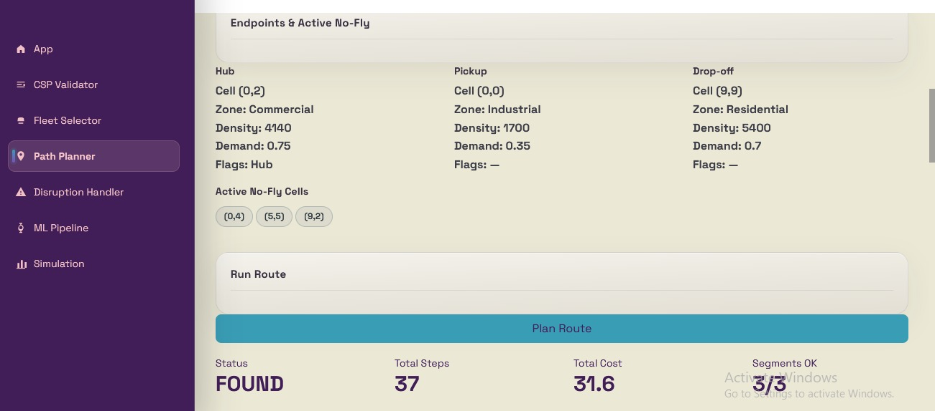
Figure 17 — Route metrics: total cost, steps, commercial corridor savings
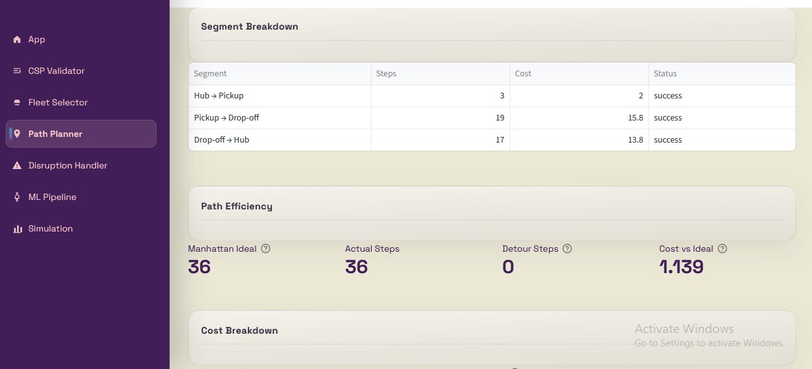
Figure 18 — Cost breakdown table: 37 cells visited, 23 commercial corridor cells
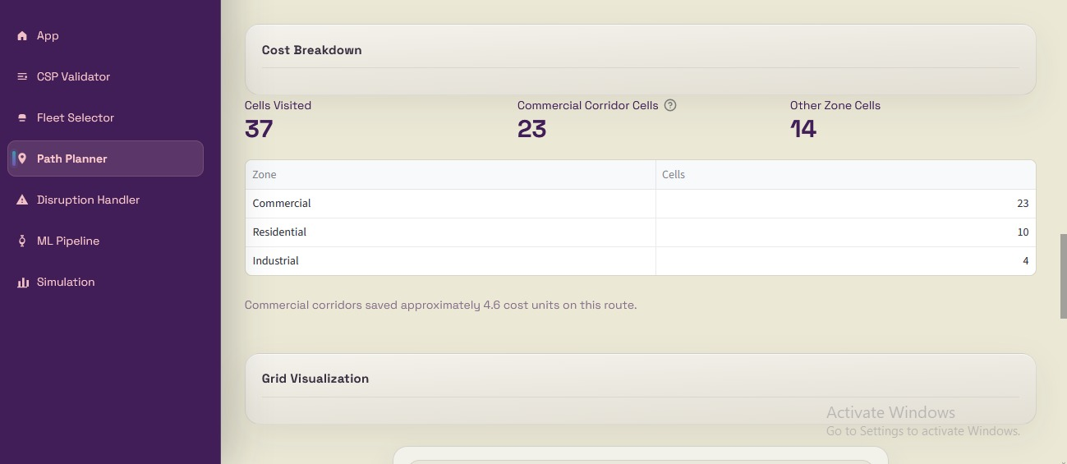
Figure 19 — Grid visualisation of the computed A* path
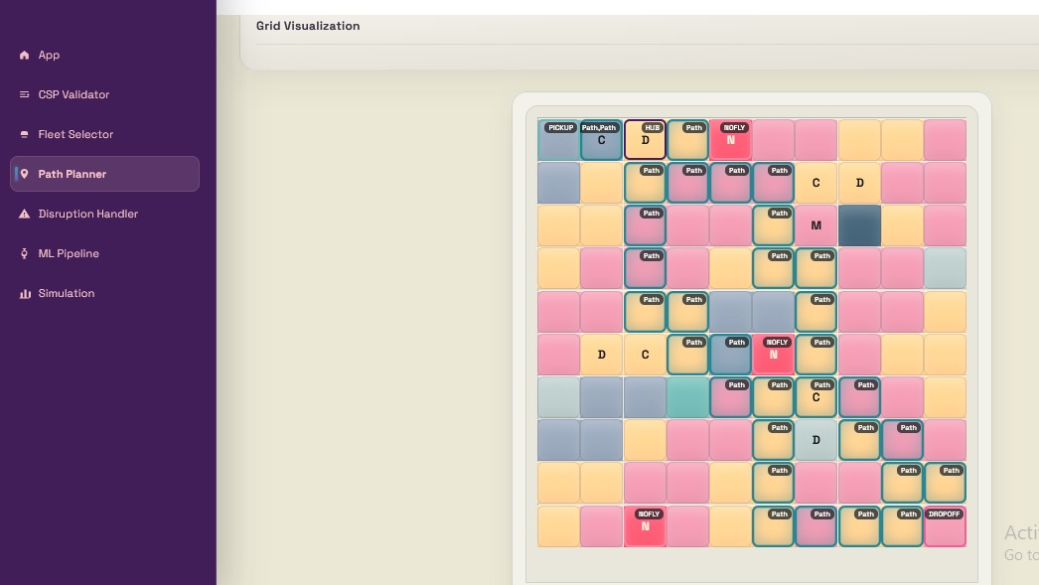
Figure 20 — A* path overlaid on city grid with pickup and drop-off markers
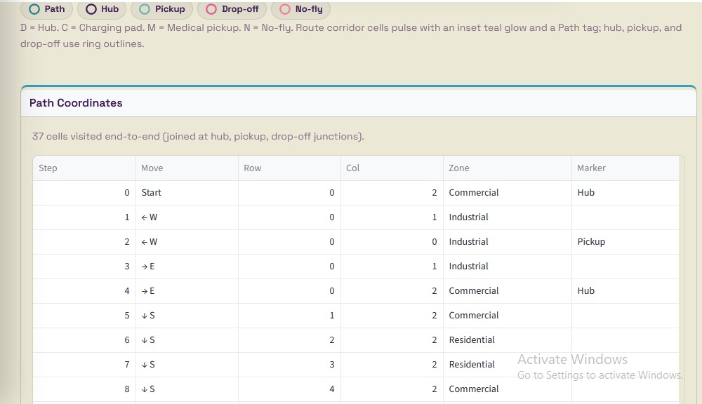
Figure 21 — Path detail with no-fly cells blocked in red
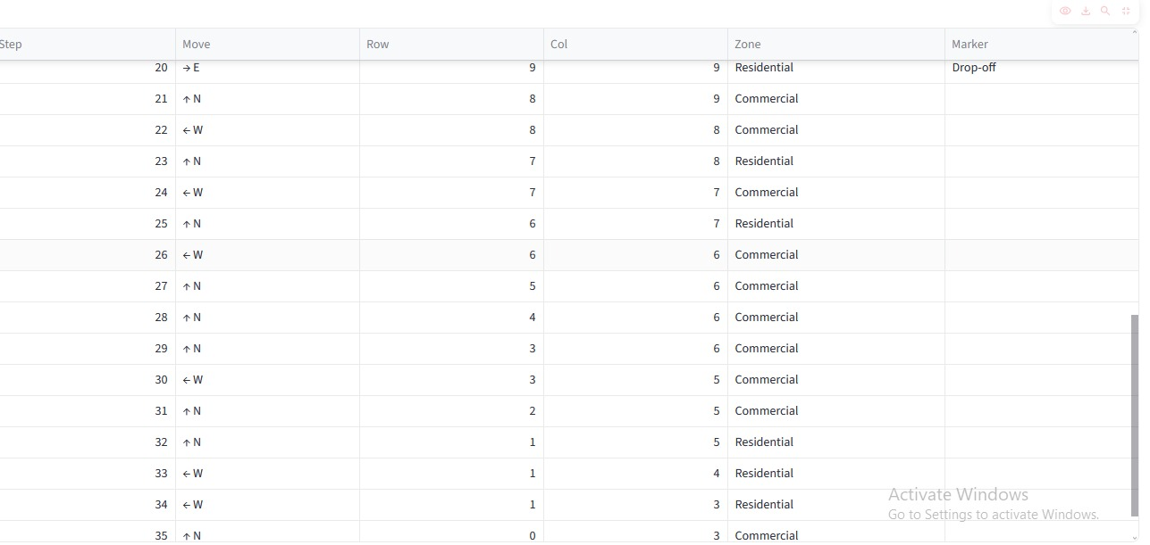
Figure 22 — Full route segment breakdown with per-segment cost and step count

5. Disruption Handler
Module 4 simulates real-time disruptions by activating no-fly zones mid-flight. When a cell is marked no-fly, any drone whose current route passes through that cell must immediately replan. The handler calls A* again from the drone's current position to its next waypoint using the updated grid, then reconstructs the remaining route. If no safe path can be found, the delivery is marked DELAYED.

Event Handling
Event | System Action
No-fly cell activated | grid[row][col].no_fly = True; all route checks re-run
Route crosses no-fly cell | A* called again from current drone position
No safe path exists | Delivery marked DELAYED; drone idles at current cell
Anomaly detected | Optional: activate nearby no-fly cell or force hub return

Implementation
The Streamlit page reads the last route computed by the Path Planner (hub, pickup, drop-off coordinates). The user enters a row and column to activate as a new no-fly zone and presses Activate. The handler adds that cell to the extra_no_fly set, rebuilds the adapter grid, and re-runs plan_delivery_route. The page displays the original path with a dashed overlay, the rerouted path in a new colour, and a route comparison panel showing original cost, new cost, and steps change.
In the sample run shown, activating no-fly at (9,3) — which falls on the original drop-off corridor — caused the rerouting to fail: no alternative safe path existed between hub (0,2), pickup (0,0) and drop-off (9,9) avoiding all blocked cells. The system correctly reported the delivery as DELAYED with the original cost of 31.6 preserved in the comparison panel.

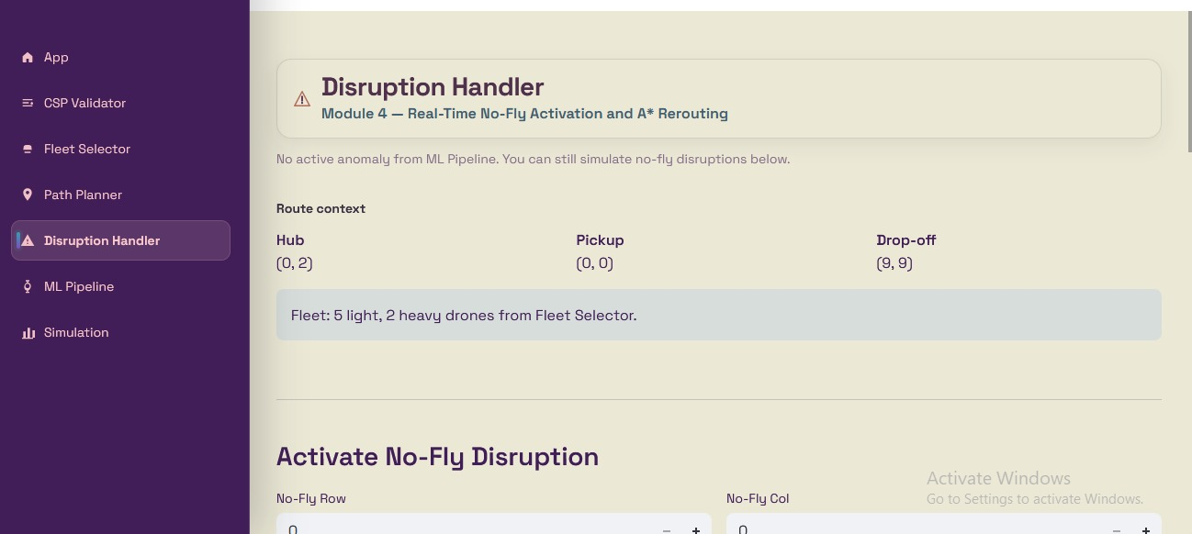
Figure 23 — Disruption Handler: route context and no-fly activation form
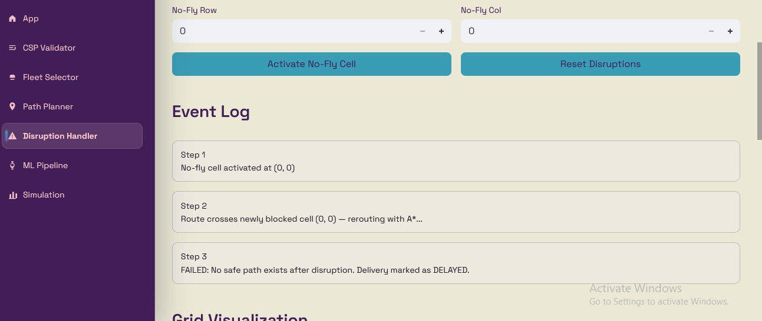
Figure 24 — Disruption triggered: rerouting A* re-runs from current position
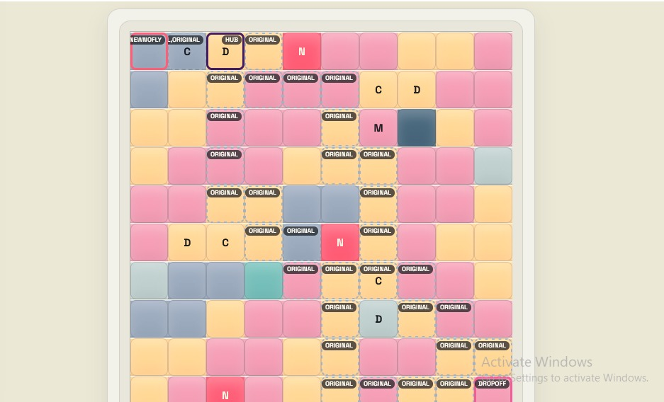
Figure 25 — Rerouted path vs original path on the grid
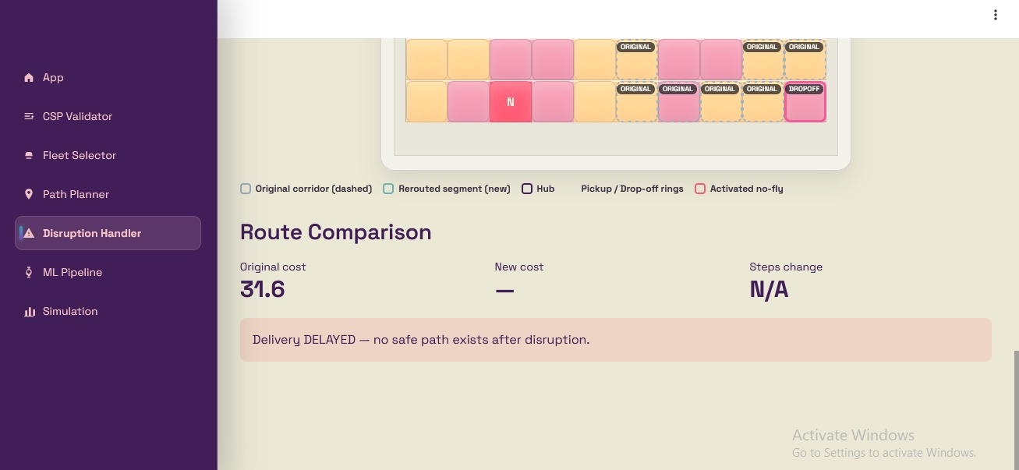
Figure 26 — Route comparison: original cost 31.6, delivery DELAYED — no safe path

6. ML Pipeline
Module 5 provides the machine learning backbone of the project through two trained models loaded from serialised .pkl files. The demand forecasting model predicts delivery demand for any hour/season/weather combination and can sweep the entire 10×10 grid to produce a demand heatmap. The anomaly detection model classifies drone telemetry readings into four categories in real time.

6.1 Demand Forecasting (Regression)
The demand model is trained on the Kaggle Bike Sharing Demand dataset. Features used are hour, season, holiday flag, working day flag, weather condition code, normalised temperature, humidity, and wind speed. A Random Forest Regressor was trained alongside Linear Regression, Ridge, and Gradient Boosting for comparison. The Random Forest produced the best R² score on the held-out test set.
The key feature driving demand is hour of day (importance ≈ 0.63 in the Random Forest), followed by temperature (≈ 0.15). Season, humidity, and weather contribute smaller but meaningful fractions. Demand peaks between 17:00–18:00 (evening rush), with a secondary peak at 08:00, and drops sharply after midnight — a pattern consistent with commuter-driven bike-sharing that the model uses as a proxy for drone delivery demand.

6.2 Anomaly Detection (Classification)
The anomaly classifier is trained on synthetic drone telemetry with four classes: Normal, Battery Anomaly, Route Anomaly, and Sensor Spike. Each class is defined by a deterministic rule applied to features such as battery_drop, route_deviation, altitude_change, and speed_change. A Battery Anomaly is characterised by a sudden high battery_drop; a Route Anomaly by a high route_deviation; a Sensor Spike by abnormal altitude or speed changes.
Four classifiers were evaluated on a stratified 80/20 split: Random Forest, Decision Tree, KNN, and Naive Bayes. Random Forest, Decision Tree, and Naive Bayes all achieved 100% accuracy on the held-out test set. KNN achieved 99.8% (one Battery Anomaly misclassified as Route Anomaly, and one Route Anomaly missed). The confusion matrices confirm all four models can cleanly separate the synthetic classes, which is expected given the deterministic construction of the anomaly labels.
In the anomaly feature importance plot, battery_drop and route_deviation together account for over 70% of the Random Forest's decision power, with altitude_change and speed_change contributing the remaining 30%. This aligns with the synthetic rules used to generate the labels.

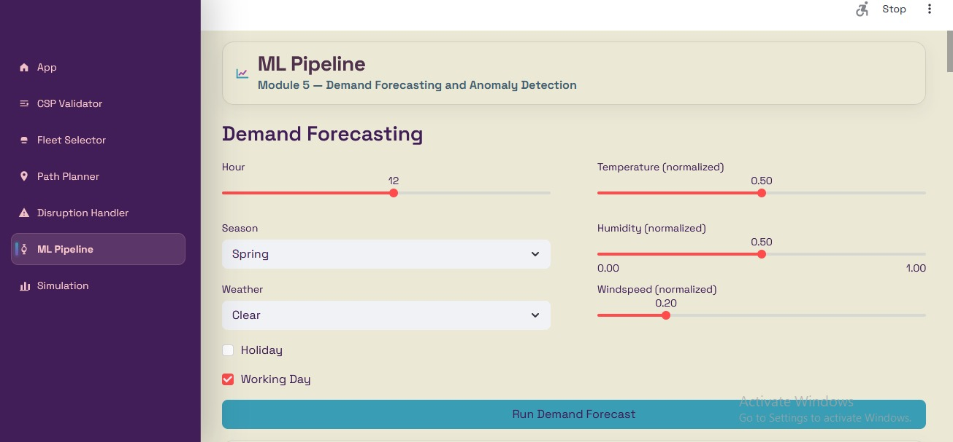
Figure 27 — ML Pipeline: demand forecasting input panel
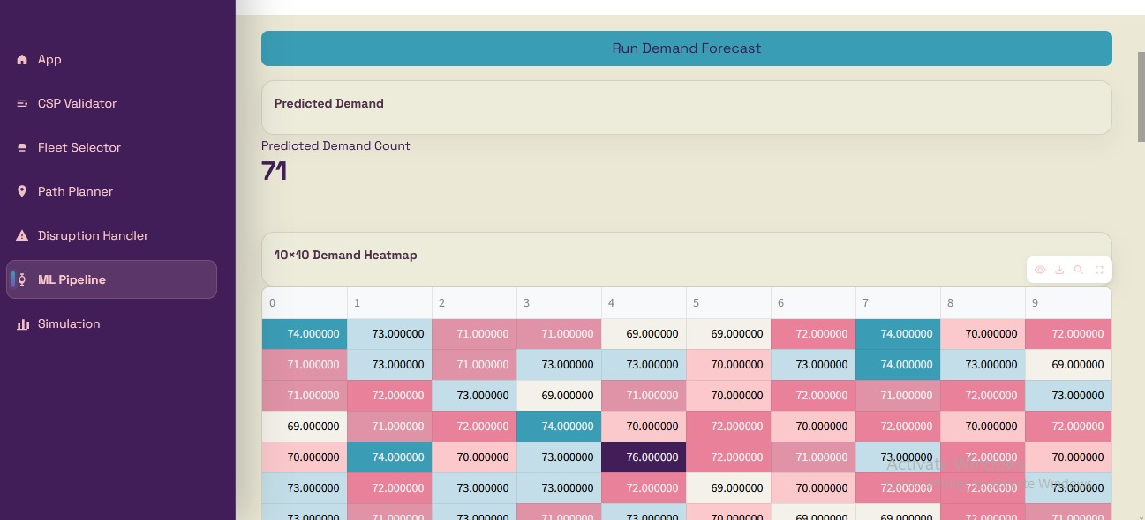
Figure 28 — Single-point demand forecast output
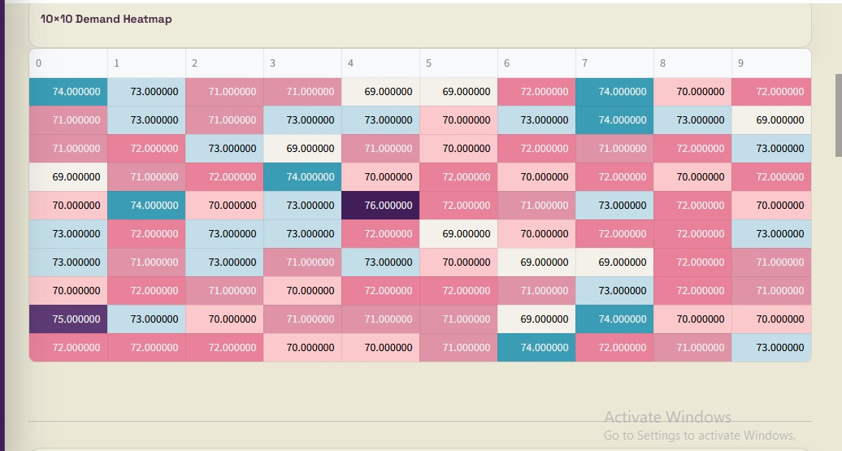
Figure 29 — 10×10 demand heatmap: all grid cells predicted simultaneously
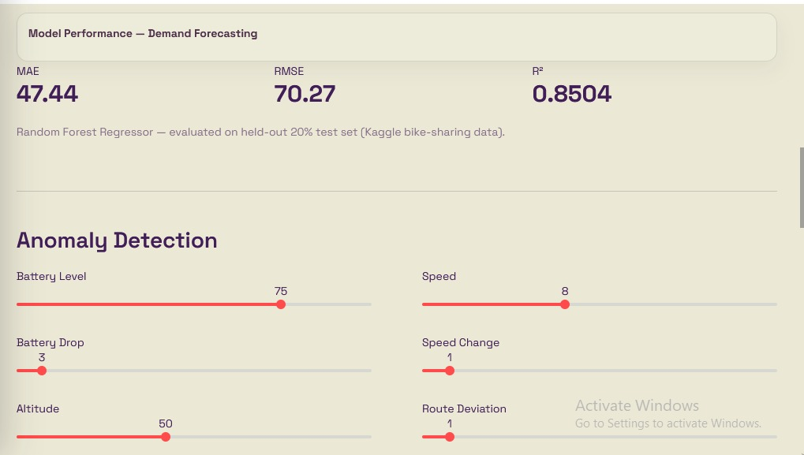
Figure 30 — Anomaly detection input form with drone telemetry fields
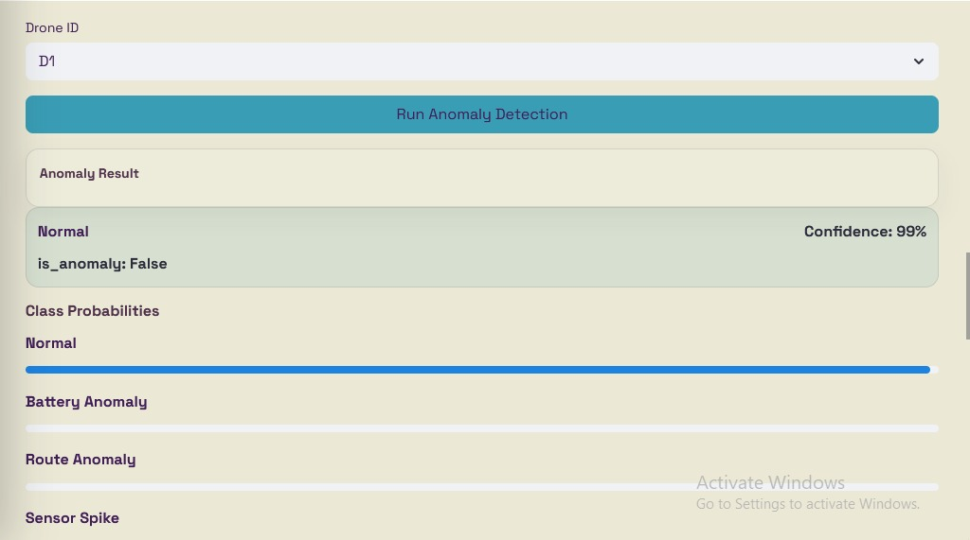
Figure 31 — Anomaly classification result with prediction confidence
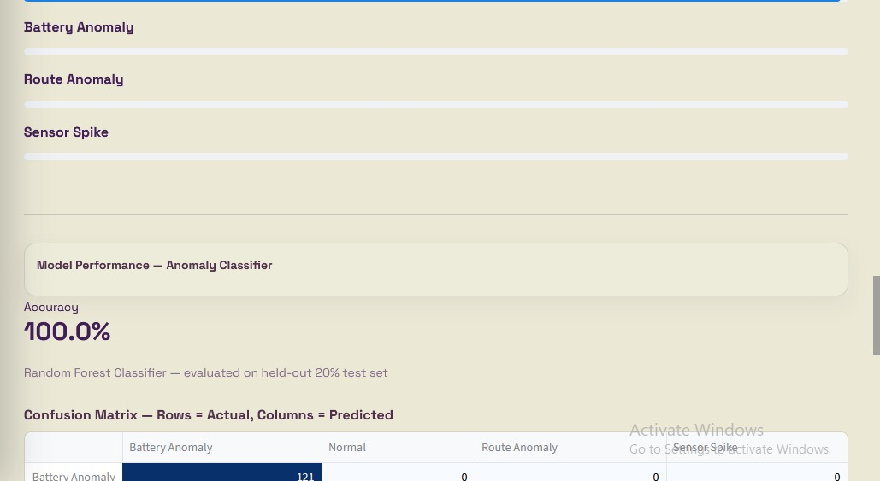
Figure 32 — Anomaly classifier performance: 100% accuracy, confusion matrix
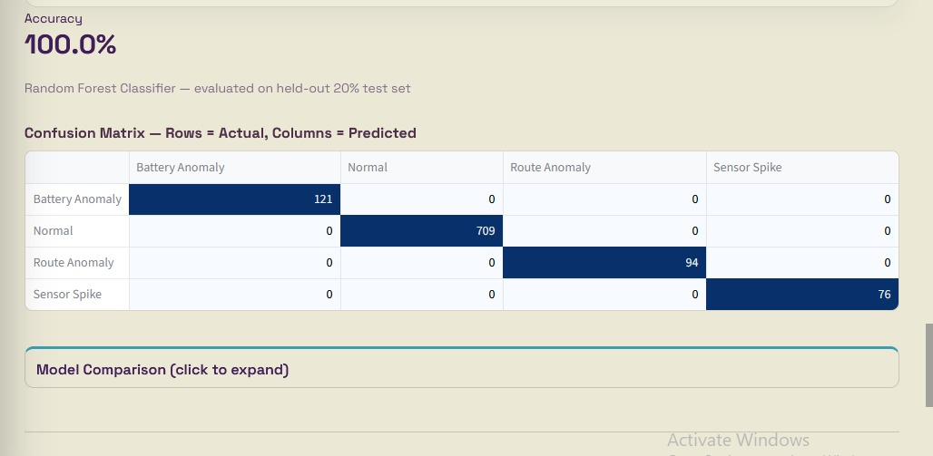
Figure 33 — Demand EDA tab: average demand by hour of day
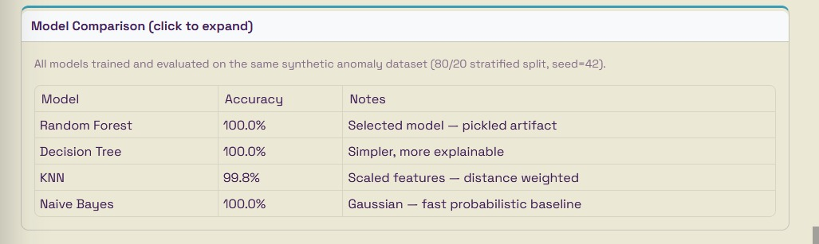
Figure 34 — Demand EDA: demand by season and by weather condition
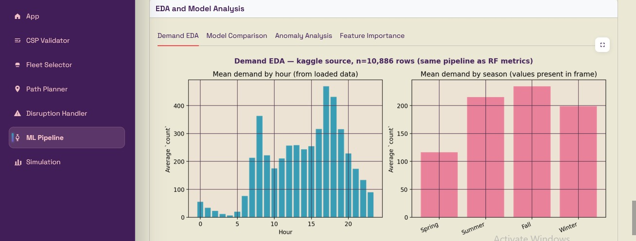
Figure 35 — Temperature vs demand scatter plot
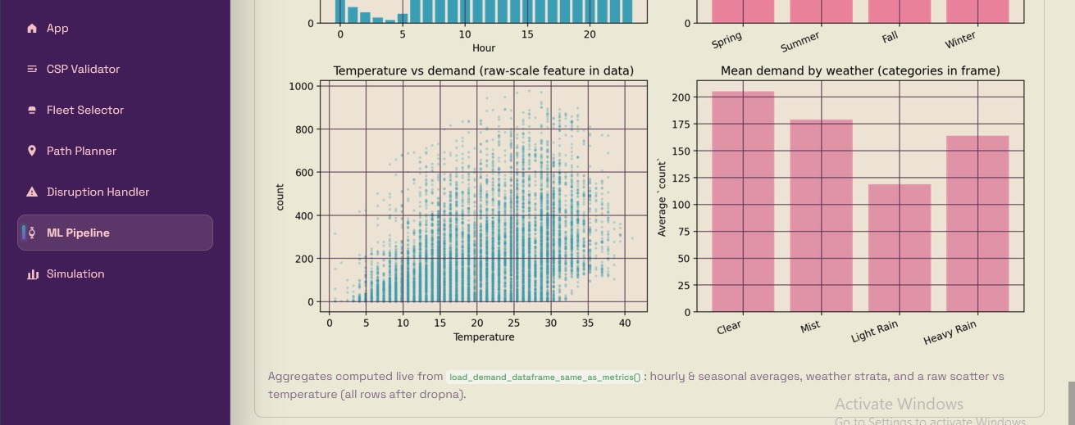
Figure 36 — Demand model comparison: RMSE and MAE across regressors
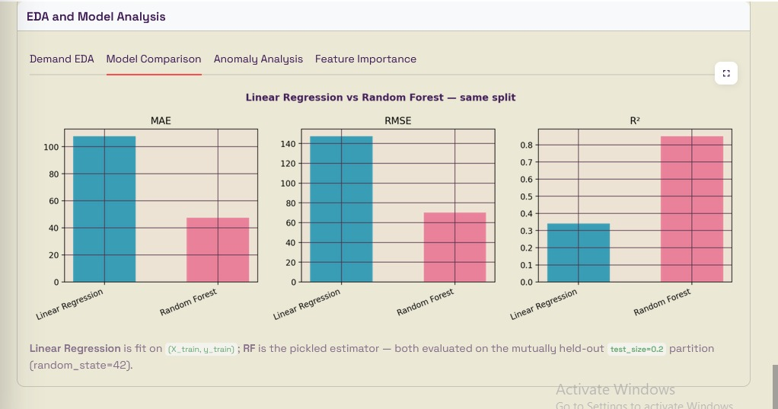
Figure 37 — Demand model comparison: R² scores
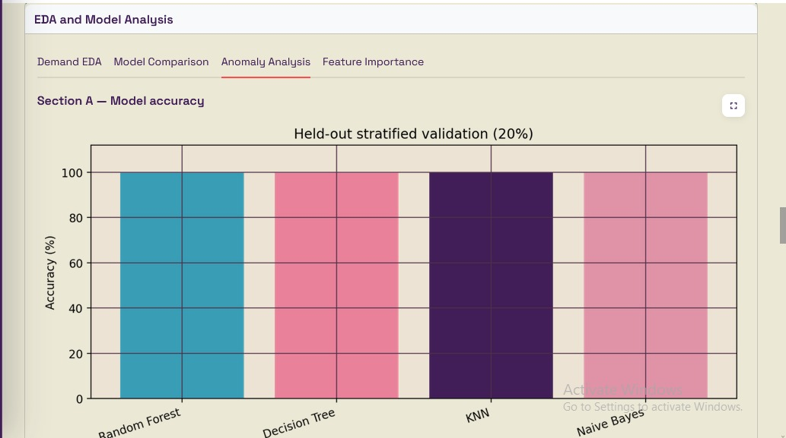
Figure 38 — Anomaly model comparison: all four classifiers at 100% accuracy
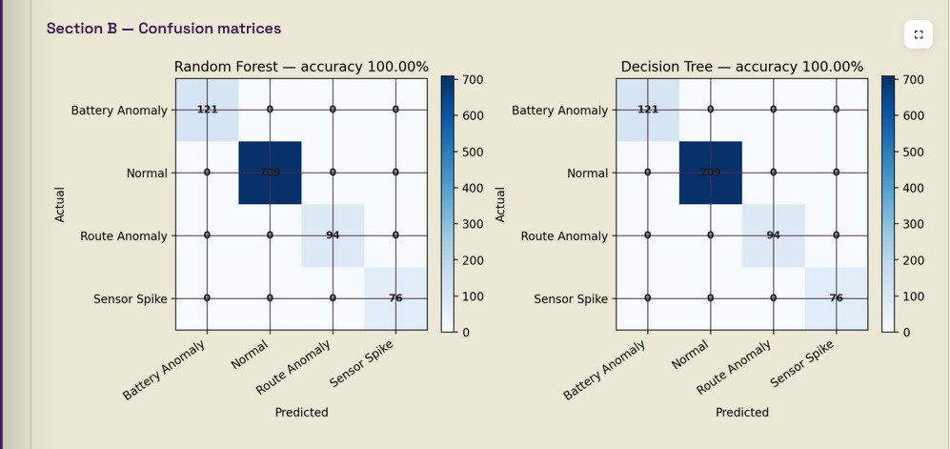
Figure 39 — Anomaly Analysis: feature boxplots by anomaly type
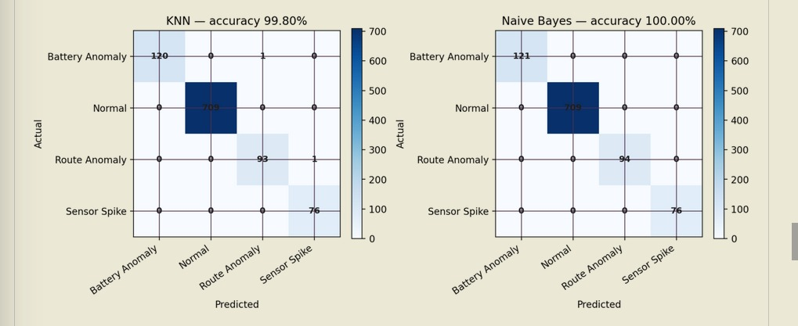
Figure 40 — Feature distributions per anomaly class
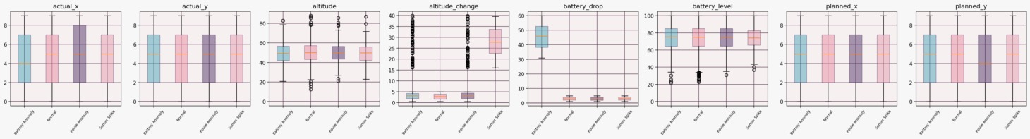
Figure 41 — Extended feature boxplots (altitude, battery, position)
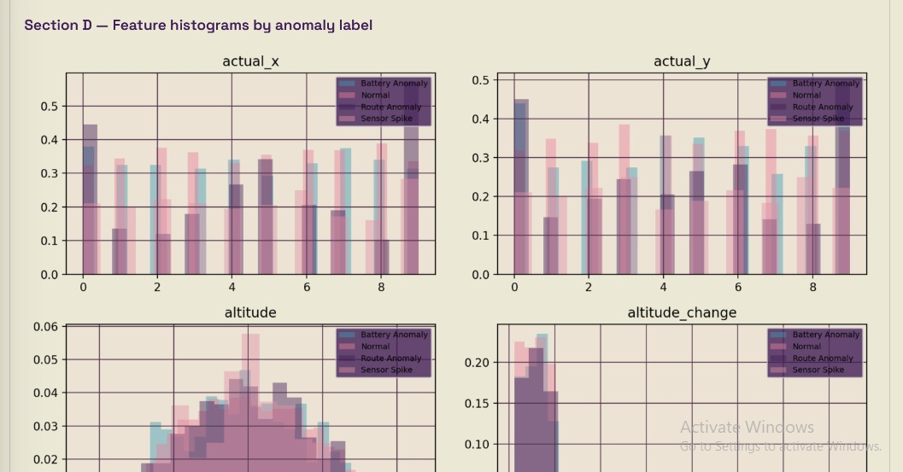
Figure 42 — Confusion matrices for Decision Tree, Random Forest, KNN, Naive Bayes
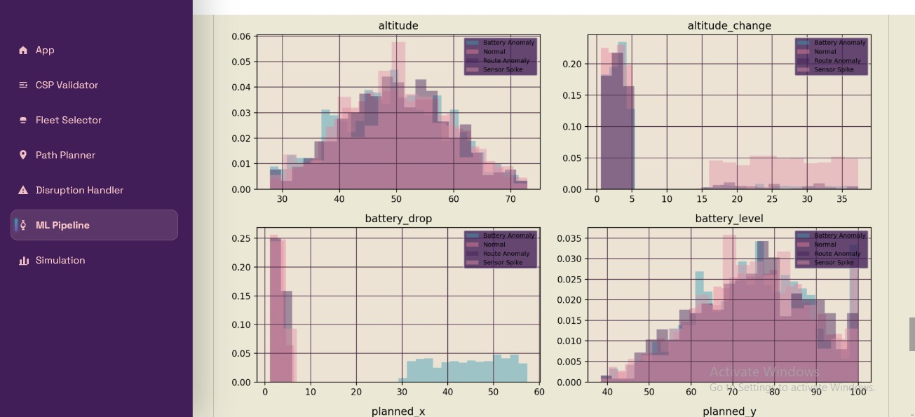
Figure 43 — Decision tree structure visualisation
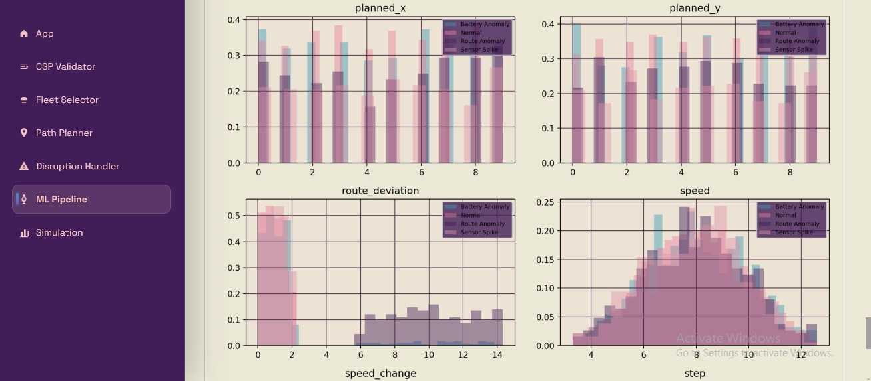
Figure 44 — Demand correlation matrix
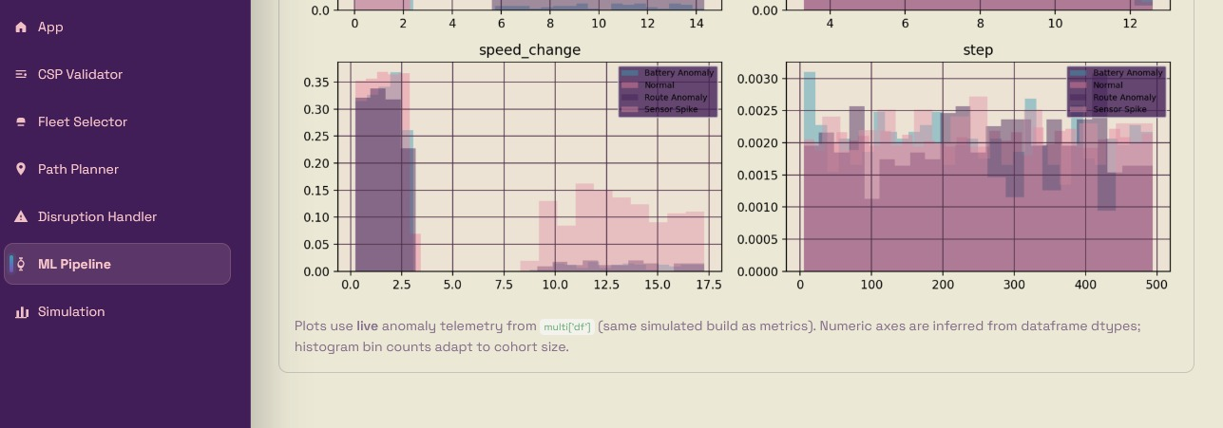
Figure 45 — Demand residual plots: predicted vs actual and error distribution
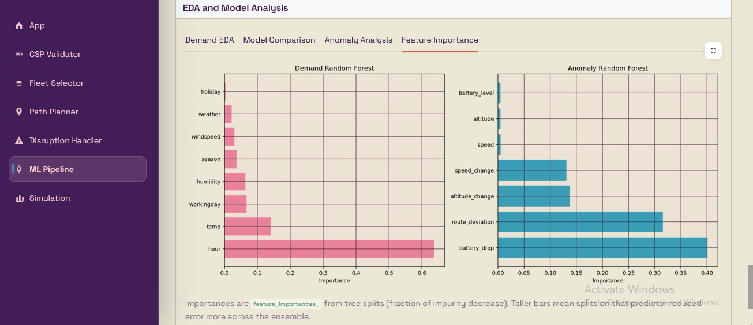
Figure 46 — Feature importance: Demand RF and Anomaly RF side by side

7. Simulation
The Simulation page ties all five modules together into a single 20-step integration run. The system readiness panel confirms the state of each module before launch: CSP violations count, fleet composition (e.g. 5L + 2H), demand forecast (e.g. 71 units), anomaly status (None), and route planning status (Planned). The user can tune the no-fly activation step, no-fly cell coordinates, and anomaly detection step before pressing Run.

20-Step Scenario
Step Range | Event
Steps 1–3 | Initialise grid, run CSP validator, select fleet
Steps 4–6 | Generate deliveries, assign drones, compute A* routes
Steps 7–10 | Move drones along planned paths; corridor updates
Step 11 | Activate no-fly cell at (4,7); A* replanning engaged
Steps 12–13 | Conflict sweep; stalled deliveries transitioned to DELAYED
Step 14 | Sustainment pulse; telemetry nominal; holding pattern
Step 15 | Demand forecast retrieved (71 units for active corridor)
Steps 16–17 | Continue movement; delivery progress logged
Step 18 | Anomaly detection step; drone telemetry checked
Steps 19–20 | Final movement; simulation complete; summary printed

Integration Points
The DeliverySimulator class (delivery_simulator.py) holds the drone list, delivery list, and the set of extra no-fly cells accumulated during the run. Each step it calls _adapt() to rebuild the A* adapter grid with the latest no-fly geometry, moves drones one step along their paths, checks for route invalidation, and appends a human-readable event string to the log. The Streamlit page streams this log step by step and renders the final grid state with delivery drop-off markers.
In the sample run, DEL-1, DEL-2, and DEL-3 were all initiated successfully. The no-fly activation at step 11 triggered replanning. The final map shows drop-off positions for each delivery alongside the activated no-fly cell. The anomaly events panel confirmed no anomalies were detected in this run.

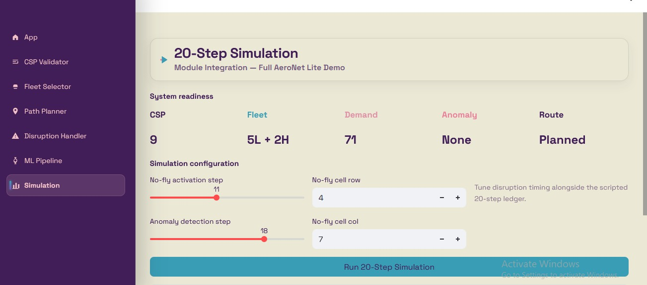
Figure 47 — Simulation page: system readiness panel and configuration
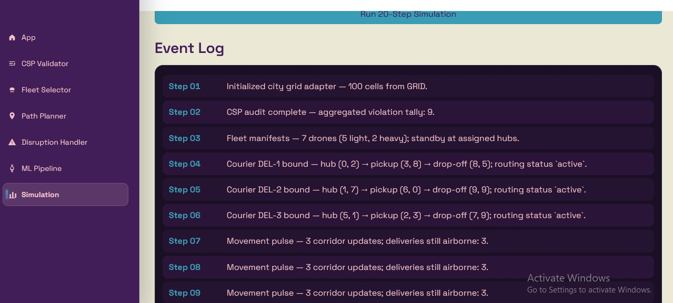
Figure 48 — Simulation running: 20-step event log header
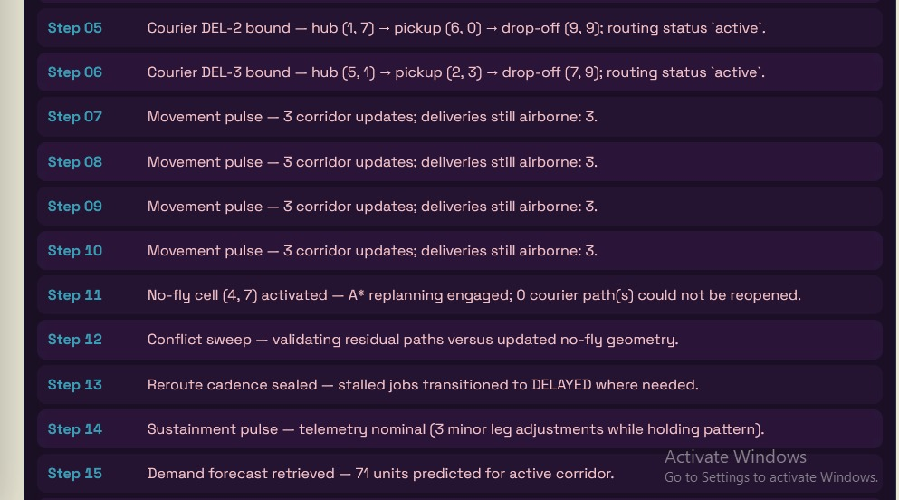
Figure 49 — Event log steps 5–15: disruption at (4,7), rerouting, demand forecast
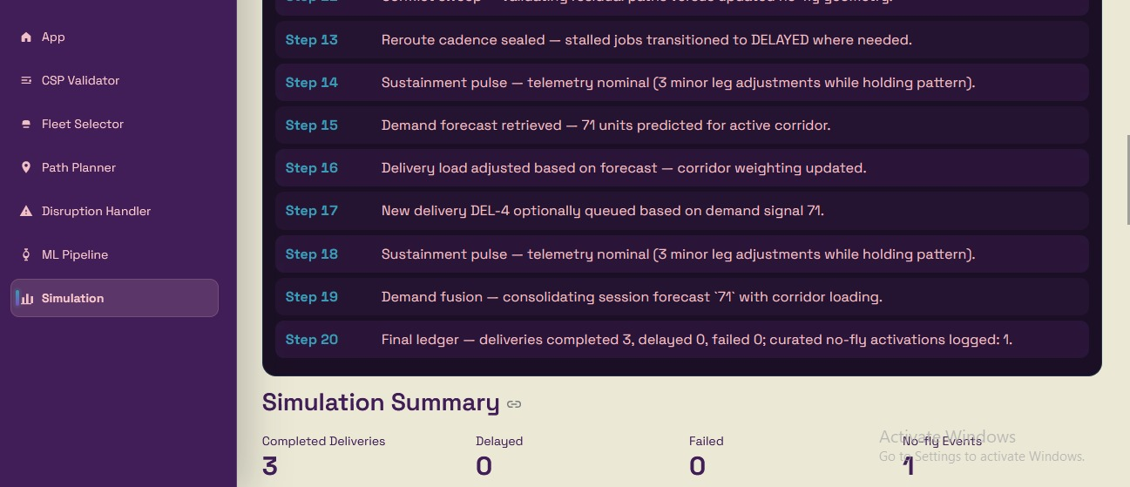
Figure 50 — Steps 16–20: anomaly detection, final summary
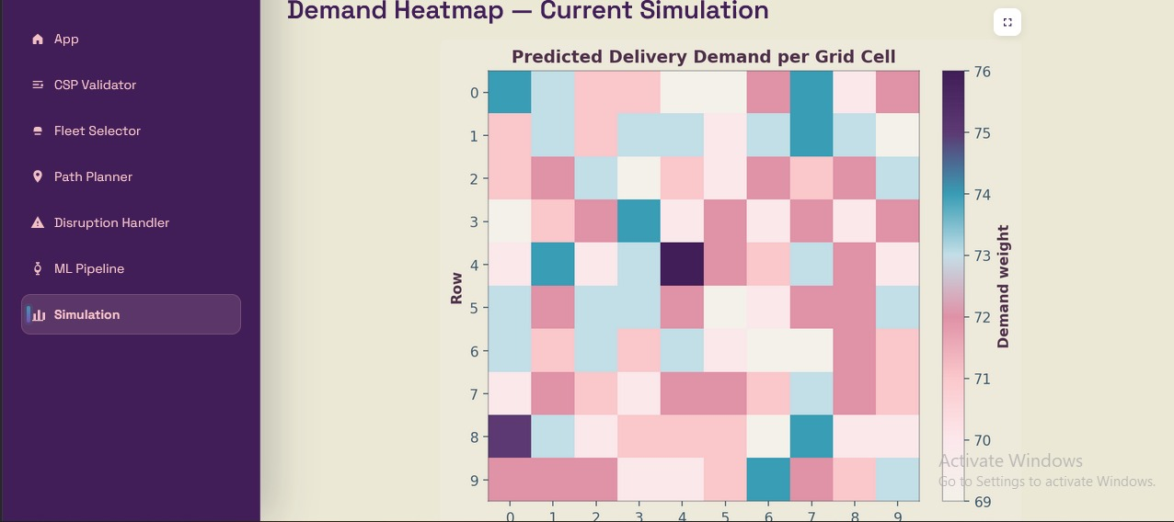
Figure 51 — Final delivery map: drop-off positions and no-fly overlay
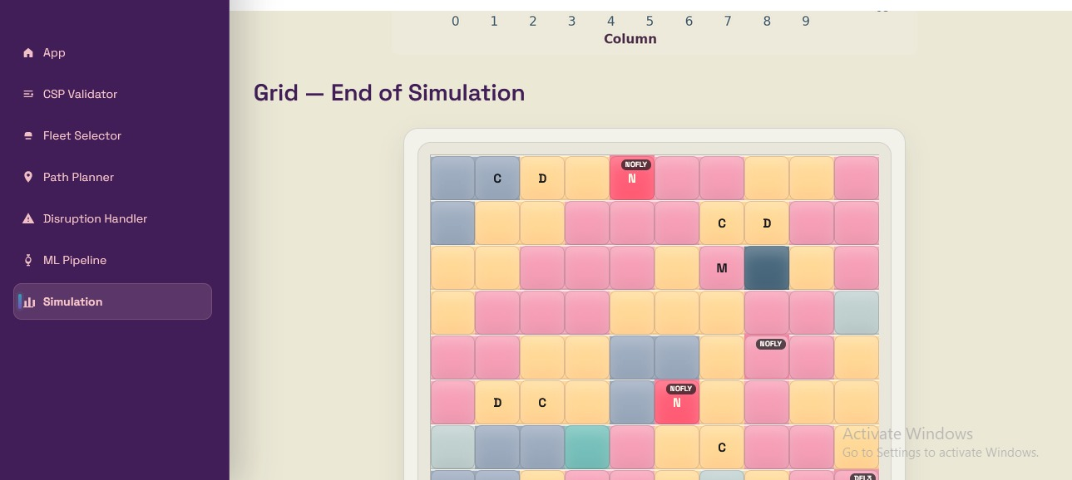
Figure 52 — Delivery summary statistics: completed, delayed, failed
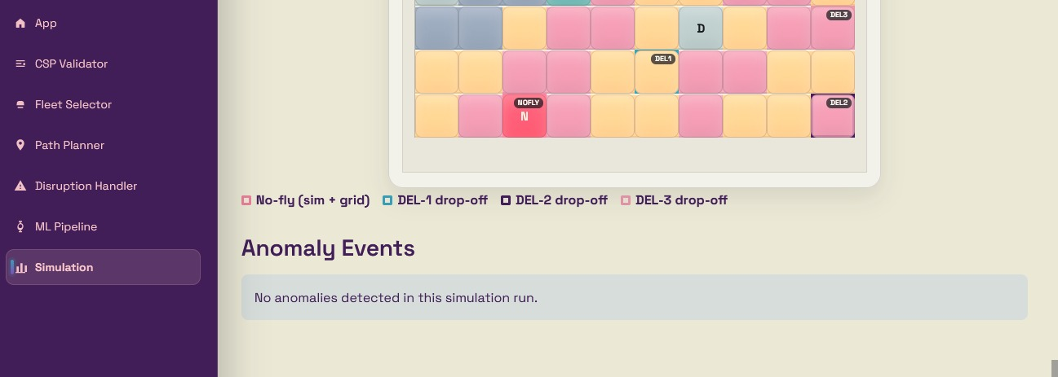
Figure 53 — Anomaly events panel and drop-off grid at simulation end

8. Application Interface
The application is built with Streamlit and structured as a multi-page app. The left sidebar provides navigation to all six pages: App (home), CSP Validator, Fleet Selector, Path Planner, Disruption Handler, ML Pipeline, and Simulation. The colour scheme uses a deep purple sidebar with cream/lavender content area, matching the project's pink-purple theme throughout.

Home Page
The home page provides a live view of the 10×10 city grid with interactive cell hover details. Zone colours distinguish Residential (pink), Industrial (slate), Commercial (gold), Hospital (teal), School (light blue), and Open Field (cream). Cell markers indicate Hubs (D), Charging pads (C), Medical pickups (M), and No-fly zones (N in red). Below the grid, a demand heatmap shows the live demand weight of every cell, updated whenever the ML Pipeline runs. A Reset System button clears all shared state for a fresh run.

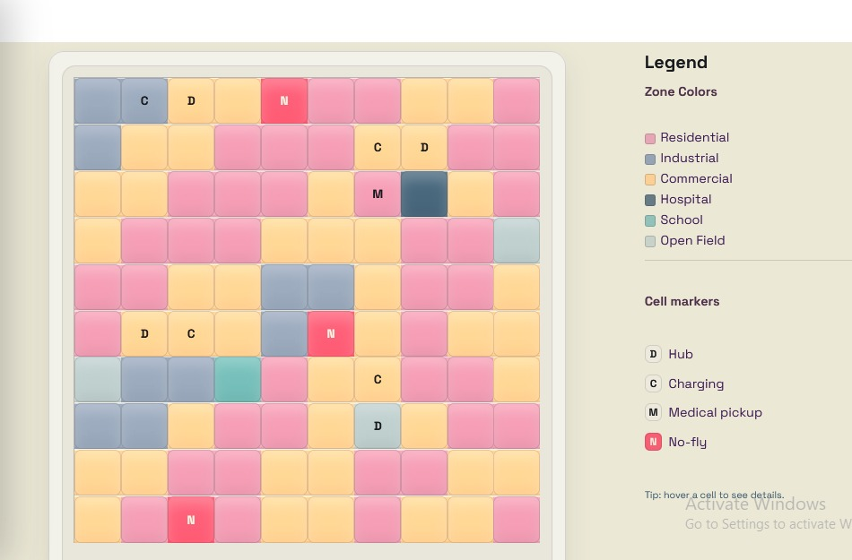
Figure 54 — Home page: city grid with zone and cell marker legend
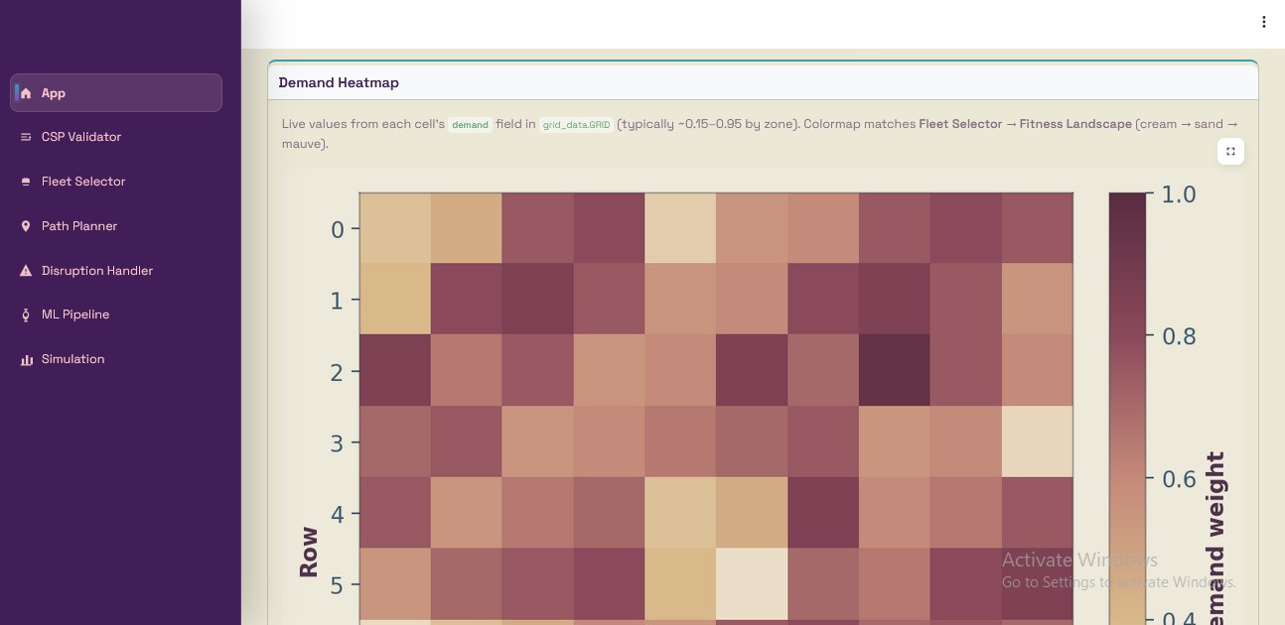
Figure 55 — Home page: demand heatmap showing live cell demand values
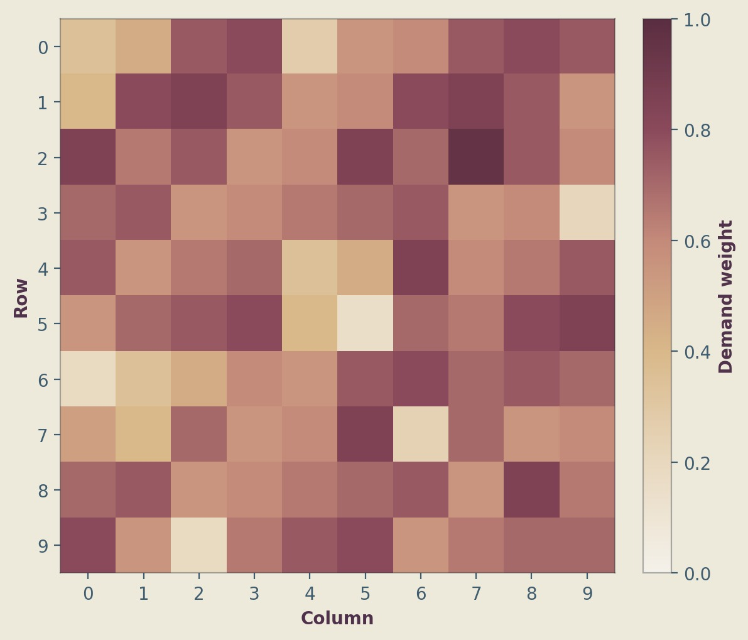
Figure 56 — Home page: full demand heatmap with cream-to-mauve colormap
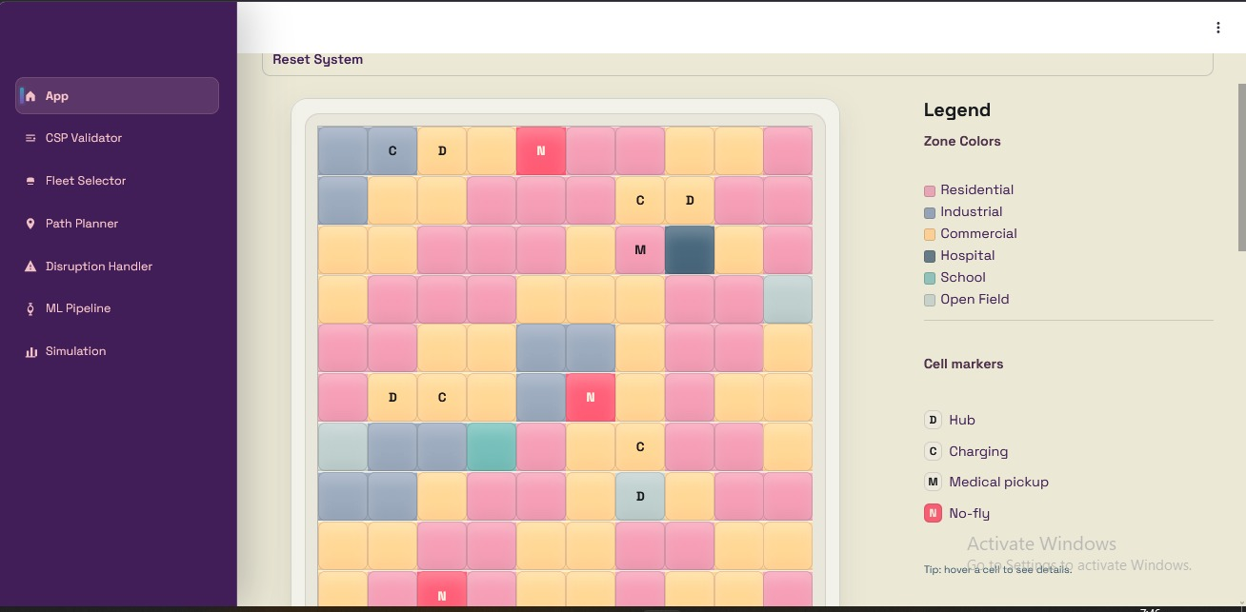
Figure 57 — Home page: Reset System button and full navigation sidebar

