

**PG DEPARTMENT OF COMPUTER APPLICATIONS**

**REPORT ON**

**EXPLORING THE BOUNDLESS HORIZONS OF AI**

AS A PART OF PMC2317-SOCIAL INITIATIVES (EXTRA CREDIT COURSE)

**SUBMITTED BY, SUBMITTED TO ,**

ALVIN K SABU Mrs. KOCHUMOL ABRAHAM

I MCA ASSISTANT PROFESSOR

23PMC105 PG DEPARTMENT OF

MARIAN COLLEGE AUTONOMOUS COMPUTER APPLICATIONS

KUTTIKANAM

DOS:28-03-2024

**INTRODUCTION**

On February 9, 2024, Mary Matha Arts and Science College, Alakode, became the epicenter of innovation as a session on "Exploring the Boundless Horizons of Artificial Intelligence" unfolded. With a keen focus on empowering students with cutting-edge knowledge, the session aimed to unravel the mysteries of AI and ignite a passion for innovation among the budding minds of the college.

In this report, my aim to unravel the complexities of AI and its transformative potential, shedding light on its fundamental concepts, practical applications, and far-reaching implications. Through a comprehensive analysis of AI's benefits, challenges, and ethical considerations, we seek to provide a nuanced understanding of this groundbreaking technology and its implications for our society. The session began by unraveling the foundational principles of AI, delving into its definition, historical evolution, and wide-ranging applications across diverse sectors such as healthcare, finance, and education. Through illustrative examples and real-world case studies, students gained insight into how AI technologies are revolutionizing industries and shaping the future of human-machine interaction.

Beginning with an overarching view of innovation empowerment, the session gradually delved into the intricate workings of AI tools, illustrating their pivotal role as catalysts for change across diverse domains. Attendees were not only introduced to the fundamental concepts of AI but also motivated to actively engage in driving forward today's technological revolution, becoming architects of tomorrow's digital advancements.

**OBJECTIVE**

The primary objective of the session was multifaceted:

**Comprehensive Understanding of AI**: To offer participants a thorough comprehension of artificial intelligence, encompassing its fundamental principles, diverse applications, and implications across various industries and domains.

**Exploration of AI Tools and Platforms**: To introduce attendees to popular AI tools, frameworks, and platforms, enabling them to explore the practical utility of these technologies and understand how they contribute to AI-driven innovation.

**Inspiration for Innovation and Problem-Solving**: To inspire participants to leverage AI as a catalyst for innovation and problem-solving, encouraging them to explore novel applications of AI in addressing real-world challenges and driving positive societal change.

**Empowerment for Future Endeavors**: To empower attendees with the knowledge, skills, and mindset needed to navigate the rapidly evolving landscape of AI confidently, equipping them to pursue further education, research, and professional opportunities in AI-related fields

**CONTENT OVERVIEW**

1. Introduction to AI: The session kicked off with an exploration of AI's foundational principles, shedding light on its definition, evolution, and diverse applications across industries. Real-world examples were presented to elucidate AI's role in revolutionizing fields such as healthcare, finance, and transportation.
2. Deep Dive into AI Tools: Students were introduced to a spectrum of AI tools and platforms like ChatGPT, Bard, Gamma, etc .In addition to the exploration of artificial intelligence, the session also provided students of computer applications with a foundational understanding of Database Management Systems (DBMS).

1. Application-Oriented Discussions: The session delved into AI's application in solving real-world challenges, prompting students to brainstorm innovative solutions using AI techniques. Case studies were examined to illustrate AI's role in areas like predictive analytics, image recognition, and autonomous systems, fostering a deeper understanding of AI's practical implications

**AUDIENCE RESPONSE**

The audience response to the session on artificial intelligence (AI) was overwhelmingly positive and engaged. Participants showed genuine interest and enthusiasm throughout the session, actively participating in discussions, asking insightful questions, and eagerly engaging in hands-on activities.

Many attendees expressed excitement about the potential of AI to drive innovation and solve complex problems across various domains. They were particularly intrigued by the practical demonstrations of popular AI tools and platforms, as well as the real-world examples showcasing AI applications in diverse industries.

Overall, the audience response reflected a genuine curiosity and eagerness to learn about AI and its transformative potential. The session succeeded in inspiring attendees to consider the possibilities of AI-driven innovation and problem-solving, leaving them with a sense of empowerment and excitement for the future of technology.

**PRESENTATION STYLE**

The presentation style for the session on artificial intelligence (AI) was dynamic, interactive, and engaging.

**Multimedia Integration**: The session incorporated multimedia elements such as slides, videos, and interactive visualizations to illustrate key concepts and enhance understanding.

**Interactive Discussions**: Participants were encouraged to actively participate in discussions, share their insights, and ask questions throughout the session. This fostered a collaborative learning environment where ideas were exchanged and diverse perspectives were valued.

**Practical Demonstrations**: Practical demonstrations of popular AI tools and platforms were conducted to provide attendees with hands-on experience. This allowed participants to see AI technologies in action and understand their practical utility.

**Hands-on Activities**: Interactive hands-on activities were organized to allow participants to experiment with AI concepts and tools firsthand. This experiential learning approach enabled attendees to deepen their understanding of AI and develop practical skills.

**IMAGES**

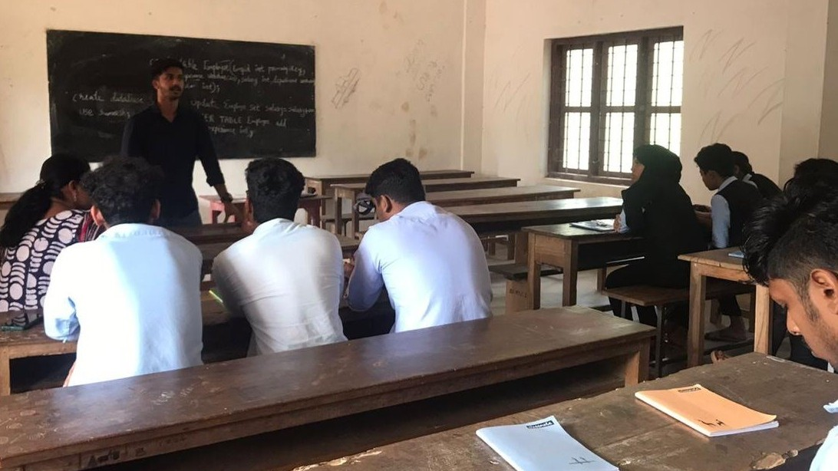



**CONCLUSION**

In conclusion, the session on artificial intelligence (AI) was a resounding success, leaving attendees inspired, informed, and empowered. Throughout the session, participants were provided with a comprehensive understanding of AI concepts, applications, and tools, enabling them to grasp the transformative potential of this groundbreaking technology.

From interactive discussions to practical demonstrations and hands-on activities, the session effectively engaged attendees and fostered a collaborative learning environment. Participants showed genuine enthusiasm and curiosity, actively participating in discussions, asking insightful questions, and eagerly experimenting with AI tools.

Furthermore, the session succeeded in inspiring attendees to explore AI-driven innovation and problem-solving in their academic and professional endeavors. Many expressed a desire to delve deeper into AI-related topics and integrate AI into their future projects and endeavors.

Overall, the session not only provided attendees with valuable insights into AI but also ignited a passion for exploring the limitless possibilities that AI offers in shaping the future of technology and society