- We used a lightweight ABFS mechanism, adapted for our purpose of meta-feature extraction rather than feature selection.
- We maintain one decision stump and one drift detector per feature. The stump learns to predict the class label using only that feature, and its prediction accuracy over time serves as the relevance score for that feature.
- For the decision stumps we used River's Hoeffding Tree classifier with maximum depth 1. We chose this over a simple fixed-threshold stump because it learns the optimal split point from the data: deciding both where to split and when enough instances have been seen to make a reliable decision, rather than assuming a fixed arbitrary split value that may not reflect the actual feature distribution.
- For the drift detectors we used River's ADWIN. We chose ADWIN because it does not require any sensitivity parameter to be set manually: it automatically adapts to the current rate of change in the stream.
- Unlike the original ABFS, our stumps are completely independent: there is no boosting weight propagation between them. This is intentional: we want each stump's score to reflect the predictive power of its own feature alone, without being influenced by what other stumps selected first.
- One practical issue we encountered is that raw stump accuracy is inflated by the majority class baseline: an irrelevant feature can still achieve decent accuracy just by always predicting the most common class. To fix this we normalize the scores, so that truly irrelevant features score near zero and only genuinely predictive features score above zero.
- When ADWIN detects a significant change in a stump's error rate, signaling that the feature's relevance has changed: the stump is reset and starts relearning from scratch.
- The output is a relevance score vector updated after every instance, one score per feature, which we then use as the basis for our proposed stream meta-features.

To test whether meta-features based on relevance scores work well, we performed a sanity check of 8 distinct meta-features on different data stream configurations, differing in the type of concept drifts occurring.
The two synthetic streams we have used are:
- SEA
- 3 features: f1, f2 (relevant) and f3 (irrelevant).
- Boundary drift only same feature relevance across the stream same relevance scores.
- What we want to show: same features remain relevant after drift meta-features stable drift_count small but possibly non-zero.
- drift_count may fire under boundary drift
not because features changed relevance.
but because the stump temporarily underperforms during relearning (since decision boundaries may change).
it is a performance signal, not a feature relevance signal.
true drift at instance 5000 → boundary shifts 8 → 9
↓
stump accuracy drops temporarily
↓
ADWIN detects error rate change → fires drift signal
↓
drift_count = 0.04 (only 1 window out of 25 had a signal)
BEFORE DRIFT: f1 + f2 <= 8 → class 0, else class 1
AFTER DRIFT: f1 + f2 <= 9 → class 0, else class 1
- Decision boundary shifts but the relevant features remain the same.

- STAGGER
- 3 categorical features: size, color, shape.
- Feature drift feature relevance changes across the stream different relevance scores.
- What we wan to show: relevance scores shift at drift meta-features change drift_count > 0 and n_changed > 0.
concept 0: size=small AND color=red → class 1 (relevant features: size, color)
concept 1: color=green OR shape=circle → class 1 (relevant features: color, shape)
concept 2: size=medium OR size=large → class 1 (relevant features: size)

- SEA Sudden Drift – Results
Meta-feature means per concept:
concept A (BEFORE DRIFT) concept B (AFTER DRIFT)
entropy 0.6817 0.6924
n_relevant 2.0000 2.0000
max_score 0.1950 0.3442
std_score 0.0852 0.1575
delta_mean 0.0131 0.0110
n_changed 0.0000 0.0000
drift_count 0.0000 0.0400
time_since_drift 2600.0000 2531.2000

The drift_count = 0.04 is due to the stump accuracy decrease due to the boundary shift.

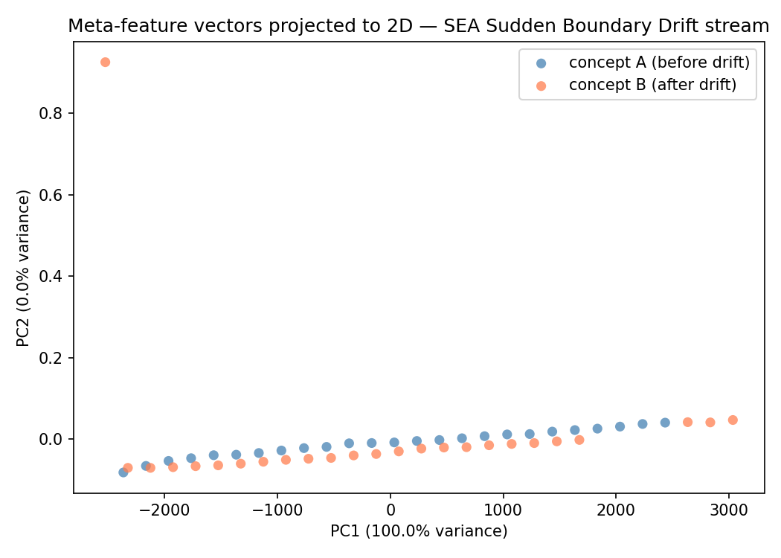
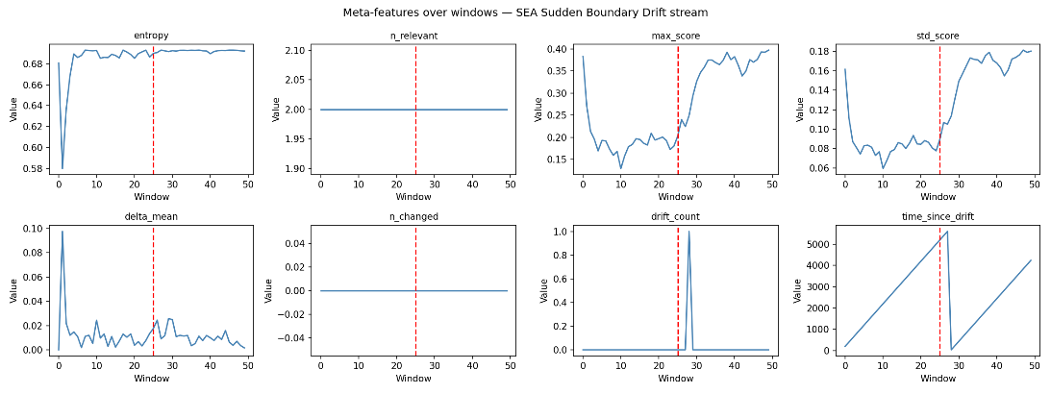
NOTE: the number of relevant features is the same throughout, and the number of features changed is zero, before and after the drift. The behaviour is as expected.
NOTE: in this plot, each point represents a window of the stream. Its position is determined by projecting the meta-feature vector for that window onto the 2D plane defined by PC1 and PC2. Points that are close together have similar meta-feature vectors: they represent similar concepts. Points that are far apart have different meta-feature vectors: they represent different concepts.
For this stream configuration, almost complete overlap between blue and orange. This is the expected behaviour for boundary drift: the two concepts should not be separable in meta-feature space since the relevant features did not change.
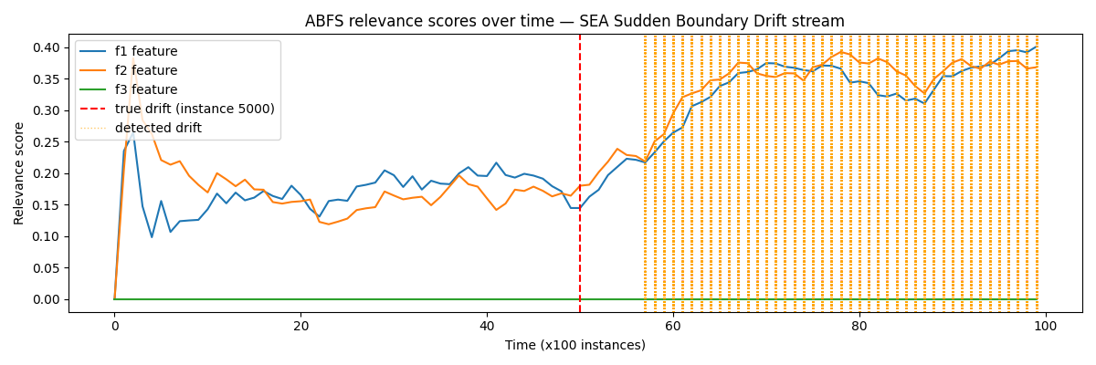
NOTE: in this plot, the x axis is time in units of 100 instances, so: x = 0 is instance 0, x = 10 is instance 1000, etc.
For this stream configuration, relevance score for feature 3 (f3) remains at 0.0 (irrelevant) through the entire stream. The rise in relevance score for f1 and f2 after the boundary drift may be due to the shift in the decision boundary making it slightly easier for the stumps to achieve higher accuracy.

- STAGGER Sudden Drift (concept 1 concept 2) – Results
Concept 1: relevant features = color, shape
Concept 2: relevant features = size
Meta-feature means per concept:
concept A (BEFORE DRIFT) concept B (AFTER DRIFT)
entropy 0.6636 0.1271
n_relevant 1.9600 1.2000
max_score 0.4850 0.7235
std_score 0.2216 0.3397
delta_mean 0.0153 0.0260
n_changed 0.0400 0.1200
drift_count 0.0400 0.2400
time_since_drift 2217.2800 1358.7200
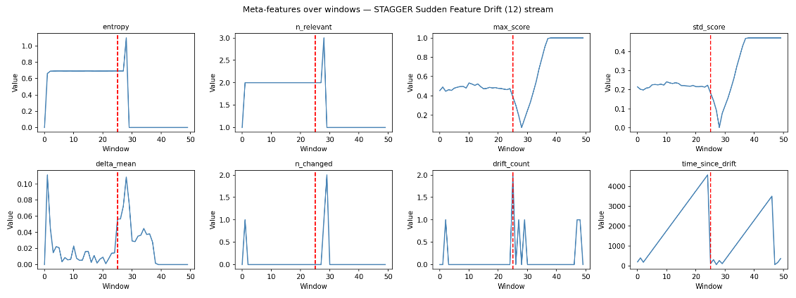
NOTE: the entropy drops significantly after drift, from approx. 0.66 to approx. 0.13, reflecting that concept 2 has only one dominant relevant feature. max_score rises sharply, showing that the relevant feature is dominant (since it is the only relevant feature). The number of relevant features (n_relevant) correctly drops from 2 to 1. The drift count (drift_count) spikes at the drift window.
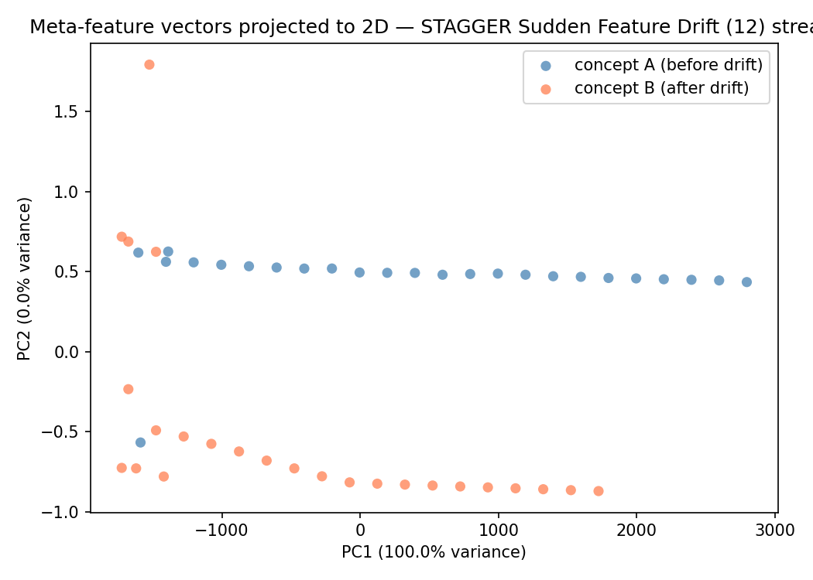

NOTE: the two concepts form clearly separated clusters, windows belonging to concept 1 produce similar meta-feature vectors, as do windows belonging to concept 2 while the two groups are clearly distinguishable from each other. This is expected since we expect different feature relevance structures produce discriminative meta-feature vectors. The windows in the transition zone, where the sliding window still contains a mix of instances from both concepts, appear between the two clusters (the concept label and meta-feature vector are temporarily misaligned), reflecting the gradual adaptation of the relevance scores after the drift.

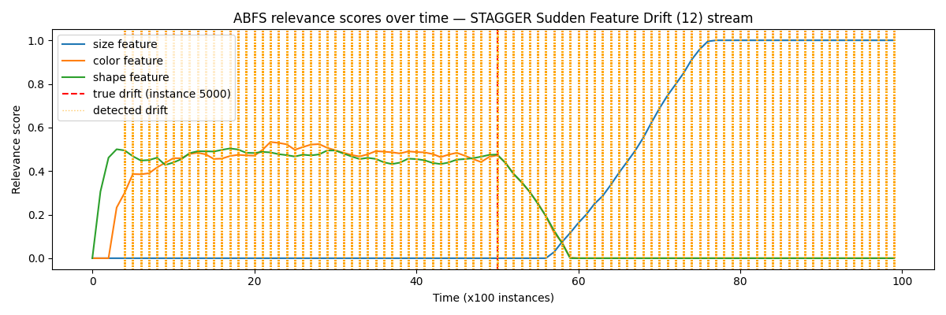
NOTE: Before drift (concept 1): color and shape score near 0.47 (relevant features), size scores near 0 (irrelevant). After drift (concept 2): size rises to approx. 1.0 becomes relevant), while color and shape drop to near 0 (become irrelevant). The gradual transition reflects the sliding window adaptation period.

