
COMSATS University Islamabad,
Abbottabad Campus

Project Proposal
(SCOPE DOCUMENT)
for
SmartCrop – AI & IoT-Based Crop Suitability and Monitoring System
Version 1.0
By
Aleeza Javed CIIT/SP23-BCS-141/ATD
Zulkifl Ahmad CIIT/SP23-BCS-047/ATD
Muneeba Kalsoom CIIT/SP23-BCS-147/ATD

Supervisor
Sir Yasar Khan

Bachelor of Science in Computer Science (2023-2027)
No. | Comment | Action
SCOPE DOCUMENT REVSION HISTORY

Supervisor Signature
Date:

Table of Contents
1. Abstract 1
2. Introduction 1
3. Problem Statemen 1
4. Problem Solution for Proposed System 2
5. Related System Analysis/Literature Review 2
6. Advantages/Benefits of Proposed System 3
7. Scope 4
8. Modules 5
9. System Limitations/Constraints 6
10. Software Process Methodology 7
11. Tools and Technologies 8
12. Project Stakeholders and Roles 8
13. Team Members Individual Tasks/Work Division 8
14. Data Gathering Approach 9
15. Concepts 10
16. Gantt chart 11
17. Mockups 12
18. Conclusion 13
19. References 14
20. Plaragism Report 15

Project Category:
- Internet of Things (IoT)
- Artificial Intelligence / Machine Learning
- Mobile Application Development

Abstract
SmartCrop is an AI- and IoT-based intelligent crop monitoring and recommendation system for helping farmers make informed decisions regarding farming. The system collects real-time soil and environmental data from all kinds of sensors like pH, NPK, moisture, temperature and humidity. The data is collected, processed and stored via a cloud platform and can be monitored and traced over time. This data is input into a machine learning algorithm that outputs the best crops to grow.
In addition, the system has automatic irrigation control that optimises the irrigation water supply according to the soil. Mobile application delivers real-time sensor data, smart alerts and actionable intelligence. The aim of the SmartCrop is to enhance the productivity of crops, minimize the waste of resources and modernize the traditional farming system in Pakistan.

Introduction
The main objective of this project is to design an intelligent agricultural system using the concept of IoT and Artificial Intelligence to help farmers in making better decisions. Despite its importance, agriculture is still considered a very traditional sector and farmers are using traditional way of choosing crop and irrigation.
SmartCrop provides a modern solution by combining real-time sensing, cloud storage, and predictive analytics. Soil and environmental parameters are measured on a continuous basis using sensors. This data is fed into a cloud database and machine learning algorithms are applied to make appropriate crop recommendations.
The system also features a mobile app that enables farmers to track their fields remotely and get alerts. Moreover, automatic irrigation guarantees that water is used efficiently. The goal of this project is to connect the traditional method of farming and the modern technology, resulting in an improvement in productivity and sustainability.

Problem Statement
The farmers in Pakistan are facing a number of problems as a result of inability to access scientific data and modern technology. A challenge is a lack of knowledge on the most appropriate crops to grow on the soils they have. Frequently neglected or un-known soil parameters include pH, nitrogen, phosphorus and potassium levels and moisture content. Current agricultural methods depend on a lot of experience and guesswork to make sure that the right type of crops are planted and that yield is maximized. Also, the management of irrigation can lead to water loss and crop damage. The farming decisions are further complicated by weather conditions because farmers have no means to monitor the environment in real time. There are a number of systems available to monitor soil, but they only provide data and not intelligent recommendations.
Likewise, there are some AI-driven solutions that make predictions and don't have the real-time data integration. No single system integrates the monitoring, prediction, automation and reporting. The purpose of this project is to overcome such issues to develop an integrated system. In this project, we hope to gain knowledge of IoT development, machine learning model development, mobile app development and cloud integration.

Problem Solution for Proposed System

System SmartCrop offers a full solution as it combines IoT devices, AI models and mobile technology into one platform. The system gathers real time soil and environmental information such as moisture, temperature, humidity, pH, nutrients, etc. with the help of sensors. This information is uploaded to a cloud database (Firebase) which stores and processes the information. The data is used in a machine learning model to predict which plants would be best grown on the land. Then the results are shown on the mobile application. It also has an automated irrigation system that begins once it reaches a specific moisture level. This means efficient utilisation of water and lesser manual effort. Besides this, the system provides smart alerts for various events like low moisture, rainfall etc. A reporting module delivers information on plant well-being and environment conditions. With all these features, SmartCrop provides a full smart farming solution.

Related System Analysis/Literature Review

A System Analysis/Literature Review is performed in conjunction with various related research topics.
- Plantix

[4] Plantix is an AI-powered mobile app that enables farmers to diagnose plant diseases and nutrient deficiencies through image recognition. It offers recommendations, based on plant leaves, and is one of the world's largest agricultural apps. It only aims to detect disease and does not offer real-time monitoring of an IoT device, control of irrigation or prediction of crop suitability.

- CropX

[12] CropX is an advanced smart farming system that uses soil sensors and cloud analytics to monitor soil conditions such as moisture and salinity. It gives irrigation recommendations on the basis of information gathered and makes water more efficient. It is primarily about optimizing water use efficiencies for irrigation and doesn't include any AI-based crop recommendation based on soil nutrients such as NPK and pH.

- IoT-Based Smart Irrigation Systems (Research Prototypes)

There are a number of IoT irrigation systems that collect data from sensors (such as temperature, humidity, soil moisture) and pass it to cloud platforms that automatically adjust water delivery to the farm. These can help to save water and increase irrigation efficiency. These systems are only for irrigation and are not crop prediction or mobile.

- AI-Based Smart Agriculture Systems (Research Studies)

The studies conducted in recent times reveal that when AI and IoT are combined, it has the potential to monitor, analyse and automate agriculture in real time. These systems enhance decision making, resource optimization and productivity.The majority of research systems are theoretical or partly developed, and do not have a full solution for using mobile apps, automating and reporting for the end users.

Table 1 Related System Analysis with proposed project solution
Application Name | Weakness | Proposed Project Solution
Plantix | Only disease detection, no IoT or automation. | SmartCrop combines sensors +AI + automation.
CropX | Focus on irrigation only | Adds crop prediction using soil data information and Automatic irrigation.
AI Smart Agriculture Research | Mostly theoretical, not fully integrated | Complete working prototype with mobile app

Advantages/Benefits of Proposed System
The following are the advantages/benefits of the proposed system:

- Improved Crop Selection
The system makes a recommendation of the most appropriate crop using AI analysis of soil and environment. This will minimize guesswork and boost potential yields.
- Real-Time Monitoring
Farmers can check the soil moisture, soil pH, soil temperature, humidity and nutrients at all times with continuous monitoring.
- Efficient Water Usage
The automatic irrigation system will ensure that water is only supplied when it is required, thus minimising water loss and maximising the efficiency of irrigation water.
- Early Alerts and Notifications
Farmers get immediate notifications on critical events like low soil moisture, rain or temperature change so that they can take timely action.
- Remote Accessibility
The mobile app allows farmers to keep track of their fields remotely, eliminating the need for on-site inspections

- Increased Productivity
Data-driven decision making is a way of enhancing crop health and overall agricultural productivity.

- Cost Effective Solution
It's designed to be used by small and medium scale farmers and is supported with low cost equipment and free/open source software.

- Cloud based Data Storage
All sensor readings are uploaded to the cloud of Firebase where historical data can be tracked and analyzed for trends which can be valuable for future planning.

- Integrated Plateform
SmartCrop integrates monitoring, prediction, automation and reporting in a single platform, unlike the current systems that address only a single layer of one of these functions.
Scope

SmartCrop is an AI and IoT based intelligent system to determine the suitability and monitor the crops to help farmers make data-driven decisions. The system will gather real-time soil and environmental data through multiple sensors like pH, EC, NPK, Soil moisture, soil temperature, humidity, rainfall, and light intensity. This data will be continuously pushed into Firebase cloud database [2] and real-time stored, processed and tracked in the past. The information gathered will be fed into a machine learning model which will suggest the best crop among the options of wheat, rice, maize, cotton and tomato. An Android mobile application will be built using Flutter technology [3] that will give farmers a real-time sensor data dashboard, crop suggestions powered by AI, and intelligent alert notifications. The mobile app will also show the trend of the data to assist farmers in analysing the field condition over time. Smart alerts will be issued for critical conditions like low soil moisture, heavy rainfall, high temperature and nutrient deficiency that will enable farmers to take timely action. The readings from every sensor will all be stored in Firebase Realtime Database, which can be used for ongoing monitoring and data analysis. Open agricultural datasets will be used in conjunction with actual sensor data to train and validate the AI prediction model for the system. The project will utilize cheap and open-source components such as the ESP32 microcontroller [8], Arduino IDE, Python, and Flutter framework. There will be no crop disease detection, pest identification or any image-based analysis in the system, however. The system will not have a web-based Dashboard and only will be available via the Mobile Application. Cloud communication will require an Internet connection, so there will be no support for offline AI prediction. The system will not involve any autonomous farming
That is, it will not be used for large-scale industrial or commercial farming but will use machinery like tractors or robots.

Modules
Module 1: IoT Sensor Data Collection Module
Responsible for all data that is pulled from the hardware level of the sensors (pH, NPK, moisture, temperature, humidity, rainfall, light). ESP32 microcontroller [8] reads sensor values continuously and sends them to Firebase. The whole system starts with this Module and is based on it.
Module 2: Firebase Cloud Data Logging Module
Handles real-time storage and retrieval of sensor data in Firebase Realtime Database. Every incoming reading is recorded with a time stamp and stored for display in real time and for historical viewing. This module simplifies keeping the backend and app updated.
Module 3: AI/ML Crop Prediction Module
An AI trained model (Scikit-learn/TensorFlow [5][6]) to predict the most appropriate crop based on soil and environmental data. This module includes elements of data preparation, model training, and model validation. It generates predictions that are used by the mobile app.
Module 4: Smart Alert & Notification Module
Compares incoming sensor data to pre-defined thresholds (low moisture, heavy rain, high temperature, nutrient imbalance, etc.) and alerts the farmer in real time through a push notification to their mobile device. The alerts are triggered automatically, without the person's intervention.
Module 5: Automatic Irrigation Control Module
This module will start the irrigation mechanism using a relay that is attached to the ESP32 when the soil becomes dry and reaches a certain level. It saves man power and saves water. This is a distinguishing automation element of SmartCrop which sets it apart from passive monitoring systems.
Module 6: Mobile App Dashboard Module
An Android app that has been developed using Flutter, which will send a live sensor data dashboard, crop recommendations based on AI and past data trends. Farmers can access the field condition remotely and receive alerts from anywhere. This is the main client side user interface of the system.
Module 7: User Authentication & Profile Module
Manages farmers registration, login, and their profile management with Firebase Authentication. Provides personalised and secure data and notifications per user. Supports role-based access, if extended in the future.
Module 8: Reporting & Data Visualization Module

Produces visual charts and summaries of historical sensor data to enable farmers to analyze trends over time in their fields. Reports may include moisture trends, temperature trends, crop recommendation history. This module is used for long-term decision making based on data.

Module 9: Testing Module

Performs unit, integration and system tests of all modules. Monitors sensor accuracy, cloud sync, AI predictions, alerts, irrigation and app performance. Evaluates the reliability of measures using such indicators as latency, accuracy, response time. Supports seamless integration of SmartCrop prior to deployment in the real-world.

Module10:

System Limitations/Constraints
- Dataset Availability

Now, SmartCrop is utilizing publicly available agricultural data for its AI training. These data are effective but can not adequately represent local conditions in Pakistan. The system will also be designed to be able to integrate local sensor data over time, thereby enhancing the accuracy and relevance of the data.

- Internet connection and Power Outlet

SmartCrop needs a reliable internet connection and electricity to transmit data in real-time and to process the data in a cloud. Future enhancements that can be considered are the support of this off-line and solar-powered in order to be more convenient in rural regions.

- Focused Crop Support

SmartCrop is currently available for 5 major crops: Wheat, Rice, Maize, Cotton and Tomato which are the most common crops grown in Pakistan. This targeted method enables the AI model to make highly accurate and reliable recommendations to these crops. System is scalable, so that in future versions the additional crops can be added with minimum effort.

- Controlled Environment Testing

The first testing and validation of the SmartCrop system will be carried out in a controlled environment, with a prototype system. This guarantees that all parts are completely tested and validated before use in the real world. It is developed using a scalable architecture, which can be expanded to full-scale field deployment in future iterations, thus setting a good basis for a complete smart farming solution.

Software Process Methodology
SmartCrop uses the Incremental Development Model as its software process methodology. The project is divided into four distinct parts – IoT hardware, Firebase backend, AI/ML model, and the Flutter mobile app – so you could develop each part and test it independently, incrementally, and then integrate it together at the end. The methodology was selected as it is directly aligned to the milestones laid out in the project's Gantt chart (10%, 30%, 60%, 100%) and enables parallel development within the team across various technical areas.

Tools and Technologies
In order to develop SmartCrop, the following areas of technology and tooling will need to be explored: Hardware programming, Cloud Services, Machine Learning, and mobile Application development. The ESP32 microcontroller [8] is programmed via Arduino IDE, and the Python and Flutter codebase is developed using VS Code. Using Firebase as the backend platform, all data is stored in the cloud, and it also supports push notifications and user authentication for the application. Firebase offers real-time database, user authentication and push notification capabilities without requiring a custom backend server. Crop prediction is done using a machine learning model trained and evaluated in Python using Scikit-learn. The cross-platform mobile application that offers farmers a live dashboard, alerts and recommendations is built using Flutter and Dart. The free GPUs support on Google Colab is used for model training and experimentation; Figma is used for creating UI mockups prior to implementation. Together, these tools guarantee that all four pillars of the system IoT, AI, cloud and mobile are built using industry standard and open-source technologies, and that it remains cost-effective and scalable.

Table 2Tools and Technologies for Proposed Project
Tool | Version | Rationale
Arduino IDE | 2.3.2 | Programming and flashing ESP32 firmware
Visual Studio Code (VS Code) | 1.89 | Primary IDE for Python and Flutter development
Firebase Console | Latest | Cloud database setup and management
Android Studio | Hedgehog 2023.1.1 | Flutter app testing and emulation
Figma | Latest | UI/UX mockup and screen design
Google Colab | Latest | AI model training and experimentation
Microsoft Word | 2021 | Documentation
Microsoft PowerPoint | 2021 | Presentation preparation
OpenProject | Latest | Gantt chart and project management

Technology | Version | Rationale
Python | 3.11 | AI/ML model development
Dart | 3.3 | Flutter mobile app programming language
Flutter SDK | 3.19 | Cross-platform mobile app framework
Firebase Realtime Database | Latest | Real-time cloud data storage and synchronization
Firebase Authentication | Latest | User authentication and profile management
Firebase Cloud Messaging (FCM) | Latest | Push notifications and smart alerts
Scikit-learn | 1.4 | Machine learning model training and evaluation
TensorFlow | 2.16 | Deep learning model development (if required)
Arduino C/C++ | Latest | ESP32 sensor firmware programming
HTTP/REST API | Latest | Communication between mobile application and backend services

Project Stakeholders and Roles
Project Stakeholders for Proposed Project
Project Sponsor | COMSATS University, Islamabad
Stakeholder | - Group Members and Developers of the project  Aleeza Javed CIIT/SP23-BCS-141/ATD  Zulkifl Ahmad CIIT/SP23-BCS-047/ATD  Muneeba Kalsoom CIIT/SP23-BCS-147/ATD  - Project Supervisor: Sir Yasar Khan  - Final Year Project Committee: Evaluation of project

Team Members Individual Tasks/Work Division
Each team member is assigned a specific task that must be completed. The SmartCrop project is split into three so that each team member can be assigned to a specific expertise and the three big technological areas of the system. Aleeza Javed handles all things IoT from hardware selection, integration of sensors, ESP32 firmware development to sending the real-time data to Firebase and Iot sensors integration into Mobile app. Zulkifl Ahmad works on the machine learning model development, data preparation, back end configuration, and ML model integration into Mobile app. Muneeba Kalsoom is responsible for the complete Flutter mobile application development, ranging from UI Design, Dashboard implementation, alert notifications. All three team members will be involved in the same testing, ensuring that all components of IoT, AI and mobile app are tested in parallel so that the system integration is smooth. This division helps to ensure that every team member has an area of ownership, and that all three parts work together as a seamless whole in the final system.

Table 4Team Member Work Division for Proposed Project
Student Name | Student Registration Number | Responsibility / Modules
Aleeza Javed | CIIT/SP23-BCS-141/ATD | IoT  Module 1 (IoT Sensor Data Collection) and Module 5 (Automatic Irrigation Control). Tasks involves: sensor selection, programming in ESP32, setting up the hardware circuits, calibration of sensors and realtime data transfer to Firebase Realtime Database and fetch in Mobile app.
Zulkifl Ahmad | CIIT/SP23-BCS-047/ATD | AI/ML  Module 2 (Firebase Cloud Data Logging), Module 3 (AI/ML Crop Prediction), Module 4 (Smart Alert & Notification)).  Tasks involves: preparing the datasets, training and evaluating the machine learning model, setup of the Firebase Realtime Database, and the implementation of the backend logic.
Muneeba Kalsoom | CIIT/SP23-BCS-147/ATD | Mobile Application Development  Module 6 (Mobile App Dashboard), Module 7 (User Authentication & Profile), Module 8 (Reporting & Data Visualization).  Task involves: Flutter app development, UI/UX implementation, Firebase Authentication integration, and push notification setup.

Data Gathering Approach
The main data collection techniques used by SmartCrop are: 1) dataset collection and 2) field-based sensor data. The agricultural datasets will be initially used to train the AI models which are available publicly, such as Crop Recommendation Dataset from Kaggle [1], that includes soil parameters such as NPK, pH, moisture, temperature, and humidity along with suitable crops. Second, sensor readings from the real-world prototype of the IoT device using the ESP32 will be taken directly from the prototype and locally relevant data will be fed into the model, increasing the accuracy of the model. Furthermore, online research and literature of some smart agriculture systems, like Plantix and CropX were performed to understand the needs of the systems and identify gaps. Surveys could also be done with the local farmers using questionnaires to understand their current problems, their crop preferences and field conditions in the Pakistani farming context.

Concepts
Concept 1: Internet of Things (IoT)
The Internet of Things (IoT) is a network of physical devices equipped with sensors and software that gather and share data with each other via the Internet. The ESP32 microcontroller [8] is used with several soil and environmental sensors to implement IoT in SmartCrop. These sensors continuously collect real-time data from the field and send them to Firebase cloud for processing. The project offers practical knowledge of IoT integration with hardware, sensor calibration, and wireless data transmission.
Concept 2: Machine Learning (ML)
Artificial Intelligence (AI) is a field of computer science that focuses on the ability of machines to learn from data and make predictions without relying on explicit programming. Machine Learning is a subset of AI that is particularly concerned with the ability of machines to learn from data and make predictions without being explicitly programmed. SmartCrop is a supervised ML model trained with agricultural datasets of soil parameters to foresee the best crop to grow under specific soil conditions. The model is created using python libraries like Scikit-learn and scored by accuracy and F1 score. This project will give hands-on experience in data preprocessing, model training, and model performance evaluation.
Concept 3: Cloud Computing & Firebase
Cloud computing is defined as the delivery of computing services (including storage, databases and processing) over the internet. In SmartCrop, sensor readings are stored and synchronized in real-time between the IoT device and the mobile application in Firebase Realtime Database. For user management, Firebase Authentication and Cloud Messaging are also used in this application. This project offers experience in cloud-based backend development and real-time data synchronization.
Concept 4: Mobile Application Development
Mobile Application Development is the process of designing and developing the software applications to be used on mobile devices. SmartCrop is a cross-platform Android application created using Flutter framework and Dart language, which presents live sensor data, crop suggestions and smart alerts. The app connects to Firebase backend to get and show real-time data to the farmer. This project gives hands-on experience of UI/UX design, state management and API in mobile environment.
Concept 5: REST APIs & System Integration
A REST API is a collection of rules that enable two software systems to interact with each other via HTTP. In this instance, SmartCrop utilizes REST API to link the machine learning model deployed on the back-end server with the mobile app developed using Flutter for delivering real-time crop predictions. This concept involves sending, receiving and processing data between several parts of the system. This project experience allows the programming of APIs, handling of JSON data, and integration of multiple components in a system.

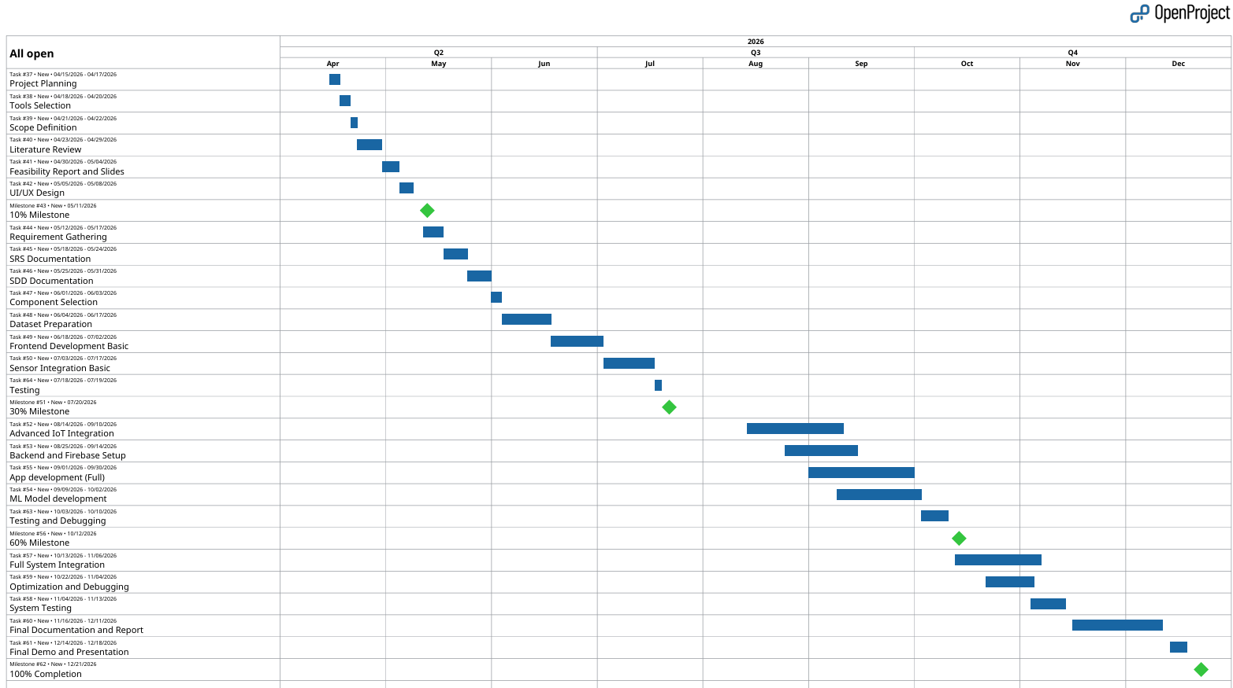
Gantt chart
Figure 1Sample Gantt chart

Mockups
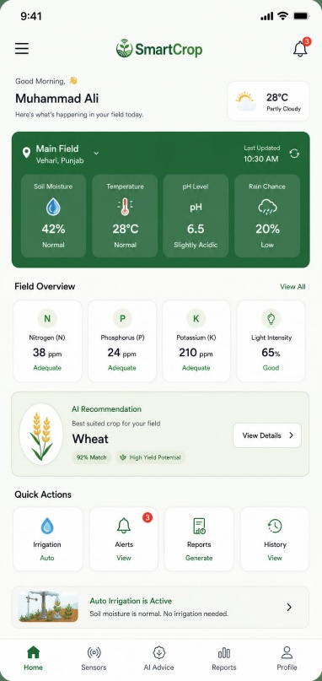
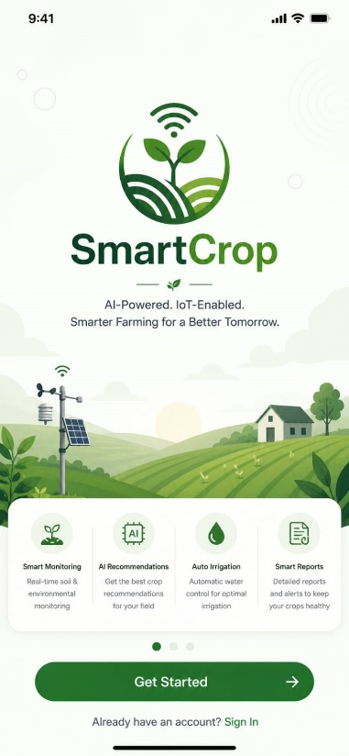
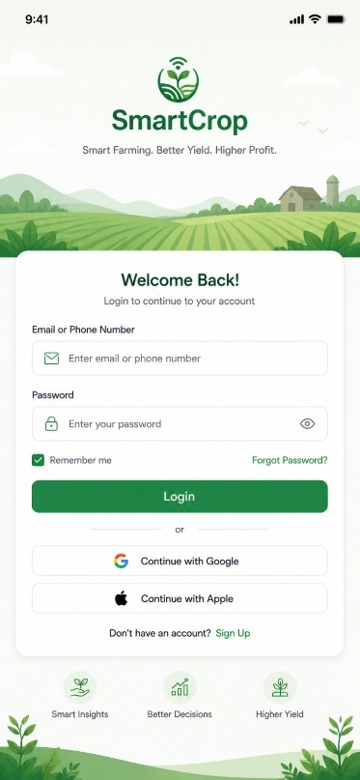

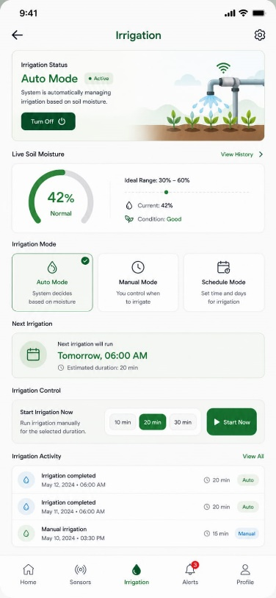
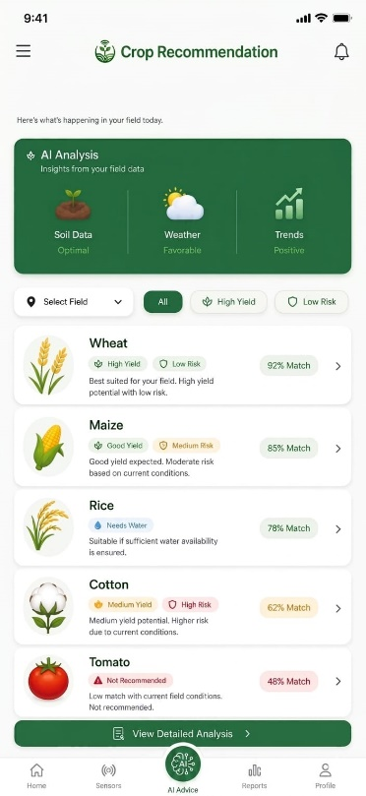

Conclusion
SmartCrop is an AI + IoT-based crop monitoring and prediction system in order to modernize farming in Pakistan. It combines real-time sensing, crop recommendations through the use of ML, Firebase cloud and a mobile application built with Flutter. Structured testing and integration, with clear team roles and incremental development. The project will result in a working prototype that can be scaled up in AgriTech.

References

[1] | Kaggle, “Crop Recommendation Dataset,” [Online]. Available: https://www.kaggle.com/datasets/atharvaingle/crop-recommendation-dataset.
[2] | Google, “Firebase Documentation,” [Online]. Available: https://firebase.google.com/docs.
[3] | Google, “Flutter Documentation,” [Online]. Available: https://flutter.dev/docs.
[4] | Plantix , “Plantix - Digital Agriculture Solutions,” [Online]. Available: https://www.plantix.net.
[5] | scikit-learn, “Scikit-learn Documentation,” [Online]. Available: https://scikit-learn.org/stable/documentation.html.
[6] | Google, “TensorFlow API Documentation,” [Online]. Available: https://www.tensorflow.org/api_docs.
[7] | “Crop Recommendation using Machine Learning,” International Journal for Research in Applied Science and Engineering Technology, 2024.
[8] | Espressif Systems, “ESP32 Technical Reference Manual,” [Online]. Available: https://www.espressif.com/en/support/documents/technical-documents.
[9] | “Soil-based crop recommendation system using using NPK and Weather Parameters,” 2024.
[10] | M. Karar, F. Alotaibi, A. AL Rasheed and O. Reyad, “A Pilot Study of Smart Agricultural Irrigation using Unmanned Aerial Vehicles and IoT-Based Cloud System,” arXiv, 2021.
[11] | A. Montalvo, O. Camacho and D. Chavez, “Cyber-Physical Systems for Smart Farming: A Systematic Review,” Sustainability, vol. 17, no. 14, 2025.
[12] | CropX, “CropX system,” [Online]. Available: https://www.cropx.com.

Plagrism Report

Attach the Plagrism report of your project scope document from library staff of turnitin tool (http://turnitin.com

