Lab 3 – Aleeza Iftikhar

3) Use vi to open “RealEstate.csv”. vi RealEstate.csv

4) Move the cursor to the last line (without knowing the number of last line). G

5) Display line number. :.=

6) Search for the transaction for the estate located at "111 EAST" ?111 EAST

Which line is this string located? (Please just write down the line number) 6

Delete this line. dd

7) Move the cursor to the line 50. :50

8) Substitute all comma "," with colon ":" from line 50 to line 54. :50,54s/foo/bar/g

9) Copy line 50 to line 54 to the end of file.

:50,54y

G

p

10) Remove line 50 to line 54.

:50

5dd

11) Describe how to enter the text mode and insert a new line "Recorded in year

2008" between line 1 and line 2.

:1

o

i

Recorded in year 2008

12) Switch back to command mode.

Esc

13) Save the file and quit vi.

:wq

10)



12) here r-- means that all users (me, other in my group, other in out of group) have read permissions only.

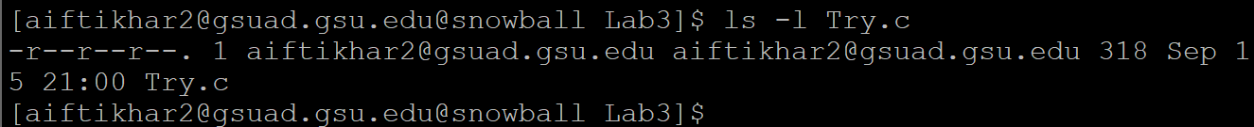

13)



I quitted by undo ‘u’ and then ‘:q’ (without saving)

14)

chmod 666 Try.c

15) here rw- means all users have read write permissions only.

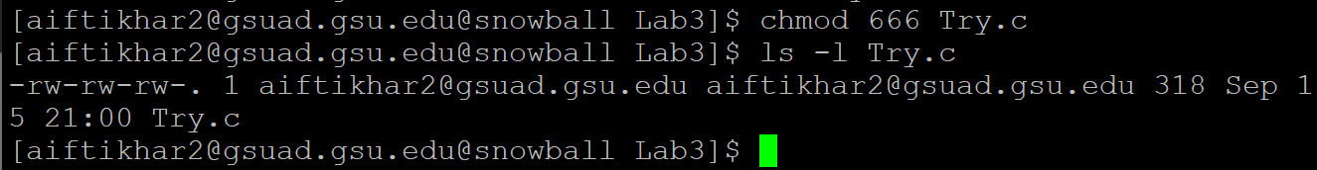

PART 4:

A. Check the contents in directory Lab3.

$ls ~/Lab3 N (Permission denied)

B. Create a directory named as "test" in Lab3.

$mkdir ~/Lab3/test N (Permission denied)

C. Create a file named as "test.txt" in Lab3.

$cat>~/Lab3/test.txt N (bash: Permission denied)

A test

^D

6

D. If (B) succeeds, remove the created directory "test" of Lab3.

$rm -r ~/Lab3/test N/A

E. If (C) succeeds, copy "test.txt" from your Lab3 into your home directory.

$cp ~/Lab3/test.txt . N/A

F. Go into directory Lab3.

$cd ~/Lab3 N (bash: Permission denied)

