Student Name: Aleeza Iftikhar

Lab Assignment 4 - Part 2 (Out of lab)

Instructor: Bello Babatunde

1) Use grep to print all lines where the mountains are at Towns or Union

County.

grep 'Towns\|Union' mountainList.txt

2) Use wc and grep to count the number of mountains located at Rabun County.

grep -i 'Rabun County' mountainList.txt | wc -l

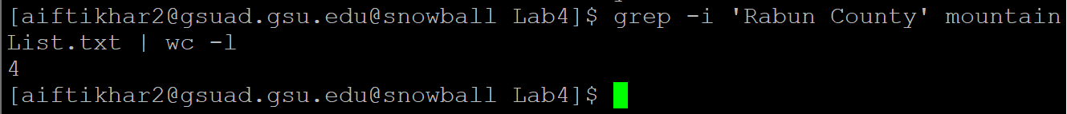

There are 4 mountains.

3) Finish task 2) by using only grep.

grep -c -i 'Rabun County' mountainList.txt

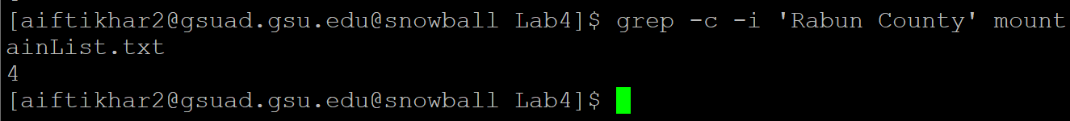

4) A. Type command sed ‘s/ridge high point/r.h.p./p’ mountainList.txt  and execute it. Then attach a screenshot of the output.

B.Type command sed -n ‘s/ridge high point/r.h.p./p’ mountainList.txt and  execute it. Then attach a screenshot of the output.

C. Open the manual page of sed and describe what does –n do in sed?

According to sed -help, -n suppress automatic printing of pattern space.

D. Describe what does the sed command in (B) do?

It replaced ridge high point with r.h.p. then it lines(instances) only where those changes occurred due to -n which suppressed output. (By default, sed prints all lines, as it did in part A)

5) Use sed to remove the leading spaces in "mountainList.txt" and print out the processed lines.

sed 's/^[ \t]\*//g' mountainList.txt

6) Finish task 5) and save the output to file "newList.txt".

sed 's/^[ \t]\*//g' mountainList.txt > newList.txt

7) Use sed to list the lines beginning with white spaces in "mountainList.txt".

Sample Output

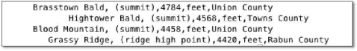

sed -n '/^[ \t]/p' mountainList.txt

2

8) Use sed to delete the lines where the mountains are only at Union County

in "mountainList.txt".

Sample Output

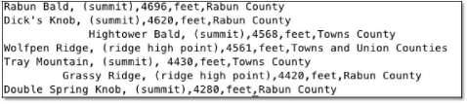

sed -n '/^.\*Union County/!p' mountainList.txt

9) Use sed to remove the middle three fields in each line of

"mountainList.txt". Hint: Think about the meaning of regex '[^,]'

sed -r 's/,([^,]\*){3},/,/g' public/mountainList.txt

Sample Output

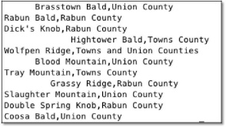

10) Use awk to finish task 9).

11) Use sed to insert a new line “Table: Eleven highest mountains in Georgia” at the beginning of "mountainList.txt".

12) Use sort to print out the sorted lines in alphabetical order according to the names of mountains.

13) Use sort to print out the sorted lines in descending order according to the height of mountains.

14) “When a pattern groups all or part of its content into a pair of parentheses, it captures that content and stores it temporarily in memory. You can reuse that content if you wish by using a back-reference, in the form:\1 or $1, where \1 or $1 reference the first captured group” (Refer to [1]). For example, the following command add a colon between Union and County sed -E ‘s/(Union)\s(County)/\1:\2/g’ mountainList.txt

Attach a screenshot of the output of the above sed command.

15) Now can you write a command to finish task 9) using sed with backreference?

Useful Links:

[1] Introducing Regular Expression - Capturing Groups and Backreferences https://www.safaribooksonline.com/library/view/introducingregular expressions/9781449338879/ch04.html

[2] Drew's grep tutorial http://www.uccs.edu/~ahitchco/grep/

[3] Grep and Regular Expressions!

http://ryanstutorials.net/linuxtutorial/grep.php [4] Web

Scraping with Regular Expressions

https://www.datascraping.co/doc/22/regular-expression