Aleeza Iftikhar Lab5

Q1: it is filename not command.  
Q2: Don’t have correct permissions.



Q3: Successful!

Q4:

By default, echo prints with end line character at the end, but due to -n option, there is no end line character at the end.

Q5:

Yes, simple script is comment.

Q6:

No, it is not comment. it is always put in first line, so that shell scripts can take it as an interpreter (in this case, it is taking bash as an interpreter).

Q7: 5 directories

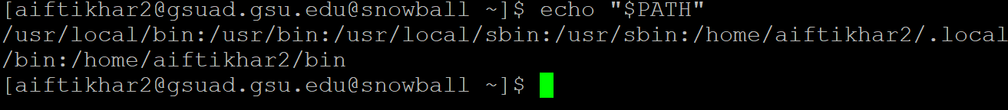

Q9:



Q10:



Error because settings has reset.