Informal Report

- A written statement of the goal(s)
  - Why do the stakeholders want to do the project?
    - Over the past year Credit One has seen a number of customers who have defaulted on loans they have secured. And Credit One, as their scoring service, could risk loosing business if they do not take clear actions to solve the problem.
  - What do they need from it?.
    - They need a way to understand how much credit to allow someone to use or, at a very least, if someone should be approved or not. Keeping defaults as low as possible.
  - Why is their current solution inadequate?
    - I don’t know the state of art of their current solution. But based on what they asked us to do, it seems it’s not working quite well, and/or they think it could be improved.
  - What resources do you need?
    - A dataset with corresponding and useful data.
    - Open source software like Jupyter Lab, and libraries like Pandas, Numpy, Matplotlib, etc
  - How will the result of your project be deployed?
    - Using Python and a bunch of nice libraries (Pandas, Numpy, Matplotlib, etc) I will try to predict if a customer will default his loan. This is a predictive analysis problem, that will try to classify customers based on their financial behavior.
    - The dataset, and all the analysis will be uploaded and available from GitHub.
- A well-defined data science process framework and the reasons you are proposing it.

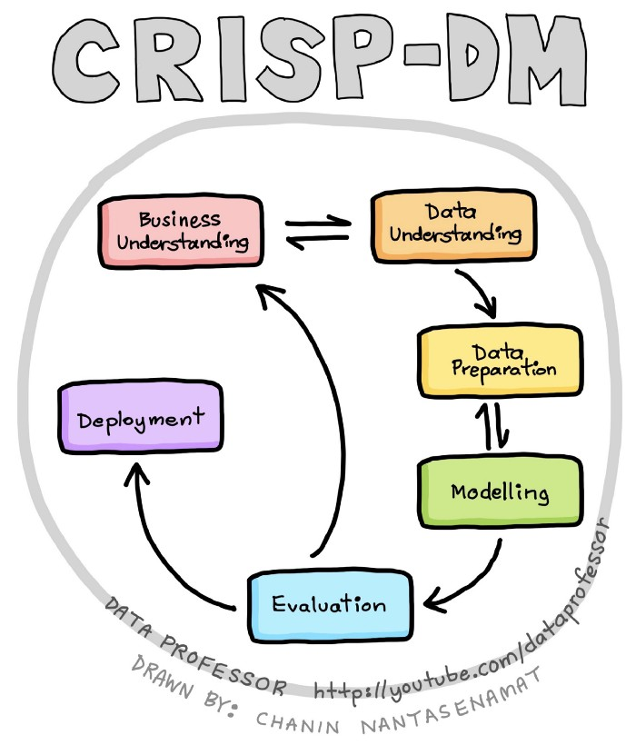
The acronym CRISP-DM stands for Cross Industry Standard Process for Data Mining and CRISP-DM was introduced in 1996 in efforts to standardize the process of data mining (also referred to as knowledge discovery in data) such that it can serve as a standard and reliable workflow that can be adopted and applied in various industry. The CRISP-DM framework is comprised of 6 major steps:
  - Business understanding — This entails the understanding of a project’s objectives and requirements from the business viewpoint. Such business perspectives are used to figure out what business problems to solve via the use of data mining.
  - Data understanding — This phase allows us to become familiarize with the data and this involves performing exploratory data analysis. Such initial data exploration may allow us to figure out which subsets of data to use for further modeling as well as aid in the generation of hypothesis to explore.
  - Data preparation — This can be considered to be the most time-consuming phase of the data mining process as it involves rigorous data cleaning and pre-processing as well as the handling of missing data.
  - Modelling — The pre-processed data are used for model building in which learning algorithms are used to perform multivariate analysis.
  - Evaluation — In performing the 4 aforementioned steps, it is important to evaluate the accrued results and review the process performed thusfar to determine whether the originally set business objectives are met or not. If deemed appropriate, some steps may need to be performed again. Rinse and repeat. Once it is deemed that the results and process are satisfactory then we are ready to move to deployment. Additionally, in this evaluation phase, some findings may ignite new project ideas for which to explore.
  - Deployment — Once the model is of satisfactory quality, the model is then deployed, which may range from being a simple report, an API that can be accessed via programmatic calls, a web application, etc.

- Descriptions and location of related data sources.
  - All the downloaded data, the analysis and all the files will be uploaded to
https://github.com/alefbenages/CreditOne
- An explanation of how you will manage the data for the project
  - First at all get the data. I have been given a link to connect to a Database and download it.
  - First Exploration just to see what could be found.
  - Data cleaning, relabeling, etc. Just to make data usable and legible.
  - Exploratory Data Analysis, grouping and plots to visualize the data and try to understand it better.
  - Then try to apply some ML algorithms to solve the classification problem.
- Any known issues with the data and how you plan to address them?.
  - Strange labeling… I think can be solved with some relabeling.
  - Seems that there are some undocumented categories.
- A flowchart visualizing the detailed process you will follow, annotated with any potential pitfalls you’ve identified and your proposed solutions to such pitfalls.

- Any initial insights you can glean from your quick look at the data.

