**PART 1 - TABLE ORDERS**

**-- ------------------------------------------------------------------------------------**

**-- Q5. How many orders were placed in total?**

SELECT

COUNT(*) AS 'Number_of_placed_Orders'

FROM

orders;

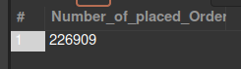

**-- ------------------------------------------------------------------------------------**

**-- Q6. How many orders by state?**

SELECT

state, COUNT(*) AS OrdersByState

FROM

orders

GROUP BY state;

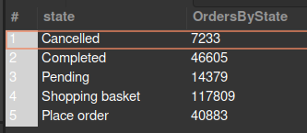

**-- ------------------------------------------------------------------------------------**

**-- Q7. Select all the orders placed in January of 2017**

SELECT

*

FROM

orders

WHERE

MONTH(created_date) = 1

AND YEAR(created_date) = 2017;

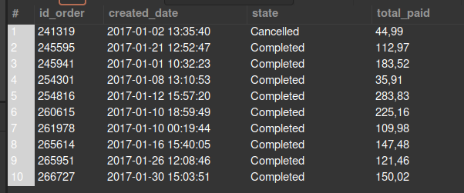

**-- ------------------------------------------------------------------------------------**

**-- Q8. How many orders were placed in January of 2017?**

SELECT

COUNT(*) AS '# Orders of Jan-2017'

FROM

orders

WHERE

MONTH(created_date) = 1

AND YEAR(created_date) = 2017;

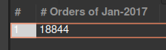

**-- ------------------------------------------------------------------------------------**

**-- Q9. How many orders were cancelled on January 4th 2017?**

SELECT

COUNT(*) AS 'Cancelled Orders of Jan-4-2017'

FROM

orders

WHERE

DAY(created_date) = 4

AND MONTH(created_date) = 1

AND YEAR(created_date) = 2017

AND state LIKE '%ancel%'; -- includes Cancel, cancel, Cancelled, cancell, etc...



**-- ------------------------------------------------------------------------------------**

**-- Q10. How many orders have been placed each month of the year?**

SELECT

YEAR(created_date) AS 'Year',

MONTH(created_date) AS 'Month',

COUNT(MONTH(created_date)) AS '#Orders'

FROM

orders

GROUP BY YEAR(created_date) , MONTH(created_date)

ORDER BY YEAR(created_date) , MONTH(created_date);

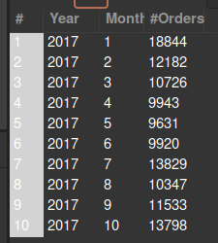

**-- ------------------------------------------------------------------------------------**

**-- Q11. What is the total amount paid in all the orders?**

SELECT

SUM(total_paid) AS 'Total Paid'

FROM

orders;

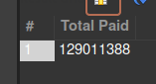

**-- ------------------------------------------------------------------------------------**

**-- Q12. What is the average amount paid per order? Give a result to the previous question with only 2 decimals**

SELECT

ROUND(AVG(total_paid), 2) AS 'Avg amount Paid'

FROM

orders;

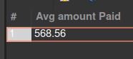

**-- ------------------------------------------------------------------------------------**

**-- Q13 What is the date of the newest order? # Expected output: 2017-01-01 00:07:19**

SELECT

created_date AS 'Newest Order'

FROM

orders

ORDER BY created_date ASC

LIMIT 1;



**-- ------------------------------------------------------------------------------------**

**-- Q13.1 What about the oldest? # Expected output: 2018-03-14 13:58:36**

SELECT

created_date AS 'Oldest Order'

FROM

orders

ORDER BY created_date DESC

LIMIT 1;

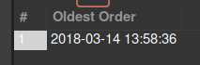

**-- ------------------------------------------------------------------------------------**

**-- Q13.2 What is the day with the highest amount paid (and how much was paid that day)?**

**-- # Expected output: 2017-11-24; 3,103,713**

**-- it ask for the highest amount paid in a day**

SELECT

CONCAT(YEAR(created_date), '-', MONTH(created_date), '-',DAY(created_date)) AS 'Date',

SUM(total_paid) AS total_paid

FROM

orders

GROUP BY Date

ORDER BY total_paid DESC

LIMIT 1;

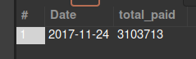

**-- ------------------------------------------------------------------------------------**

**-- Q13.3 What is the day with the highest amount of completed orders (and how many completed orders were placed that day)? # Expected output: 2017-11-24; 1,569**

SELECT

CONCAT(YEAR(created_date), '-', MONTH(created_date), '-',DAY(created_date)) AS 'Date',

state,

COUNT(state) AS 'amount_of_orders'

FROM

orders

WHERE

state = 'Completed'

GROUP BY Date, state

ORDER BY amount_of_orders DESC

LIMIT 1;

