**PART 2 - Table Products**

-- ------------------------------------------------------------------------------------

-- **Q14 -- How many products are there?**

SELECT

COUNT(*) AS 'Amount_of_products'

FROM

products;

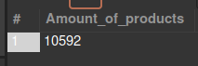

-- ------------------------------------------------------------------------------------

-- **Q15 -- How many brands?**

SELECT

COUNT(DISTINCT brand) as UniqueBrands

FROM

products;



-- ------------------------------------------------------------------------------------

-- **Q16.1 -- How many products per brand ?**

SELECT

brand, COUNT(brand) AS items

FROM

products

GROUP BY brand

ORDER BY items DESC;

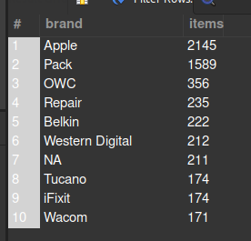

-- ------------------------------------------------------------------------------------

-- **Q16.2 -- How many products per category?**

SELECT

manual_categories AS 'Categories',

COUNT(manual_categories) AS ProductsPerCategory

FROM

products

GROUP BY manual_categories

ORDER BY ProductsPerCategory DESC;



-- ------------------------------------------------------------------------------------

-- **Q17.1 -- What is the average price per brand?**

SELECT

brand, ROUND((SUM(price) / COUNT(price)), 2) AS AvgPrice

FROM

products

GROUP BY brand

ORDER BY AvgPrice DESC;

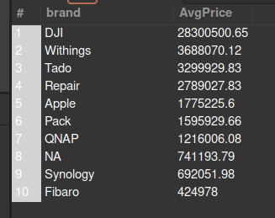

-- ------------------------------------------------------------------------------------

-- **Q17.2 -- What is the average price per category?**

SELECT

manual_categories,

ROUND((SUM(price) / COUNT(price)), 2) AS AvgPrice

FROM

products

GROUP BY manual_categories

ORDER BY AvgPrice DESC;

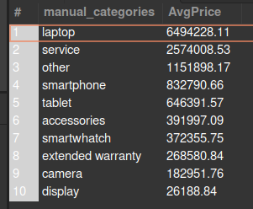

-- ------------------------------------------------------------------------------------

**-- Q18.1 -- What is the name and description of the most expensive product per brand ?**

SELECT

inn.name_en, inn.short_desc_en

FROM

(SELECT

p.name_en, p.short_desc_en, p.brand, MAX(CAST(p.price as FLOAT)) as MxP

FROM

products p

GROUP BY p.name_en, p.short_desc_en, p.brand

ORDER BY MxP DESC

) AS inn;

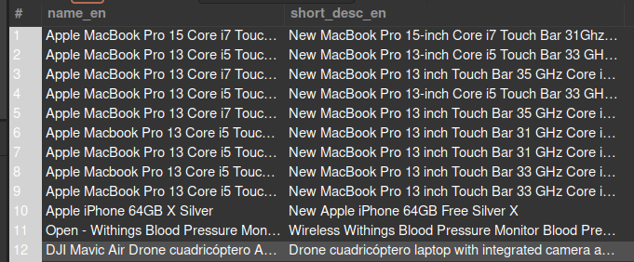

/* This version shows the brand and price

SELECT

name_en, short_desc_en, brand, MAX(CAST(price as FLOAT)) as price

FROM

products

GROUP BY brand, name_en, short_desc_en

ORDER BY price DESC;

*/

-- ------------------------------------------------------------------------------------

**-- Q18.2 -- What is the name and description of the most expensive product per category?**

SELECT

inn.name_en, inn.short_desc_en

FROM

(SELECT

p.name_en, p.short_desc_en, p.manual_categories, MAX(CAST(p.price as FLOAT)) as MxP

FROM

products p

GROUP BY p.name_en, p.short_desc_en, p.manual_categories

ORDER BY MxP DESC

) AS inn;

