**PART 1 – TABLE ITEMS**

**Q1. Select the entire line_item table.**

SELECT

*

FROM

line_item;

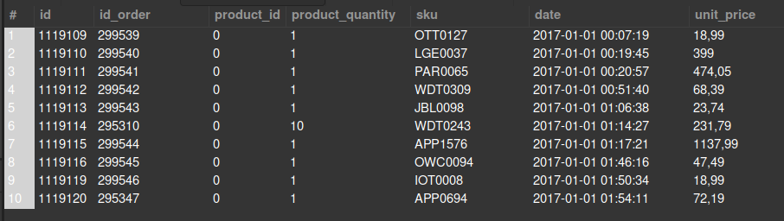

**Q1.1 Select only the first 10 rows from the line_item table**

SELECT

*

FROM

line_item

LIMIT 10;

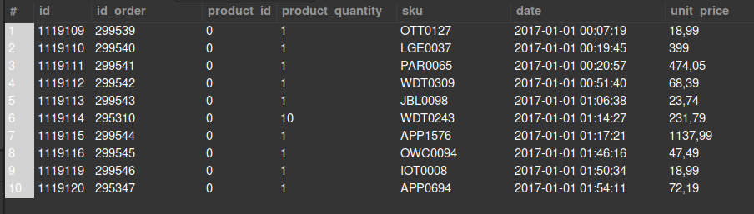

**Q2. Count the total number of rows of the line_item table # Expected output: 293983**

SELECT

COUNT(*) AS "Total number of Rows"

FROM

line_item;



**Q2.1. Count the total number of unique "sku" from the line_item table. #Expected output: 7951**

SELECT

COUNT(DISTINCT sku) AS "Total number of Unique SKU"

FROM

line_item;



**Q3. Generate a table with the average price of each sku.**

SELECT

sku, ROUND(AVG(unit_price),2) AS avg_price

FROM

line_item

GROUP BY sku;

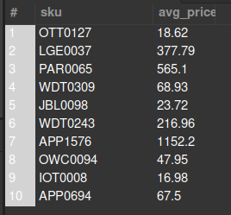

**Q3.1. Now name the column of the previous query with the average price "avg_price" through and alias, and sort the list by that column (bigger to smaller price)**

SELECT

line_item.sku, ROUND(AVG(unit_price),2) AS avg_price

FROM

line_item

GROUP BY sku

ORDER BY avg_price DESC;

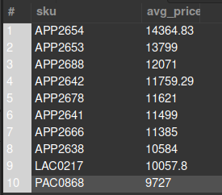

**Q4. Which products were bought in the largest quantities? Select the “stock keeping unit” (sku) and product_quantity of the 100 products with the biggest "product quantity"**

SELECT

sku, product_quantity

FROM

line_item

ORDER BY product_quantity DESC

LIMIT 100;

