**SQL CRASH COURSE PART 2**

**Query the database joining tables**

**-- ----------------------------------------------------**

**-- Query 1 ​ Our first query should return the "sku", "product_quantity", "date" and "unit_price" from the line_item table together with the "name" and the "price" of each product from the "products" table. We want only products present in both tables.**

SELECT

itm.sku,

itm.product_quantity,

itm.date,

itm.unit_price AS IPrice,

prd.name_en,

prd.price AS PPrice

FROM

line_item itm

INNER JOIN

products prd ON itm.sku = prd.sku;

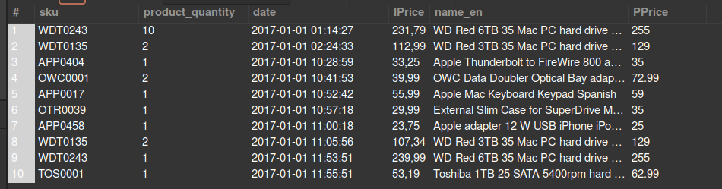

**-- ----------------------------------------------------**

**-- Query 2 You might notice that the ​ unit_price ​ from the ​ line_item ​ table and the price from the ​ product ​ table is not the same. Let's investigate that! Extend your previous query by adding a column with the difference in price. Name that column ​ price_difference ​ .**

SELECT

itm.sku,

itm.product_quantity,

itm.date,

itm.unit_price AS IPrice,

prd.name_en,

prd.price AS PPrice,

ROUND(prd.price - itm.unit_price, 1) AS price_diff

FROM

line_item itm

INNER JOIN

products prd ON itm.sku = prd.sku;

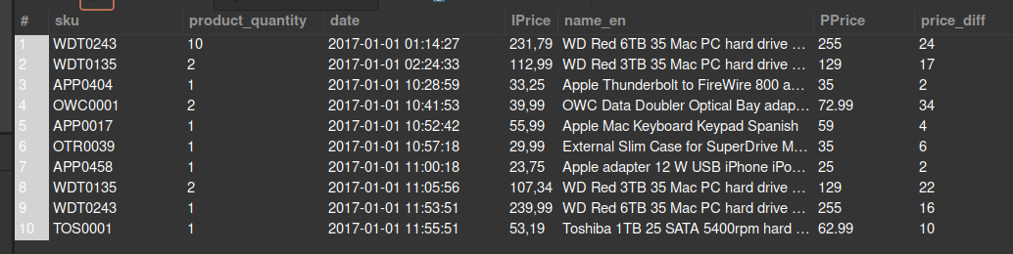

**-- ----------------------------------------------------**

**-- Query 3 Build a query that outputs the price difference that you just calculated, grouping products by category. Round the result.**

SELECT

inn.manual_categories,

ROUND(AVG(inn.price_dif),2) as AVG_Price_diff

FROM

(SELECT

line_item.sku,

line_item.product_quantity,

line_item.date,

line_item.unit_price,

products.name_en,

products.price,

ROUND(ABS(line_item.unit_price - products.price), 1) AS price_dif,

products.manual_categories

FROM line_item

INNER JOIN products

ON line_item.sku = products.sku) as inn

GROUP BY inn.manual_categories;

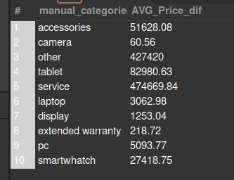

**-- ----------------------------------------------------**

**-- Query 4. ​ Create the same query as before (calculating the price difference between the ​line_item and the ​products tables, but now grouping by brands instead of categories.**

SELECT

inn.brand,

ROUND(AVG(inn.price_dif),1) as AVG_price_dif

FROM

(SELECT

itm.sku,

itm.product_quantity,

itm.date,

prd.name_en,

itm.unit_price AS IPrice,

prd.brand,

prd.price AS PPrice,

ROUND(prd.price - itm.unit_price, 1) AS price_dif

FROM

line_item itm

INNER JOIN

products prd ON itm.sku = prd.sku ) AS inn

GROUP BY inn.brand

ORDER BY AVG_price_dif DESC;

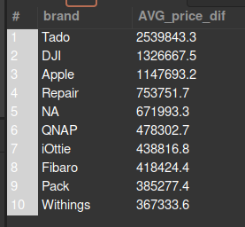

**-- ----------------------------------------------------**

**-- Query 5. ​ Let's focus on the brands with a big price difference: run the same query as before, but now limiting the results to only brands with an avg_price_dif of more than 50000. Order the results by ​ avg_price_dif ​ (bigger to smaller).**

SELECT

inn.brand,

ROUND(AVG(inn.price_dif),1) as AVG_price_dif

FROM

(SELECT

itm.sku,

itm.product_quantity,

itm.date,

prd.name_en,

itm.unit_price AS IPrice,

prd.brand,

prd.price AS PPrice,

ROUND(prd.price - itm.unit_price, 1) AS price_dif

FROM

line_item itm

INNER JOIN

products prd ON itm.sku = prd.sku ) AS inn

WHERE

inn.price_dif > 50000

GROUP BY inn.brand

ORDER BY AVG_price_dif DESC;

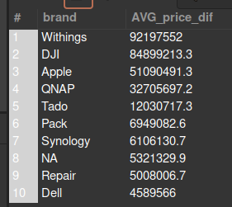

**-- ----------------------------------------------------**

**-- Query 6. ​ Query 6. We want to know the sku, product_quantity and date of all the orders, ordered by SKU. If it takes too long and/or the connection gets lost try first selecting only the first 50 results and then ordering by sku.**

SELECT

ord.created_date,

ord.state,

itm.sku,

itm.product_quantity

FROM line_item AS itm

INNER JOIN orders AS ord ON itm.id_order = ord.id_order

ORDER BY itm.sku;

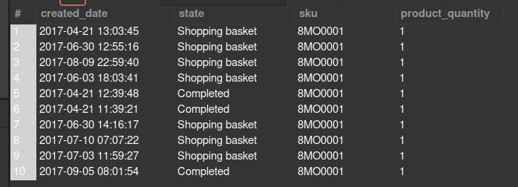

**-- ----------------------------------------------------**

**-- Query 7. ​ Add to the previous information about "​brand" ​and "​manual_categories" fields from the products table.**

SELECT

ord.created_date, ord.state,

itm.sku, itm.product_quantity,

prd.brand, prd.manual_categories

FROM

line_item AS itm

INNER JOIN

orders AS ord ON itm.id_order = ord.id_order

INNER JOIN

products AS prd ON itm.sku = prd.sku;

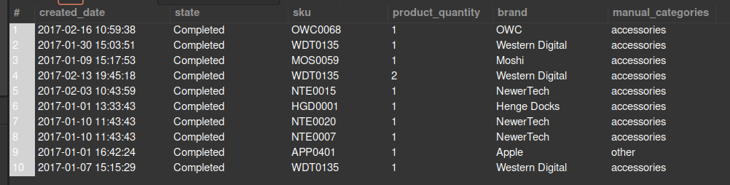

**-- -----------------------------------------------------------------------------**

**-- Query 8.​ We want to know which brand and which categories are most frequent in Cancelled orders.**

**-- Let's keep working on the same query: now we want to keep only Cancelled orders. Modify this query to group the results from the previous query, first by category and then by brand, adding in both cases a count and ordering by descending count. If it takes too long and/or the connection gets lost try putting a LIMIT command.**

SELECT

inn.brand, COUNT(*) AS 'Cancelled Orders by Brand'

FROM (

SELECT

-- ord.created_date,

ord.state,

-- itm.sku,

-- itm.product_quantity,

prd.brand -- , prd.manual_categories

FROM

line_item AS itm

INNER JOIN

orders AS ord ON itm.id_order = ord.id_order

INNER JOIN

products AS prd ON itm.sku = prd.sku

LIMIT 1000

) as inn

WHERE inn.state = 'Cancelled'

GROUP BY inn.brand ;

