**SQL CRASH COURSE Part 3**

**-- ----------------------------------------------------------------------**

**-- Q1. What is the employee id of the highest paid employee?**

SELECT

emp_id, MAX(salary) AS Higest_Payed

FROM

salaries

GROUP BY emp_id

ORDER BY Higest_Payed DESC;

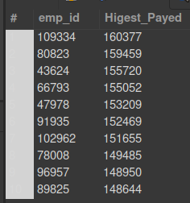

**-- ----------------------------------------------------------------------**

**-- Q2. What is the name of the youngest employee ?**

SELECT

concat(first_name, ' ', last_name) as full_name, hire_date AS Oldest_Employee

FROM

employees

Order by Oldest_Employee DESC;

-- there are a lot of employees hired in the same day.

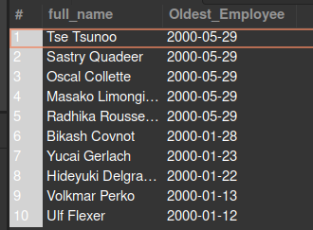

**-- ----------------------------------------------------------------------**

**-- Q3. What is the name of the first hired employee ?**

SELECT

concat(first_name, ' ', last_name) as full_name, hire_date AS Oldest_Employee

FROM

employees

Order by Oldest_Employee ASC;

-- there are a lot of employees hired in the same day.

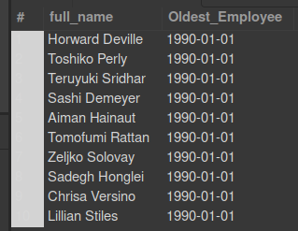

**-- ----------------------------------------------------------------------**

**-- Q4. What percentage of employees are Female?**

-- version with this facny tool over()

select gender, count(*) * 100.0 / sum(count(*)) over() as 'Gender_in_%'

from employees

group by gender;

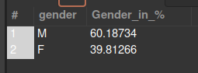

-- version calculed 'by hand'

SELECT

(ROUND(((SELECT COUNT(gender) FROM employees WHERE gender = 'F') * 100) / COUNT(gender),0)) as "%_Female",

(ROUND(((SELECT COUNT(gender) FROM employees WHERE gender = 'M') * 100) / COUNT(gender),0)) as "%_Male"

FROM employees;



**-- ----------------------------------------------------------------------**

**-- Q5 Show the employee count by department name wise, sorted alphabetically on department name.**

-- number employees listed on 'dept_emp' by dept

SELECT

inn.dept_name AS "Dept_Name" , COUNT(inn.dept_name) as "Number of employees by dept"

FROM

(SELECT

dts.dept_no, dts.dept_name,

dem.emp_id

FROM

departments AS dts

INNER JOIN dept_emp AS dem

ON dts.dept_no = dem.dept_no

) AS inn

GROUP BY inn.dept_name

ORDER BY inn.dept_name;

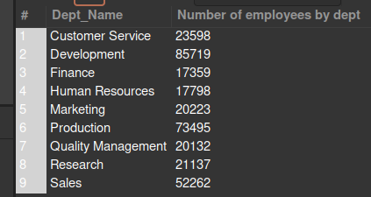

**-- ----------------------------------------------------------------------**

**-- Q6. Count the number of new employees by each calendar year (take the value of year from from_date)**

SELECT

YEAR(from_date) AS 'YEAR', COUNT(*) AS "number of new employees by year"

FROM

dept_emp

GROUP BY YEAR(from_date)

ORDER BY YEAR(from_date);

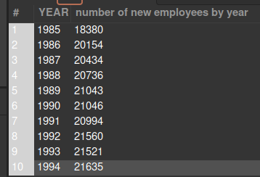

**-- ---------------------------------------------------------------------**

**-- Q7. Count the number of employees by each calendar year (take the value of year from from_date)**

**/\***

didn't know how to solve this...

*/

**-- ---------------------------------------------------------------------**

**-- Q8. What is the number of managers hired each calendar year.**

SELECT YEAR(from_date) AS 'YEAR', COUNT(*) AS "number of new Managers by year"

FROM dept_manager

GROUP BY YEAR(from_date)

ORDER BY YEAR(from_date);

**-- ---------------------------------------------------------------------**

**-- Q9 # What will be the department wise break up of managers ?**

SELECT

inn.dept_name AS "Dept_Name" , COUNT(inn.dept_name) as "Managers by dept"

FROM

(SELECT

dts.dept_no, dts.dept_name,

dma.emp_id

FROM

departments AS dts

INNER JOIN dept_manager AS dma

ON dts.dept_no = dma.dept_no

) AS inn

GROUP BY inn.dept_name

ORDER BY inn.dept_name;

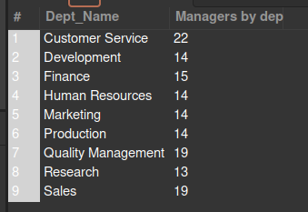

**-- ---------------------------------------------------------------------**

**-- Q10. What is the number of male and female managers hired each calendar year from 1990 onward?**

SELECT

COUNT(inn.gender) as "Female Managers from 1990 onwards"

FROM(

SELECT

emp.gender, dma.from_date,

dma.emp_id

FROM

employees AS emp

INNER JOIN dept_manager AS dma

ON emp.emp_id = dma.emp_id

) AS inn

WHERE inn.gender = 'F' AND YEAR(inn.from_date) > 1990;



SELECT

COUNT(inn.gender) as "Male Managers from 1990 onwards"

FROM(

SELECT

emp.gender, dma.from_date,

dma.emp_id

FROM

employees AS emp

INNER JOIN dept_manager AS dma

ON emp.emp_id = dma.emp_id

) AS inn

WHERE inn.gender = 'M' AND YEAR(inn.from_date) > 1990;



/* Tried this, but didn't work. The idea was to get both numbers in the same table, as in the Q4.

The problem is in the "FROM inn" from the subquery. says that the table "inn" doesn't exist.

Didn't know how to solve this.

SELECT

(SELECT COUNT(inn.gender) FROM inn WHERE (gender = 'F' AND YEAR(inn.from_date) >= 1990)) as "Female Managers",

(SELECT COUNT(inn.gender) FROM inn WHERE (gender = 'F' AND YEAR(inn.from_date) >= 1990)) as "Female Managers"

FROM(

SELECT

emp.gender, dma.from_date,

dma.emp_id

FROM

employees AS emp

INNER JOIN dept_manager AS dma

ON emp.emp_id = dma.emp_id

) inn;

*/