PART 1 - TABLE ORDERS

-- ------------------------------------------------------------------------------------
-- Q5. How many orders were placed in total?

SELECT
COUNT(*) AS 'Number_of_placed_Orders'
FROM
orders;

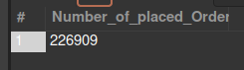

-- ------------------------------------------------------------------------------------
-- Q6. How many orders by state?

SELECT
state, COUNT(*) AS OrdersByState
FROM
orders
GROUP BY state;

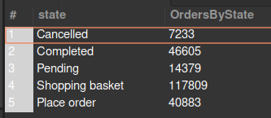

-- ------------------------------------------------------------------------------------
-- Q7. Select all the orders placed in January of 2017

SELECT
*
FROM
orders
WHERE
MONTH(created_date) = 1
AND YEAR(created_date) = 2017;

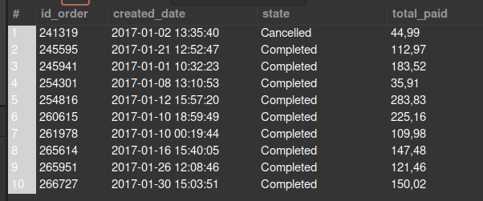

-- ------------------------------------------------------------------------------------
-- Q8. How many orders were placed in January of 2017?

SELECT
COUNT(*) AS '# Orders of Jan-2017'
FROM
orders
WHERE
MONTH(created_date) = 1
AND YEAR(created_date) = 2017;



-- ------------------------------------------------------------------------------------
-- Q9. How many orders were cancelled on January 4th 2017?

SELECT
COUNT(*) AS 'Cancelled Orders of Jan-4-2017'
FROM
orders
WHERE
DAY(created_date) = 4
AND MONTH(created_date) = 1
AND YEAR(created_date) = 2017
AND state LIKE '%ancel%'; -- includes Cancel, cancel, Cancelled, cancell, etc...



-- ------------------------------------------------------------------------------------
-- Q10. How many orders have been placed each month of the year?

SELECT
YEAR(created_date) AS 'Year',
MONTH(created_date) AS 'Month',
COUNT(MONTH(created_date)) AS '#Orders'
FROM
orders
GROUP BY YEAR(created_date) , MONTH(created_date)
ORDER BY YEAR(created_date) , MONTH(created_date);

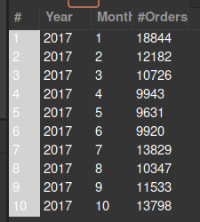

-- ------------------------------------------------------------------------------------
-- Q11. What is the total amount paid in all the orders?

SELECT
SUM(total_paid) AS 'Total Paid'
FROM
orders;

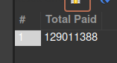

-- ------------------------------------------------------------------------------------
-- Q12. What is the average amount paid per order? Give a result to the previous question with only 2 decimals

SELECT
ROUND(AVG(total_paid), 2) AS 'Avg amount Paid'
FROM
orders;

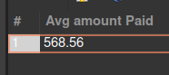

-- ------------------------------------------------------------------------------------
-- Q13 What is the date of the newest order? # Expected output: 2017-01-01 00:07:19

SELECT
created_date AS 'Newest Order'
FROM
orders
ORDER BY created_date ASC
LIMIT 1;



-- ------------------------------------------------------------------------------------
-- Q13.1 What about the oldest? # Expected output: 2018-03-14 13:58:36

SELECT
created_date AS 'Oldest Order'
FROM
orders
ORDER BY created_date DESC
LIMIT 1;

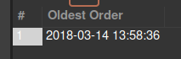

-- ------------------------------------------------------------------------------------
-- Q13.2 What is the day with the highest amount paid (and how much was paid that day)?
-- # Expected output: 2017-11-24; 3,103,713
-- it ask for the highest amount paid in a day

SELECT
CONCAT(YEAR(created_date), '-', MONTH(created_date), '-',DAY(created_date)) AS 'Date',
SUM(total_paid) AS total_paid
FROM
orders
GROUP BY Date
ORDER BY total_paid DESC
LIMIT 1;

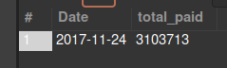

-- ------------------------------------------------------------------------------------
-- Q13.3 What is the day with the highest amount of completed orders (and how many completed orders were placed that day)? # Expected output: 2017-11-24; 1,569

SELECT
CONCAT(YEAR(created_date), '-', MONTH(created_date), '-',DAY(created_date)) AS 'Date',
state,
COUNT(state) AS 'amount_of_orders'
FROM
orders
WHERE
state = 'Completed'
GROUP BY Date, state
ORDER BY amount_of_orders DESC
LIMIT 1;

