PART 2 - Table Products

-- ------------------------------------------------------------------------------------
-- Q14 -- How many products are there?

SELECT
COUNT(*) AS 'Amount_of_products'
FROM
products;

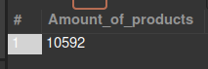

-- ------------------------------------------------------------------------------------
-- Q15 -- How many brands?

SELECT
COUNT(DISTINCT brand) as UniqueBrands
FROM
products;

-- ------------------------------------------------------------------------------------
-- Q16.1 -- How many products per brand ?

SELECT
brand, COUNT(brand) AS items
FROM
products
GROUP BY brand
ORDER BY items DESC;

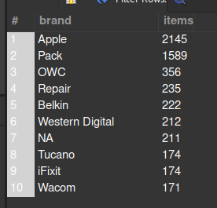

-- ------------------------------------------------------------------------------------
-- Q16.2 -- How many products per category?

SELECT
manual_categories AS 'Categories',
COUNT(manual_categories) AS ProductsPerCategory
FROM
products
GROUP BY manual_categories
ORDER BY ProductsPerCategory DESC;

-- ------------------------------------------------------------------------------------
-- Q17.1 -- What is the average price per brand?

SELECT
brand, ROUND((SUM(price) / COUNT(price)), 2) AS AvgPrice
FROM
products
GROUP BY brand
ORDER BY AvgPrice DESC;

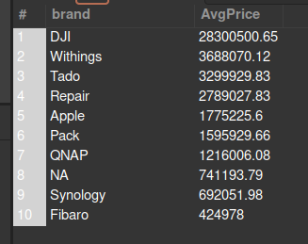

-- ------------------------------------------------------------------------------------
-- Q17.2 -- What is the average price per category?

SELECT
manual_categories,
ROUND((SUM(price) / COUNT(price)), 2) AS AvgPrice
FROM
products
GROUP BY manual_categories
ORDER BY AvgPrice DESC;

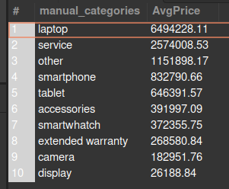

-- ------------------------------------------------------------------------------------
-- Q18.1 -- What is the name and description of the most expensive product per brand ?

SELECT
inn.name_en, inn.short_desc_en
FROM
(SELECT
p.name_en, p.short_desc_en, p.brand, MAX(CAST(p.price as FLOAT)) as MxP
FROM
products p
GROUP BY p.name_en, p.short_desc_en, p.brand
ORDER BY MxP DESC
) AS inn;

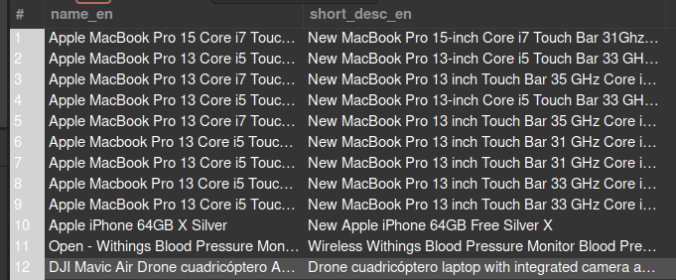
/* This version shows the brand and price
SELECT
name_en, short_desc_en, brand, MAX(CAST(price as FLOAT)) as price
FROM
products
GROUP BY brand, name_en, short_desc_en
ORDER BY price DESC;
*/

-- ------------------------------------------------------------------------------------
-- Q18.2 -- What is the name and description of the most expensive product per category?

SELECT
inn.name_en, inn.short_desc_en
FROM
(SELECT
p.name_en, p.short_desc_en, p.manual_categories, MAX(CAST(p.price as FLOAT)) as MxP
FROM
products p
GROUP BY p.name_en, p.short_desc_en, p.manual_categories
ORDER BY MxP DESC
) AS inn;

