PART 1 – TABLE ITEMS

Q1. Select the entire line_item table.

SELECT
*
FROM
line_item;

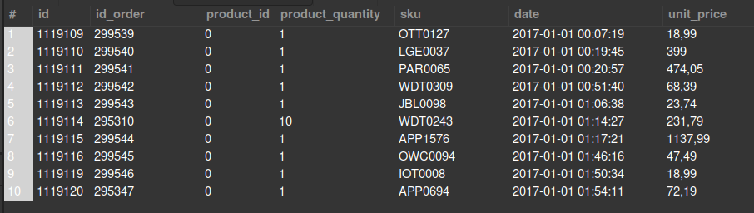

Q1.1 Select only the first 10 rows from the line_item table

SELECT
*
FROM
line_item
LIMIT 10;

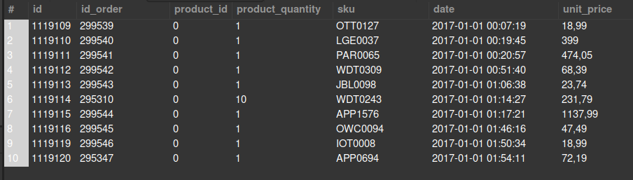

Q2. Count the total number of rows of the line_item table # Expected output: 293983

SELECT
COUNT(*) AS "Total number of Rows"
FROM
line_item;



Q2.1. Count the total number of unique "sku" from the line_item table. #Expected output: 7951

SELECT
COUNT(DISTINCT sku) AS "Total number of Unique SKU"
FROM
line_item;



Q3. Generate a table with the average price of each sku.

SELECT
sku, ROUND(AVG(unit_price),2) AS avg_price
FROM
line_item
GROUP BY sku;

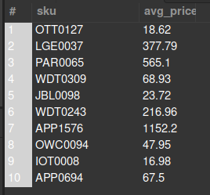
Q3.1. Now name the column of the previous query with the average price "avg_price" through and alias, and sort the list by that column (bigger to smaller price)

SELECT
line_item.sku, ROUND(AVG(unit_price),2) AS avg_price
FROM
line_item
GROUP BY sku
ORDER BY avg_price DESC;

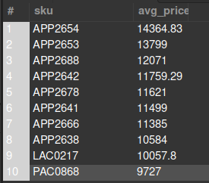

Q4. Which products were bought in the largest quantities? Select the “stock keeping unit” (sku) and product_quantity of the 100 products with the biggest "product quantity"

SELECT
sku, product_quantity
FROM
line_item
ORDER BY product_quantity DESC
LIMIT 100;

