SQL CRASH COURSE PART 2
Query the database joining tables

-- ----------------------------------------------------
-- Query 1 ​ Our first query should return the "sku", "product_quantity", "date" and "unit_price" from the line_item table together with the "name" and the "price" of each product from the "products" table. We want only products present in both tables.

SELECT
itm.sku,
itm.product_quantity,
itm.date,
itm.unit_price AS IPrice,
prd.name_en,
prd.price AS PPrice
FROM
line_item itm
INNER JOIN
products prd ON itm.sku = prd.sku;

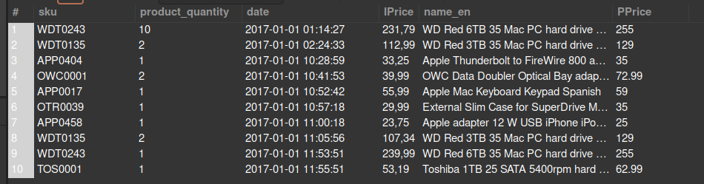

-- ----------------------------------------------------
-- Query 2 You might notice that the ​ unit_price ​ from the ​ line_item ​ table and the price from the ​ product ​ table is not the same. Let's investigate that! Extend your previous query by adding a column with the difference in price. Name that column ​ price_difference ​ .

SELECT
itm.sku,
itm.product_quantity,
itm.date,
itm.unit_price AS IPrice,
prd.name_en,
prd.price AS PPrice,
ROUND(prd.price - itm.unit_price, 1) AS price_diff
FROM
line_item itm
INNER JOIN
products prd ON itm.sku = prd.sku;

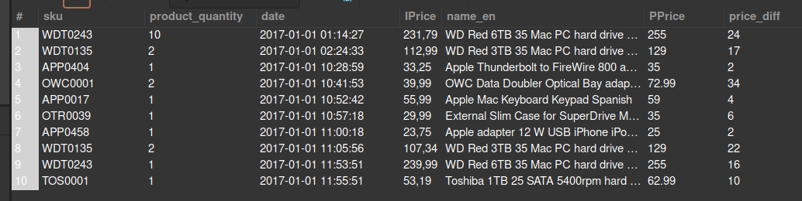

-- ----------------------------------------------------
-- Query 3 Build a query that outputs the price difference that you just calculated, grouping products by category. Round the result.

SELECT
inn.manual_categories,
ROUND(AVG(inn.price_dif),2) as AVG_Price_diff
FROM
(SELECT
line_item.sku,
line_item.product_quantity,
line_item.date,
line_item.unit_price,
products.name_en,
products.price,
ROUND(ABS(line_item.unit_price - products.price), 1) AS price_dif,
products.manual_categories
FROM line_item
INNER JOIN products
ON line_item.sku = products.sku) as inn
GROUP BY inn.manual_categories;

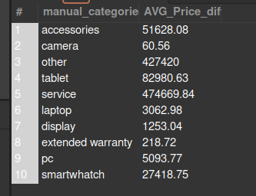

-- ----------------------------------------------------
-- Query 4. ​ Create the same query as before (calculating the price difference between the ​line_item and the ​products tables, but now grouping by brands instead of categories.

SELECT
inn.brand,
ROUND(AVG(inn.price_dif),1) as AVG_price_dif
FROM
(SELECT
itm.sku,
itm.product_quantity,
itm.date,
prd.name_en,
itm.unit_price AS IPrice,
prd.brand,
prd.price AS PPrice,
ROUND(prd.price - itm.unit_price, 1) AS price_dif
FROM
line_item itm
INNER JOIN
products prd ON itm.sku = prd.sku ) AS inn
GROUP BY inn.brand
ORDER BY AVG_price_dif DESC;

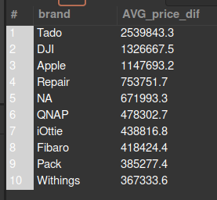

-- ----------------------------------------------------
-- Query 5. ​ Let's focus on the brands with a big price difference: run the same query as before, but now limiting the results to only brands with an avg_price_dif of more than 50000. Order the results by ​ avg_price_dif ​ (bigger to smaller).

SELECT
inn.brand,
ROUND(AVG(inn.price_dif),1) as AVG_price_dif
FROM
(SELECT
itm.sku,
itm.product_quantity,
itm.date,
prd.name_en,
itm.unit_price AS IPrice,
prd.brand,
prd.price AS PPrice,
ROUND(prd.price - itm.unit_price, 1) AS price_dif
FROM
line_item itm
INNER JOIN
products prd ON itm.sku = prd.sku ) AS inn
WHERE
inn.price_dif > 50000
GROUP BY inn.brand
ORDER BY AVG_price_dif DESC;

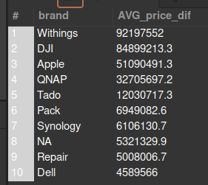

-- ----------------------------------------------------
-- Query 6. ​ Query 6. We want to know the sku, product_quantity and date of all the orders, ordered by SKU. If it takes too long and/or the connection gets lost try first selecting only the first 50 results and then ordering by sku.

SELECT
ord.created_date,
ord.state,
itm.sku,
itm.product_quantity
FROM line_item AS itm
INNER JOIN orders AS ord ON itm.id_order = ord.id_order
ORDER BY itm.sku;

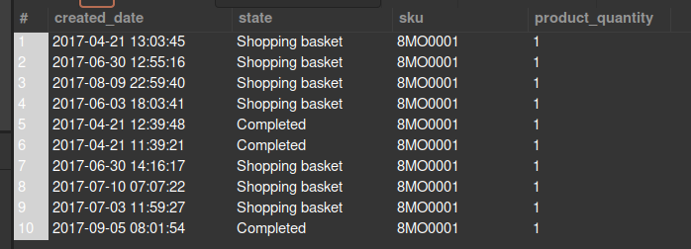

-- ----------------------------------------------------
-- Query 7. ​ Add to the previous information about "​brand" ​and "​manual_categories" fields from the products table.

SELECT
ord.created_date, ord.state,
itm.sku, itm.product_quantity,
prd.brand, prd.manual_categories
FROM
line_item AS itm
INNER JOIN
orders AS ord ON itm.id_order = ord.id_order
INNER JOIN
products AS prd ON itm.sku = prd.sku;

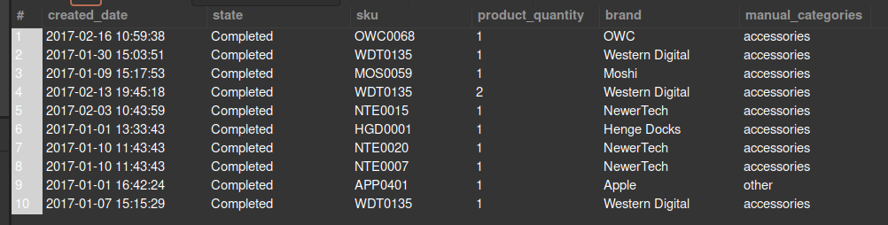

-- -----------------------------------------------------------------------------
-- Query 8.​ We want to know which brand and which categories are most frequent in Cancelled orders.
-- Let's keep working on the same query: now we want to keep only Cancelled orders. Modify this query to group the results from the previous query, first by category and then by brand, adding in both cases a count and ordering by descending count. If it takes too long and/or the connection gets lost try putting a LIMIT command.

SELECT
inn.brand, COUNT(*) AS 'Cancelled Orders by Brand'
FROM (
SELECT
-- ord.created_date,
ord.state,
-- itm.sku,
-- itm.product_quantity,
prd.brand -- , prd.manual_categories
FROM
line_item AS itm
INNER JOIN
orders AS ord ON itm.id_order = ord.id_order
INNER JOIN
products AS prd ON itm.sku = prd.sku
LIMIT 1000
) as inn
WHERE inn.state = 'Cancelled'
GROUP BY inn.brand ;
