SQL CRASH COURSE Part 3

-- ----------------------------------------------------------------------
-- Q1. What is the employee id of the highest paid employee?

SELECT
emp_id, MAX(salary) AS Higest_Payed
FROM
salaries
GROUP BY emp_id
ORDER BY Higest_Payed DESC;

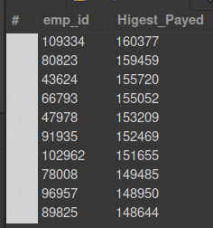

-- ----------------------------------------------------------------------
-- Q2. What is the name of the youngest employee ?

SELECT
concat(first_name, ' ', last_name) as full_name, hire_date AS Oldest_Employee
FROM
employees
Order by Oldest_Employee DESC;
-- there are a lot of employees hired in the same day.

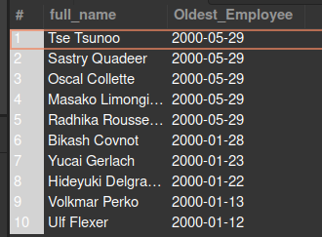

-- ----------------------------------------------------------------------
-- Q3. What is the name of the first hired employee ?

SELECT
concat(first_name, ' ', last_name) as full_name, hire_date AS Oldest_Employee
FROM
employees
Order by Oldest_Employee ASC;
-- there are a lot of employees hired in the same day.

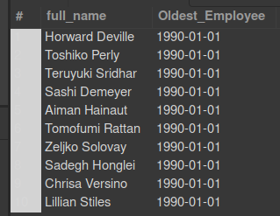

-- ----------------------------------------------------------------------
-- Q4. What percentage of employees are Female?

-- version with this facny tool over()
select gender, count(*) * 100.0 / sum(count(*)) over() as 'Gender_in_%'
from employees
group by gender;

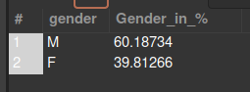

-- version calculed 'by hand'
SELECT
(ROUND(((SELECT COUNT(gender) FROM employees WHERE gender = 'F') * 100) / COUNT(gender),0)) as "%_Female",
(ROUND(((SELECT COUNT(gender) FROM employees WHERE gender = 'M') * 100) / COUNT(gender),0)) as "%_Male"
FROM employees;

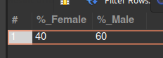

-- ----------------------------------------------------------------------
-- Q5 Show the employee count by department name wise, sorted alphabetically on department name.

-- number employees listed on 'dept_emp' by dept
SELECT
inn.dept_name AS "Dept_Name" , COUNT(inn.dept_name) as "Number of employees by dept"
FROM
(SELECT
dts.dept_no, dts.dept_name,
dem.emp_id
FROM
departments AS dts
INNER JOIN dept_emp AS dem
ON dts.dept_no = dem.dept_no
) AS inn
GROUP BY inn.dept_name
ORDER BY inn.dept_name;

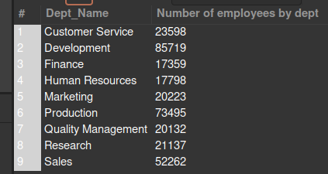

-- ----------------------------------------------------------------------
-- Q6. Count the number of new employees by each calendar year (take the value of year from from_date)

SELECT
YEAR(from_date) AS 'YEAR', COUNT(*) AS "number of new employees by year"
FROM
dept_emp
GROUP BY YEAR(from_date)
ORDER BY YEAR(from_date);

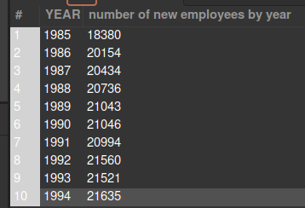

-- ---------------------------------------------------------------------
-- Q7. Count the number of employees by each calendar year (take the value of year from from_date)

/*
didn't know how to solve this...
*/

-- ---------------------------------------------------------------------
-- Q8. What is the number of managers hired each calendar year.

SELECT YEAR(from_date) AS 'YEAR', COUNT(*) AS "number of new Managers by year"
FROM dept_manager
GROUP BY YEAR(from_date)
ORDER BY YEAR(from_date);

-- ---------------------------------------------------------------------
-- Q9 # What will be the department wise break up of managers ?

SELECT
inn.dept_name AS "Dept_Name" , COUNT(inn.dept_name) as "Managers by dept"
FROM
(SELECT
dts.dept_no, dts.dept_name,
dma.emp_id
FROM
departments AS dts
INNER JOIN dept_manager AS dma
ON dts.dept_no = dma.dept_no
) AS inn
GROUP BY inn.dept_name
ORDER BY inn.dept_name;

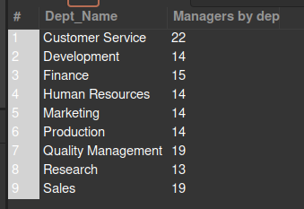

-- ---------------------------------------------------------------------
-- Q10. What is the number of male and female managers hired each calendar year from 1990 onward?

SELECT
COUNT(inn.gender) as "Female Managers from 1990 onwards"
FROM(
SELECT
emp.gender, dma.from_date,
dma.emp_id
FROM
employees AS emp
INNER JOIN dept_manager AS dma
ON emp.emp_id = dma.emp_id
) AS inn
WHERE inn.gender = 'F' AND YEAR(inn.from_date) > 1990;


SELECT
COUNT(inn.gender) as "Male Managers from 1990 onwards"
FROM(
SELECT
emp.gender, dma.from_date,
dma.emp_id
FROM
employees AS emp
INNER JOIN dept_manager AS dma
ON emp.emp_id = dma.emp_id
) AS inn
WHERE inn.gender = 'M' AND YEAR(inn.from_date) > 1990;



/* Tried this, but didn't work. The idea was to get both numbers in the same table, as in the Q4.
The problem is in the "FROM inn" from the subquery. says that the table "inn" doesn't exist.
Didn't know how to solve this.

SELECT
(SELECT COUNT(inn.gender) FROM inn WHERE (gender = 'F' AND YEAR(inn.from_date) >= 1990)) as "Female Managers",
(SELECT COUNT(inn.gender) FROM inn WHERE (gender = 'F' AND YEAR(inn.from_date) >= 1990)) as "Female Managers"
FROM(
SELECT
emp.gender, dma.from_date,
dma.emp_id
FROM
employees AS emp
INNER JOIN dept_manager AS dma
ON emp.emp_id = dma.emp_id
) inn;
*/

