Job Interview Task – Map Application (Client/Server)

Objectives
Develop a Client–Server application for managing geographic objects (Polygons and Objects) on an interactive map.
- Client: React (with a map library such as Leaflet/MapLibre)
- Server: ASP.NET Core (REST API)
- Database: MongoDB

UI Layout
The application will be divided into four panels:
1. Map – A large central panel on the left showing the interactive map.
2. Polygon – A panel on the top right for polygon management.
3. Objects – A panel below Polygon for object (Marker) management.
4. Map Data – A panel below Objects with a table containing: Object / Lat / Lon.

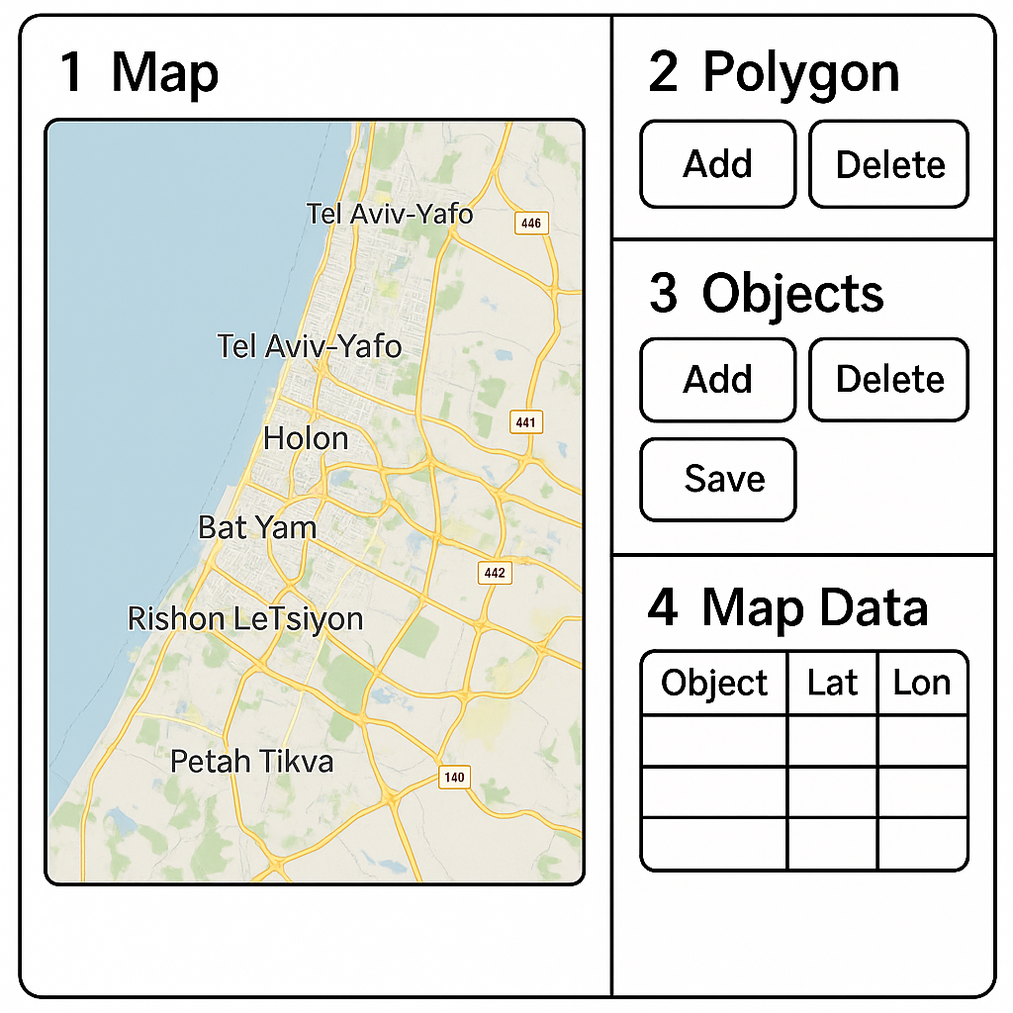 Actions

Polygon
- Add – Switches the map to drawing mode. The user clicks on the map to create vertices. Clicking the starting point again closes the polygon.
- Save – Sends polygon data to the server using a RESTful API (POST). Data is stored in MongoDB and the Map Data table is updated.
- Delete – Deletes a selected polygon or all polygons from the map and database using a DELETE request.

Objects
- Add – Adds a new object on the map. The object can be a standard Marker or a custom Symbol (e.g., Jeep).
- Save – Sends the list of objects to the server (POST). Data is stored in MongoDB and the table is updated.
- Delete – Removes the selected object from the map and the database (DELETE).

Functional Requirements – Client
- Interactive map with polygon drawing.
- Ability to add Objects as Markers or custom Symbols (e.g., Jeep).
- Add / Save / Delete buttons function as expected.
- Map Data table updates after each Save action.

Functional Requirements – Server
- Implement REST API for Polygons and Objects (Create, Read, Delete).
- Store data in MongoDB using GeoJSON structure.
- Return updated data to the client after Save operations.

Acceptance Criteria
1. Map is displayed and polygons can be drawn.
2. Polygon management (Add / Save / Delete) works as expected.
3. Objects can be added as standard Markers or custom Symbols (such as Jeep).
4. Map Data table updates correctly with Object / Lat / Lon.
5. Data is stored and retrieved from MongoDB via RESTful API.
6. Code is clean, documented, and modular.

