This Assessment Cover Sheet is required to be attached to your   
assessment task prior to submission for marking

|  |  |  |  |  |
| --- | --- | --- | --- | --- |
| Student Details | | | | |
| Family Name: | Ferro | | | |
| Given Name: | Alessandro | | | |
| Subject Details | | | | |
| Qualification: | Diploma of Web Development | | | |
| Unit Code and Title: | ICTWEB516 – Research and apply emerging web technology trends | | | |
| Trainers’ Name: | Ida Ho | | | |
| Assignment Details | | | | |
| Due Date: | 14/02/2021 | Assessment No:  (If applicable) | |  |
| Date Submitted: | 14/02/2021 | | | |
| Checklist | | | | |
| * I have kept a copy of my assignment before submitting * I have completed and signed this page * I have answered all questions in the assignment * I have attached any relevant evidence/documentation, as required for the assessment | | | | |
| Declaration | | | | |
| I have been advised of the assessment requirements and have been made aware of my rights and responsibilities as an assessment candidate.  I declare that, to the best of my knowledge and belief, this assignment is my own work, all sources have been properly acknowledged, and the assignment contains no plagiarism. This assignment or any part thereof has not previously been submitted for assessment **at this or any other RTO**. | | | | |
| Student’s signature:  Alessandro Ferro | | | Date:  14/02/2021 | |

|  |  |  |  |  |
| --- | --- | --- | --- | --- |
|  | | | | |
| **Assessment Feedback** | | | | |
|  | | | | |
|  | | | | |
|  | | | | |
|  | | | | |
|  | | | | |
|  | | | | |
|  | | | | |
|  | | | | |
| **Result** | **Satisfactory** | **Not Satisfactory** | **RPL** | **RCC** |
| **NYC – New assessment date scheduled or FIR – Further information Required** | | | **Date:** | |
| Trainers/Assessors signature: | | | Date: | |
| **Student Comments** | | | | |
|  | | | | |
|  | | | | |
|  | | | | |
| * I have received my assessment result and am satisfied with the feedback given on this assessment | | | | |
| Student’s signature:  Alessandro Ferro | | | Date:  14/02/2021 | |

Questions:

1.1

Research about Emerging Web Technologies and trends.

**Answer**

1. Progressive Web Apps (PWA)

With web browsers available on pretty much any device nowadays, web technologies are the most immediate way to write an application and make it available everywhere. By using HTML, CSS and JavaScript (with or without any framework), a web developer can create web applications that, once opened in browser, behave and perform closely enough to native applications.

Thanks to modern browsers and technologies, which implement local web storage, it is also possible to cache the content to make the application available offline, although with the obvious limitations that come from not being connected to the internet.

1. AI and Machine Learning

Most of the more common customer service tasks do not require 24/7 human intervention anymore. With advancement in AI and machine learning, chatbots are now capable to solve many of the most common issues, while at the same time automatically collecting and processing consumer behaviour analytics.

1. Single Page Application (SPA)

A web application that, as the name suggests, load a single page and present it to the user. Most of the functionalities offered to the user are implemented through JavaScript and the only communication with the server, happens to retrieve the data needed.

SPAs are fast. The HTML, CSS and JavaScript needed to render the page are loaded the first time and not anymore. When the application communicate with the server, there is no need to request more HTML, JavaScript, or in rare cases CSS (most of the times, all the CSS needed is contained in a single file transmitted the first time anyway).

With most of the code needed to run a SPA already cached on the client side, the application can also work offline or with poor connectivity, and the only thing needed is to refresh the data from the backend when a connection is available.

All this considered, it is important to note that the workload put on the browser by SPAs is quite intensive, which can result inpoor performancec on low power devices.

SPAs also rely heavily on JavaScript and if the right precautions are not taken, the entire app wouldn’t work on devices that have it deactivated.

Security is another issue with SPAs. The entire application is loaded on the client the first time that is requested, making it vulnerable to XSS attacks. No new pages loaded means that a successful JavaScript injection on the client is all it takes. No new pages load also means that the initial load shouldn’t contain any sensitive information that shouldn’t be accessible by all users.

1. Voice commmands

Voice activation and recognition is becoming more and more used in modern devices, ranging from phones to IoT.

Not only it can improve user experience by cutting down typing time, but it can also provide useful information for what concerns behaviour analytics.

1. JavaScript

Javascript has been, is and is most likely going to be a big thing in the years to come. Existing frameworks keep evolving and new ones are created every year. Since the creation of the Node runtime environment, JavaScript is not restrained to the front end of development anymore and can be now used for the back end as well. Although its presence on the market is still limited, comparatively to other server side languages such as Java or C#, it is rapidly increasing.

The possibility to implement a full application from top to bottom, using a single do-it-all language* can be attractive for many developers and today JavaScript is the only language capable to do this.

*When talking about a “single language” it is meant as in “porgramming” or “scripting” languages. Other languages with different purpose such as HTML, CSS and SQL are probabily going to be still needed.

1. Severless architecture

By providing server functionalities as a service on the cloud, some companies (Amazon, Microsoft) are making it possible to build applications without needing any dedicated infrastructure.

Relying on a “pay by usage” model and conuming only the power that is effectively needed, this achitecture is proving to be cost efficient, scalable and sustainable for the internet environment.

1. Internet of Things (Iot)

For younger generations it seems natural how many of the things we interact with today are connected to the internet. Not so many years ago things were different and it wasn’t uncommon to hear people jokingly mocking the trend to attach an internet connected application to everything. “Even a plant pot” they may have said “seems to need an internet connection”.

Well, today that’s the case and although still not so widespread, at leat in the western world it’s becoming more and more normalized and the trend doesn’t seem destined to invert anytime soon, if at all.

1. Responsive, Mobile friendly and Mobile first development

Mobile became integral part of our everyday life. Even most of the cheapest devices available today have internet access and integrated applications that used to be run on.y on a computer (e.g. Google Maps).

In the first years of smart phones, the mobile application market boomed and it looked like that was the way of the future.

Reality proved different. A huge part of people time is still spent on mobile applications, but the market is shared by just a few of them, with the rest just reaching a niche of users and ususally just for a limited amount of time. Social networks, Google maps, Uber and a few others are the giants of the industry. On average, for their needs, people still rather browsing the internet for a solution than searching through any applications marketplace. As a result, websites needed to better adapt to the variable sizes of mobile screens.

Responsive development optimize the design of a website to make it accessible both on desktop and mobile devices. One of the most famous examples of how the problem has been tackled is represented by Bootstrap, a HTML, CSS and JavaScript library widely used even today in its fourth incarnation, that rearranged and transformed elements on screen according to the viewport size.

Mobile friendly development tries to simplify matters by focusing on the design of the website, so that the elements are arranged on the screen in such a way that, no matter the vewport size, can be easily rendered by the browser withouth any modification aside from their size.

Lastly the most recent approach: Mobile first development represents the opposite end compared to the first iteration of responsive design. Where in the beginning responsive design tried to make a website designed for desktop or laptop devices, accessible through mobile, with mobile first the opposite happens. An application is planned and designed with mobile screens and functionalities in mind and adapted to be used from desktop and laptop devices as well.

1. Cyber security

It goes withouth saying that the more we rely on interconnected devices, the more risks will appear. The perfect software doesn’t exist and there are always going to be bugs and vulnerabilities exploitable by cyber criminals.

Researchers, pentesters and other cyber security professionals are constantly looking for ways to counter act these threats and for any new technolgy or technology implementation that becomes available, a related advancement in the technology needed to attack it and to defend it follows.

1.2

Pick one Web Technology and explain why the most appropriate for the project.

**Answer**

In relation to the Bazaar Ceramics project, an ecommerce solution with a rather small catalogue and simple functionalities, the first thing that comes to mind is design.

In this age talking about design, for a web developer means considering screens sizes. Who is going to browse the website? And from where?

The latest trends indicate that a “mobile first” approach would be the way to go, but does that always hold true?

Mobile first puts great emphasis on simplicity, with fewer elements in immediate reach of a user’s thumb, to avoid screen pollution and keep things immediate to understand and easy to use on mobile devices smaller screens.

Analytics suggest that most online shopping transactions happen through a mobile device and for any ecommerce, offering a solid mobile browsing experience to their customers is crucial to success.

Moreover, google indexing would rank better a website with fast loading times and mobile first development, with its simplicity and if well implemented, can help to greatly improve loading speed, epecially when communication with the server is kept to a minimum.

On top of the considerations realtive to the technology itself, some parameters specific to Bazaar Ceramics play a role in deciding what’s best.

The company is growing, yet their revenue seems to lag behind. Reasons for this are the costs related to keep and maintain the infrastructure necessary for retail sales. The shop and gallery have been and still are the major source of profit, but local market only has so much to offer. The recent expansion on wider national and international market is giving positive results, to the point that a complete shift to online commerce seems not only viable, but also reccomendable. Lower infrastructure, administration and marketing costs, paired with efficient processes automation, are attractive, but a poor design choice could result in bad user experience and would risk to damage the company’s image and reputation.

The opportunity is there and take it or waste it is a matter of chaining the right choices, with that of design coming first.

Lastly, the requirements gathered so far do not highlight any layer of complexity that would prevent the implementation of a simple and clean UI that is at the core of the mobile first approach.

All of the above considered, it seems that Bazaar Ceramics would benefit from Mobile First design for the development of their website.

2.1

Build the page structure with divs(as detailed in exercise), define CSS rules, Adding SEO and externalizing the CSS rules. Incorporate appropriate metadata (keywords). Using the “Moving CSS Rules” option from the CSS panel, Create templates with editable regions.

**Answer**

Please refer to the attached folder “code”

2.2

Test the new site in several browsers, Mozilla Firefox, Internet Explorer, Safari, etc., Check links. Before we publish our site on the Internet, ensure all links are correctly coded and functioning properly using Dreamweaver's

**Answer**

Cross browser compatibility tested on three different browsers

Edge

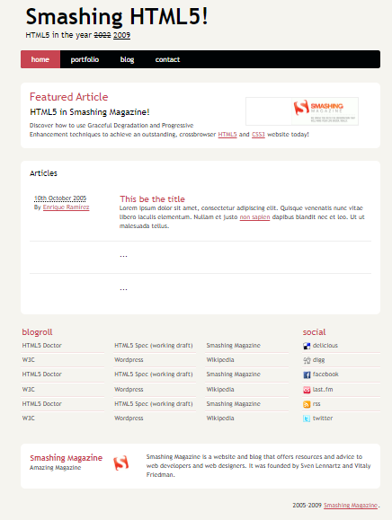

Chrome

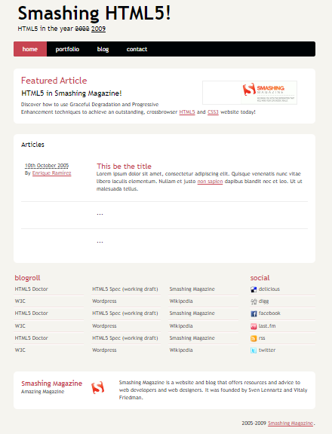

Firefox

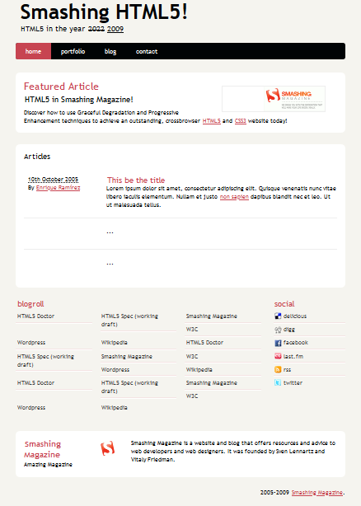

HTML validation service provided by W3C

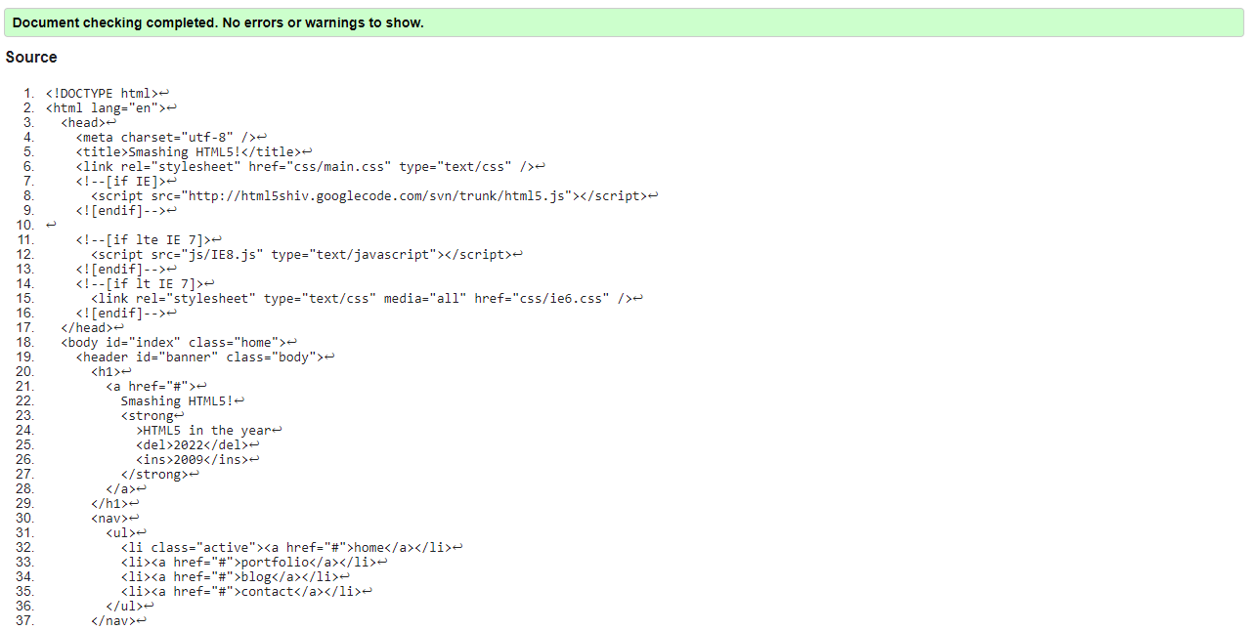

Link check done using npm link checker

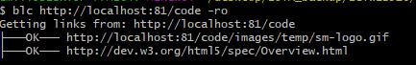

Please note that in the project all the anchors for links have no target, either internal nor external.