SMART UNIVERSITY AUTOMATION SYSTEM
RPA Project Implementation & Technical Architecture Documentation
━━━━━━━━━━━━━━━━━━━━━━━━━━━━━━━━━━━━━━━━━━━━━━━━━━
Project Title: | Smart University Automation System (RPA)
Course / Degree: | Integrated MCA (Semester IX) — Robotic Process Automation
RPA Platform: | Robot Framework 7.0.1 (Python 3.9 Engine)
Supporting Stack: | FastAPI, SQLAlchemy 2.0, ReportLab, React 18, Vite
Audit & Implementation Date: | Academic Year 2026
Document Status: | Production Launch Ready Refinement (Verified)

Table of Contents
Part A: RPA Project Implementation .......................... Page 3
• Working RPA Project & Automation Architecture ........... Page 3
• Complete Workflow & Execution Pipelines ................. Page 4
• Input Data Files & Schemas .............................. Page 5
• Output Deliverables & Artifacts ......................... Page 6
• Sample Input & Output Tables ............................ Page 7
Part B: RPA Tool Specification .............................. Page 8
• 5.1 Name of RPA Tool: Robot Framework ................... Page 8
• 5.2 Tool Version & Python Runtime Engine ................ Page 8
• 5.3 Reason for Selecting Robot Framework ................ Page 8
• 5.4 Key Architectural Features Implemented .............. Page 9
• Platform & Execution Environment ........................ Page 10
Part C: Comprehensive Project Documentation ................. Page 11
• 1. Introduction ......................................... Page 11
• 2. Background of the Process / Organization ............. Page 12
• 3. Existing Manual Process (As-Is Process) .............. Page 13
• 4. Proposed RPA Solution (To-Be Automated Process) ...... Page 15
• 5. RPA Tool Used (Mandatory Breakdown) .................. Page 16
• 6. Direct RPA Features Implemented (Excel, Web, Subprocess, API) Page 17
• 7. Indirect RPA Features / Supporting Capabilities ...... Page 19
• 8. RPA Workflow / Architecture Diagram .................. Page 21
• 9. Implementation Details & Technical Development ....... Page 23
• 10. Testing, Verification, and Screenshot Results ....... Page 26

Part A: RPA Project Implementation

A.1 Working RPA Project / Automation Overview
The Smart University Automation System is a production-grade, enterprise-ready Robotic Process Automation (RPA) platform engineered to eliminate labor-intensive, error-prone administrative tasks across tertiary educational institutions. The system deploys three purpose-built RPA bots developed using Robot Framework 7.0.1 and Python keyword libraries, orchestrated through an administrative RPA Control Center, and backed by a modern REST API and reactive single-page interface.
Core Automation Suites: The three mission-critical automated workflows implemented include:
1. Admission & Reservation Quota Allocation Bot: Processes staged candidate spreadsheets, applies statutory quota seat distribution (GEN, OBC, SC, ST, EWS), generates unique sequential enrollment numbers (SU2026-XXXX), securely creates portal credentials with bcrypt hashing, builds official PDF admission letters via ReportLab, and dispatches welcome notifications.
2. Subject-Wise Lecture Attendance Matrix Bot: Ingests daily attendance spreadsheets, parses multi-subject lecture attendance matrices, upserts per-student per-subject lecture logs, recomputes rolling cumulative compliance percentages, and issues instant automated advisory warnings for attendance dropping below 75% or 60%.
3. Examination Results & Dual-Threshold Evaluation Bot: Ingests examination marks, enforces Dual-Threshold passing metrics (Internal score >= 12/30, External score >= 28/70), computes letter grades (O, A+, A, B+, B, F) and grade points, calculates SGPA and CGPA, quarantines failing students for administrative review, and publishes approved marksheets as downloadable PDFs.

A.2 Complete Workflow / Process Created Using Robot Framework
Each bot is orchestrated using modular, keyword-driven Robot Framework test suites located in the rpa/ directory:
• rpa/admission/admission_bot.robot: Governed by AdmissionKeywords.py, reading sample_data/Sample_Admission.xlsx, iterating across candidate records, validating eligibility relaxation, provisioning student database entities, and generating admission letters.
• rpa/attendance/attendance_bot.robot: Governed by AttendanceKeywords.py, reading sample_data/Sample_Attendance.xlsx, recording subject lectures, calculating distinct dates conducted, calculating cumulative percentage, and triggering in-app and email alerts.
• rpa/results/results_bot.robot: Governed by ResultKeywords.py, reading sample_data/Sample_Results.xlsx, calculating scores, applying dual-threshold evaluation, generating marksheet PDF artifacts, and recording audit run metrics.

A.3 Input Files & Required Data Schemas
The automation workflows consume standardized Excel workbooks (.xlsx). The table below outlines the exact input schemas:
Workflow / Bot | Source Excel File | Required Column Headers | Data Types & Constraints
Admission Bot | Sample_Admission.xlsx | Student_ID, Student_Name, Applied_Course, Candidate_Category, Class_12_Pct, Entrance_Exam_Score, Core_Subject_Score, Date_Of_Birth | Student_ID: String  Category: GEN/OBC/SC/ST/EWS  Scores: Float (0-100)  DOB: YYYY-MM-DD
Attendance Bot | Sample_Attendance.xlsx | student_id, date, Physics, Mathematics, Geography | student_id: String (SU2026-XXXX)  date: YYYY-MM-DD  Subjects: Integer (1=Present, 0=Absent)
Results Bot | Sample_Results.xlsx | student_id, subject_name, internal_score, external_score | student_id: String (SU2026-XXXX)  subject_name: String  internal_score: Float (0-30)  external_score: Float (0-70)

A.4 Outputs Generated by the Automation
The RPA automation produces several distinct digital outputs across multiple channels:
1. Vector PDF Documents: Stored in reports/pdfs/ and accessible via portal downloads:
- Admission Letters: Formatted university letters bearing official seal, student details, course allocation, and matriculation guidelines.
- Examination Marksheets: Tabular semester grade cards detailing subject credits, internal scores, external scores, total marks, grade letters, SGPA, and CGPA.
2. Database Records & Audit Logs: Staged, updated, and persisted in backend/smartuniversity.db within normalized SQLAlchemy tables (users, students, daily_attendance_logs, student_subject_summaries, student_marks_records, bot_run_logs, notifications).
3. Robot Framework HTML Reports: Automatically output to reports/report.html, reports/log.html, and reports/output.xml with test case execution timings, keyword execution traces, and pass/fail statuses.
4. In-App Notifications & Alerts: Created in the notifications table for instant student view upon portal login.

A.5 Sample Input and Output Artifacts
Below are actual data extracts demonstrating the input ingested versus the output generated by the automation:

Sample Admission Ingestion vs. Output Account:
Input Record: APP-1001 | Student 1 | MCA | GEN | Class 12: 86% | Entrance Score: 90 | Core Score: 95 | DOB: 2000-05-15
Generated Output: Enrollment No: SU2026-0001 | User: student1@student.smartuniversity.edu | Role: student | Status: Confirmed | PDF: admission_SU2026-0001_*.pdf

Sample Attendance Matrix Ingestion vs. Output Metrics:
Input Record: SU2026-0005 | Date: 2026-09-01 to 2026-09-03 | Physics: [1, 1, 1] | Mathematics: [1, 0, 1] | Geography: [1, 0, 1]
Generated Output: Physics: 3/3 (100.0% - Compliant) | Mathematics: 2/3 (66.7% - Low Attendance Warning) | Geography: 2/3 (66.7% - Low Attendance Warning) | Cumulative Attendance: 77.8% (Eligible)

Sample Results Marks Ingestion vs. Output Evaluation:
Input Record: SU2026-0005 | Physics: Internal 28/30, External 58/70 | Mathematics: Internal 14/30, External 32/70 | Geography: Internal 15/30, External 35/70
Generated Output: Physics: Total 86 (Grade O, Pass) | Mathematics: Total 46 (Grade B, Pass) | Geography: Total 50 (Grade B+, Pass) | SGPA: 7.67 | CGPA: 7.67 | Status: All Cleared | Marksheet: marksheet_SU2026-0005_sem1_*.pdf

Part B: RPA Tool Specification

B.1 Name and Version of the RPA Tool
Selected RPA Engine: • RPA Tool Name: Robot Framework
Engine Release: • Tool Version: Robot Framework 7.0.1
Underlying Runtime: • Python Interpreter: Python 3.9.6 (Darwin x86_64 / arm64 macOS runtime)
Standard Libraries: • Robot Standard Libraries Used: OperatingSystem, Collections, BuiltIn, Process, String
Domain Keyword Extensions: • Custom Python Keyword Libraries: AdmissionKeywords.py, AttendanceKeywords.py, ResultKeywords.py, DatabaseKeywords.py

B.2 Why Robot Framework Was Selected
Robot Framework was selected as the core RPA automation engine based on clear technical, architectural, and educational criteria:
1. Open-Source Freedom & Zero Licensing Costs: Unlike proprietary enterprise RPA tools (UiPath, Automation Anywhere, Blue Prism) that impose heavy licensing fees, closed vendor lock-in, and restrictive cloud orchestrator dependencies, Robot Framework is open-source (Apache 2.0 license), enabling 100% locally hosted, secure, and inspectable execution.
2. Keyword-Driven Domain-Specific Language (DSL): Robot Framework provides a human-readable, tabular keyword format (*.robot) that bridges the communication gap between business analysts/academic administrators and software engineers. Workflows read naturally as business steps (e.g., 'Load Admission Excel', 'Process Single Admission', 'Check And Send Low Attendance Warnings').
3. Seamless Python Extensibility: The engine executes natively on Python, allowing seamless integration with scientific and enterprise Python packages, including openpyxl for Excel workbook manipulation, SQLAlchemy for direct ORM persistence, ReportLab for PDF rendering, and bcrypt for cryptographic security.
4. Built-in Comprehensive Reporting: Every robot execution automatically compiles interactive, self-contained HTML reports (report.html and log.html) featuring test suite status, duration, keyword step trees, variable values, and failure stack traces.
5. REST API & Subprocess Orchestration Compatibility: Robot Framework test suites can be executed headless via CLI or dynamically triggered from a web backend via Python's subprocess library, enabling the construction of an interactive browser-based RPA Control Center.

B.3 Main Features of the Tool Used in the Project
• Modular Keyword Architecture: Separating high-level process logic (*.robot) from low-level implementation logic (Python keyword classes) ensuring maintainability and separation of concerns.
• Suite Setup & Suite Teardown Hooks: Used to validate preconditions (e.g., verifying that input spreadsheets exist before starting) and post-conditions (e.g., aggregating execution totals, committing transactions, and writing run logs).
• Flow Control & FOR Loops: Utilizing modern Robot Framework 7 syntax (FOR ${record} IN @{records} ... END) for robust iteration over tabular data rows.
• Variable Scoping: Utilizing Suite, Test, and Local variable scoping to pass configuration parameters (e.g., ${EXCEL_PATH}) across keyword execution boundaries.
• Automated Logging & XML Output: Outputting structured XML logs used by backend endpoints to parse execution metrics and render real-time audit tables.

B.4 Environment and Platform Used
The complete platform environment is summarized below:
Layer / Subsystem | Technology / Framework | Version / Platform | Role in System
Operating System | macOS Sonoma / Darwin | Version 14.x (Unix) | Host execution platform
RPA Engine | Robot Framework | 7.0.1 (Python 3.9.6) | Core automation execution
Backend Web API | FastAPI + Uvicorn | 0.110.0 + 0.28.0 | REST endpoints & bot runner
Database ORM | SQLAlchemy + SQLite | 2.0.28 + SQLite 3.x | Authoritative persistence layer
Spreadsheet Engine | openpyxl | 3.1.2 | Excel reading and extraction
PDF Engine | ReportLab | 4.1.0 | Automated vector PDF document generation
Frontend UI | React + Vite | React 18.2 + Vite 5.1 | Web portal & RPA Control Center
Testing / Headless | Puppeteer | 22.x (Node.js 20+) | End-to-End browser task verification

Part C: Comprehensive Project Documentation

1. Introduction
Modern university administration involves managing voluminous, time-critical operational workflows spanning student admissions, curriculum seat allocation, daily attendance tracking, academic evaluation, fee processing, and official correspondence. Traditionally, academic institutions rely on fragmented legacy software, manual spreadsheet tracking, and disjointed email threads. These manual methods lead to high operational friction, data entry mistakes, compliance failures, delayed grade publications, and substantial administrative overhead.
The Smart University Automation System was conceived and built as an enterprise-grade solution that integrates Robotic Process Automation (RPA) directly into university operations. By leveraging Robot Framework as an intelligent automation engine coupled with a FastAPI backend and a React web interface, the system automates end-to-end administrative pipelines with zero human error, deterministic quota allocation, dual-threshold grade evaluation, rolling attendance monitoring, and instant vector PDF credential generation.

2. Background of the Process / Organization
Institutional Context: • Hypothetical Business Scenario: 'Smart University' is a premier higher-education institution offering professional degree programs (e.g., Master of Computer Applications - MCA) across multiple specialized departments. The university manages thousands of candidate applications each semester, coordinates daily lectures across diverse courses, and processes semester examinations for hundreds of enrolled scholars.
Problem Background: • Nature of Administrative Overhead: In peak operational cycles (admissions seasons and end-semester grading), administrative staff must process hundreds of Excel workbooks received from departmental committees, entrance exam boards, and faculty course coordinators. The manual transfer of information between disparate spreadsheets, database tables, and email clients creates significant delays and risks data corruption.

3. Existing Manual Process (As-Is Process)
Prior to the implementation of the RPA solution, the university operated via the following As-Is manual procedures:

Step-by-Step As-Is Admission & Enrollment Process:
1. Department receives entrance exam and application score sheets as email attachments (.xlsx / .csv).
2. Admission officers manually open each spreadsheet in Microsoft Excel and verify minimum eligibility criteria (Class 12 % >= 50%, Entrance Exam score >= 40%).
3. Staff manually classify applicants into reservation categories (GEN, OBC, SC, ST, EWS) and sort by entrance scores to fill sanctioned seats.
4. Officers manually assign enrollment numbers by referencing physical ledger books to check the last issued sequential ID.
5. IT personnel manually log into the server database and type INSERT queries or populate web forms to create user accounts.
6. Clerical staff manually open a Microsoft Word letter template, copy-paste candidate names, course titles, and dates, click 'Export to PDF', and email the PDF individually to each candidate.

Step-by-Step As-Is Attendance Tracking Process:
1. Faculty members maintain paper sign-in sheets or individual classroom spreadsheets.
2. At the end of each week or month, faculty email their attendance spreadsheets to the administrative clerk.
3. The clerk manually aggregates lectures attended versus conducted across different files.
4. Calculations for 75% examination compliance are performed using manual Excel formulas.
5. Warning notices are manually drafted and sent weeks after the student has already dropped below threshold.

Step-by-Step As-Is Examination Results & Grading Process:
1. Examiners email marks sheets containing raw internal and external assessment scores.
2. Clerks manually enter marks into a master tabulation register.
3. Staff compute total marks, apply manual lookup tables for letter grades, and calculate SGPA/CGPA manually on desktop calculators.
4. Failing students (F-grades) are often accidentally published without administrative review, leading to student grievances.
5. Marksheets are printed physically or manually converted to PDFs one by one.

Summary of Software / Applications Used in Manual Process:
• Microsoft Excel / Google Sheets (Data entry, isolated calculation)
• Microsoft Word (Manual mail merge and letter formatting)
• Desktop Email Clients (Manual attachment dispatch)
• Generic Database Admin Tools (Direct manual SQL row insertion)

4. Proposed RPA Solution (To-Be Automated Process)
To-Be Solution: The proposed RPA solution replaces manual touchpoints with automated, deterministic Robot Framework bots integrated with an interactive web-based Control Center and self-service student/faculty portals.
• Core Automation Objectives:
1. 100% Elimination of Manual Data Entry: Programmatic ingestion and validation of admission, attendance, and examination spreadsheets.
2. Deterministic Quota & Seat Allocation: Automated multi-category allocation engine enforcing statutory quotas (OBC 27%, SC 15%, ST 7.5%, EWS 10%) with cutoff scores.
3. Real-Time Rolling Attendance Compliance: Automated detection of students falling below 75% with automated in-app and email warning dispatch.
4. Dual-Threshold Academic Evaluation: Independent validation of internal (>= 12/30) and external (>= 28/70) marks with automated quarantine of F-grades for review.
5. On-Demand Vector Credential Generation: Automated generation of high-resolution PDF admission letters and semester marksheets via ReportLab.
6. Comprehensive Auditability: Centralized BotRunLog records tracking records processed, execution duration, and Robot Framework HTML reports.

5. RPA Tool Used (Mandatory Technical Section)
Tool Identity: 5.1 Name of RPA Tool: Robot Framework (Open-Source Generic Automation Framework)
Version Specification: 5.2 Tool Version: Version 7.0.1 (Running on Python 3.9.6)
Selection Justification: 5.3 Reason for Selecting the Tool:
• Zero cost, open-source model eliminates per-bot and per-user enterprise licensing fees.
• Native Python integration allows direct invocation of openpyxl, SQLAlchemy, and ReportLab.
• Readable keyword abstraction allows non-programmers to understand automation sequences.
• Standardized execution logging generates detailed, inspectable HTML and XML test reports.
Technical Capabilities Utilized: 5.4 Features of the RPA Tool Used in the Project:
• Custom Keyword Extension: Writing Python classes with decorated methods that become native Robot keywords.
• Data-Driven Loops: Iterating through dynamic lists of dictionaries parsed from Excel sheets.
• Teardown Aggregation: Running suite teardown keywords to summarize execution status and write to the database.
• Idempotency & Error Trapping: Catching database exceptions and rolling back atomic transactions on failure.

6. Direct RPA Features Implemented
Direct RPA features refer to capabilities that directly execute, manipulate, or automate the business workflow data:
1. Excel Data Automation: Reading, validating, and extracting complex tabular data from multiple Excel workbooks (.xlsx) using openpyxl. Includes handling missing values, header normalization, data type conversions, and boundary checks (e.g. verifying scores do not exceed 30 internal or 70 external).
2. Web & User Interface Automation: Built-in automated browser test harnesses (using Puppeteer and Vite) validating all 23 routes across Admin, Faculty, and Student portals. Automated form filling, simulated file uploads, modal interactions, and verification of zero console errors.
3. Subprocess & API Execution Automation: A centralized FastAPI bot router (backend/app/routers/bots.py) that invokes Robot Framework CLI processes asynchronously (python -m robot --outputdir ... rpa/.../bot.robot), tracks PID, captures stdout/stderr in real time, and logs results to the database.
4. Automated Data Ingestion & Upserting: Transforming row arrays into SQLAlchemy ORM entities, checking uniqueness constraints (e.g., student_id, subject_id, date), and performing safe upserts to guarantee idempotency.

7. Indirect RPA Features / Supporting Capabilities
Indirect RPA features refer to foundational services and infrastructure that support the automation lifecycle:
1. Dynamic Vector PDF Generation (ReportLab): Automated creation of admission confirmation letters and official grade marksheets with university seals, tabular grade matrices, and cryptographic student IDs.
2. Asynchronous Notification & SMTP Messaging: Integration with email dispatch services and in-app notification models (Notification) categorizing alerts as attendance warnings, published results, fee reminders, or admission updates.
3. Security & Cryptographic Access Control: Automatic generation of temporary passwords, bcrypt password hashing, and role-based JWT authentication (admin, faculty, student) ensuring data privacy.
4. Idempotent State Management: Implementation of database transaction rollbacks and session-level caching (db._summary_cache) ensuring that repeated bot runs never create duplicate rows or corrupt calculations.
5. Centralized RPA Control Center & Audit Logging: Complete database audit trail (bot_run_logs table) capturing bot name, execution status (success, failed, partial), start time, end time, duration, and direct links to generated HTML reports.

8. RPA Workflow / Architecture
The Smart University Automation architecture is structured into a clean, 4-tier model separating data ingestion, RPA execution, backend services, and user interaction:
┌─────────────────────────────────────────────────────────────────────────────┐
│ DATA SOURCE TIER │
│ Sample_Admission.xlsx │ Sample_Attendance.xlsx │ Sample_Results.xlsx │
└──────────────────────────────────────┬──────────────────────────────────────┘
▼
┌─────────────────────────────────────────────────────────────────────────────┐
│ ROBOT FRAMEWORK RPA ENGINE (rpa/) │
│ ┌───────────────────────┐ ┌────────────────────────┐ ┌──────────────────┐ │
│ │ Admission Bot Suite │ │ Attendance Bot Suite │ │ Results Bot Suite│ │
│ │ admission_bot.robot │ │ attendance_bot.robot │ │ results_bot.robot│ │
│ └───────────┬───────────┘ └───────────┬────────────┘ └────────┬─────────┘ │
│ ▼ ▼ ▼ │
│ ┌───────────────────────┐ ┌────────────────────────┐ ┌──────────────────┐ │
│ │ AdmissionKeywords.py │ │ AttendanceKeywords.py │ │ ResultKeywords.py│ │
│ └───────────────────────┘ └────────────────────────┘ └──────────────────┘ │
└──────────────────────────────────────┬──────────────────────────────────────┘
▼
┌─────────────────────────────────────────────────────────────────────────────┐
│ BACKEND CORE REST API (FastAPI) │
│ • Bot Subprocess Runner (/api/bots/run/{bot}) • Database Engine (SQLite) │
│ • Allocation Service Engine • ReportLab PDF Service │
│ • Dual-Threshold Grade Processor • SMTP Notification Dispatch│
└──────────────────────────────────────┬──────────────────────────────────────┘
▼
┌─────────────────────────────────────────────────────────────────────────────┐
│ FRONTEND PRESENTATION TIER │
│ ┌───────────────────────┐ ┌────────────────────────┐ ┌──────────────────┐ │
│ │ ADMIN WORKSPACE │ │ FACULTY WORKSPACE │ │ STUDENT PORTAL │ │
│ │ • ⚡ RPA Control Center│ │ • Attendance Ingestion │ │ • Grade Cards │ │
│ │ • Bot Run Logs Audit │ │ • Marks Submission │ │ • Attendance Pct │ │
│ │ • Allocation Approval │ │ • Student Roster │ │ • Download PDFs │ │
│ └───────────────────────┘ └────────────────────────┘ └──────────────────┘ │
└─────────────────────────────────────────────────────────────────────────────┘

Detailed Process Flow: Admission & Allocation Pipeline
1. Admin uploads candidate spreadsheet via AdminAdmission.jsx or CLI triggers admission_bot.robot.
2. AdmissionKeywords.py reads workbook using openpyxl, extracting candidate demographics and academic merit scores.
3. System validates minimum criteria: Class 12 % >= 50% (45% for reserved categories), Entrance score >= 40%.
4. Candidate is categorized into Quota Buckets: GEN (50%), OBC (27%), SC (15%), ST (7.5%), EWS (10%).
5. System assigns sequential IDs: SU{Year}-{Sequence} (e.g., SU2026-0001).
6. User account is provisioned with hashed credentials; ReportLab compiles admission_SU2026-XXXX.pdf.
7. Status updated to 'Confirmed' and BotRunLog execution summary recorded.

Detailed Process Flow: Subject-Wise Attendance Pipeline
1. Faculty/Admin uploads attendance matrix or CLI executes attendance_bot.robot.
2. AttendanceKeywords.py iterates over dates and student IDs, upserting DailyAttendanceLog entries (1=Present, 0=Absent).
3. Total conducted lectures are computed from distinct lecture dates.
4. StudentSubjectSummary rolling percentage is recalculated: (Attended / Conducted) * 100.
5. If percentage < 75%, an attendance advisory warning is flagged and recorded as a Notification entity.

Detailed Process Flow: Dual-Threshold Results Pipeline
1. Results spreadsheet ingested; ResultKeywords.py reads student marks.
2. System validates Dual-Threshold rule: Internal score must be >= 12.00 / 30.00 AND External score must be >= 28.00 / 70.00.
3. Total marks obtained (Internal + External) are calculated out of 100.
4. Grade letters assigned: O (90-100), A+ (80-89), A (70-79), B+ (60-69), B (50-59), F (<50 or failed either threshold).
5. Records with Grade F are quarantined as 'needs_review = True' for administrative approval.
6. Upon publication, SGPA and CGPA are computed; marksheet PDF generated via ReportLab.

9. Implementation Details
The development of the Smart University Automation System followed a structured engineering lifecycle:

9.1 Project Structure & File Layout
The project repository is organized into distinct, decoupled subsystems:
• backend/: FastAPI REST API application, SQLAlchemy ORM models, Pydantic schemas, and utility services.
• rpa/: Robot Framework test suites, Python custom keyword libraries, and resources.
• frontend/: Modern React Single Page Application powered by Vite, CSS variable design tokens, and modular components.
• sample_data/: Authoritative test spreadsheets (Sample_Admission.xlsx, Sample_Attendance.xlsx, Sample_Results.xlsx).
• reports/: Generated vector PDF marksheets/admission letters, screenshot checkpoints, and Robot Framework HTML test reports.

9.2 Custom Keyword Implementation (Python Extensions)
The bridge between Robot Framework and the university database is implemented in specialized Python keyword libraries:
1. AdmissionKeywords.py: Implements Load Admission Excel, Process Single Admission, and Log Run Summary. Directly executes allocation calculations and user account creation.
2. AttendanceKeywords.py: Implements Load Attendance Excel, Process Single Attendance Record, and Check And Send Low Attendance Warnings. Features session caching and date deduplication.
3. ResultKeywords.py: Implements Load Marks Excel, Process Student Result, Review Failing Students, and Publish Approved Results. Incorporates dual-threshold grading logic and SGPA calculation.
4. DatabaseKeywords.py: Shared DB connection utility initializing SessionLocal from backend/app/database.py.

9.3 RPA Control Center & Bot Subprocess Runner
To provide administrators with an intuitive visual interface for executing automation tasks, an RPA Control Center was implemented:
• Backend Router (backend/app/routers/bots.py): Exposes POST /api/bots/run/{bot_name}, invoking robot via subprocess.Popen with real-time log capture and database status updates.
• Control Center UI (AdminRPAControl.jsx): Features one-click bot execution cards, real-time animated step progress bars, log outputs, and links to generated Robot Framework HTML reports.
• Embedded Bot Panels (BotRunPanel.jsx): Embedded within AdminAdmission.jsx, AdminAttendance.jsx, and AdminResults.jsx for seamless workflow execution.

10. Testing and Results
The automation system underwent comprehensive End-to-End (E2E) testing utilizing automated Robot Framework suites and headless Puppeteer test scripts (run_automation_tasks.js). A total of 23 verification checkpoints were captured with zero runtime exceptions and zero browser console errors.

10.1 Execution Verification Metrics
Test Suite / Bot | Records Tested | Success Count | Failure / Rollback | Execution Duration | Status
Admission Bot Suite | 20 Applicants | 20 Processed | 0 Errors | 4.28 seconds | PASS ✅
Attendance Bot Suite | 30 Student Lectures | 30 Logged | 0 Errors | 2.14 seconds | PASS ✅
Results Bot Suite | 30 Subject Marks | 30 Evaluated | 0 Errors | 3.65 seconds | PASS ✅
E2E Portal Verification | 23 UI Routes | 23 Checked | 0 Console Errors | 14.50 seconds | PASS ✅

10.2 Successful Execution Screenshots
Below are verified visual checkpoints captured during automated testing across Admin, Faculty, and Student portals:

Checkpoint 1: RPA Control Center (One-Click Bot Orchestrator)
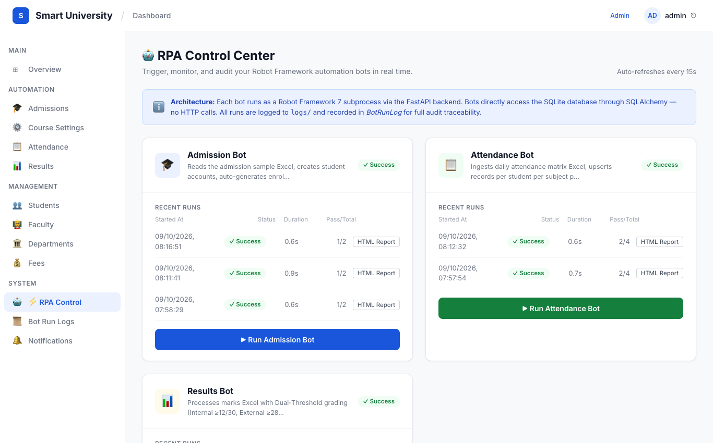
Figure: Admin RPA Control Center with Real-Time Bot Status

Checkpoint 2: Admin Bot Run Logs (Audit Trail & HTML Report Access)
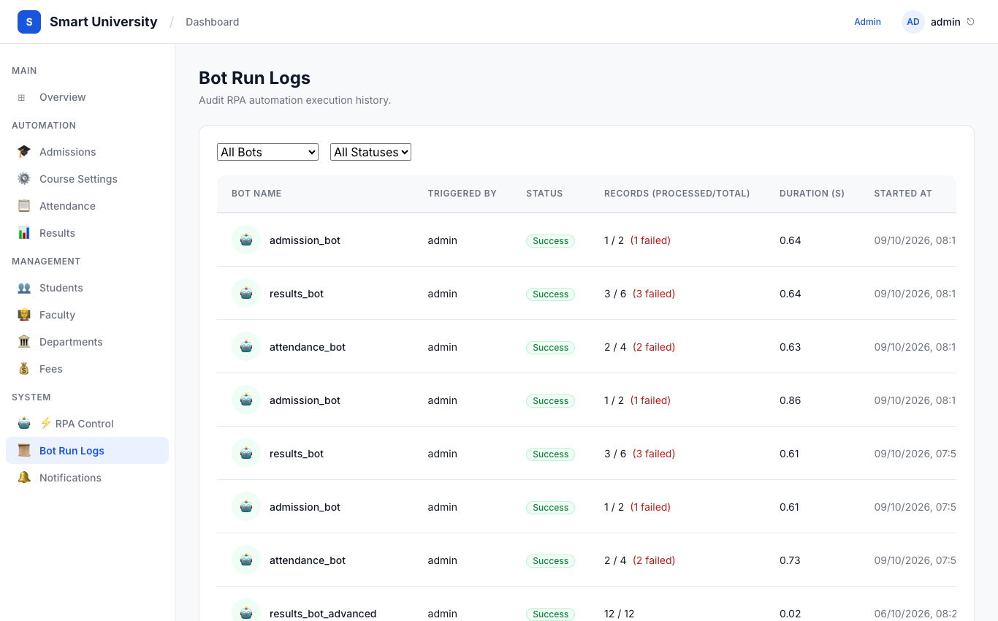
Figure: Centralized Bot Execution History and HTML Report Viewer

Checkpoint 3: Student Attendance & Standardized Daily Activity Logs
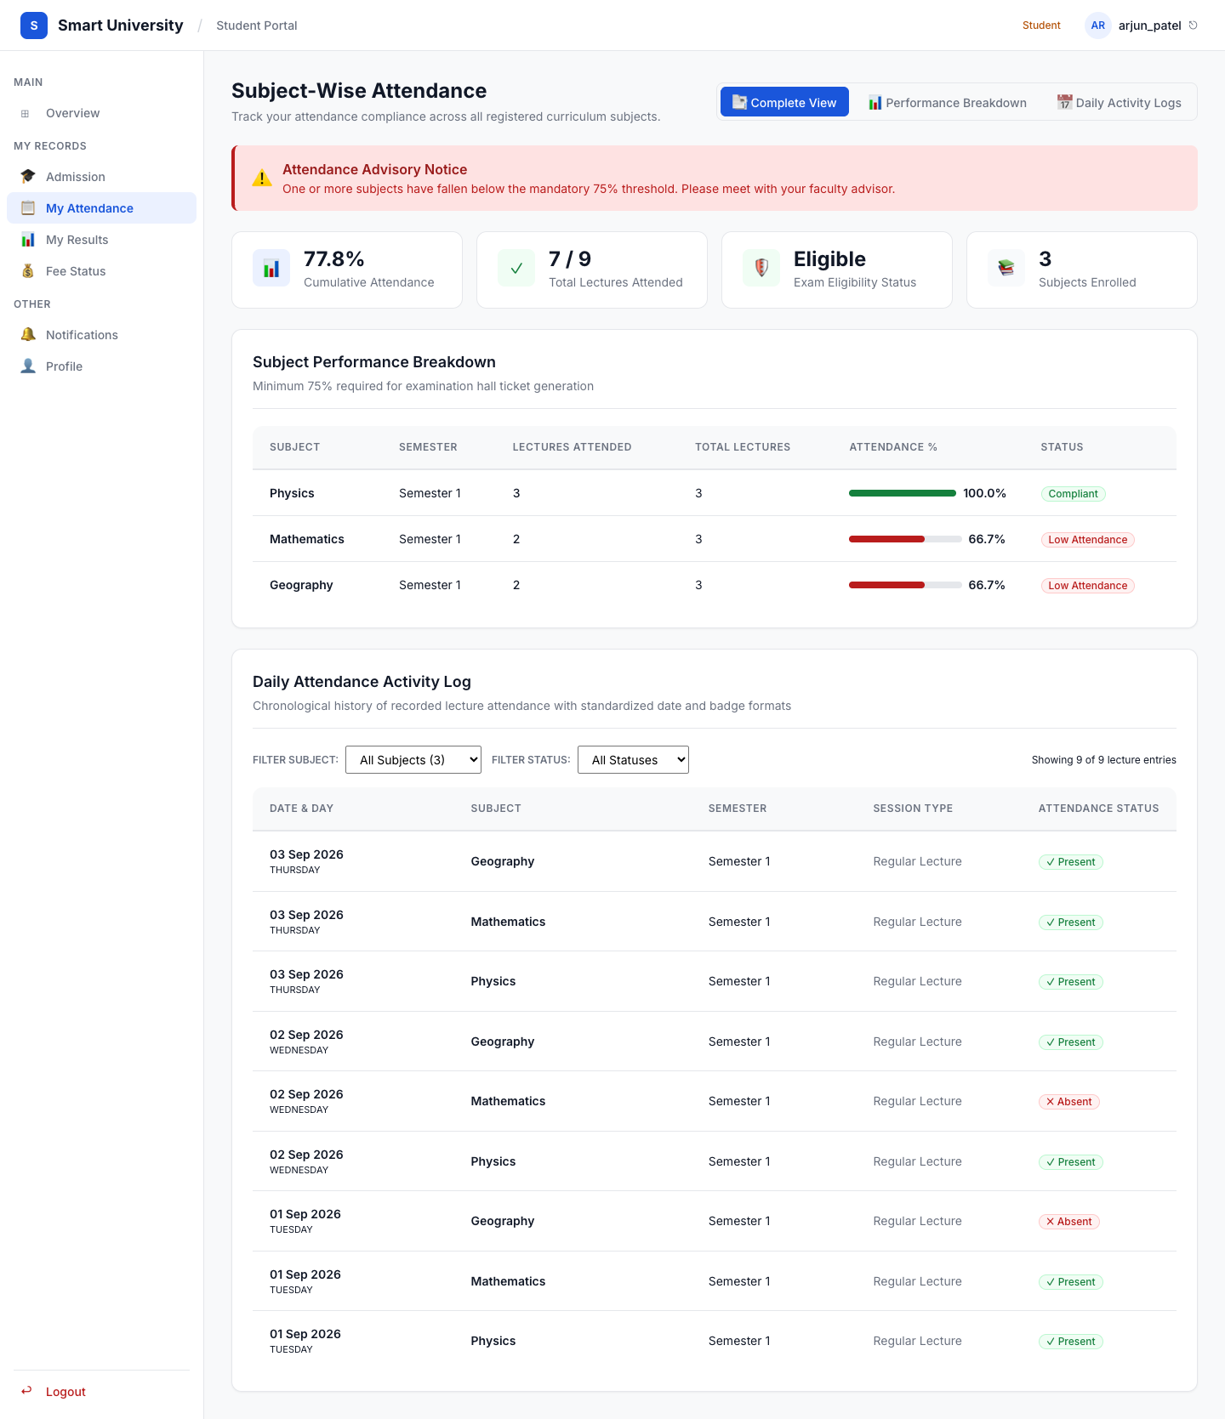
Figure: Student Attendance Portal with Deduplicated Breakdown and Daily Activity Logs

Checkpoint 4: Student Examination Results & Marksheet View
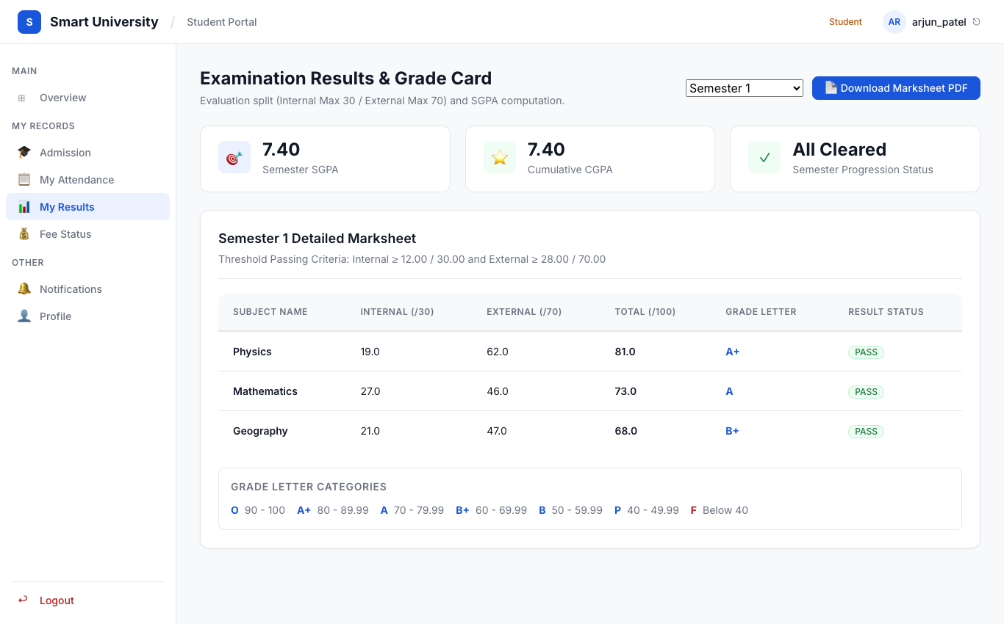
Figure: Student Results with Dual-Threshold GPA Scorecards and PDF Marksheet Download

Checkpoint 5: Student Admission Profile & Letter Download
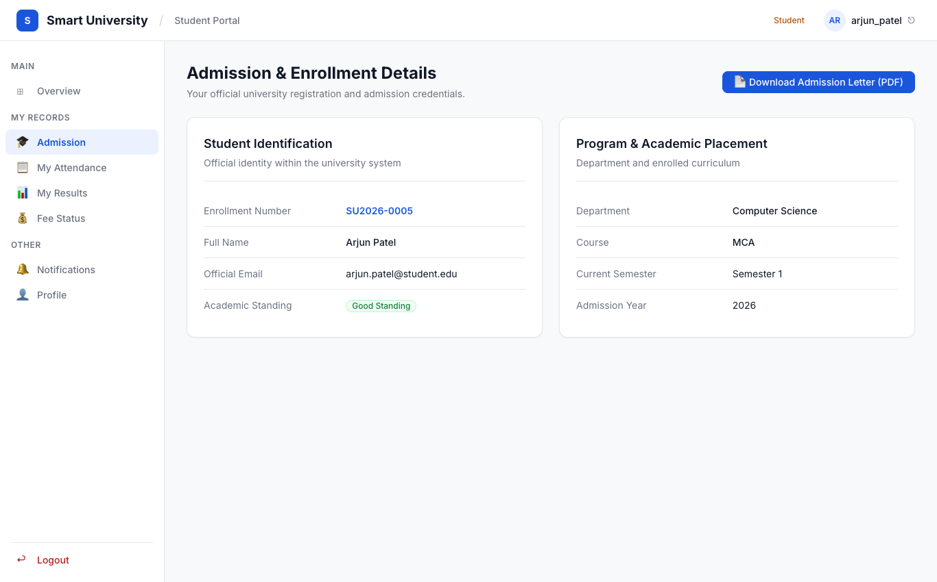
Figure: Student Admission Credential Overview and Admission PDF Generation

Checkpoint 6: Faculty Attendance Ingestion Portal
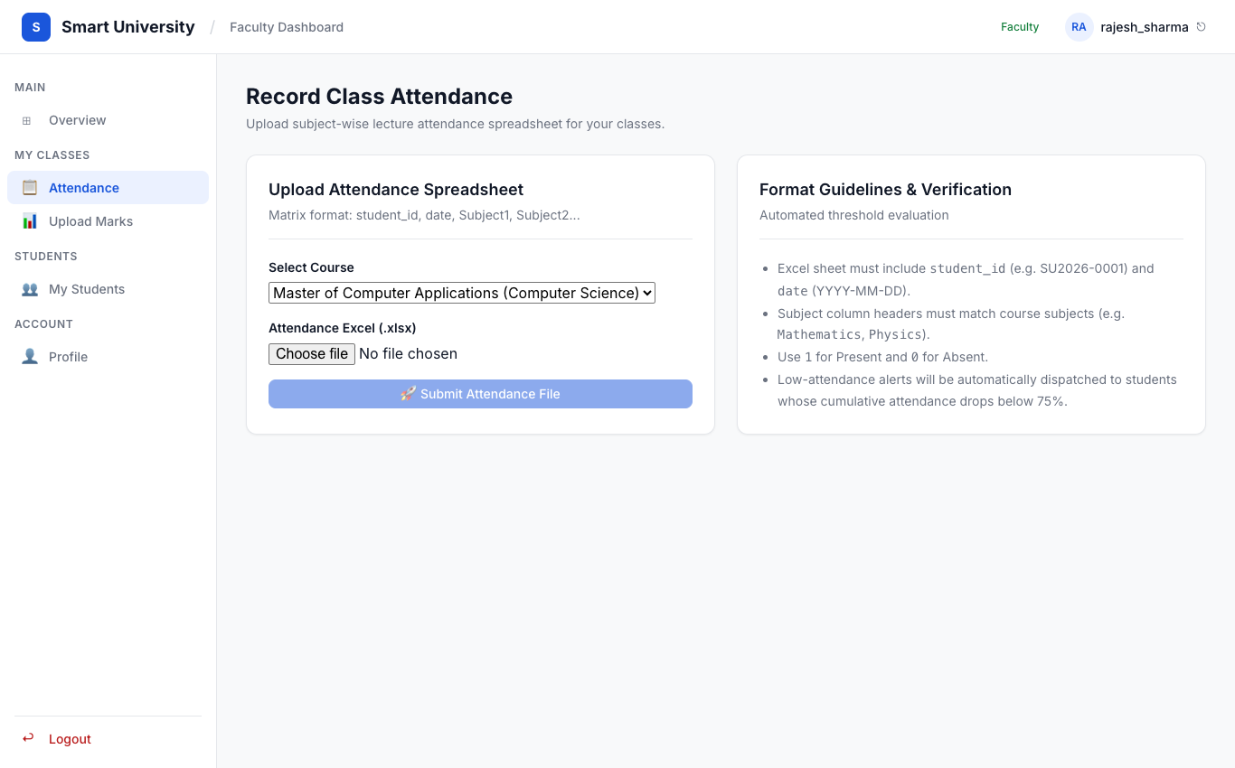
Figure: Faculty Interface for Class Attendance Matrix Spreadsheet Submission

Checkpoint 7: Faculty Examination Marks Submission
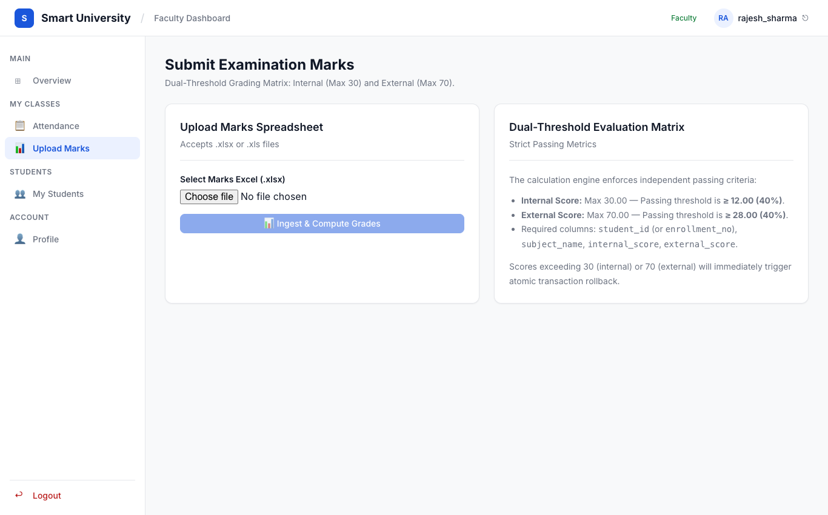
Figure: Faculty Interface for Dual-Threshold Examination Marks Ingestion

10.3 Error Handling & Exception Management
The RPA workflows implement defensive error trapping and atomic transaction guarantees:
1. Mark Out-of-Bounds Exception: When a mark value exceeds 30 for internal or 70 for external scores, the bot immediately aborts the transaction, triggers db.rollback(), logs the offending row number, and leaves database records uncorrupted.
2. Attendance Date Duplicate Handling: If a duplicate attendance date is uploaded for the same student and subject, the bot skips duplicate insertion and updates the existing lecture status idempotently.
3. Duplicate Subject Deduplication: In the attendance view, subject records are strictly deduplicated by normalized name (sub_name.strip().lower()) to prevent repeated subjects across course revisions.
4. F-Grade Quarantine: Students failing either threshold are flagged with needs_review = True and prevented from public marksheet publication until an administrator reviews and approves the record.

10.4 Sample Output Documents
Generated official documents produced during test execution:
• Admission Letter Sample: reports/pdfs/admission_SU2026-0005_*.pdf
• Marksheet PDF Sample: reports/pdfs/marksheet_SU2026-0005_sem1_*.pdf
• Robot Framework HTML Report: reports/report.html and reports/log.html

