Figures
Tasks in the NoCodeMCU Abstract Mode: the 4x4 car with PAL2v, camera and operator
IDE screenshots in the light theme with the interface in English, exported from example 16 (exemplos/en/16-abstract-4x4-car-tasks.tbk), photos of the prototype and screens of the driving page on the phone. The figures follow the style of Wang et al. (2025): panels labeled (a), (b)... and a "Fig. N." caption below.
Source code, examples and installers: https://github.com/alefplima/nocodemcu
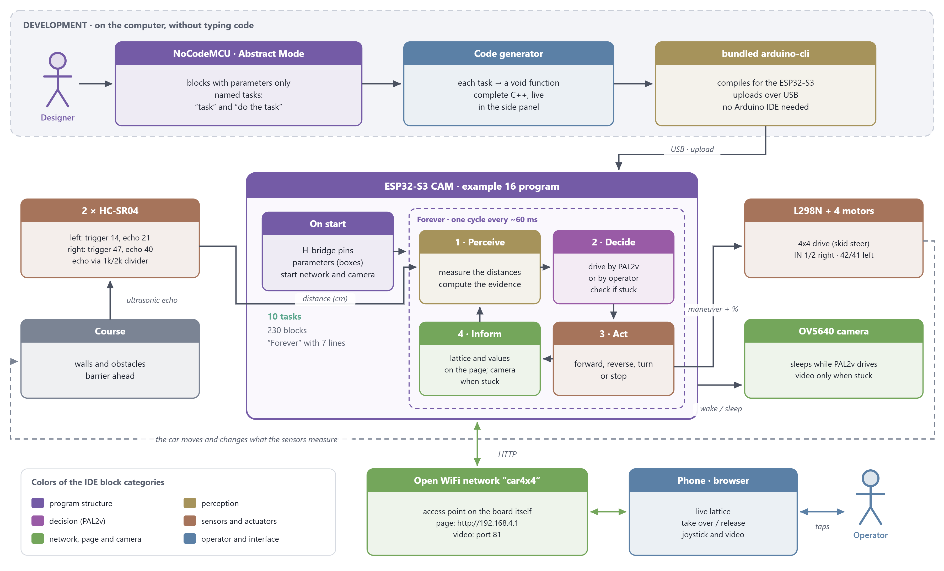
Fig. 1. High-level context diagram. On the computer, the designer builds the program from blocks and tasks; NoCodeMCU generates the C++ code and the bundled arduino-cli uploads it to the board over USB. On the ESP32-S3 CAM, "Forever" repeats the perceive, decide, act and inform cycle; the sensors read the course and the motors change it, closing the physical loop. Through the WiFi network created by the board itself, the phone shows the lattice and the video, and the operator can take control. The colors are those of the IDE block categories.
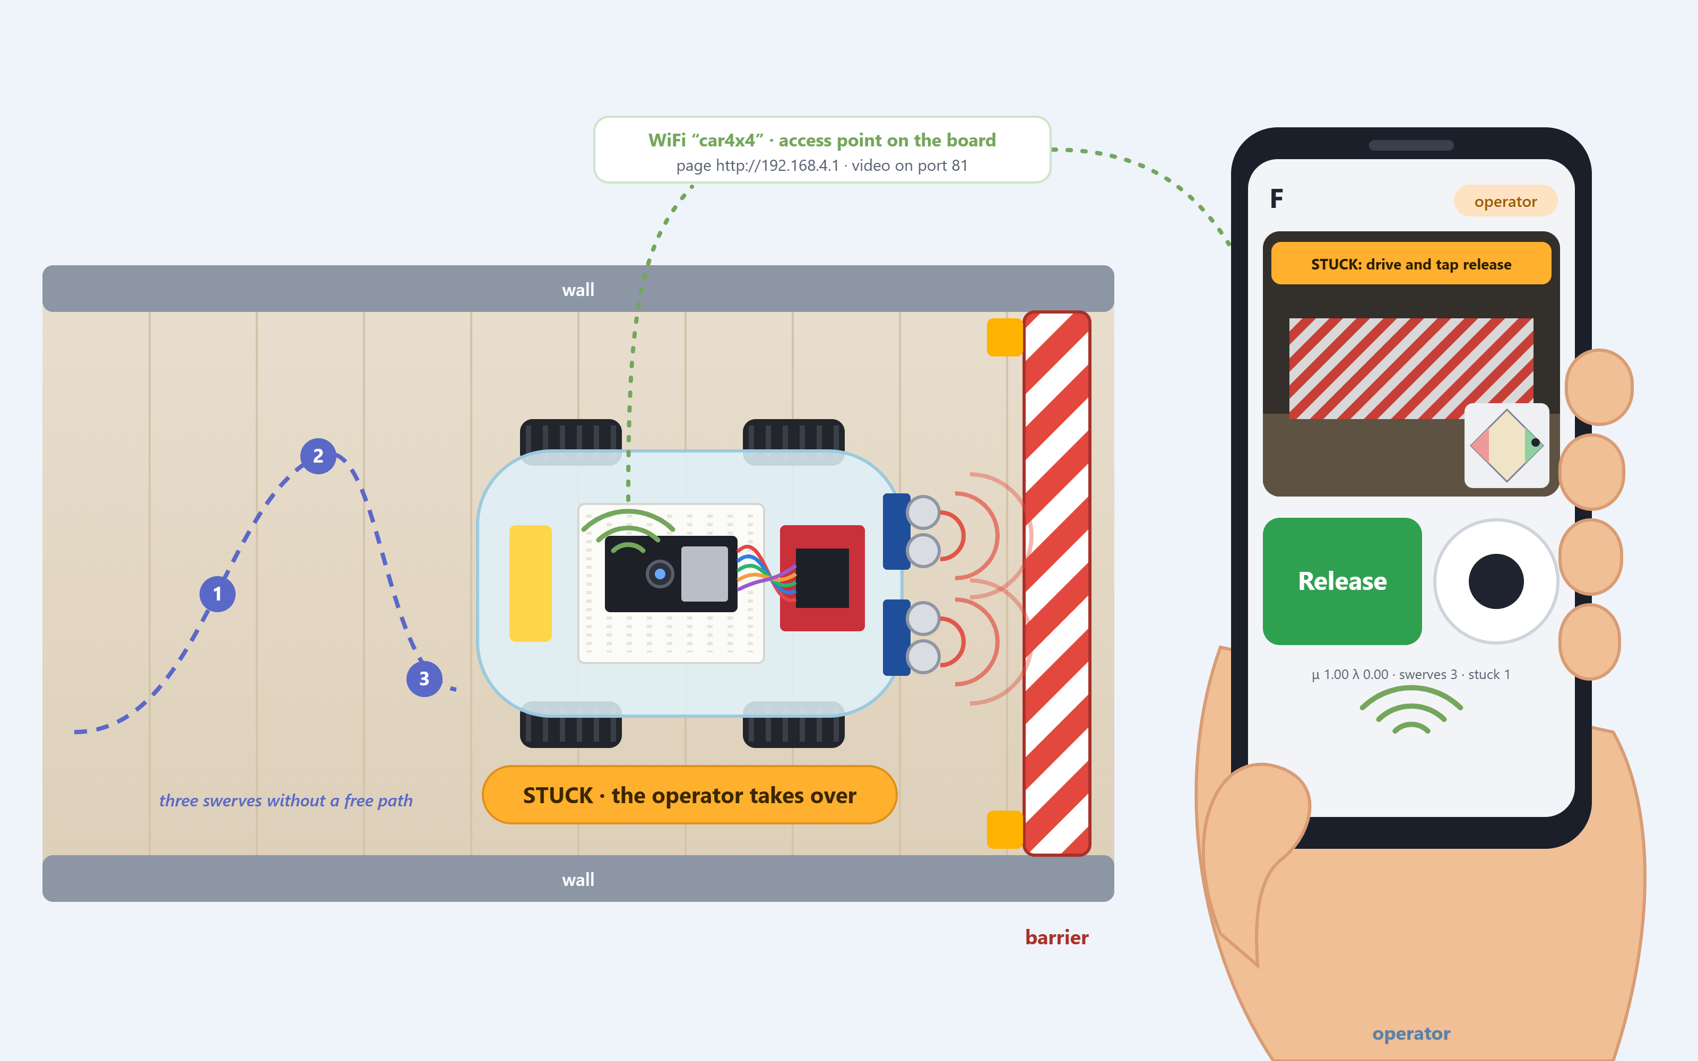
Fig. 2. Stuck scenario. After three swerves without finding a free path, the car faces the barrier with both sensors detecting an obstacle; it stops, wakes the camera and hands control to the operator, who sees the barrier on the phone connected to the "car4x4" network, drives with the joystick and returns the car to PAL2v with the Release button.

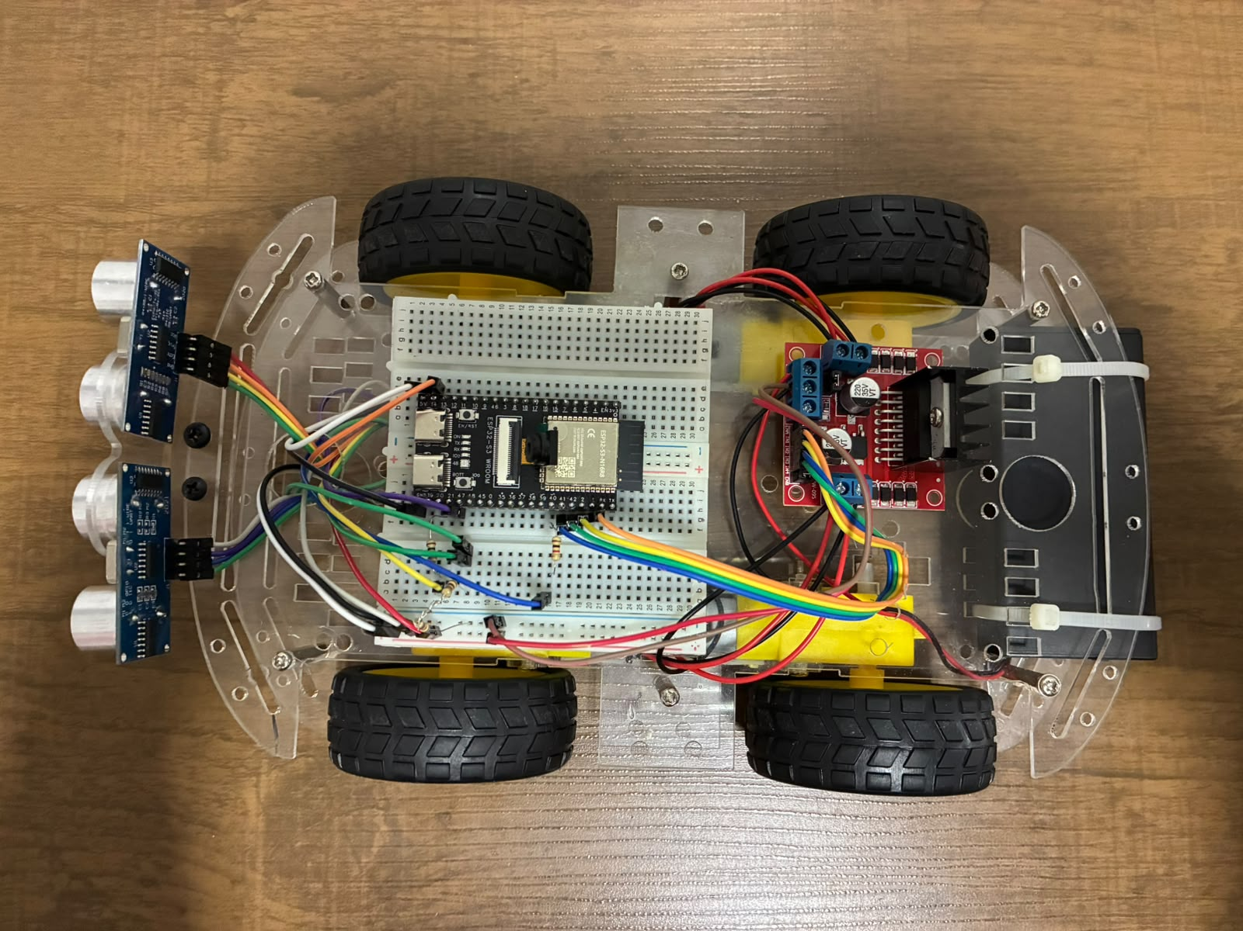 | 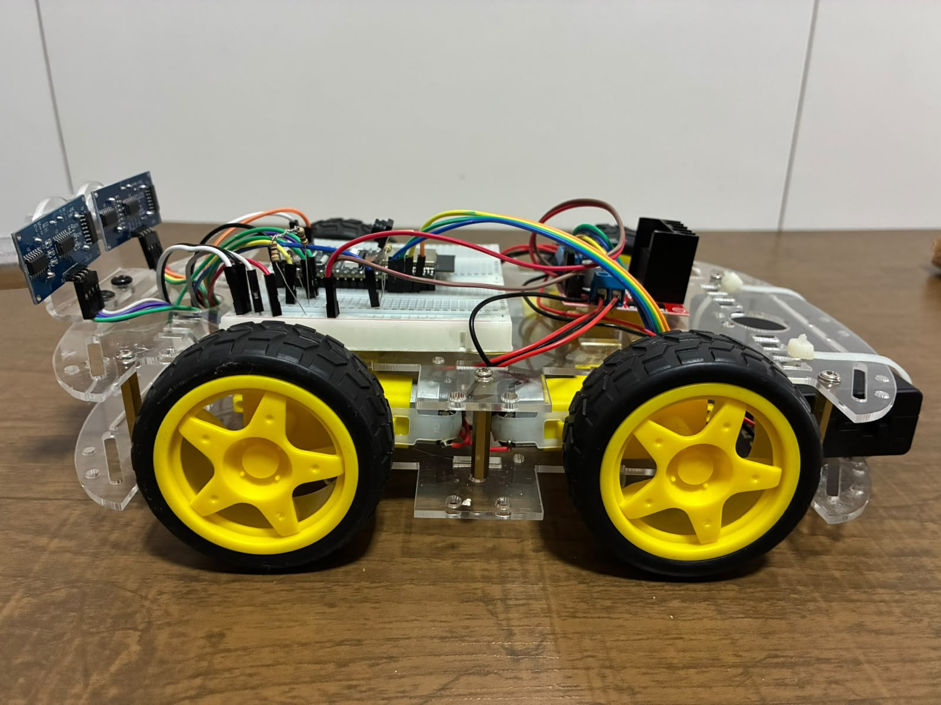
(a) Top view | (b) Side view
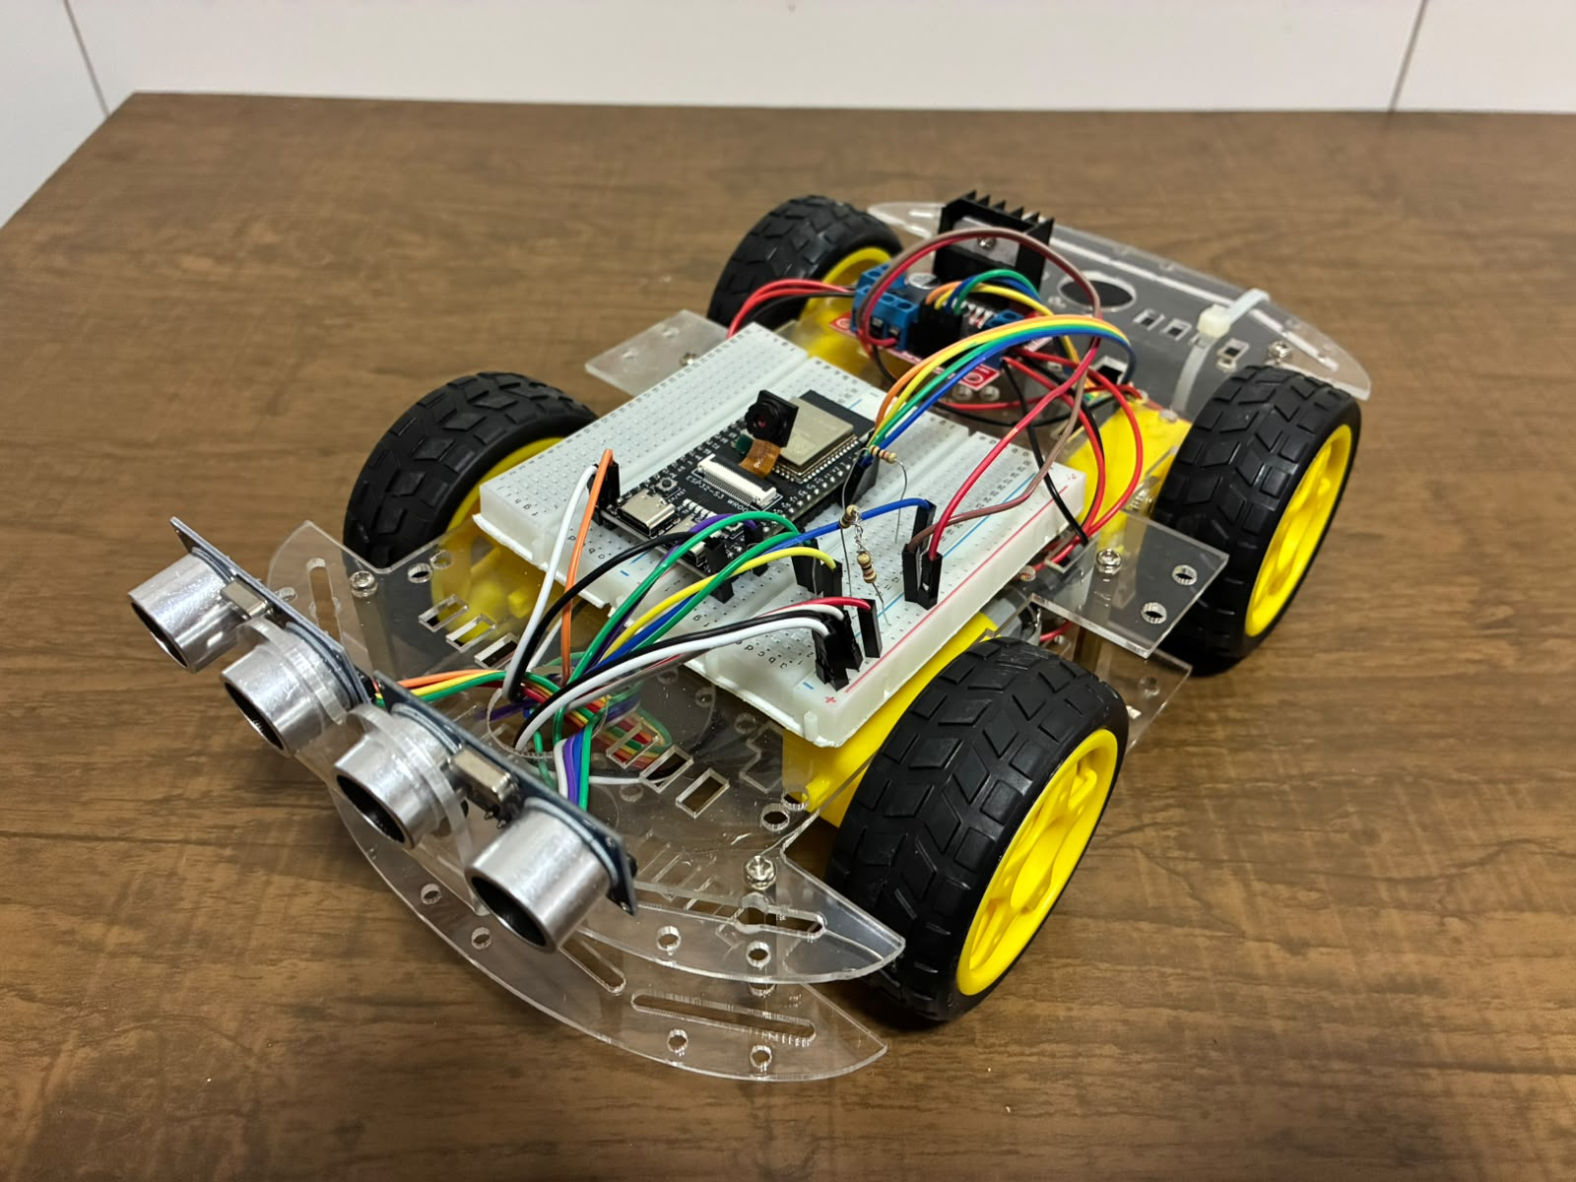 | 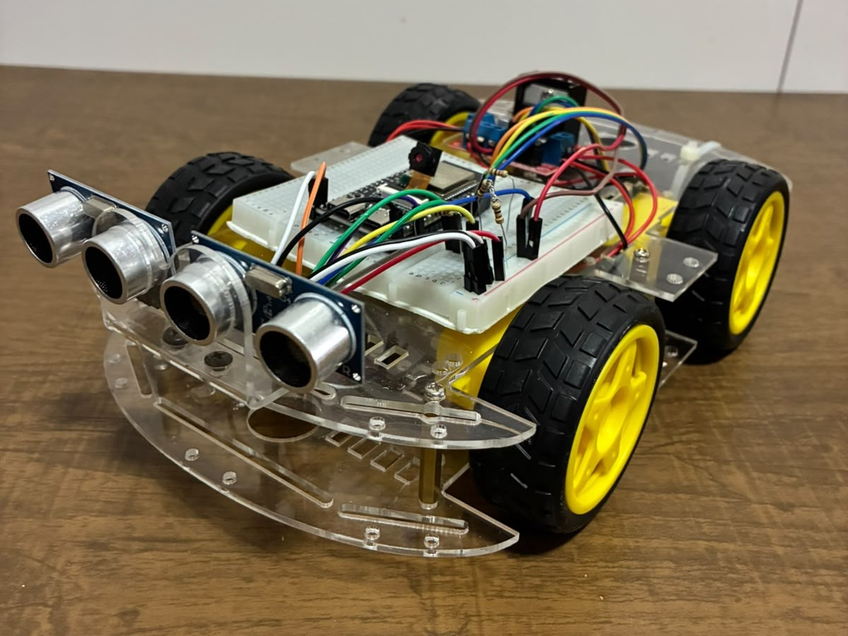
(c) Perspective | (d) Front view
Fig. 3. Prototype of the 4x4 car: ESP32-S3 CAM (ESP32-S3-WROOM-1 N16R8) on the breadboard, L298N H-bridge with the two motors on each side in parallel, and two HC-SR04 ultrasonic sensors at the front, with a resistive divider on the echo pin. (a) Top view. (b) Side view. (c) Perspective. (d) Front view.

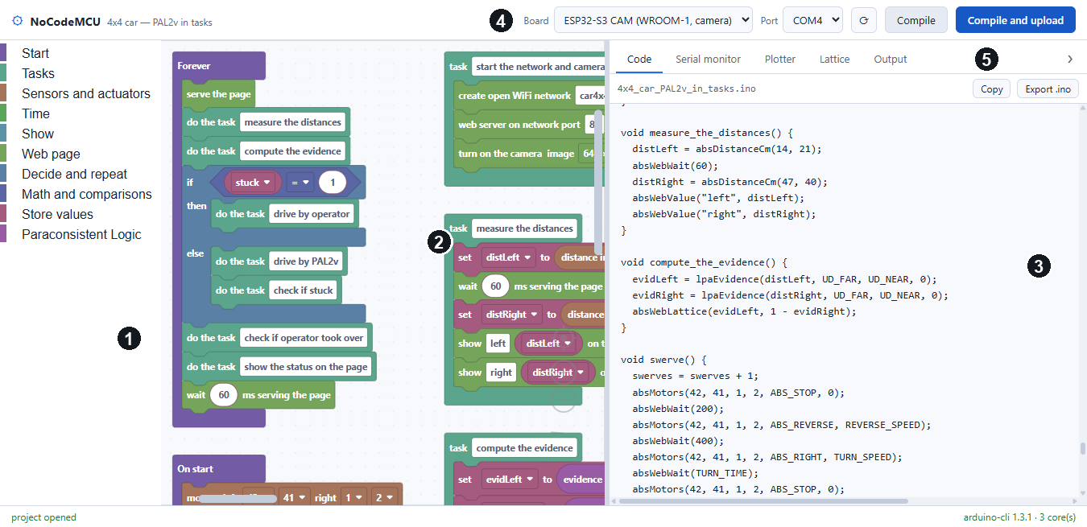
(a) Overview
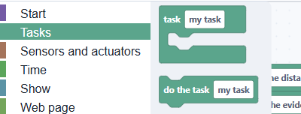
(b) Tasks category
Fig. 4. NoCodeMCU interface in Abstract Mode, light theme, language set to English (Options → Language), with example 16 open. (a) Overview: (1) toolbox organized by categories; (2) workspace, with the "Forever" block and the tasks; (3) C++ code generated in real time, here at the functions produced by the tasks; (4) board and port selection, compilation and upload over USB; (5) tabs for the serial monitor, the plotter, the PAL2v lattice and the compiler output. (b) The Tasks category open, with the "task" (define) and "do the task" (call) blocks.

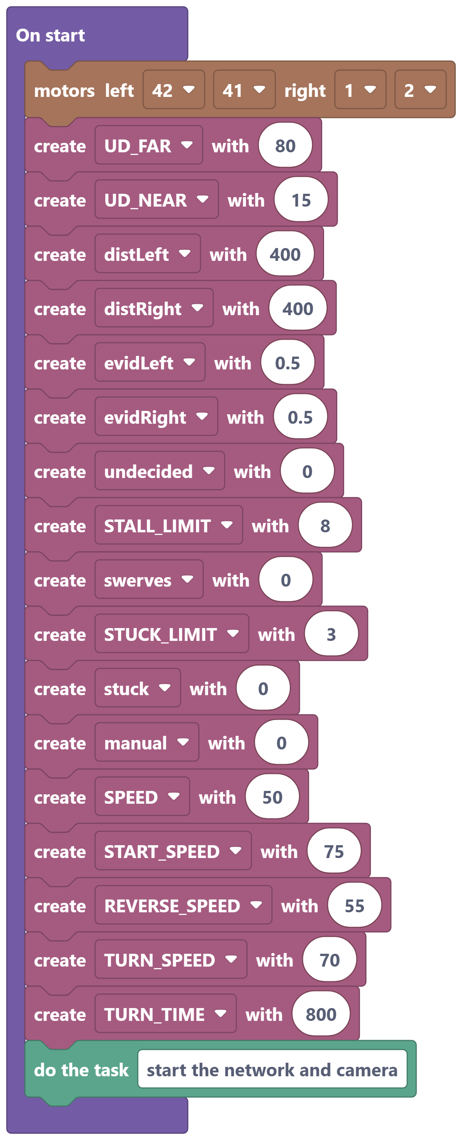 | 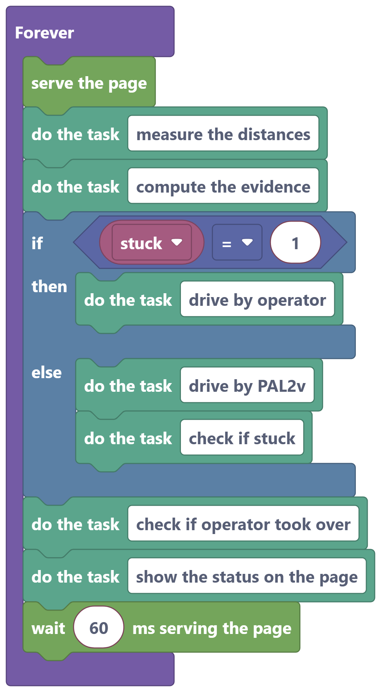
(a) On start | (b) Forever
Fig. 5. Main program structure. (a) "On start": H-bridge pins, parameters stored in boxes (universe of discourse, limits and speeds) and the call to the network task. (b) "Forever": the control cycle reduced to one line per step; the if/else block decides whether the operator or PAL2v is driving.

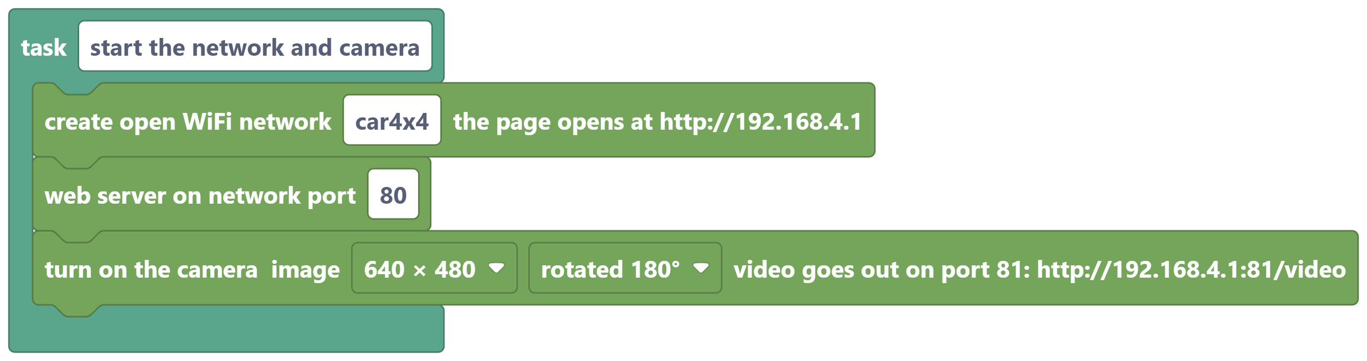
(a) start the network and camera
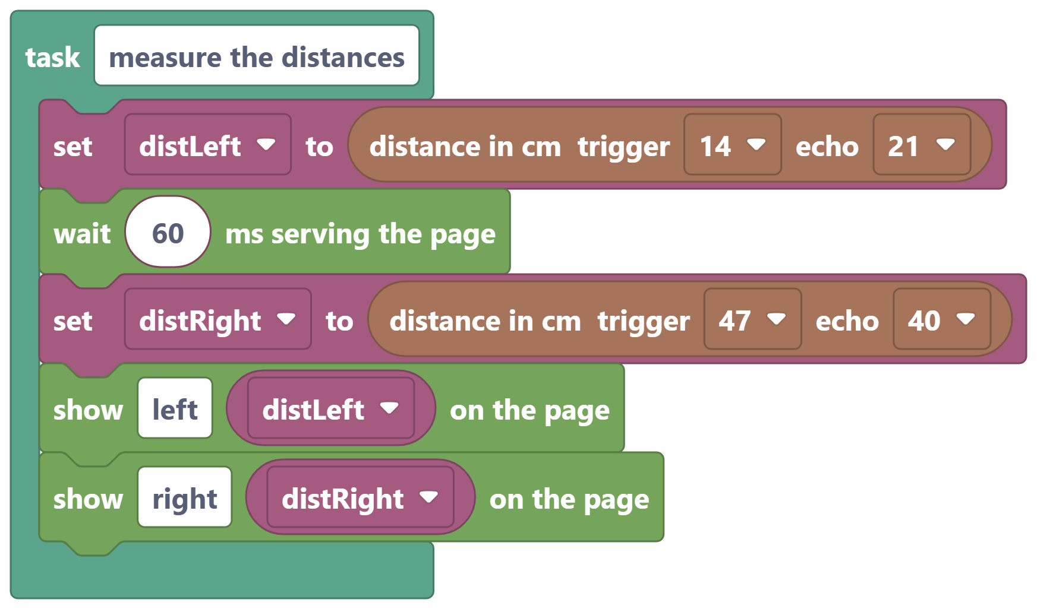
(b) measure the distances
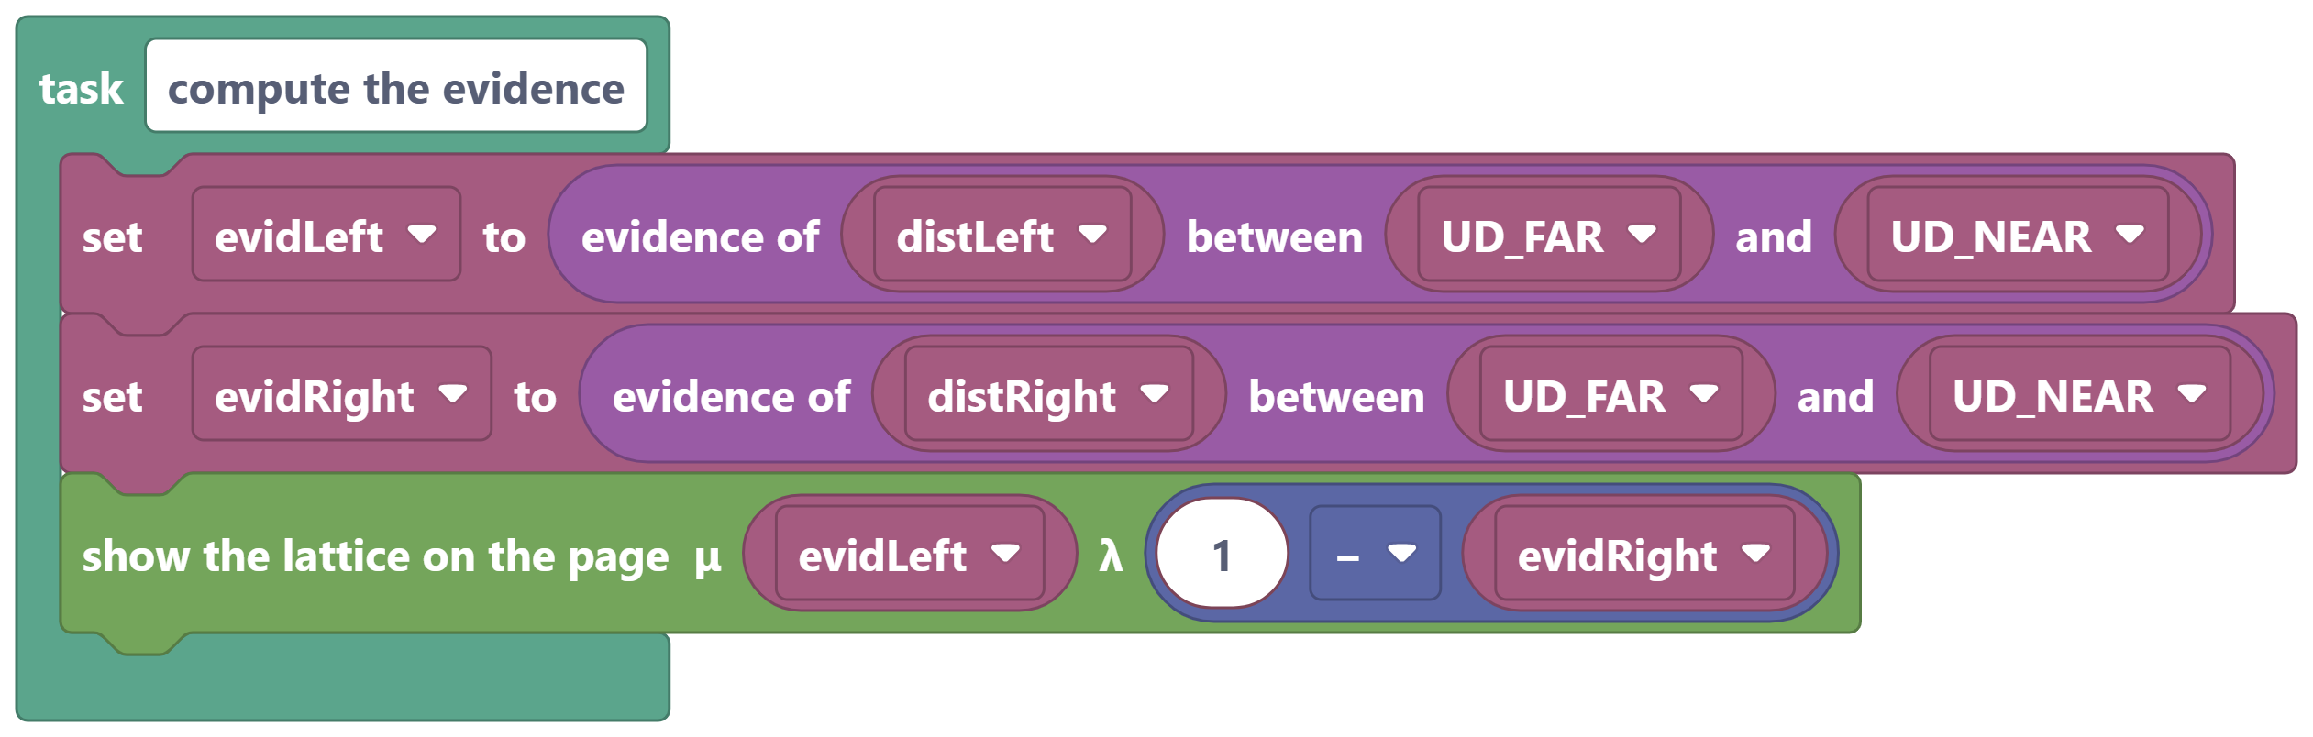
(c) compute the evidence
Fig. 6. Communication and perception tasks. (a) The board creates its own WiFi network, opens the page server and turns on the camera. (b) Reading of the two ultrasonic sensors, with an interval between triggers to avoid cross-echo, and publication of the distances on the page. (c) Conversion of the distances into evidence degrees over the universe of discourse from UD_FAR to UD_NEAR, and sending of the point (μ, λ) to the lattice drawn on the phone.

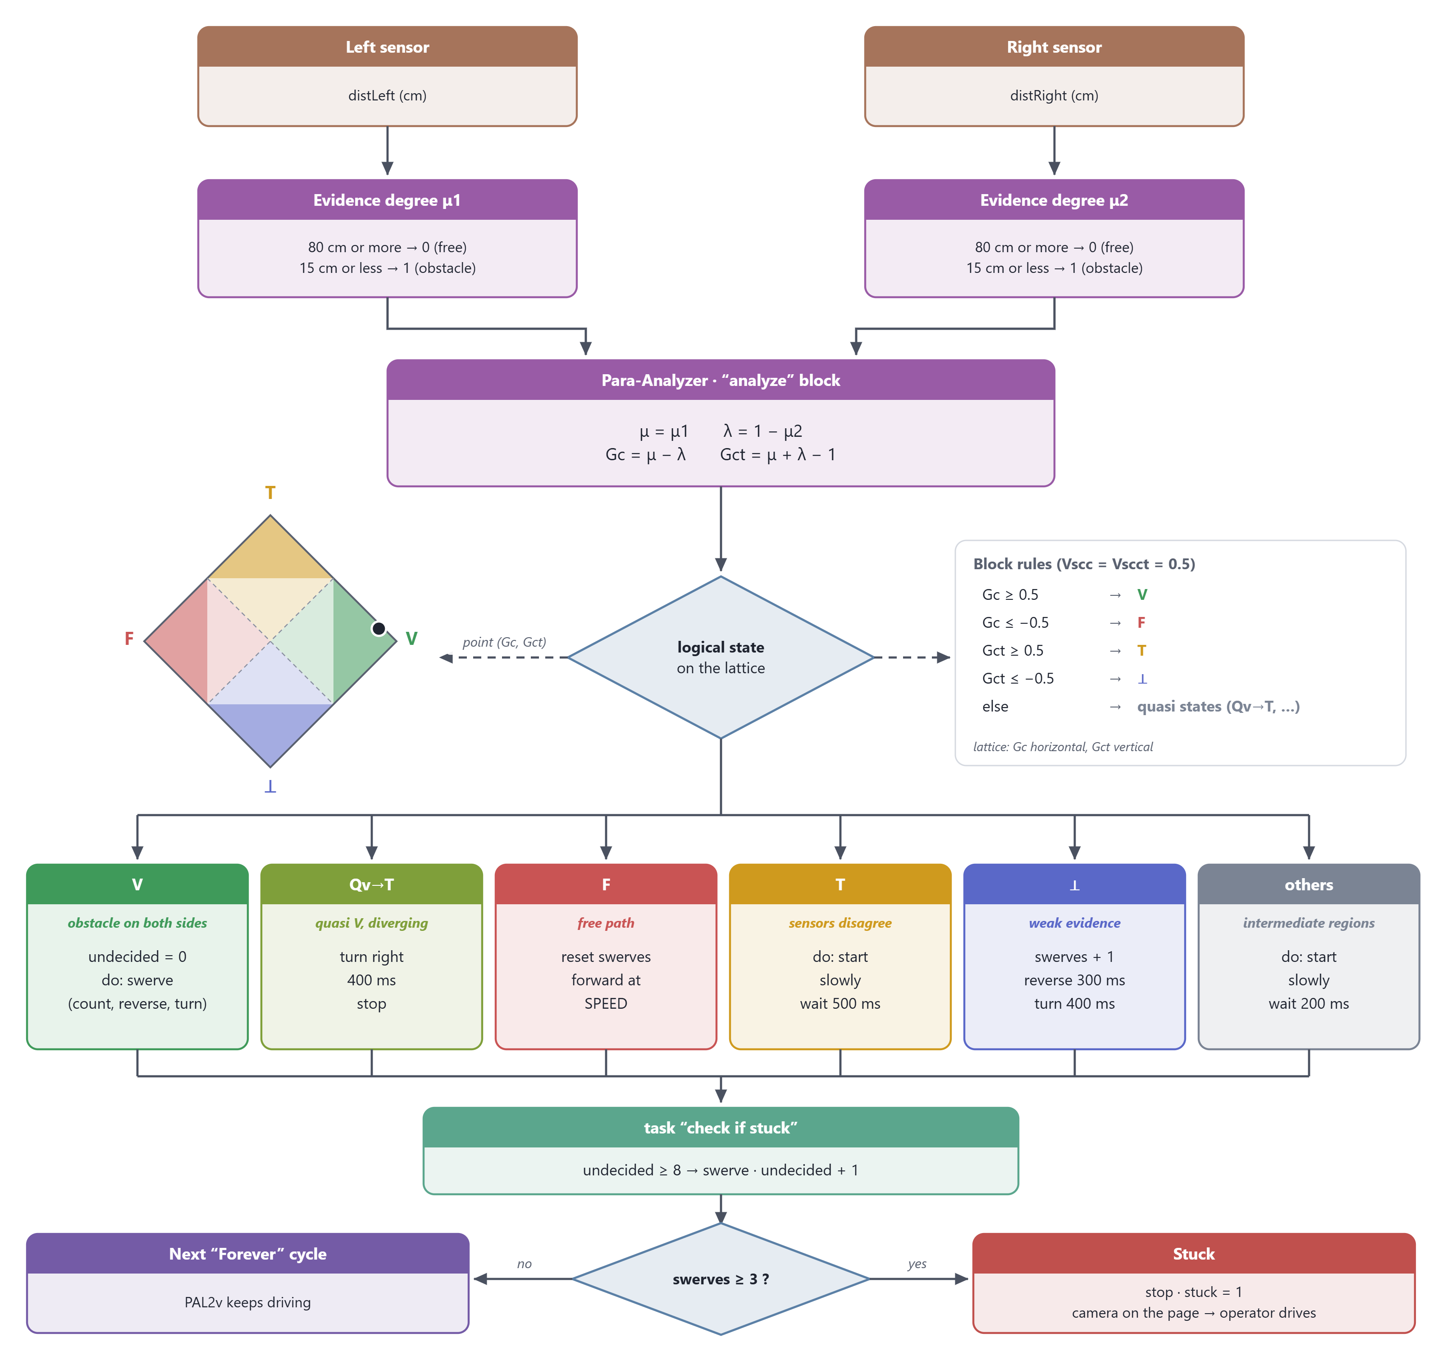
Fig. 7. Diagram of the function on which autonomous navigation depends, the "drive by PAL2v" task, followed by "check if stuck". The distances become evidence degrees; the Para-Analyzer computes the certainty degree Gc and the contradiction degree Gct, locates the logical state on the lattice (limits ±0.5) and executes the action of that state. At the end of each cycle, three swerves without a free path hand control to the operator.

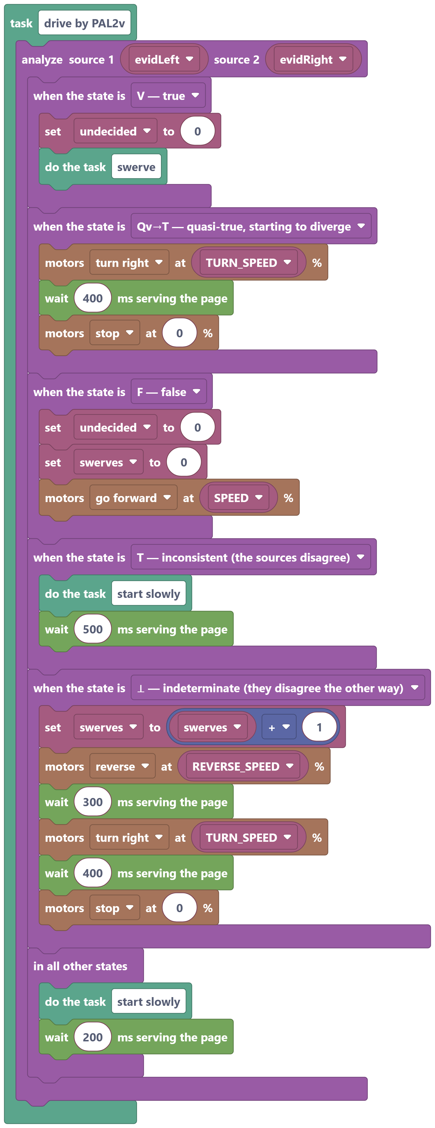
Fig. 8. The "drive by PAL2v" task: the "analyze" block compares the evidence from the two sensors and branches to the action of the resulting logical state on the lattice: V (true: both sensors see an obstacle) calls "swerve"; Qv→T makes a half turn; F (false: free path) goes forward and resets the swerve count; T (inconsistent) moves forward slowly so the readings can break the tie; ⊥ (indeterminate) makes a half maneuver and counts the swerve; the other states move slowly and measure again.

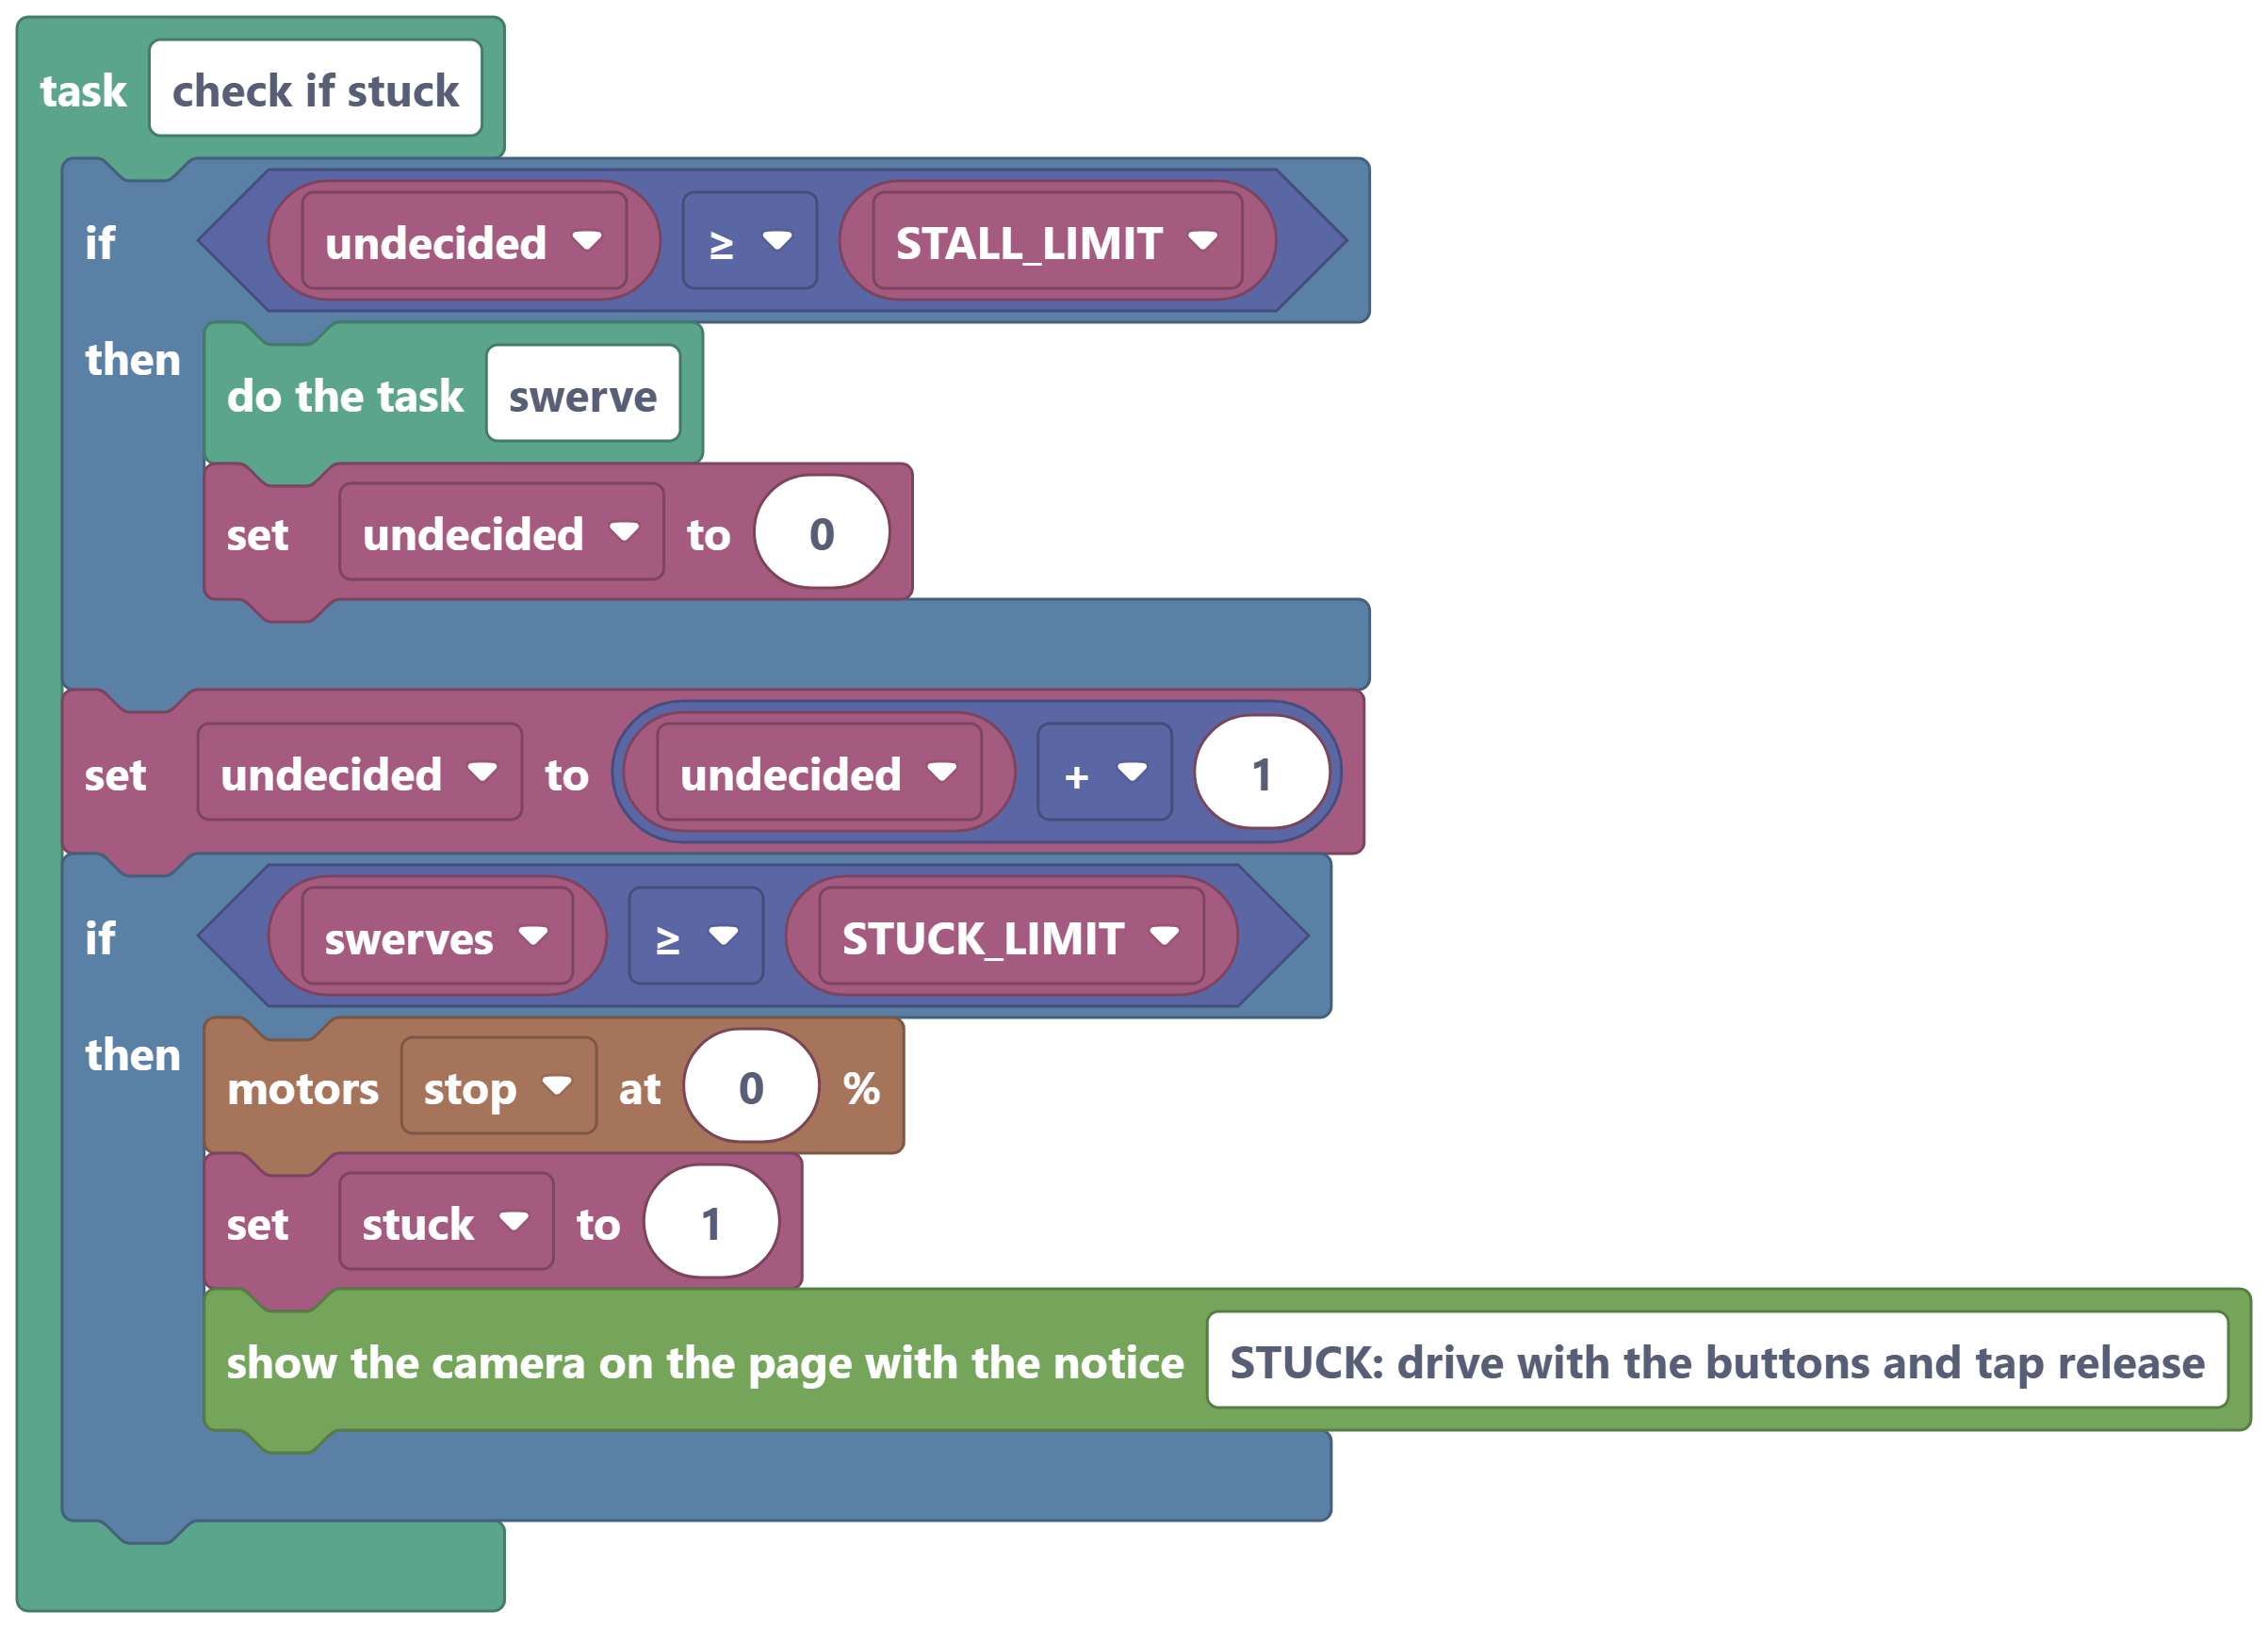
(a) check if stuck
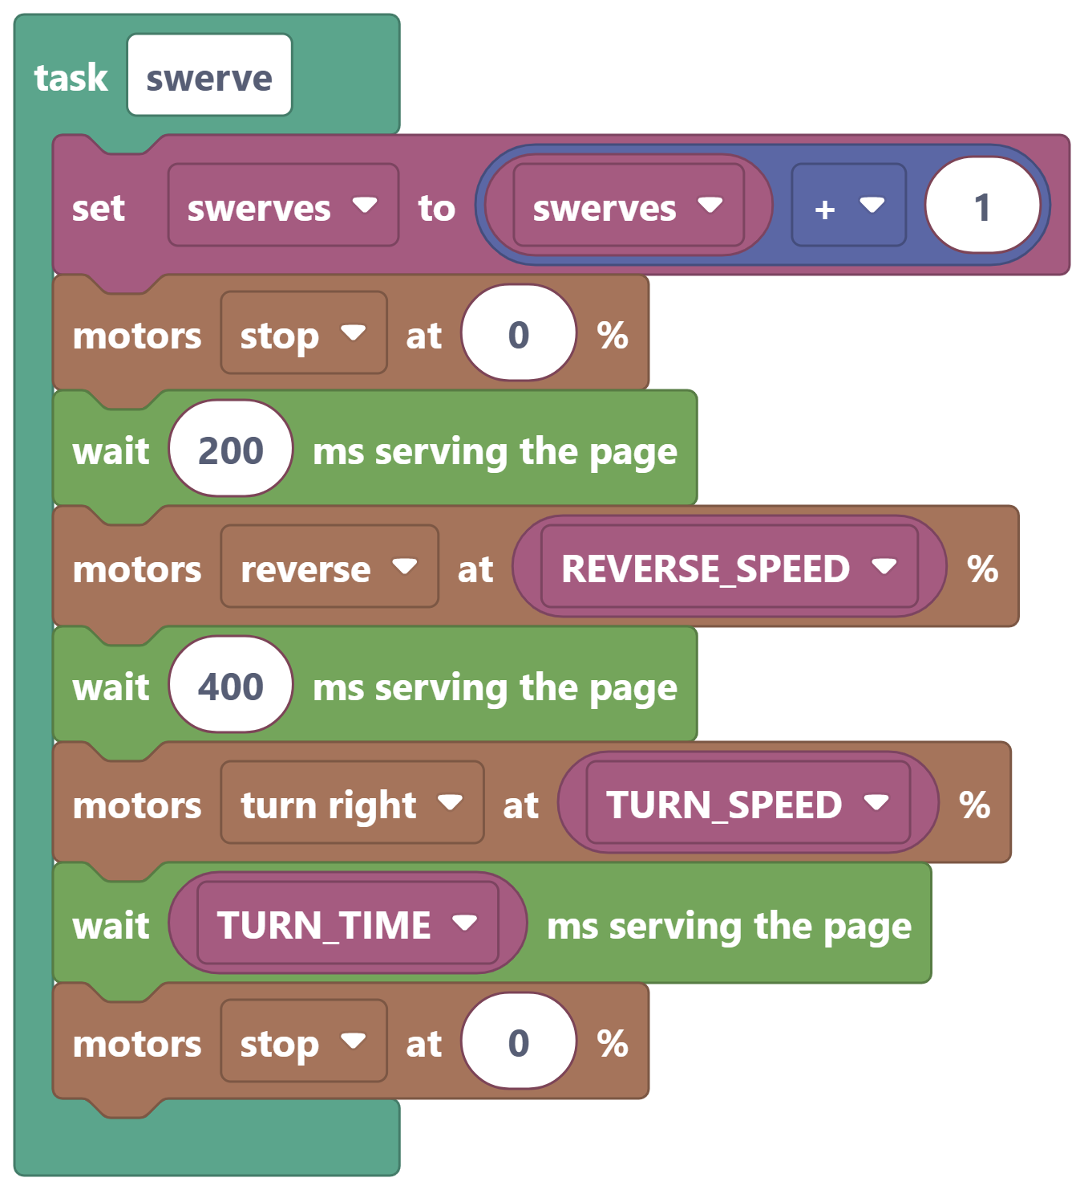 | 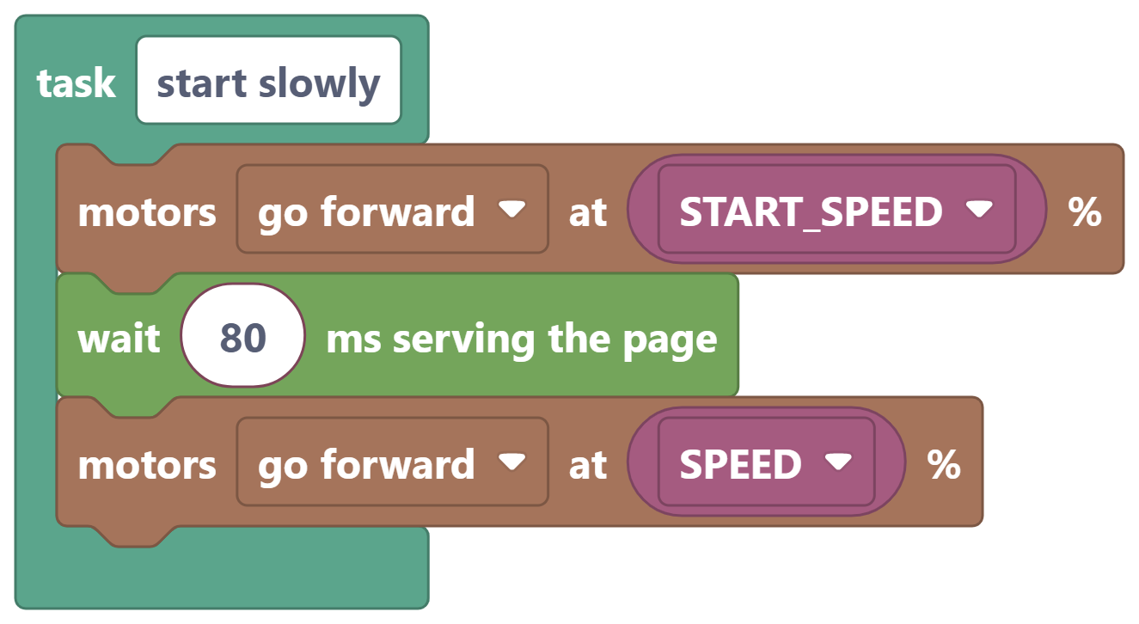
(b) swerve | (c) start slowly
Fig. 9. Maneuver tasks. (a) The safeguard against indecision (too many cycles without reaching V or F forces a swerve) and the stuck declaration: after STUCK_LIMIT swerves without a free path, the car stops and the camera opens on the phone for the operator. (b) Counted swerve: stop, reverse and turn for TURN_TIME. (c) Start with a START_SPEED impulse before the cruising speed. A task written once is called from several places: "swerve" is used in state V and in the safeguard.

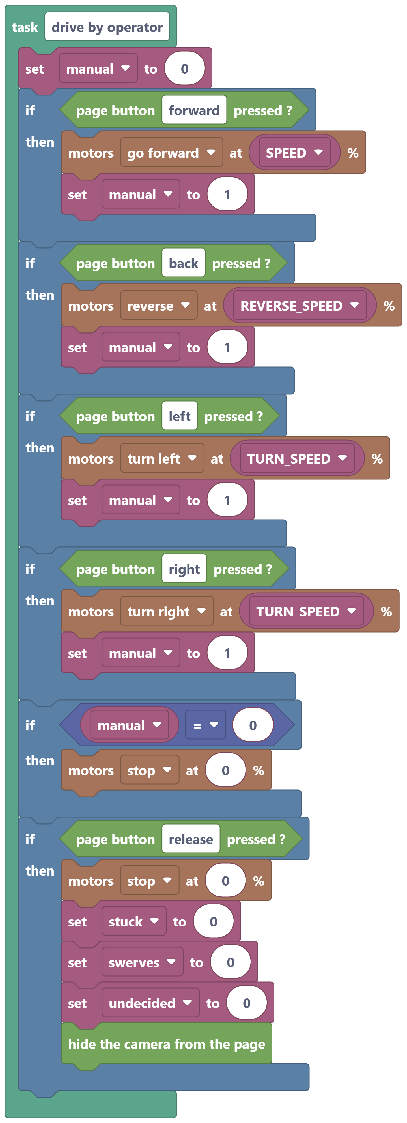
Fig. 10. The "drive by operator" task: each direction button on the page holds while the finger is on it; with no touch, the car stops. The "release" button resets the counters, hides the camera and returns control to PAL2v.

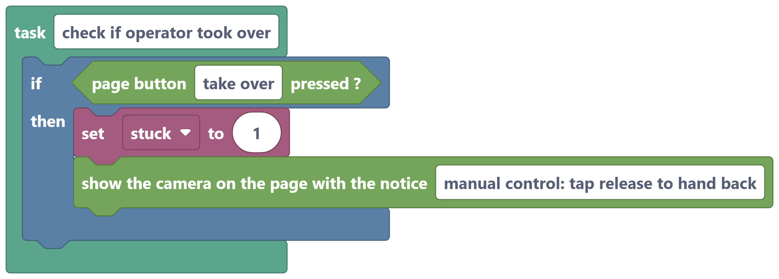
(a) check if operator took over
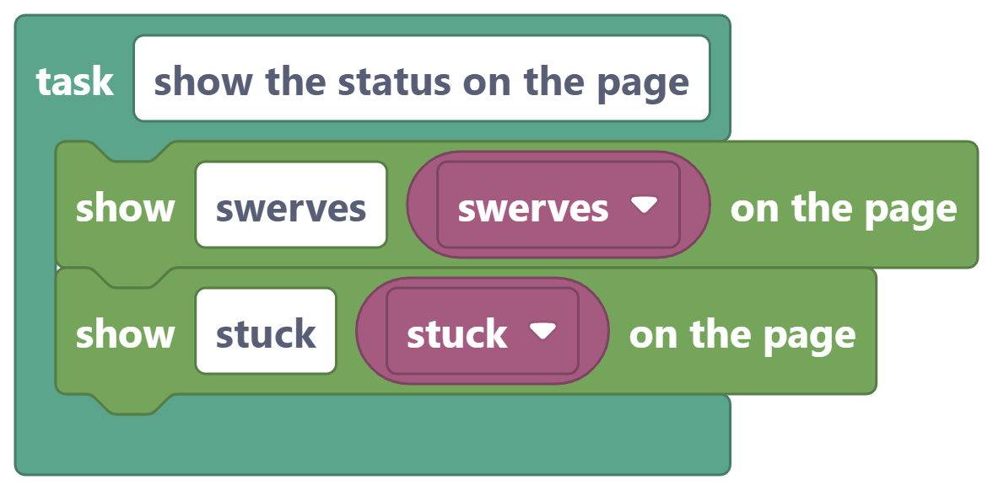
(b) show the status on the page
Fig. 11. Driving page tasks. (a) The "take over" button hands control to the operator at any time and shows the video with the notice. (b) Counters published on the page every cycle.

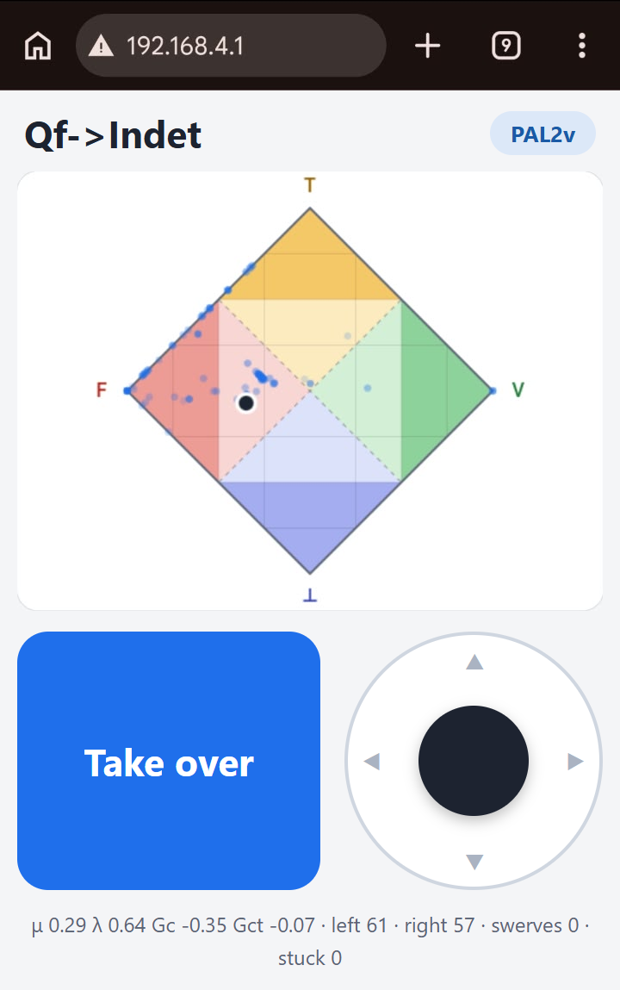 | 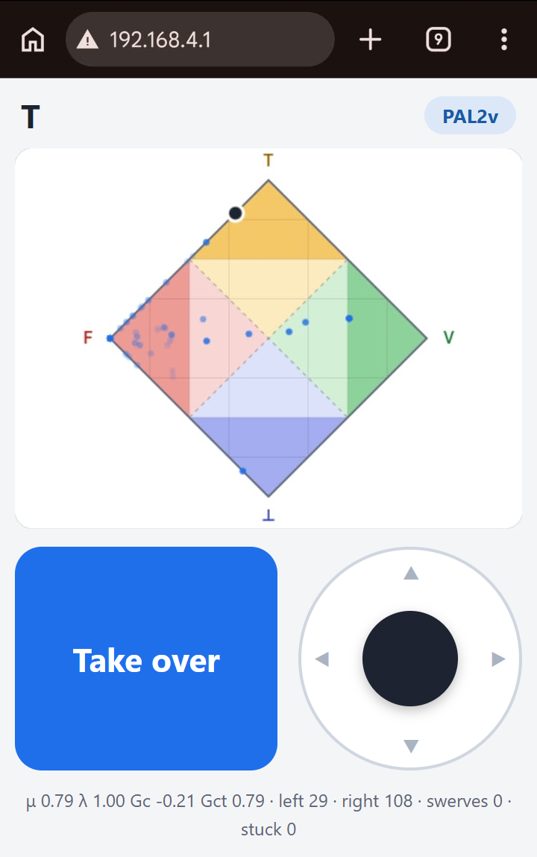
(a) PAL2v, Qf→⊥ | (b) PAL2v, T
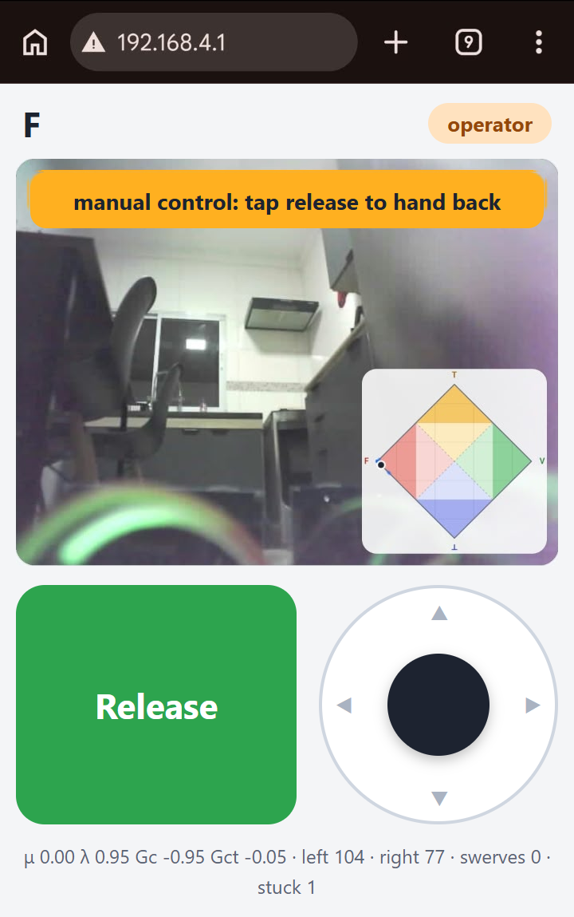 | 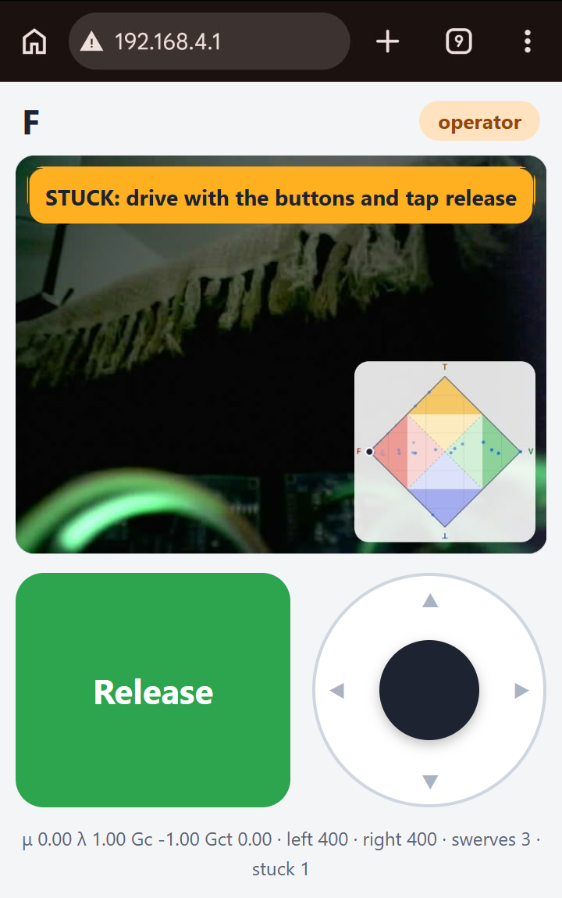
(c) Operator, manual | (d) Operator, stuck
Fig. 12. Driving page served by the board itself (http://192.168.4.1) in the phone browser. The lattice with its trail, the camera image and the readings come from the test run; the interface texts are those of the page generated from the English example. (a) PAL2v mode, quasi-false state tending to indeterminate, with the trail of the latest readings on the lattice. (b) PAL2v mode, state T (inconsistent): the sensors disagree. (c) The operator took over with the button: camera video with the notice and the lattice in the corner. (d) After three swerves without a free path the car declared itself stuck and handed control to the operator.
Reference
WANG, P.; WANG, Z.; DUAN, J.; MIAO, Y.; TIAN, W. Review of the development status of low-code programming software for robots. Digital Engineering, v. 4, 100039, 2025. DOI: 10.1016/j.dte.2025.100039.
NoCodeMCU, public repository: https://github.com/alefplima/nocodemcu

