Software Requirements Specification
for
Authentication Library
Version 1.1 approved
Prepared by Fucà Alessia
Università di Firenze
10/03/2026
Table of Contents
1. Introduction 1
1.1 Purpose 1
1.2 Document Conventions 1
1.3 Intended Audience and Reading Suggestions 1
1.4 Product Scope 1
1.5 References 1
2. Overall Description 2
2.1 Product Perspective 2
2.2 Product Functions 2
2.3 User Classes and Characteristics 2
2.4 Operating Environment 2
2.5 Design and Implementation Constraints 2
2.6 User Documentation 2
2.7 Assumptions and Dependencies 3
3. External Interface Requirements 3
3.1 User Interfaces 3
3.2 Hardware Interfaces 3
3.3 Software Interfaces 3
3.4 Communications Interfaces 3
4. System Features 4
4.1 System Feature 1 4
4.2 System Feature 2 (and so on) 4
5. Other Nonfunctional Requirements 4
5.1 Performance Requirements 4
5.2 Safety Requirements 5
5.3 Security Requirements 5
5.4 Software Quality Attributes 5
5.5 Business Rules 5
6. Other Requirements 5
7. Traceability matrix 5

Revision History
Name | Date | Reason For Changes | Version

Introduction

Purpose
Descrizione dei requisiti per un’authentication library.

<Identify the product whose software requirements are specified in this document, including the revision or release number. Describe the scope of the product that is covered by this SRS, particularly if this SRS describes only part of the system or a single subsystem.>

Document Conventions
f
<Describe any standards or typographical conventions that were followed when writing this SRS, such as fonts or highlighting that have special significance. For example, state whether priorities for higher-level requirements are assumed to be inherited by detailed requirements, or whether every requirement statement is to have its own priority.>

Intended Audience and Reading Suggestions
Stiamo scrivendo i req di una libreria sw per poi passarli a possibili progettisti, per cui l'intended audience sono sia i clienti, sia i progettisti che la implementeranno.

<Describe the different types of reader that the document is intended for, such as developers, project managers, marketing staff, users, testers, and documentation writers. Describe what the rest of this SRS contains and how it is organized. Suggest a sequence for reading the document, beginning with the overview sections and proceeding through the sections that are most pertinent to each reader type.>

Product Scope
Il prodotto permette l'autenticazione ad una serie di tool.

<Provide a short description of the software being specified and its purpose, including relevant benefits, objectives, and goals. Relate the software to corporate goals or business strategies. If a separate vision and scope document is available, refer to it rather than duplicating its contents here.>

References
Non ce ne sono al momento xxx

<List any other documents or Web addresses to which this SRS refers. These may include user interface style guides, contracts, standards, system requirements specifications, use case documents, or a vision and scope document. Provide enough information so that the reader could access a copy of each reference, including title, author, version number, date, and source or location.>

Overall Description

Product Perspective
La libreria è un nuovo prodotto software che si deve integrare con diversi tool aziendali. La libreria verrà utilizzata sui computer aziendali.

Product Functions
- Permettere operazioni di modifica, aggiunta e rimozioni di utenti da parte dell'admin;
- Permettere ad un utente di accedere inserendo email e password;
- Permettere di recuperare la password agli utenti.

User Classes and Characteristics
Il software verrà usato da due tipi di utenti: gli utenti admin e gli utenti standard che utilizzeranno la libreria. Gli utenti standard sono personale formato ad utilizzare la libreria.

Operating Environment
Il software dovrà eseguire su ogni sistema operativo e su ogni computer aziendale.

Design and Implementation Constraints
La libreria richiede connessione ad internet esclusivamente per la fase di registrazione e dev'essere integrabile con altri tool aziendali. Dev'essere inoltre garantita la sicurezza dei dati.

User Documentation

Assumptions and Dependencies
Non ci sono assunzioni di utilizzo.

External Interface Requirements

User Interfaces
<Describe the logical characteristics of each interface between the software product and the users. This may include sample screen images, any GUI standards or product family style guides that are to be followed, screen layout constraints, standard buttons and functions (e.g., help) that will appear on every screen, keyboard shortcuts, error message display standards, and so on. Define the software components for which a user interface is needed. Details of the user interface design should be documented in a separate user interface specification.>

Hardware Interfaces
<Describe the logical and physical characteristics of each interface between the software product and the hardware components of the system. This may include the supported device types, the nature of the data and control interactions between the software and the hardware, and communication protocols to be used.>

Software Interfaces
<Describe the connections between this product and other specific software components (name and version), including databases, operating systems, tools, libraries, and integrated commercial components. Identify the data items or messages coming into the system and going out and describe the purpose of each. Describe the services needed and the nature of communications. Refer to documents that describe detailed application programming interface protocols. Identify data that will be shared across software components. If the data sharing mechanism must be implemented in a specific way (for example, use of a global data area in a multitasking operating system), specify this as an implementation constraint.>

Communications Interfaces
<Describe the requirements associated with any communications functions required by this product, including e-mail, web browser, network server communications protocols, electronic forms, and so on. Define any pertinent message formatting. Identify any communication standards that will be used, such as FTP or HTTP. Specify any communication security or encryption issues, data transfer rates, and synchronization mechanisms.>

System Features
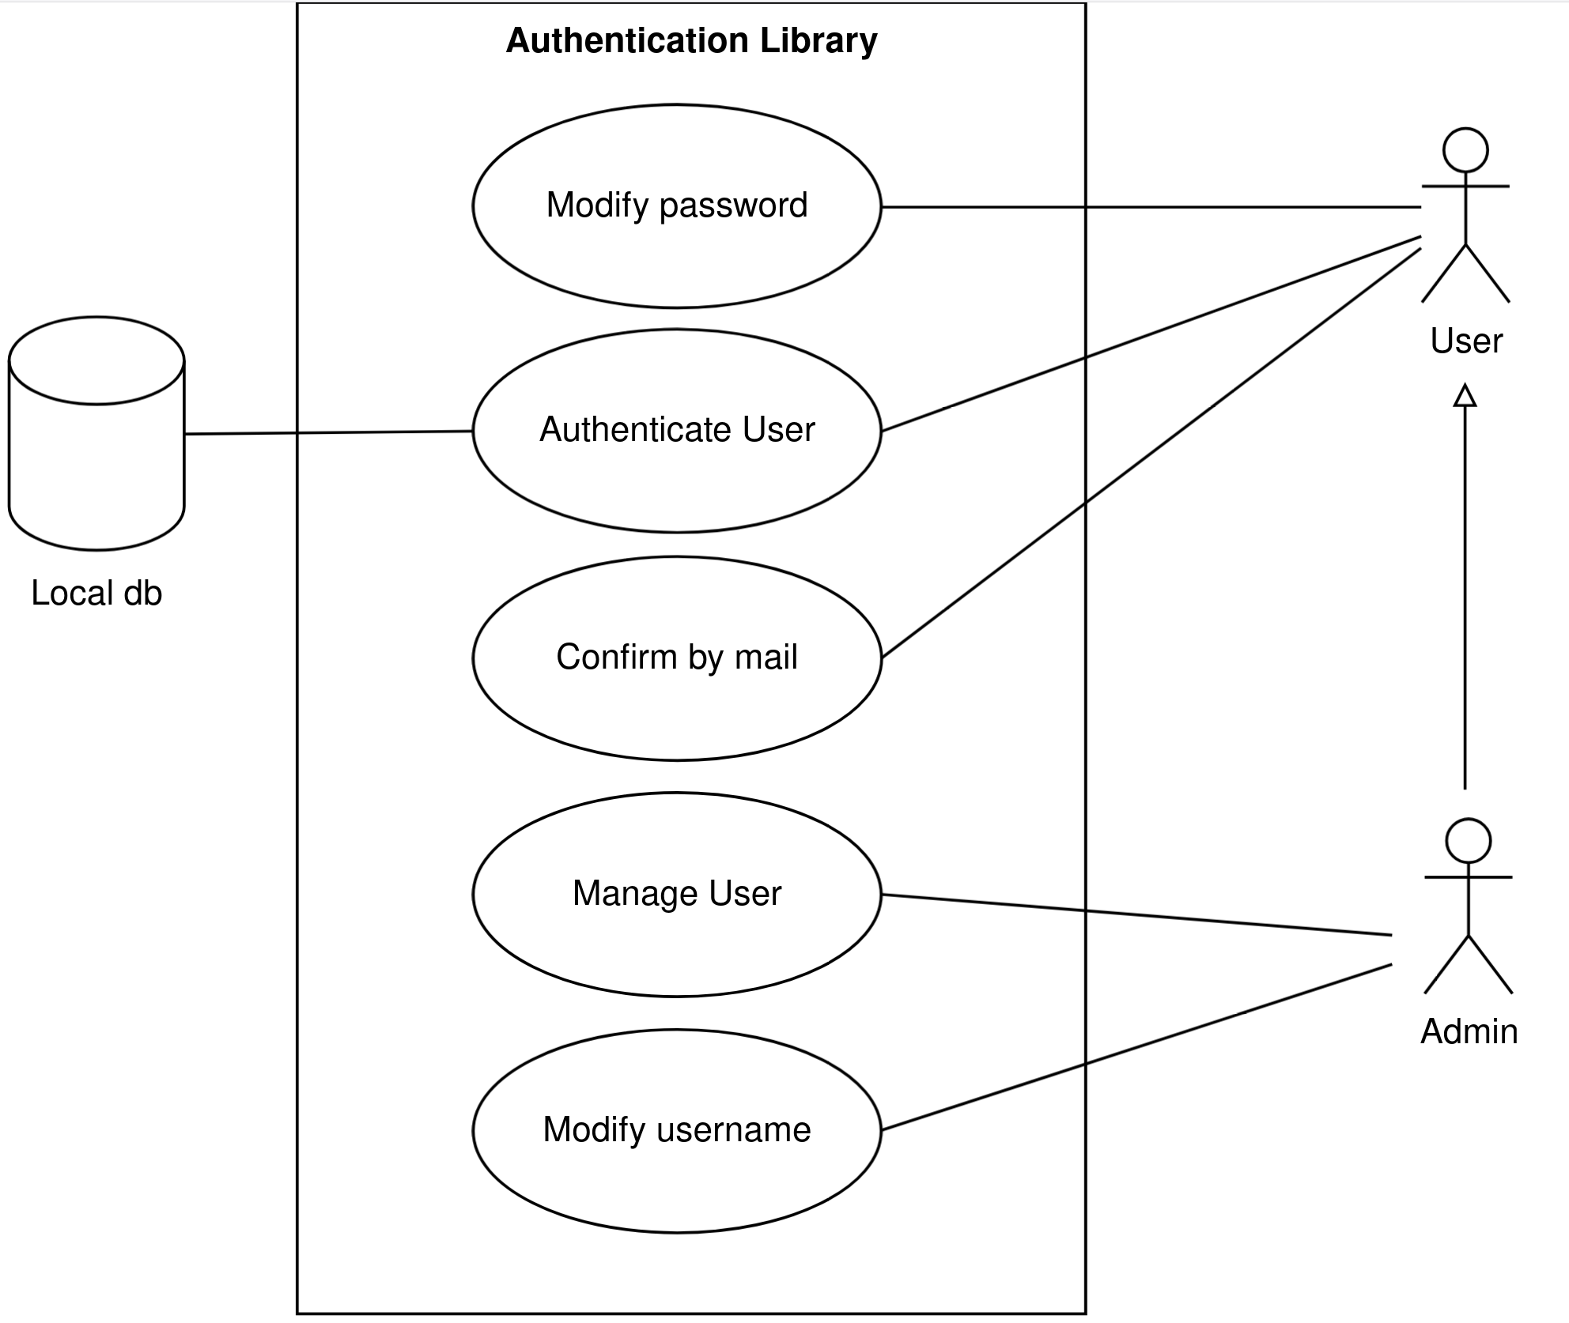
MODIFY PASSWORD

Objective – modifica della password di un user.

Actors – sono coinvolti sia l'admin di sistema, sia l'utente.

Flow of Events
- Basic flow:
  - utente richiede la modifica della password;
  - viene richiesta la conferma via email;
  - la password viene modificata;
  - l'admin riceve una notifica che un utente ha cambiato password.
- Alternative flow:
  - admin modifica la password.

AUTHENTICATE USER

Objective – autenticazione dell'utente.

Actors – sono coinvolti sia l'admin di sistema, sia l'utente.

Flow of Events
- Basic flow:
  - utente inserisce email e password;
  - verifica di controllo della correttezza dei dati inseriti, accedendo al database;
  - messaggio dell'esito della richiesta di accesso;

CONFIRM BY MAIL

Objective – conferma tramite email della registrazione dell'utente e della modifica della password.

Actors – sono coinvolti sia l'admin di sistema, sia l'utente.

Flow of Events
- Basic flow:
  - admin registra l'utente;
  - utente conferma la registrazione tramite e-mail;
- Alternative flow:
  - utente richiede la modifica della password;
  - conferma l'identità con la e-mail.

User Authentication
REQ 10 M: Il sistema di autenticazione deve permettere l'autenticazione di un utente tramite email e password.

REQ 20 M: Il sistema di autenticazione deve verificare che username e password inseriti dall'utente corrispondano ad una coppia presente su un database, memorizzato localmente.

REQ 30 M: In caso di verifica di email e password con successo, il sistema di autenticazione deve avviare il tool.

REQ 40 M: In caso di verifica di email e password fallita, il sistema di autenticazione deve negare l'avvio del tool.

Nota: Avviare il tool implica che si concede l'accesso.

Modify password
REQ 50 M: Il sistema deve permettere ad un utente di modificare la sua password.

REQ 51 M: Per richiedere la modifica della password, l'utente deve inserire la propria email.

REQ 60 M: Dopo la richiesta di modifica password, il sistema deve mandare una email all'utente per avviare una procedura di verifica dell'identità.

REQ 61 O: In caso di avviamento della procedura di verifica dell'identità per il cambio della password, l'utente può identificare la propria identità cliccando su un link ricevuto per email.

Nota: La soluzione informatica di verifica dell'identità è lasciata agli sviluppatori.

REQ 70 M: In caso di verifica d'identità avvenuta con successo, l'utente deve inserire una nuova password.

REQ 71 M: In caso di modifica della password avvenuta con successo, l'admin deve ricevere una notifica.

REQ 80 M: In caso di verifica d'identità non avvenuta, la password dell'utente non deve essere modificata.

Other Nonfunctional Requirements

Technical design
REQ 21 M: Il database dovrà essere popolato da una serie di coppie <username, password>

Security
REQ 22 M: Il database dovrà implementare meccanismi di accesso sicuro ai dati memorizzati

Performance Requirements
<If there are performance requirements for the product under various circumstances, state them here and explain their rationale, to help the developers understand the intent and make suitable design choices. Specify the timing relationships for real time systems. Make such requirements as specific as possible. You may need to state performance requirements for individual functional requirements or features.>

Safety Requirements
<Specify those requirements that are concerned with possible loss, damage, or harm that could result from the use of the product. Define any safeguards or actions that must be taken, as well as actions that must be prevented. Refer to any external policies or regulations that state safety issues that affect the product’s design or use. Define any safety certifications that must be satisfied.>

Security Requirements
<Specify any requirements regarding security or privacy issues surrounding use of the product or protection of the data used or created by the product. Define any user identity authentication requirements. Refer to any external policies or regulations containing security issues that affect the product. Define any security or privacy certifications that must be satisfied.>

Software Quality Attributes
<Specify any additional quality characteristics for the product that will be important to either the customers or the developers. Some to consider are: adaptability, availability, correctness, flexibility, interoperability, maintainability, portability, reliability, reusability, robustness, testability, and usability. Write these to be specific, quantitative, and verifiable when possible. At the least, clarify the relative preferences for various attributes, such as ease of use over ease of learning.>

Business Rules
<List any operating principles about the product, such as which individuals or roles can perform which functions under specific circumstances. These are not functional requirements in themselves, but they may imply certain functional requirements to enforce the rules.>

Other Requirements
<Define any other requirements not covered elsewhere in the SRS. This might include database requirements, internationalization requirements, legal requirements, reuse objectives for the project, and so on. Add any new sections that are pertinent to the project.>

Traceability matrix
<If an upper layer of documentation is available, it is necessary to include traceability of requirements. >

Requirements from upper layer document (identify precisely the document and its version) | This SRS
[Req-1] | [Req-SW-1], [Req-SW-2], …
… | …
Appendix A: Glossary
<Define all the terms necessary to properly interpret the SRS, including acronyms and abbreviations. You may wish to build a separate glossary that spans multiple projects or the entire organization, and just include terms specific to a single project in each SRS.>
Appendix B: Analysis Models
<Optionally, include any pertinent analysis models, such as data flow diagrams, class diagrams, state-transition diagrams, or entity-relationship diagrams.>
Appendix C: To Be Determined List
<Collect a numbered list of the TBD (to be determined) references that remain in the SRS so they can be tracked to closure.>

