**Basopra Input Variables and Data**

Basopra Model requires many input variables so it is important to know how to insert them in the files and what are the options available for each one of them. There are two input files

**Input_Data**

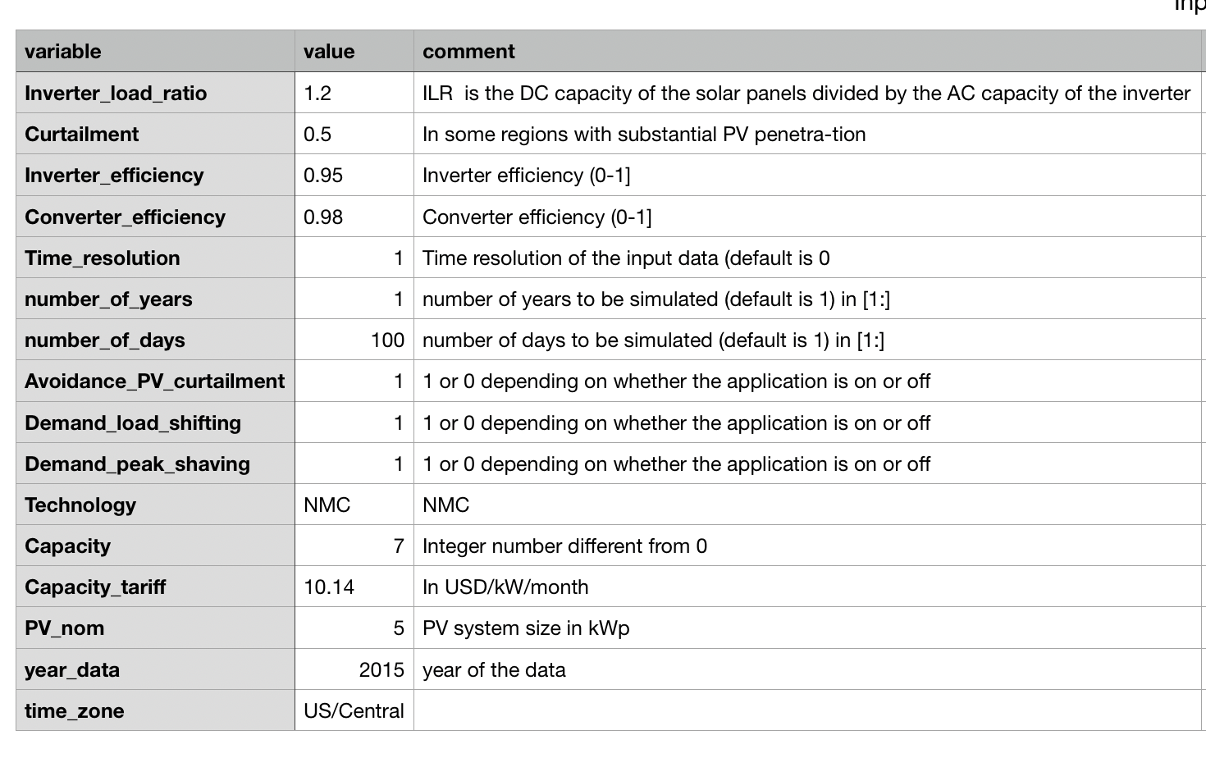

1. **Inverter_load_ratio**

ILR is the DC capacity of the solar panels divided by the AC capacity of the inverter. This difference of capacities leads to some energy being lost or clipped during the sunniest hours of the year.

kWp/kW

1. **Curtailment**

In some regions with substantial PV penetration, a feed-in limit is set above which PV power cannot be injected to the grid to keep grid stability.

It is a % based on the nameplate capacity of the PV system. So 0.5 will be a maximum injection allowed of 50% of the PV power, if there is a 5 kWp PV system, it will be a maximum of 2.5 kW taht are allowed to be injected into the grid

1. **Inverter_efficiency**

Self-explanatory

1. **Converter_efficiency**

Self-explanatory

1. **Time_resolution**

Time resolution of the input data (1 = 1 hour, 0.5 = 30 minutes, 0.25 = 15 minutes)

1. **number_of_years**

Number of years to be simulated (must match input data)

1. **number_of_years**

Number of days to be simulated (must match input data)

1. **Avoidance_PV_curtailment**

Boolean to set if the strategy to avoid PV curtailment will be applied in the model (1 it will be applied, 0 it will be off)

1. **Demand_load_shifting**

Boolean to set if the strategy of load shifting will be applied in the model (1 it will be applied, 0 it will be off)

1. **Demand_peak_shaving**

Boolean to set if the strategy of peak shaving will be applied in the model (1 it will be applied, 0 it will be off)

1. **Technology**

Battery Technology

Options:

NMC - Nickel Manganese Cobalt

NCA - Lithium Nickel Cobalt Aluminium

LFP - Lithium Iron Phosphate

LT0 - Lithium Titanate

ALA - Advanced Lead Acid

VRLA - Valve Regulated Lead Acid

1. **Capacity**

Battery Capacity. Must be an integer number

kWh

1. **Capacity_tariff**

Tariff that is additionally applied based on the capacity required by the installation. To work well it is important to verify if the Final Tariff calculation in the location is similar to the one applied in the model.

This value is defined in USD/kW/month (if the currency changes there is no problem, but must be Currency/kW/month)

1. **PV_norm**

PV system size in kWp

1. **year_data**

The year of the input data

1. **time_zone**

Self-explanatory

Options:

US/Central

**df_1h**

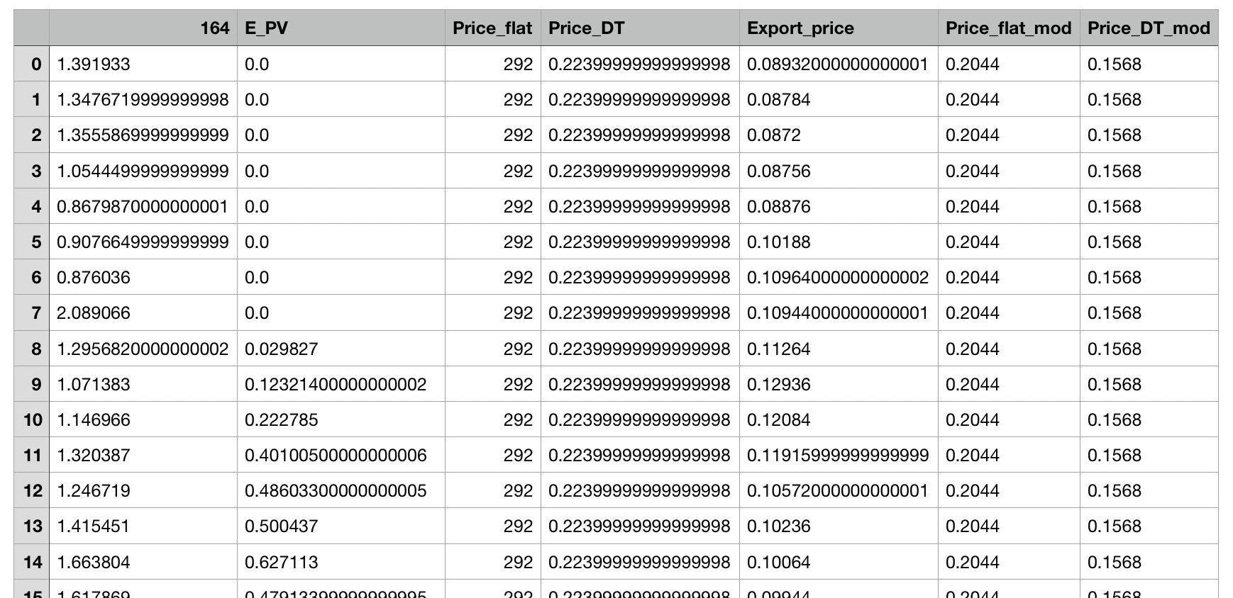

1. **164**

In kWh. 164 is only the household id

1. **E_PV**

Energy generated by the PV Panels (provided based on solar incidence)

1. **Price_flat**
2. **Price_DT**
3. **Export_price**

Price paid by the energy provided to the generator when energy is returned to the grid

1. **Price_flat_mod**
2. **Price_DT_mod**

When a capacity price is introduced, a modification on the volumetric tariff ($/kWh) is made to guarantee that the households will not face a huge increment in the bill

**Basopra Output Variables and Data**

Two files are generated: df and aggregated_results.

**df**

Shows the optimum result identified for each iteration of the model. It is the file with the data that will be transferred to Danny's existing model in excel. Can be used to generate plots of the energy flows and visually compare different cases.

Most of the output variables and their units are identified in this table

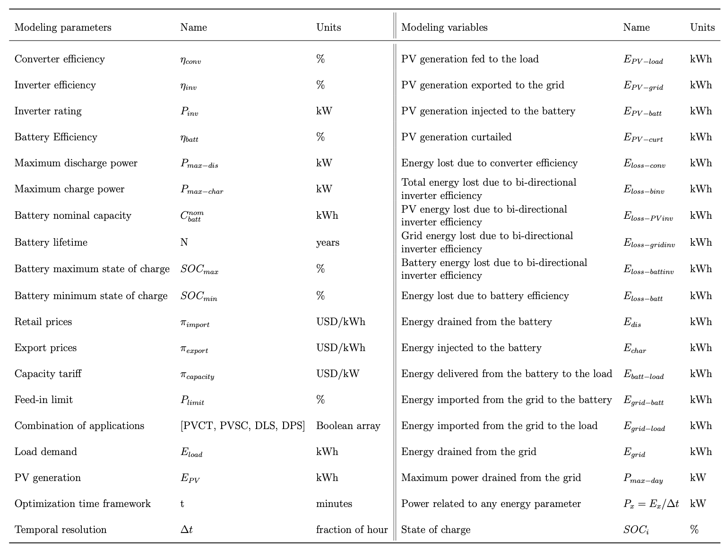

**aggregated_results**

Shows aggregated results for the entire period defined in the input data file. Energy, Power and Financial data

1. **E_PV_batt**

In the table

1. **E_PV_curt**

In the table

1. **E_PV_grid**

In the table

1. **E_PV_load**

In the table

1. **E_char**

In the table

1. **E_cons**

Total energy consumed from the grid. It is a sum of the load that was supplied by the grid, and the load that was used to charge the battery in some situations. In the table is represented by Egrid.

1. **E_dis**

In the table

1. **E_grid_batt**

In the table

1. **E_grid_load**

In the table

1. **E_loss_Batt**

In the table

1. **E_loss_conv**

In the table

1. **E_loss_inv**

In the table

1. **E_loss_inv_PV**
2. **E_loss_inv_batt**
3. **E_loss_inv_grid**
4. **E_demand**

The energy load demanded by the system. Is represented as Eload in the table.

1. **E_PV**

In the table

1. **App_comb**
2. **SOC_mean**

Mean battery state of charge

1. **SOC_max**

Max battery state of charge

1. **SOC_min**

Min battery state of charge

1. **DoD_mean**

A battery’s depth of discharge (DoD) indicates the percentage of the battery that has been discharged relative to the overall capacity of the battery. For example, if you have a Tesla Powerwall that holds 13.5 kilowatt-hours (kWh) of electricity, and you discharge 13 kWh, the DoD is approximately 96 percent.

1. **DOD_max**

Maximum DOD obtained in the cycles.

A value higher than 100 is possible if the battery charged more than once that day.

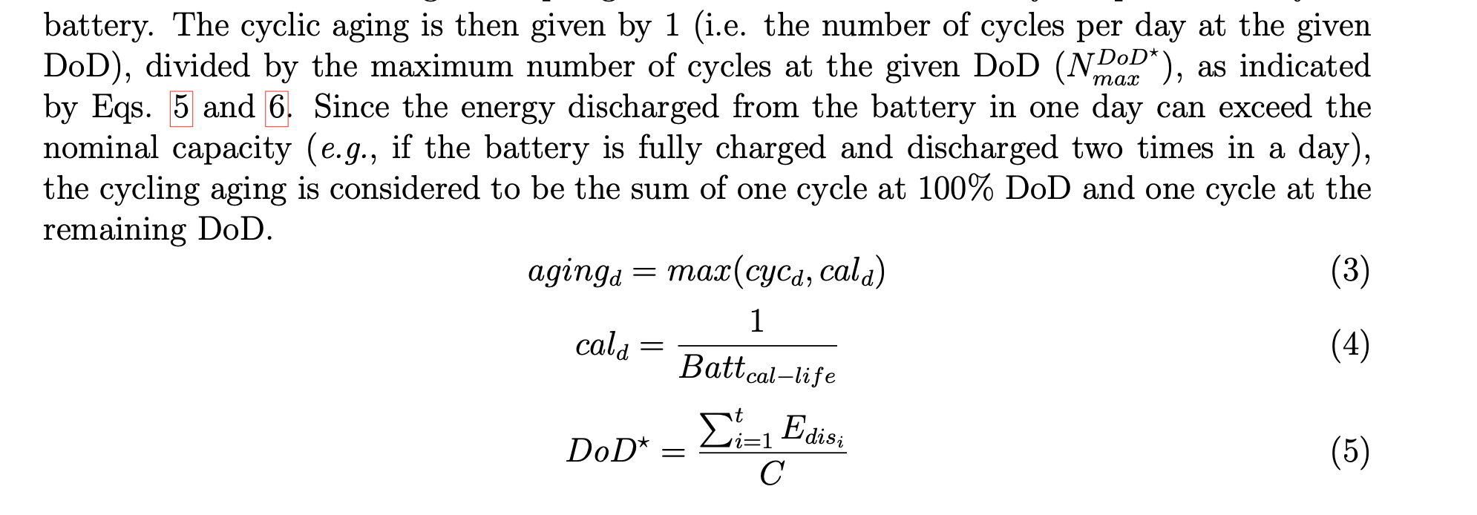

1. **DOD_min**

Minimum DOD obtained in the cycles

1. **last_cap**
2. **cap_fading**
3. **last_SOH**
4. **P_max_year_batt**
5. **P_max_year_nbatt**
6. **Capacity**
7. **Tech**
8. **PV_nom**
9. **name**
10. **results_PVbatt**
11. **results_PV**
12. **results**
13. **EFC_nolifetime**

Equivalent Full Cycles

To compute EFC, the discharge throughput is divided by the nominal capacity C of the battery.

1. **LS**

Is the relation between how much energy was consumed from the grid vs. how much energy was demanded by the load when the tariff price was at the maximum. If there was no load shifting, this would result in 0, but with load shifting there will be less consumption from the grid during the maximum tariff price. The ideal result for this relation is 100%, what would mean that No energy was consumed from the grid during the maximum tariff period, it was all demanded from the battery.

1. **TSC**

TSC - Percentage of PV energy driven to the Demand (Load) AND to the battery

1. **DSC**

DSC - Percentage of PV energy driven to the Demand (Load)

1. **ISC**

ISC - Percentage of PV energy driven to recharge the battery

1. **CU**

CU - Percentage of PV energy curtailed

1. **PS_year**

PS_year – it is a comparison between the power of the shaved peaks vs the original peaks (if there was no peak shaving).

1. **BS**

BS - Relation between the total Battery discharged energy and the total demand (a comparison on how much energy the battery discharged vs what was required by the load)

1. **cycle_to_total**

Related to the aging of the battery, to know which type of aging (calendric or due to cycling) has more weight.

1. **cases**

We use different cases in the literature. Minimum, median and maximum values are used, but you can use the default one (cases==False)