**Test Plan**

**CISC 327**

**Spice Girls**

**Allan Legemaate (Scary Spice) 10199352**

**Megan McClure (Ginger Spice) 20014234**

**Natasha Djurdjevic (Posh Spice) 20023955**

**Irena Dunjic (Sporty Spice) 20017583**

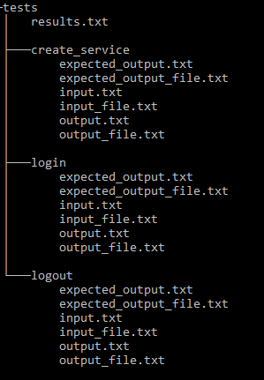

**Test Organization Structure**

Similar test cases are grouped together based on their related features in a directory structure. The directory structure consists of a top level directory containing one subsequent directory for each test category. In each of these directories there will be a subsequent directory for each related test case. These test case directories will include any input files and the expected output files.

**Running the Test**

We have written a python script that takes our csv with all the test cases in it, and restructures it as a group of folders and files with the structure described as above.

We will then, write a bash script that can takes one parameter, a path to the root directory of our “Test File Structure”. This script will parse the file structure and run each test case based upon the input files given. All the outputs will be stored in the respective test folders.

**Correctness Checking and Result Storage**

After running each test as described above, the actual output files will be compared to the expected output files we defined in our test case directories. The success or failure of each test will be then written to a master results file which will be unique to each test run. These files can then be compared between test runs so that we can gauge progress. This file will contain the test name, test result and, in the case of a failure, any discrepancies between the actual and expected outputs.