Step 1: Login into Google Cloud Console with your Gmail address

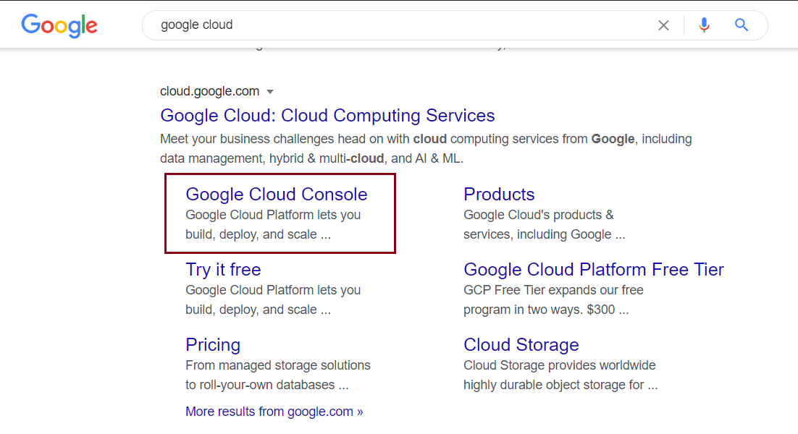

Step 2:

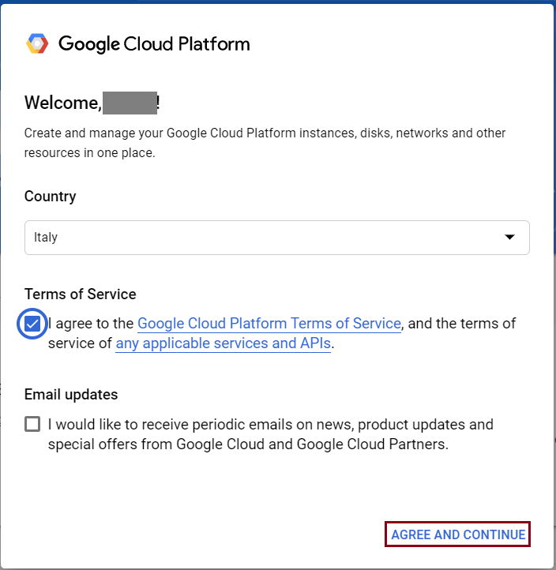

Step 3:

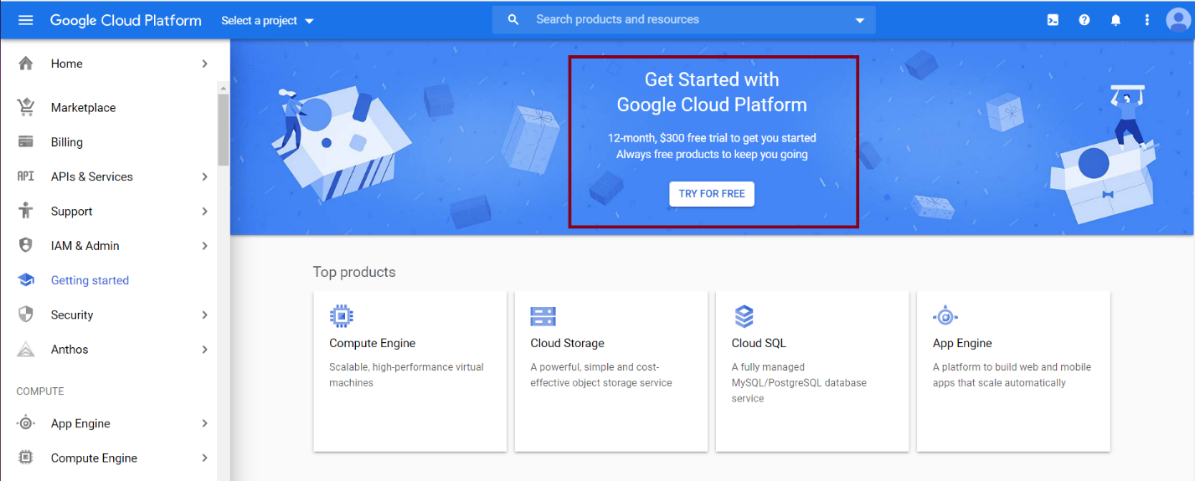

Step 4:

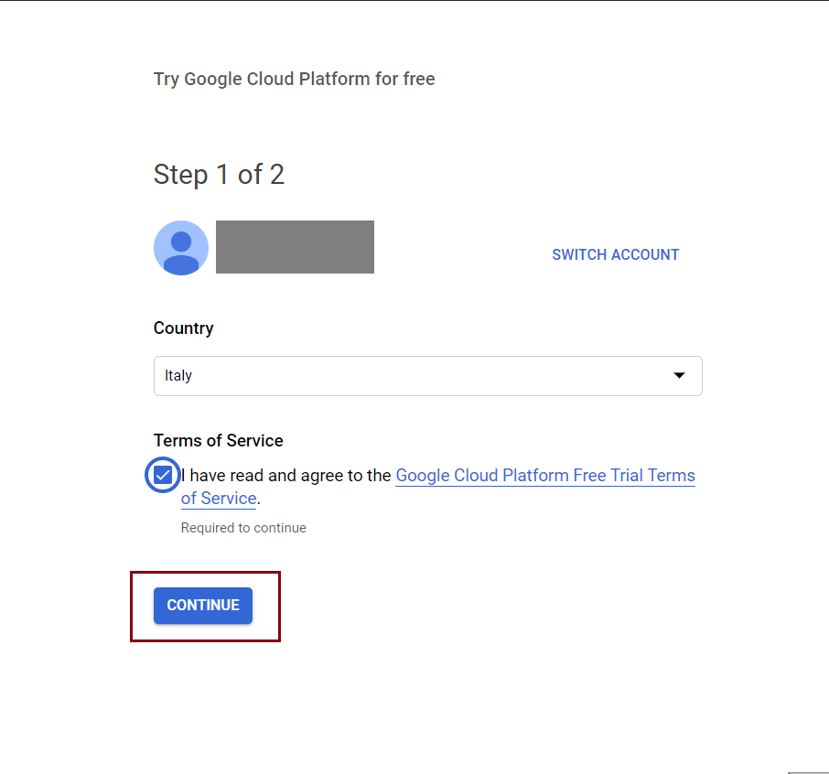

Step 5:

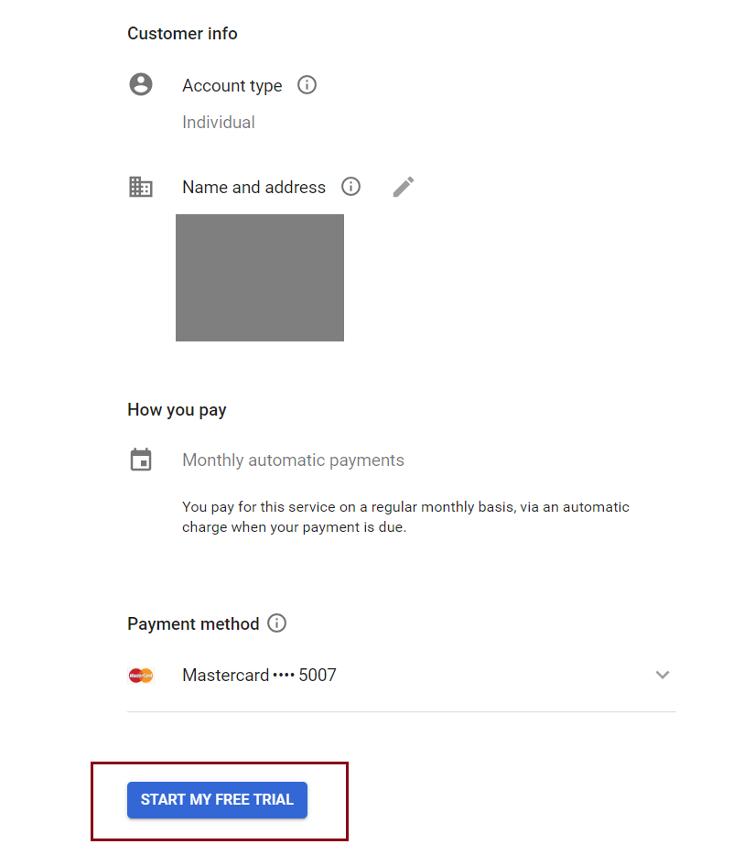

Step 6: Create a new project

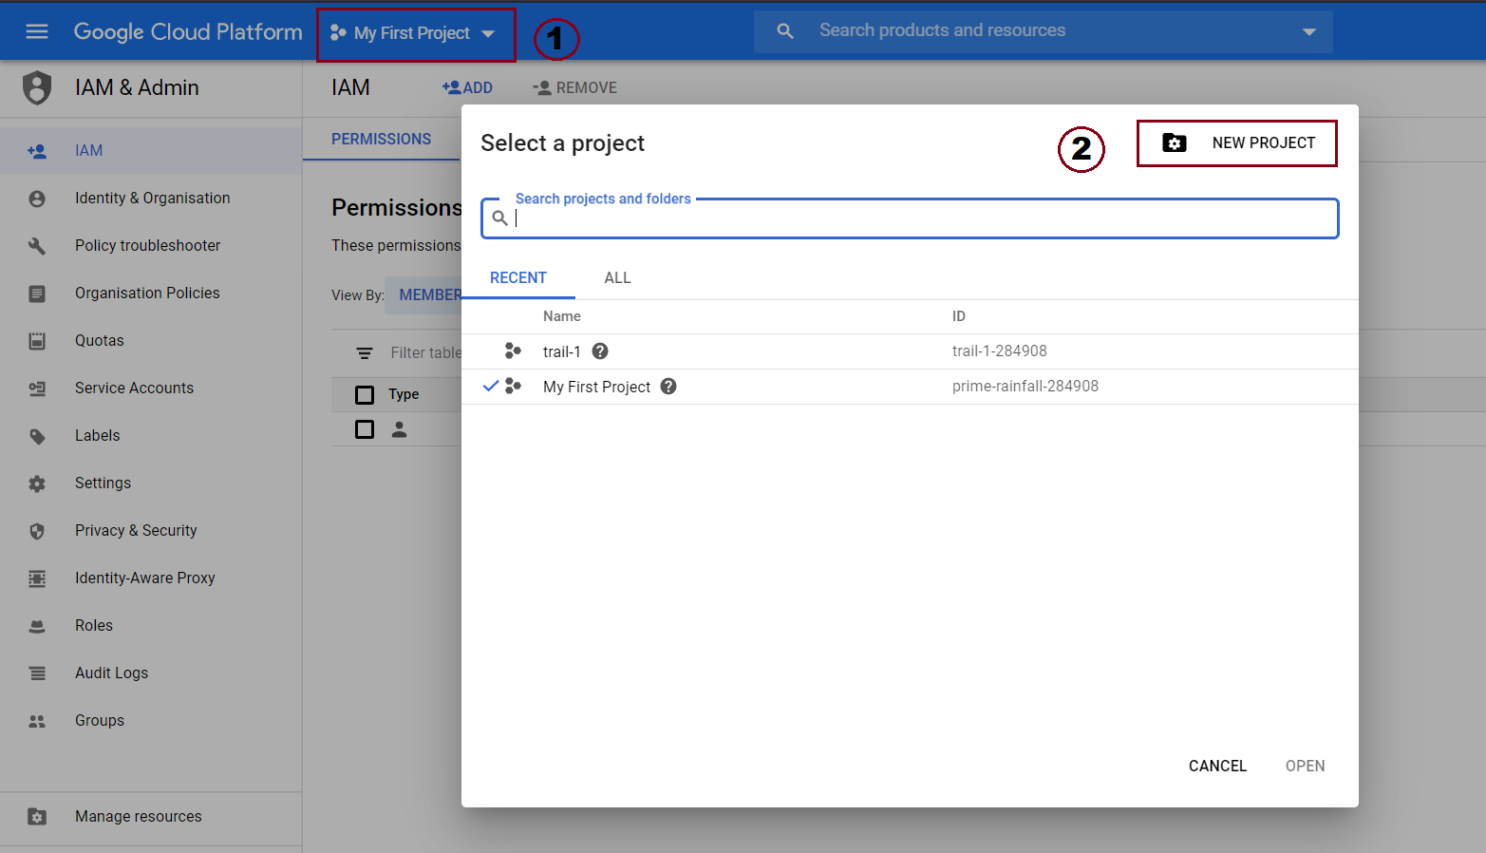

Step 7: Open cloud shell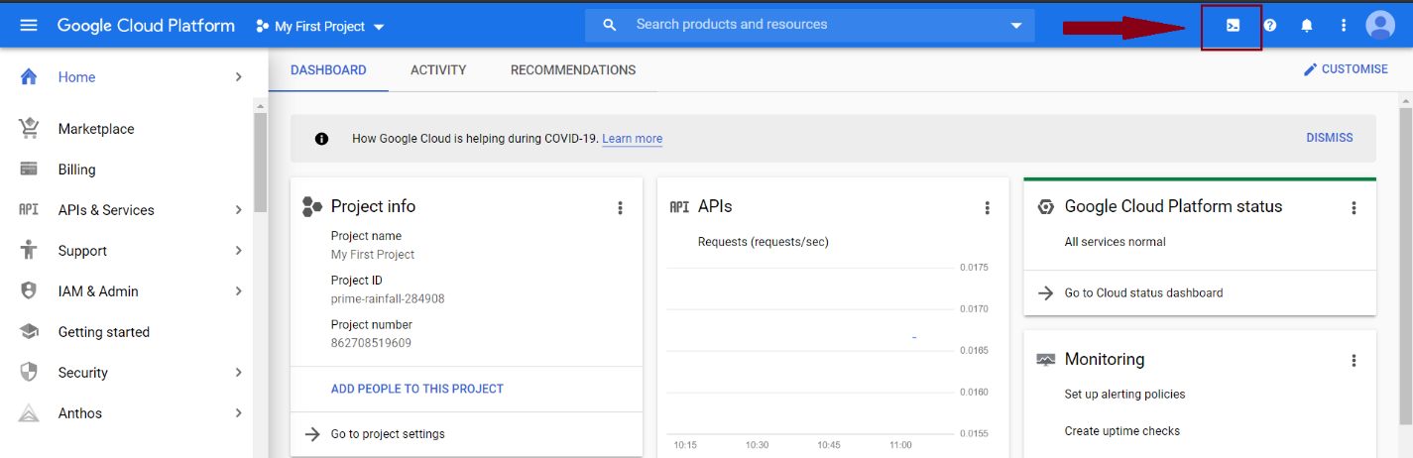

Step 8: Click on Open editor

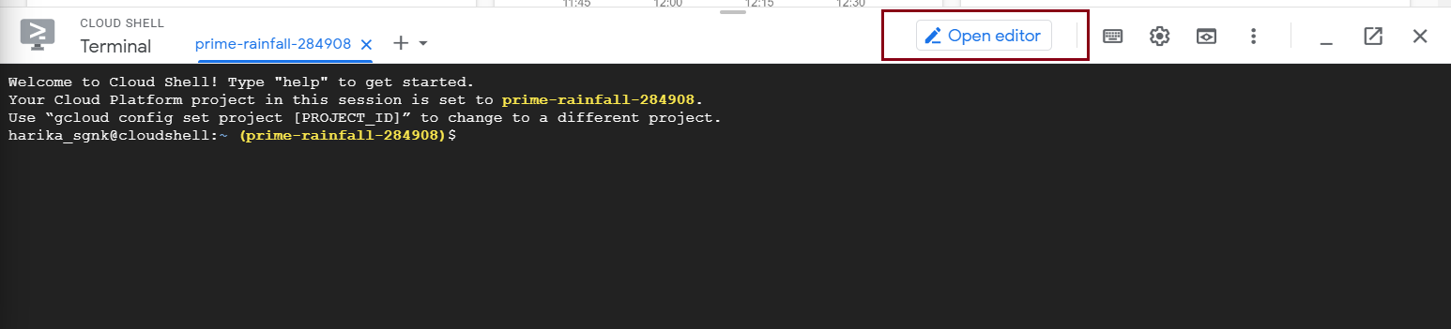

Step 9: Create a new folder for your application

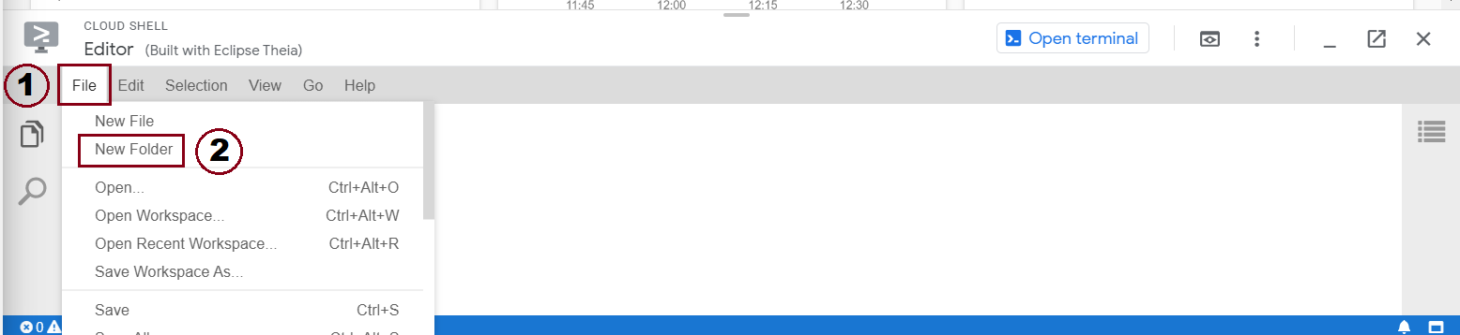

we named our folder ‘python2’, right click on it to create files.

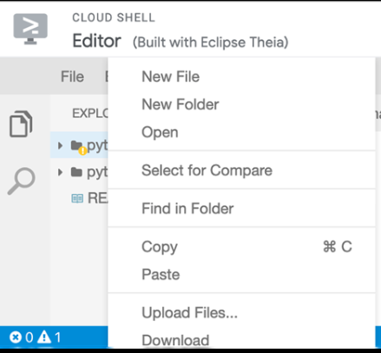

Step 10: Any application needs 3 files to be able to run: app.yaml, requirements.txt, main.py

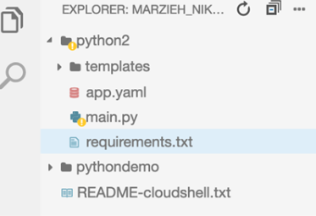

In main we have the main code of the app

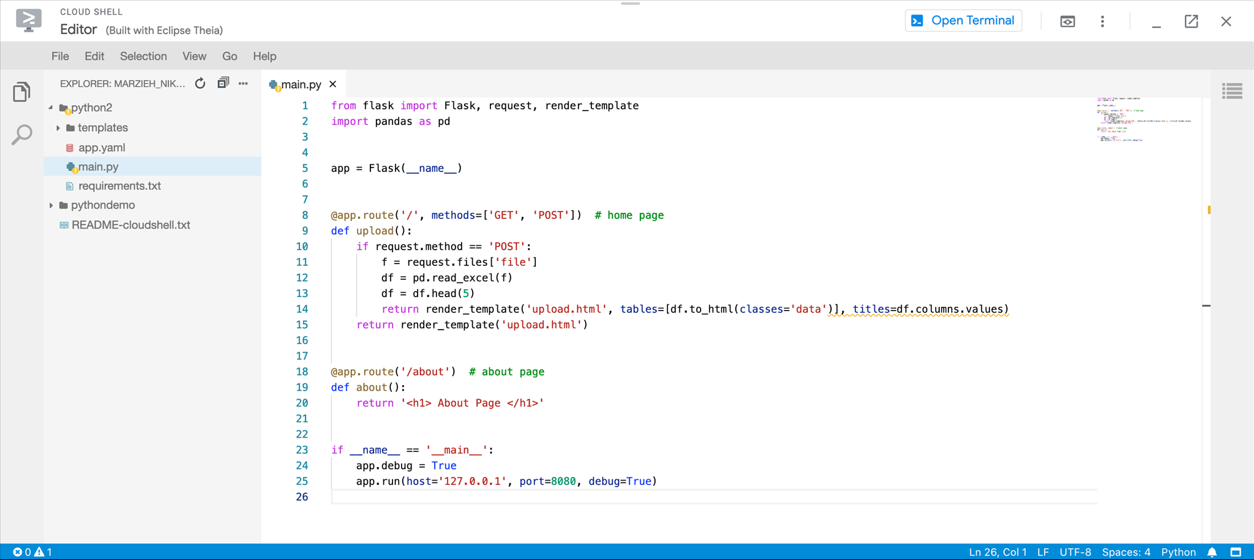

App.yaml file: for now, we use flexible environment

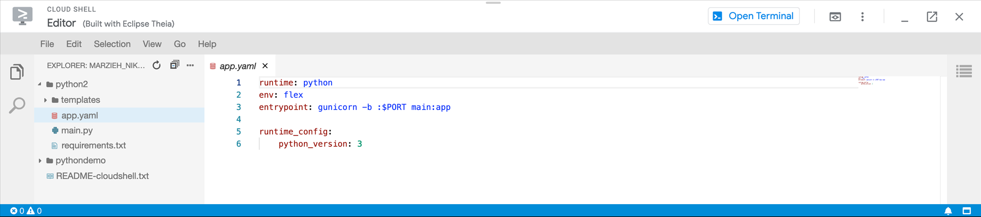

Requirements file contains the necessary packages and their versions

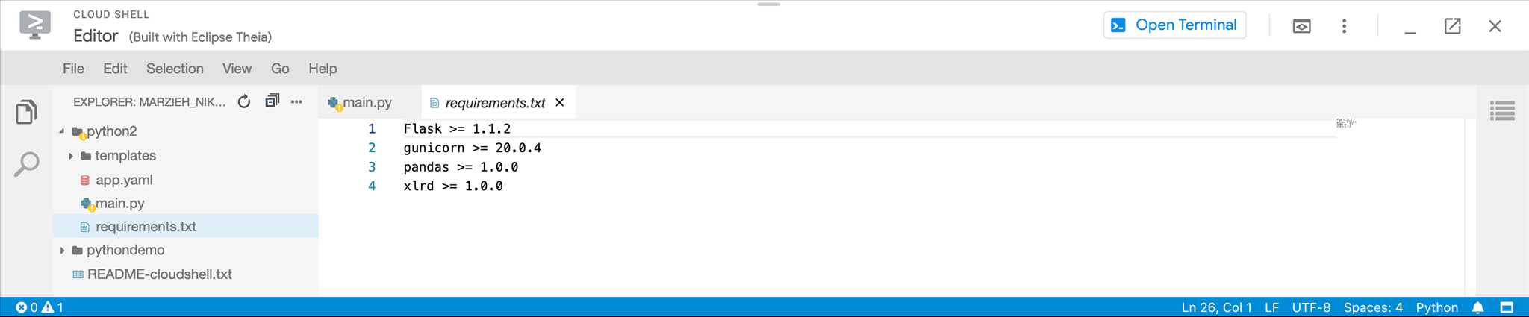

Step 11: After creating the files, click on ‘Open terminal’



Step 12: in the terminal, run following codes:

* ls
* cd python2/ (change this name based on your folder name)
* gcloud app deploy

in the end, you should see something like below picture with a URL address, copy the address

Step 13: paste the address in your browser. If you see this, then congratulations!

Step 14: disable the app when you are done

