Alegre, Beatrice C October 11, 2019

PROGCON Activity #1

***Flowcharts & Pseudocodes***

**What are Flowcharts?**

A flowchart is a visual representation of the sequence of steps and decisions needed to perform a process. Each step in the sequence is noted within a diagram shape. Steps are linked by connecting lines and directional arrows. This allows anyone to view the flowchart and logically follow the process from beginning to end.

A flowchart is a powerful business tool. With proper design and construction, it communicates the steps in a process very effectively and efficiently.

**When do we use them?**

Technically we use the flowcharts when we do the problem solving to reduces the chance that a necessary step for solving a problem will be left out because it appears obvious. In this way, it reduces cost and wastage of time.

With the help of flowchart, problem can be analyzed in more effective way. It specifically shows what type of action each step in a process requires.

**Why is it important?**

For me the importance of flowchart to us is it can help build up a progressively far reaching comprehension of how data, information, and thoughts stream together. It can also simply same segments into a straightforward representation of a complicated structure.

**What are the different flow-charting symbols?**

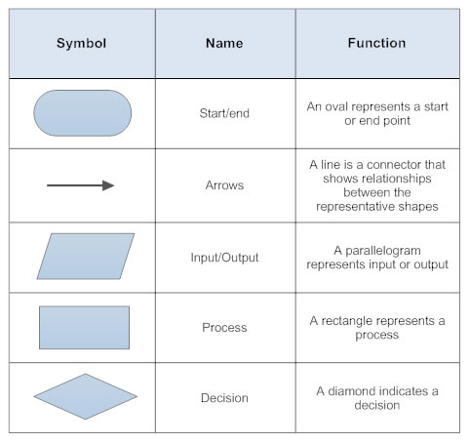

**How and when do we use them?**

Flowcharts were originally used by industrial engineers to structure work processes such as assembly line manufacturing.

Today, flowcharts are used for a variety of purposes in manufacturing, architecture, engineering, business, technology, education, medicine, government, administration and many other disciplines.

**Use the symbols** in a way that makes sense to your audience. But if you **use symbols** in a non-standard fashion, be sure to **do** it consistently so your readers understand your meaning for that symbol each time they see it.

**What are pseudo codes?**

Pseudocode is a simply way of writing programming code in English. It uses short phrases to write code for programs before you actually create it in a specific language. Once you know what the program is about and how it will function, then you can use pseudocode to create statements to achieve the required results for your program.

**When do we use them?**

Sometimes used as a detailed step in the process of developing a program. It allows designers or lead programmers to express the design in great detail and provides programmers a detailed [template](https://whatis.techtarget.com/definition/template) for the next step of writing code in a specific programming language.

**What is it important?**

Pseudocode helps others to understand our work without difficulty. So creating pseudo code and algorithms is a very useful and important skill.

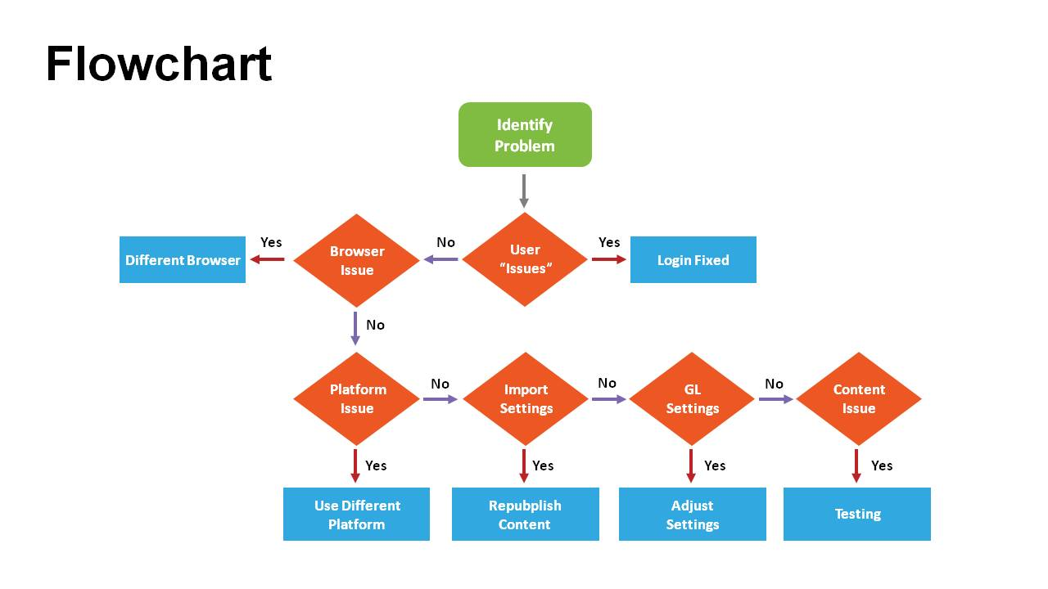**Example of Flowchart and Pseudocodes**

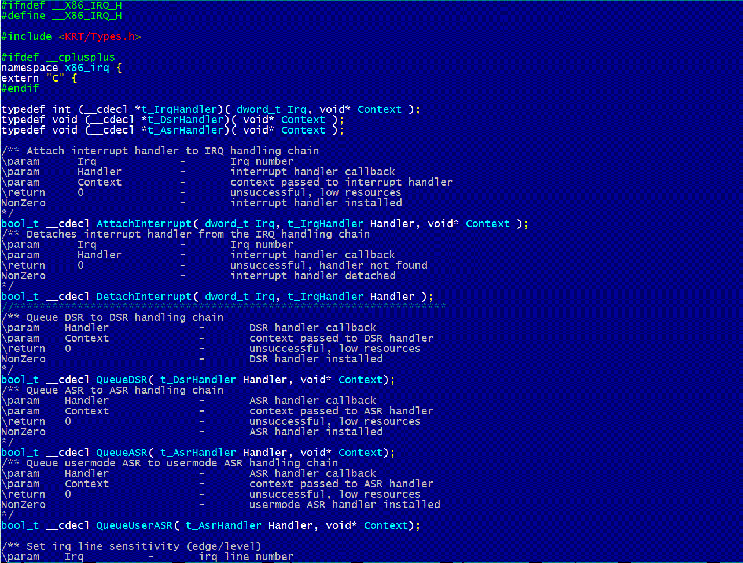**Pseucodes:**