

Pampa Science and Technology Park
Presentation for Technical Mission to China
Beijing & Shanghai
June 20 – July 9, 2026
Prepared by: Émerson Oliveira Rizzatti
Incubator Coordinator – PampaTec / UNIPAMPA

PampaTec – Pampa Science and Technology Park

Presentation for Technical Mission to China – June/July 2026

Business Development & Technology Cooperation

1. Executive Summary
PampaTec (Pampa Science and Technology Park) is the innovation hub of the Federal University of Pampa (UNIPAMPA), located in Alegrete, Rio Grande do Sul, Brazil. Since 2010, PampaTec has been fostering technology-based entrepreneurship, startup incubation, and regional innovation. The park is home to incubated companies, graduated startups, and the first semiconductor design house in the state of Rio Grande do Sul – Tuna Semiconductors, a direct outcome of the Inova Semiconductors program.
This document presents PampaTec's mission, structure, key initiatives, and achievements as a foundation for establishing cooperation and business partnerships with Chinese institutions and companies during the Technical Mission to China in 2026.

2. About UNIPAMPA and PampaTec


2.1 UNIPAMPA – Federal University of Pampa
UNIPAMPA is a federal public university established in 2008, with 10 campuses across the Pampa region of Rio Grande do Sul, at the border with Argentina e Uruguay. The university is committed to teaching, research, extension, and innovation, with a strong focus on regional development and internationalization.

2.2 PampaTec – Science and Technology Park

PampaTec was officially established in 2010 with the appointment of its first coordinator. Its internal regulation was approved by the University Council (CONSUNI) in November 2010 (Resolution No. 18). The park's physical facilities were inaugurated in April 2015, built with a joint investment of R$ 2 million from the Rio Grande do Sul State Government's Program for Technology Parks (PPGTec/RS) and UNIPAMPA.

Mission: To promote regional development through innovative, technology-based entrepreneurship.
Vision: To consolidate itself as a regional reference in innovative technology-based entrepreneurship.
Values: Ethics, Participation, Transparency, Proactivity, Commitment.
Strategic Pillars (2019-2023 Plan): 1. Stimulating knowledge and technology transfer from UNIPAMPA to companies 2. Attracting R&D activities for innovative products, processes, and services 3. Fostering technology-based ventures 4. Promoting competitiveness of knowledge-based companies 5. Supporting initiatives that stimulate entrepreneurial vision 6. Providing internship opportunities and workforce insertion 7. Bridging academia and high-tech companies 8. Supporting business development and management 9. Building partnerships between UNIPAMPA and public/private institutions 10. Enhancing professional qualification of graduates

3. Physical Infrastructure and Location
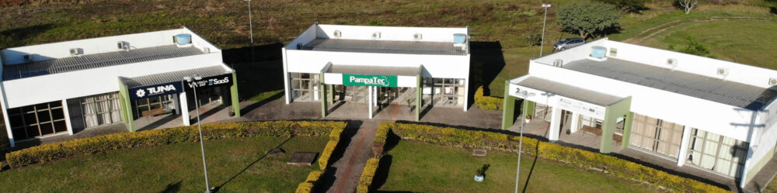 Aerial view of PampaTec
PampaTec is located within UNIPAMPA's Alegrete campus, at Av. Tiarajú, 1.406, in the Ibirapuitã neighborhood. The park occupies a total area of 6 hectares, with 647 m² of built space.

Facilities:
- 10 individual offices for technology-based companies (15 to 43 m² each)
- Air conditioning, high-speed internet, telephony, 24-hour security and janitorial services
- Shared meeting rooms (P21: 8 seats, 50" TV, projector, whiteboard; P26: glass-walled, 8 seats, projector)
- Gourmet space (kitchen, microwave, refrigerator, sink)
- Access to university laboratories and libraries

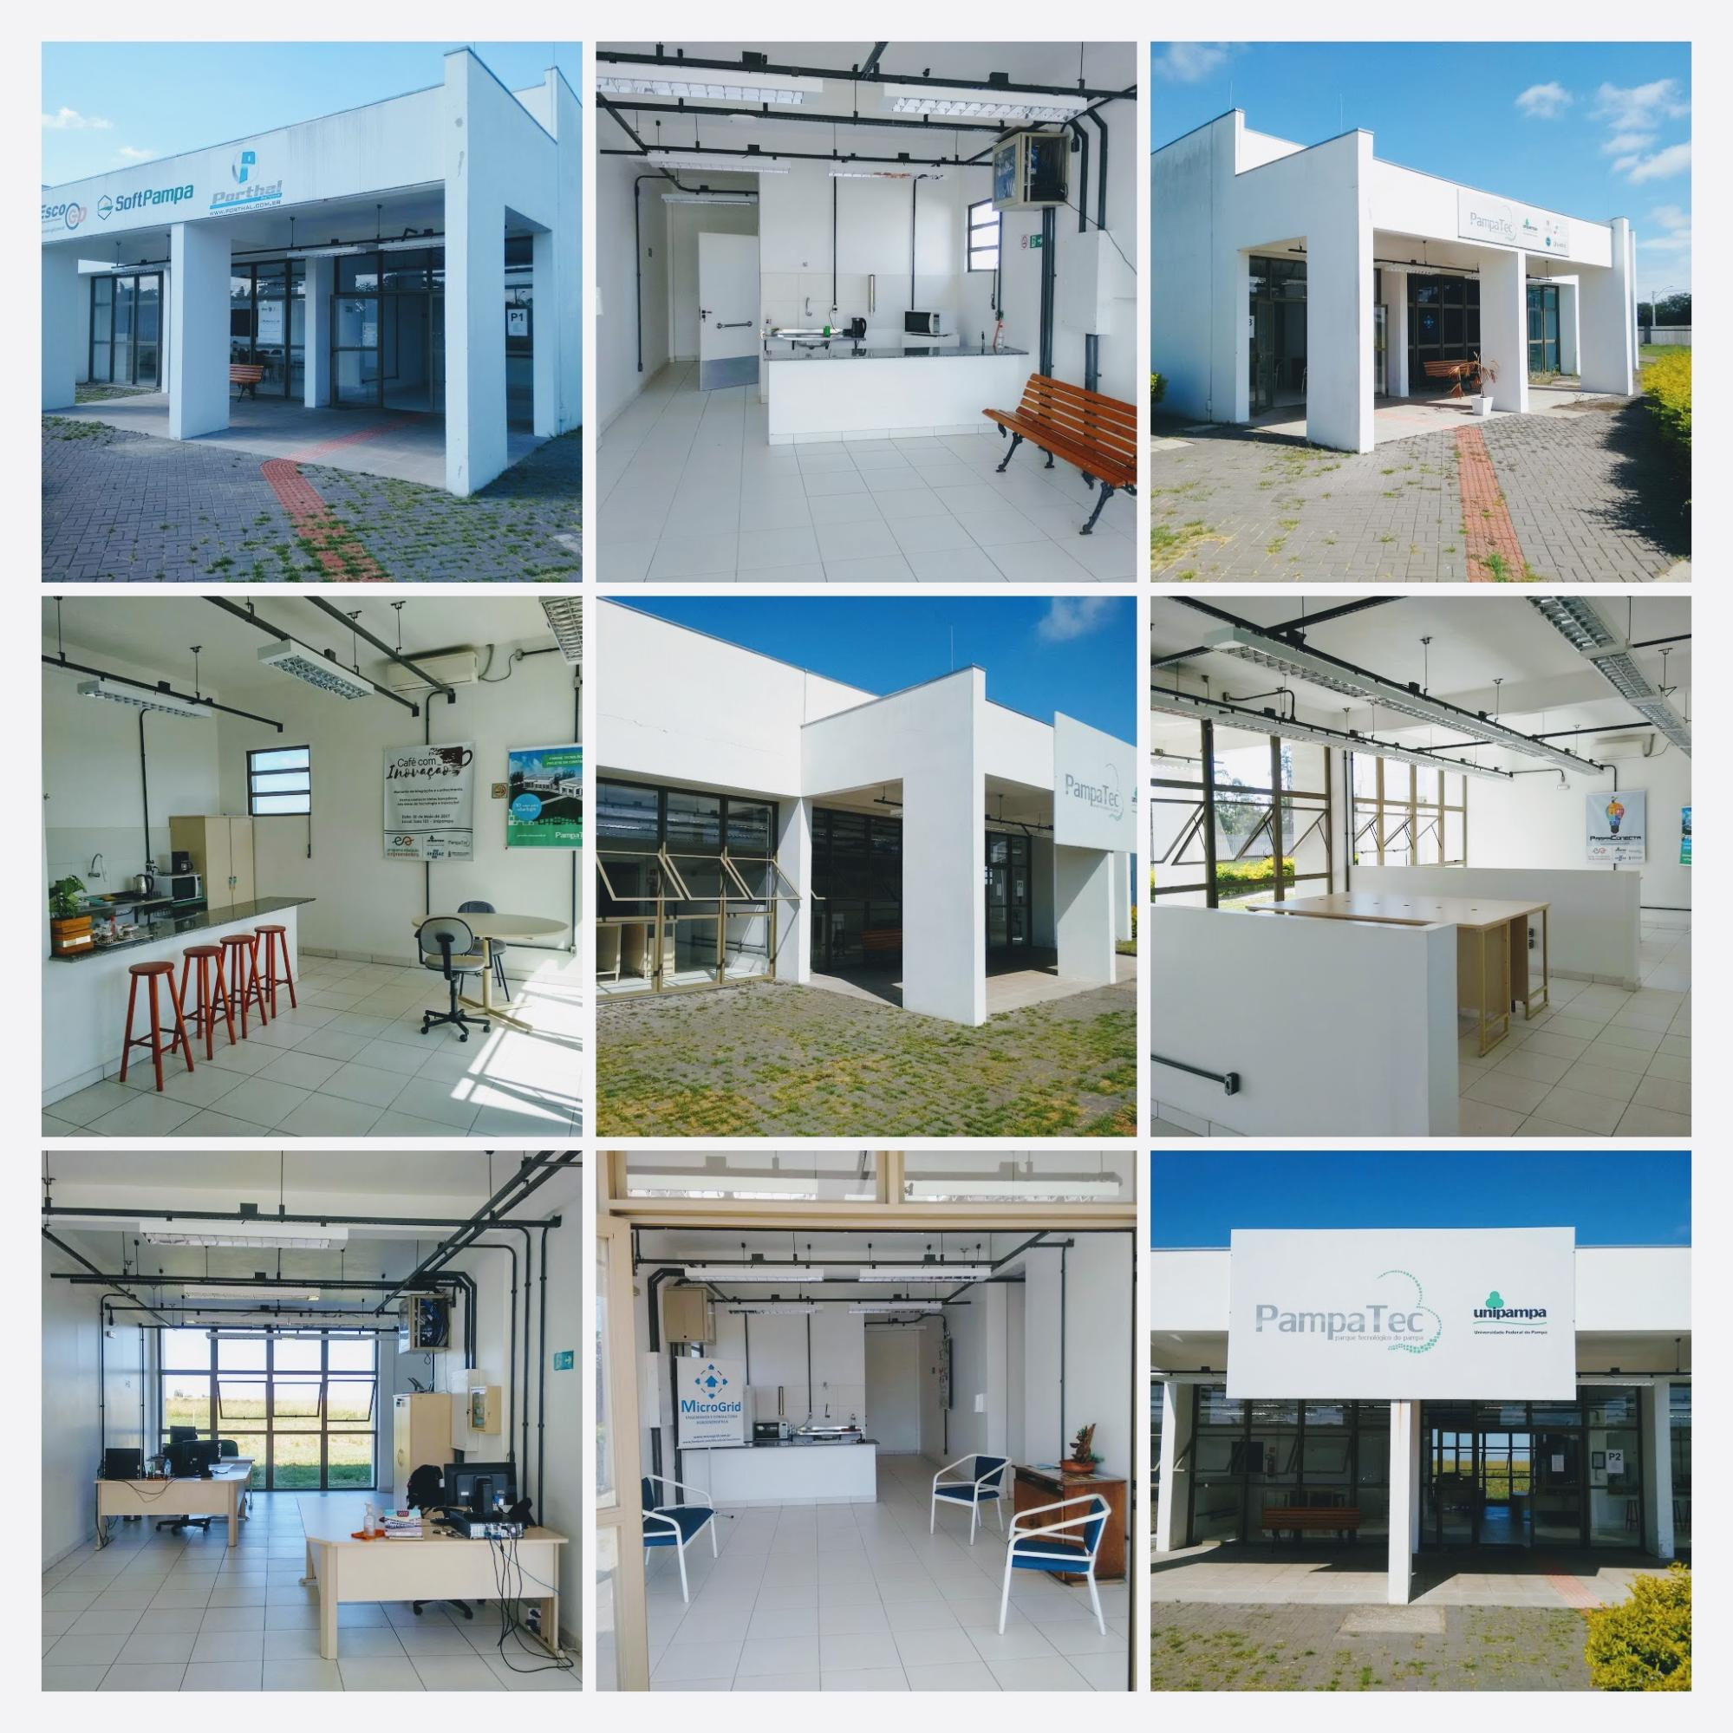 PampaTec physical structure – Exterior and interior views of the park facilities

The location at Alegrete, city in the Campanha region of Rio Grande do Sul, 500 km from Porto Alegre, with the facilities:
- Regional airport (Uruguaiana, 140 km) and bus connections to major cities
- Strategic position for agribusiness, environmental monitoring, and defense technologies
- Municipal Innovation Law (No. 5,810/2017) offering tax incentives:
- Reduced ISS rate (up to 2%) for tech companies
- IPTU exemption
- Direct funding through the Municipal Innovation Fund (FMIT)
- Infrastructure and space for entrepreneurs

4. Incubation Program
The PampaTec Incubator was established on May 23, 2013, through CONSUNI Resolution No. 57. It offers a structured program to support early-stage technology ventures.

Mission (Incubator):
To support and foster new technology-based enterprises as a means to promote social welfare and sustainable development in the southern half of Rio Grande do Sul.

Modalities:
Modality | Description
Pre-Incubation | Activities to stimulate entrepreneurship and prepare projects with business potential (6-12 months). Focus: entrepreneurial awareness, prototype development, business plan.
Incubation | Full technical support program for technology-based startups. Focus: entrepreneur training, business structuring, and growth. Entry via public selection process.
Associated Companies | For consolidated companies (CNPJ > 4 years) seeking proximity to the innovation ecosystem.

What the Incubator Offers:
- Individual office space + shared spaces
- Management support and specialized consulting
- Technical assistance (financial, legal, marketing, business plan)
- Training and qualification programs
- Networking and integration with government and industry
- Broadband internet, fax, telephone
- 24/7 security and cleaning services

Selection Process:
- Proposal reception and preliminary screening
- Oral presentation evaluation (up to 30 min) by Special Commission
- Approval, CNPJ formalization, and incubation contract signing

5. Supported Enterprises – Portfolio
PampaTec has supported over 30 startups since 2014, which have collectively generated more than R$ 7 million in taxes.

Incubated Companies (6):
Company | Value Proposition | Website
Reufy Serviços de Saúde | Complete and integrated healthcare management | reufy.com.br
Venda ERP | White-label ERP system (reseller model) | vendaerp.com.br
2Day IT Solutions | Custom IT development | 2dayitsolutions.com
Gestor Revenda | Used vehicle dealership management | gestorrevenda.com.br
Tuna Semiconductors | Semiconductor IC Design | tunasemiconductors.com
EletroGestor | Electronic assistance management | egestor.kabongo.com.br

Graduated Companies (5):
Company | Value Proposition | Website
Imobi-k | Real estate rental management software | imobik.com.br
EGD Energia | Distributed energy generation projects | egdenergia.com.br
Agrare | Rural property management | agrare.com.br
Agendei Tecnologias | Sports court scheduling platform | agendeiquadras.com.br
DEVPAMPA Sistemas | Sports management systems | devpampa.com

Pre-Incubated Projects (5):
Icaneo IT (procurement management), Seac Gestão (rural management), Controll GRC (risk and compliance), Clique Obra (marketplace for construction), VLCart (smart shopping cart).

6. Entrepreneurship Incentive Programs

6.1 Startup Pampa
A program to foster entrepreneurship within UNIPAMPA, connecting students and researchers to the innovation ecosystem.
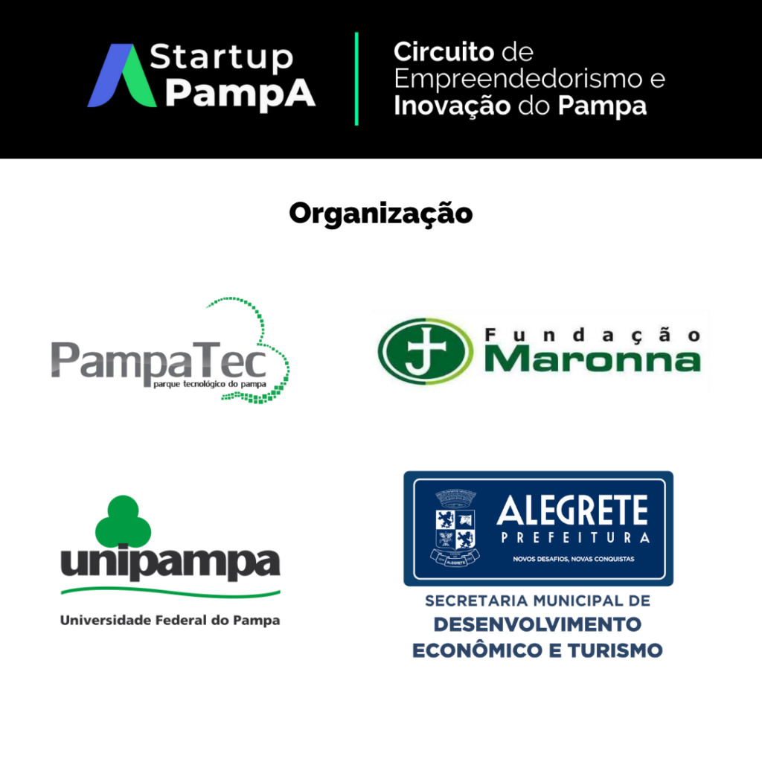
Startup Pampa program logo – Entrepreneurship incentive initiative

Startup Pampa has already fostered over 250 business projects that have become 30 startups launching their ventures with the support of PampaTec.
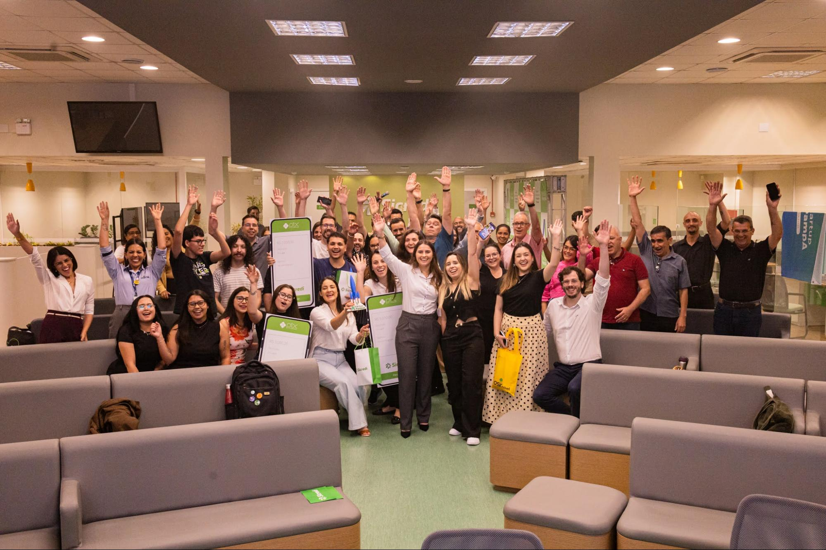 Entrepreneurs who participated in the awards ceremony for the outstanding projects at Startup Pampa 2025.

6.2 PampaCast
PampaTec's official podcast channel, featuring informal conversations with entrepreneurs, launched on YouTube and Spotify.

6.3 Mentorship Program
Launched in 2025, connecting experienced mentors with startup founders through voluntary, free participation (in-person or remote).

6.4 PampaTec Drops
Monthly newsletter covering PampaTec news, ecosystem updates, and opportunities.

7. Strategic Partners
PampaTec has established formal partnerships with leading organizations:
Partner | Type of Support
SEBRAE-RS | Entrepreneurship training and consulting
Amazon Web Services (AWS) | AWS Activate Provider – cloud credits for startups
Asaas | Discounted payment processing fees
INOVA RS (State Government) | Regional Innovation Ecosystem integration
Associação Gaúcha de Startups | Startup network and advocacy
Dell | Discounts on hardware and equipment

8. Institutional Milestones

Year | Milestone
2010 | Coordinator appointed (Portaria No. 1634 – Oct 27)
2010 | Internal Regulation approved by CONSUNI (Resolution No. 18 – Nov 25)
2010 | Registered with PPGTec/RS (Gaúcho Program for Technology Parks)
2013 | Incubator Regulation approved (Resolution No. 57 – May 23)
2015 | Facilities inaugurated – first office spaces available (April)
2025 | PampaTec launches Mentorship Program
2026 | Continuous incubation flow in operation; 16+ active ventures

9. The Inova Semiconductors Program
The Inova Semiconductors UNIPAMPA program was a landmark initiative of the Federal University of Pampa, funded by the State Secretariat for Innovation, Science and Technology (SICT-RS), to train highly qualified professionals in integrated circuit design.

Program Overview
Item | Detail
Course | IC Design Training Program – Mixed-Signal Circuits
Duration | 6 months (September 2024 – March 2025)
Total Hours | 720 hours (240h theory + 480h lab/practice)
Students | 20 selected (full scholarship of R$ 4,000/month)
Location | UNIPAMPA Alegrete Campus
Focus | Analog and Mixed-Signal IC Design (ADCs, DACs, Amplifiers, etc.)

 Inova Semiconductors UNIPAMPA – Program banner

Curriculum
22 Theoretical Modules covering: - Semiconductor physics, MOSFET modeling, single-ended and differential amplifiers - CMOS comparators, oscillators, RF and optical communication circuits - Analog layout, digital logic, HDL, logic synthesis, AMS modeling - Data conversion fundamentals (Nyquist-rate and oversampled ADCs, DACs) - Integration, testability, and AMS verification
16 Practical Modules covering: - EDA tool environment, schematic editing, symbol generation - Testbench creation, electrical simulation (transient, DC, AC, noise) - Statistical simulation (Monte Carlo, corners) - Analog layout flow: editing, DRC, LVS, extraction - Digital simulation, logic synthesis, physical synthesis - Full AMS layout flow

Faculty
The program was taught by 12 PhD professors and industry professionals from: - UNIPAMPA (Prof. Dr. Alessandro Girardi, Prof. Dr. Paulo C. C. Aguirre, Prof. Dr. Crístian Muller, Prof. Dr. Sidinei Ghissoni) - Chipus Microelectronics (Dr. Adriano Oliveira, Dr. Heider Madureira, William Prodanov, Rodrigo Rottava) - EnSilica (Daniel Barcelos, Everton Ghignatti) - UNISINOS (Prof. Dr. Sandro Binsfeld Ferreira) - ITA – Aeronautics Institute of Technology (Prof. Dr. Lucas Compassi Severo)

 GAMA (Microelectronics Support Group) logo – Program realization partner

Partner Companies and Institutions
Category | Partners
Execution | UNIPAMPA, GAMA, PampaTec, SICT-RS
Private Sector | Chipus, EnSilica
Academia | UNISINOS
Government | Alegrete City Hall / SEDETUR

In-Company Training
Each student completed: - 40 hours (5 days) of training at partner microelectronics companies - 56 hours of training at PampaTec, immersing in the practical business environment

Entrepreneurship Training
16 hours of complementary entrepreneurship and innovation training through the Startup Pampa program, equipping students with business skills alongside technical expertise.

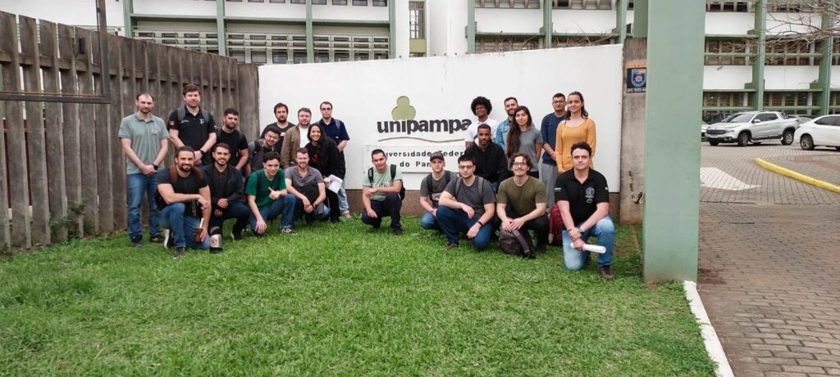 inova_aula_01.jpg > Inova Semiconductors classes in session – Students working on IC design projects

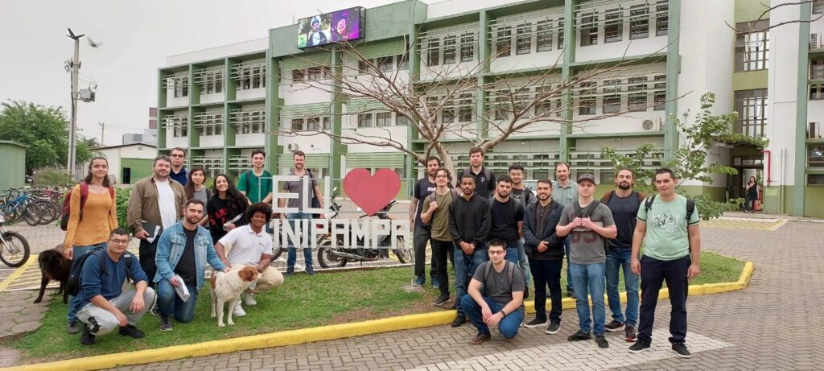 Inova Semiconductors – Practical laboratory activities at UNIPAMPA Alegrete campus

Workshop and Job Fair
On March 11, 2025, the program concluded with a Workshop and Job Fair, where students presented their IP-core projects:
Group | Project
AFE PPG | Analog Front-End for Photoplethysmography
AFE ECG | Analog Front-End for Electrocardiography
ADC ΣΔ Biomedical | Sigma-Delta ADC for biomedical applications
ADC ΣΔ Audio | Sigma-Delta ADC for audio range
ADC SAR | Successive Approximation Register ADC
Participating companies at the Job Fair: Cadence, CEITEC, Chipus, EnSilica, Impinj, Instituto SENAI de Inovação em Microeletrônica.

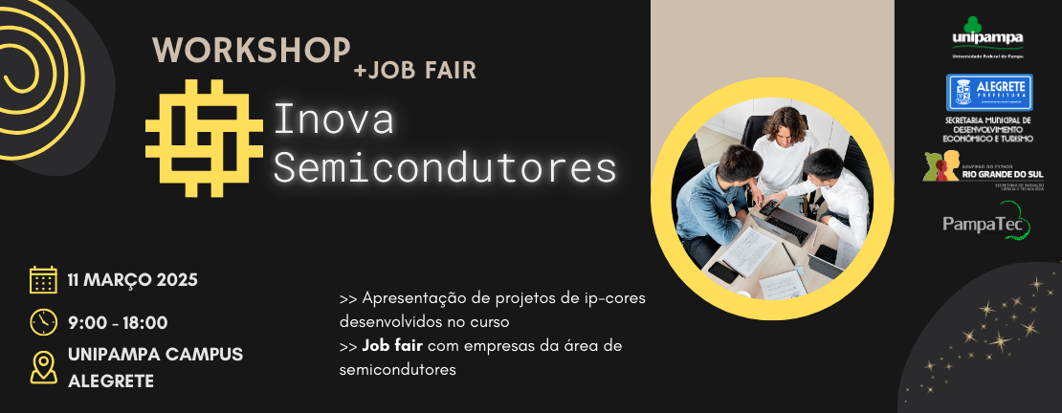 Workshop Inova Semiconductors + Job Fair – March 11, 2025

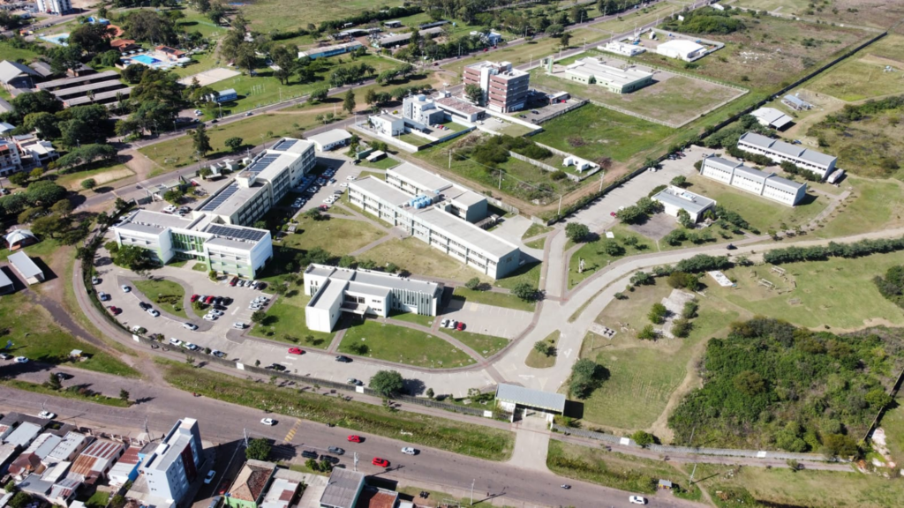
Aerial view of UNIPAMPA Alegrete Campus where the program took place

10. Tuna Semiconductors – The First Gaúcha IC Design House

Tuna Semiconductors is the first semiconductor design company based in Rio Grande do Sul, Brazil, and a direct outcome of the Inova Semiconductors program. The company was incubated at PampaTec and represents a major milestone in Brazil's semiconductor ecosystem.

Tuna Semiconductors – "Fully custom ADCs and Analog Front-Ends for your system"

Company Profile
Item | Detail
Founded | 2025
Location | PampaTec Technology Park, Alegrete - RS, Brazil
Segment | Semiconductor IC Design House
Specialization | Analog and Mixed-Signal Integrated Circuits (ADCs, Analog Front-Ends)
Website | tunasemiconductors.com
Contact | contact@tunasemiconductors.com / +55 55 98154-5493

Services
Service | Description
Analog IC Design | Amplifiers, voltage references, and custom analog blocks
Mixed-Signal Design | Integration of analog and digital systems (ADCs, DACs)
IP Core Development | Custom and reusable IP cores tailored to product requirements

Technology Focus
- CMOS technologies
- Monte Carlo and corner analysis
- Low-power and high-reliability design techniques
- End-to-end support: from concept to tape-out
- Fully custom IP development using industry-standard design flows

Why It Matters
Tuna Semiconductors represents a breakthrough for the Brazilian semiconductor industry: - First IC design house in the state of Rio Grande do Sul - Born from the successful Inova Semiconductors training program - Located in the PampaTec innovation ecosystem - Demonstrates Brazil's growing capability in advanced semiconductor design - Potential partner for Chinese semiconductor companies seeking design services, co-development, or access to the South American market

11. REGINP – Gaúcha Network of Innovation Environments
PampaTec is an active member of REGINP (Rede Gaúcha de Ambientes de Inovação), the state-level network that connects innovation environments across Rio Grande do Sul. In December 2025, Émerson Rizzatti (PampaTec Incubator Coordinator) was re-elected as Director of New Environments for the 2026-2027 term.
The network's mission is to foster collaboration, experience exchange, and joint initiatives to strengthen the innovation ecosystem in the state, including the creation of a network-wide incubation program.

12. Opportunities for Cooperation with China
Based on PampaTec's track record and the strategic focus of the 2026 China Mission, the following cooperation opportunities are identified:

12.1 Semiconductor Design & Manufacturing
- Co-development of mixed-signal IP cores with Chinese IC design companies
- Talent exchange and joint training programs inspired by the Inova Semiconductors model
- Access to advanced CMOS fabrication nodes through Chinese foundries
- Partnership with Tuna Semiconductors for custom ADC/AFE solutions

12.2 IoT and Embedded Electronics
- Collaboration on sensor networks and environmental monitoring (relevant to Beijing Emergency Expo)
- Joint R&D in edge computing and embedded AI
- Supply chain partnerships for components, PCBs, and microcontrollers

12.3 Technology Transfer and Innovation Management
- Exchange of best practices in technology park management
- Joint incubation and acceleration programs
- Brazil-China dual-market access for startups

12.4 Academic and Research Cooperation
- Student and researcher exchanges between UNIPAMPA and Chinese universities
- Joint publications and research projects in microelectronics, IoT, and AI
- Dual-degree programs in semiconductor engineering

13. Contact
PampaTec – Pampa Science and Technology Park - Federal University of Pampa (UNIPAMPA)
- Address: Av. Tiarajú, 1.406 – Bairro Ibirapuitã CEP: 97.546-550 – Alegrete – RS – Brazil
- Phone: +55 (55) 3421 8417
- E-mail: pampatec@unipampa.edu.br
Émerson Rizzatti – Incubator Coordinator / REGINP Director of New Environments
- E-mail: emersonrizzatti@unipampa.edu.br
- WeChat:

Tuna Semiconductors:
- E-mail: contact@tunasemiconductors.com
- Phone/WhatsApp: +55 55 98154-5493
- LinkedIn: linkedin.com/company/tunasemiconductors

