

COURSE TITLE: DATA and WEB MINING

# Project Title: - Predicting Students Health Information Using Data Mining Technique: in case of UOG Atse Tewdrous Campus Student Clinic

BY: -

AlehegnAdane

Lema Misgan

Lakew Tarekegn

Submitted to: Dr. Mahalakshmi

# CHAPTER ONE

## 1. Introduction

Data mining is the process of discovering interesting patterns (or knowledge) from large amounts of data or extracting or “mining” knowledge from large amounts of data. The term is actually a similar with mining of gold from rocks or sand. The data mining sources can include databases, data warehouses, the web, other information repositories, or data that are streamed into the system dynamically. Classification is the process of finding a model (or function) that describes and distinguishes data classes or concepts. The model is derived based on the analysis of a set of training data and is used to predict the class label of objects for which the class label is unknown. (Jiawei Han and Micheline Kamer, 1999)

The aim of this study is build a model which can recommend the university student clinic service. Document review was the basic data collection technique.

## 1.1 Background of the study

University of Gondar formerly called College of Medical Sciences. It is the oldest and most popular medical school in Ethiopia. It is established as Public Health College in 1954. It is located in Amhara regional state southern Gondar, Gondar city. The university serve the community in education as well in medical service using university hospital for more than 60 years. Beside this, in every campus it provides free clinical health care service for students. University of Gondar Student’s clinic provides patient medical care for all currently enrolled, eligible students for undergraduate programs in all discipline/ departments.

**Problem Statement**

University of Gondar has five branches of student clinic which provides clinical services for the students free of charge. In connection to this, the clinic is responsible to keep the wellbeing of the student’s health. The clinic provides patient medical care for all currently enrolled, eligible students for programs in all discipline/ departments.

According to the university student clinic report, student’s health information is affected by different types of diseases. The report shows students are susceptible to different health problems which lead to low academic performances and withdrawal. Data mining classification technique is used for predicting student’s medical health problem.

**Objective of the project**

**1.3.1 General objective**

The general objective of this project is to predict student’s health information using data mining classification technique by referring previous clinical history of students.

### 1.3.2 Specific Objectives

In order to achieve the general objective, the following specific objectives are specifying:

* To read data mining related literature,
* To collect data from student’s clinic,
* To preprocess row data,
* To develop model,
* To test the result,

## 1.4 Scope of the project

The scope of this project is developing a model which can predict student’s health information using classification technique. The project is conducted in University Gondar of Atse Tewdrows campus student’s clinic. The project includes the following activities;

It includes;

* Data collect
* Data preprocess
* Test the model

# CHAPTER TWO

# 2. Approach/Methodology

2.1 Data collection technique

To collect necessary data for the project we have used the document review technique. We have analyzed the two months (2006 and 2007 academic year) student’s health information that we have got from the student’s clinic.

In order to accomplished this project we used the Knowledge discovery process (KDD) data mining process: it consists of an iterative sequence as follows:

* Goal Identification: Developing an understanding of the application domain
* Data Integration: Various heterogeneous data sources may be integrated into one.
* Data Cleaning and Preprocessing: Handling noisy, erroneous, missing, or irrelevant data.
* Data Transformation: Data are transformed into forms appropriate for mining by performing aggregation operations.
* Data Mining: Intelligent mining methods are applied for searching patterns of interest.
* Pattern Evaluation: to identify the truly interesting patterns representing knowledge based on some interestingness measures
* Utilize Discovered Knowledge: Documenting gained knowledge or applying into another system for further action. Compare for conflicts with previously believed knowledge

**2.2 Tools**

* We used WEKA 3.7.9 version. It is open source software which is developed under the University of Waikato.

**2.3 Algorithms**

* Trees - J48
* Bayes- Naivebayes
* Function

**2.4 Proposed Solution**

**a) Actual preprocessing**

The actual preprocessing step for conducting this project includes Encoding of the patient records/data into excel format and then perform data cleaning process it includes (remove the outliers and fill the missing values) and select the relevant attributes.

After cleaning all the data that can be recorded in excel file format. Then we convert the excel file(.xlsx) format into .CSV (comma delimited value) file type and then convert the .CSV file type into .Arff (Attribute relation file format) file which is compatible for WEKA data mining software to easily analyze the dataset.

The initial dataset for this project is includes the following instances and attributes:

* Number of Instances = 100
* Number of attributes = 28

**Data format transforming**

|  |  |
| --- | --- |
| **Results** | **Symbol letter** |
| AFI | A |
| AGE | B |
| Allergic | C |
| Arthritis | D |
| Common Cold | E |
| Conjunctivitis | F |
| Dental | G |
| Diaharia | H |
| Dyspepsia | I |
| eye problem | J |
| fungus | K |
| Gastritis | L |
| GUTI | M |
| Headache | N |
| I/P | O |
| LRTI | Q |
| PUD | P |
| R/O TB | Q |
| RTI S | R |
| S/E | T |
| Skin allergic | U |
| Tonsillitis | V |
| Toothache | W |
| URTI | X |
| UTI | Y |

@relationlearn-weka.filters.unsupervised.attribute.Remove-R10-weka.filters.supervised.instance.Resample-B1.0-S1-Z10.0

@attribute AGE {18,19,20,21,22,23,24,25,26,28,30,34,35,37,39,40,47}

@attribute GENDER {M,F}

@attribute BLOCK numeric

@attribute DEPARTMENT {Acc, Agri, Bio, BioT, Civil, Chem,CS, Eco, Engi, Geo, Geolg, IS, IT, Law, Mark, Maths, Medi, Mgt, Phys, SpoS, Stat, Tour, Vet}

@attribute ToothPain {yes,no}

@attribute EyeSensation {yes,no}

@attribute AbdominalBowll {yes,no}

@attribute LucrtionPain {yes,no}

@attribute EarPain {yes,no}

@attribute Fever {yes,no}

@attribute Headache {yes,no}

@attribute JointPain {yes,no}

@attribute ProCough {yes,no}

@attribute EpiPain {yes,no}

@attribute EpiBurning {yes,no}

@attribute KneePain {yes,no}

@attribute nonProCough {yes,no}

@attribute SkinITching {yes,no}

@attribute Tonsil {yes,no}

@attribute SkinInfect {yes,no}

@attribute LossOFApptiet {yes,no}

@attribute ChestPain {yes,no}

@attribute UrinationBurnning {yes,no}

@attribute AbdominalCrump {yes,no}

@attribute Diharria {yes,no}

@attribute DryCough {yes,no}

@attribute RESULT {A,B,C,D,E,F,G,H,I,J,K,L,M,N,O,P,Q,R,S,T,U,V,W,X,Y}

@attribute YEAR {1,2,3,4,5,6,7}

@data

25,M,32,Agri,yes,no,no,no,no,no,no,no,no,no,no,no,no,no,no,no,no,no,no,no,no,no,W,2

19,F,24,IT,no,yes,no,no,no,no,no,no,no,no,no,no,no,no,no,no,no,no,no,no,no,no,J,2

25,M,31,Geolg,no,no,yes,no,no,no,no,no,no,no,no,no,no,no,no,no,no,no,no,no,no,no,?,2

20,M,26,CS,no,no,no,yes,no,no,no,no,no,no,no,no,no,no,no,no,no,no,no,no,no,no,?,1

24,M,34,Vet,no,no,no,no,yes,no,no,no,no,no,no,no,no,no,no,no,no,no,no,no,no,no,?,5

20,F,24,Mgt,no,no,no,no,no,yes,yes,no,yes,no,no,no,no,no,no,no,no,no,no,no,no,no,P,3

21,M,26,CS,no,no,no,no,no,yes,yes,yes,no,no,no,no,no,no,no,no,no,no,no,no,no,yes,?,1

22,F,31,CS,no,no,no,no,no,yes,yes,no,no,no,no,no,no,no,no,no,no,no,no,no,no,no,E,2

21,M,31,Acc,no,no,no,no,no,yes,yes,no,no,no,no,no,no,no,no,no,no,no,no,no,no,yes,E,3

23,M,31,Mgt,no,no,no,no,no,no,no,no,no,no,no,no,no,no,no,no,yes,no,no,no,yes,no,?,3

20,F,29,Bio,no,no,no,no,no,no,no,no,yes,no,no,no,no,no,yes,no,no,no,no,no,no,no,?,1

20,F,24,Agri,no,no,no,no,no,no,yes,no,no,no,no,no,no,no,no,no,no,no,no,no,no,no,E,2

23,F,25,Stat,no,no,no,no,no,no,yes,no,yes,no,no,no,no,no,no,no,no,no,no,no,no,no,P,4

25,M,31,CS,no,no,no,no,no,no,yes,no,yes,no,no,no,no,no,no,no,no,no,no,no,no,no,?,2

22,M,34,Vet,no,no,yes,no,no,no,no,no,no,no,no,no,no,no,no,no,no,no,no,no,no,no,O ,2

20,M,26,CS,no,no,no,no,no,no,no,no,yes,no,no,no,no,no,no,no,no,no,no,no,no,no,?,1

23,M,30,SpoS,no,no,no,no,no,no,no,no,no,yes,yes,no,no,no,no,no,no,no,no,no,no,no,Q,3

21,M,31,CS,no,no,no,no,no,no,no,no,no,no,no,yes,no,no,no,no,no,no,no,no,no,no,?,2

22,M,32,SpoS,no,no,no,no,yes,no,no,no,no,no,no,no,no,no,no,no,no,no,no,no,no,no,E,2

20,F,28,Agri,no,no,no,no,yes,no,yes,no,no,no,no,no,no,no,no,no,no,no,no,no,no,no,?,1

20,M,31,IS,no,no,no,no,no,no,yes,no,yes,no,no,no,no,no,no,no,no,no,no,no,no,no,P,3

18,M,35,Mgt,no,no,no,no,no,no,no,no,no,no,no,no,yes,no,no,no,no,no,no,no,no,no,E,1

20,F,29,CS,no,no,no,no,no,yes,no,no,no,no,no,no,no,yes,no,no,no,no,no,no,no,no,K,1

20,M,35,Mark,no,no,no,no,no,no,no,no,no,no,no,no,no,yes,no,no,no,no,no,no,no,no,K,1

21,M,35,Agri,no,no,no,no,no,no,yes,no,yes,no,no,no,no,no,no,no,no,no,no,no,no,no,P,2

21,F,26,IT,no,no,no,no,no,no,no,no,no,no,no,no,no,no,no,no,no,no,no,no,no,no,?,4

22,F,23,Bio,no,no,no,no,no,yes,yes,no,no,no,no,no,no,no,no,no,no,no,no,no,no,no,N,4

22,M,33,Vet,no,no,no,no,no,yes,yes,no,no,no,no,no,no,no,no,no,no,yes,no,no,no,no,?,4

22,M,30,Bio,no,no,no,no,no,yes,yes,no,no,no,no,no,no,no,yes,no,no,no,no,no,no,no,V,4

20,F,24,Agri,no,no,no,no,no,yes,yes,no,no,no,no,no,yes,no,no,no,no,no,no,no,no,no,S,2

20,M,30,Stat,no,no,no,no,no,no,no,no,no,no,no,no,yes,no,no,no,no,no,no,no,no,no,?,2

B) The experimentation, modeling or design of the solution performed in this project looks like the following:

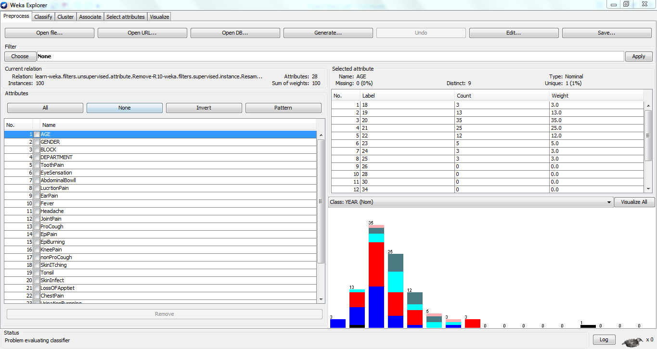

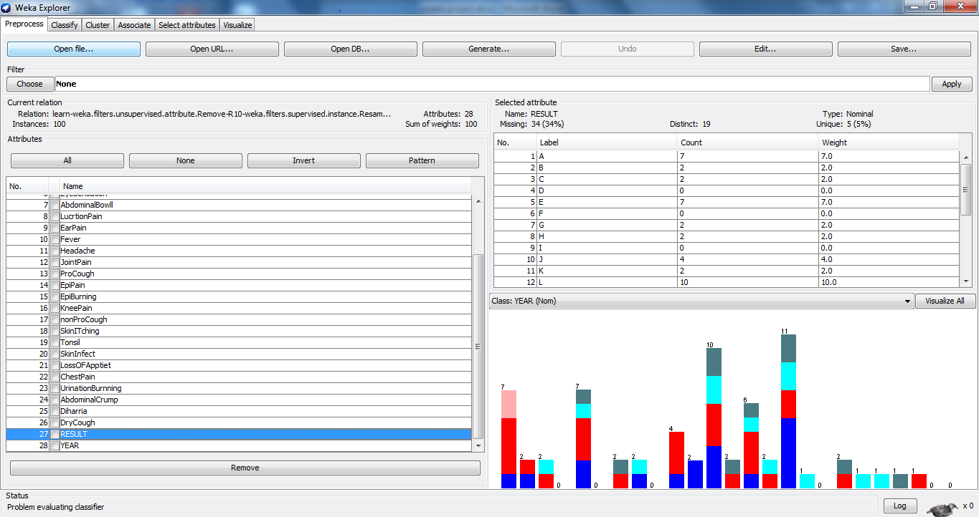

**Results**

1. **Trees – j48**

=== Run information ===

Scheme: weka.classifiers.trees.J48 -C 0.25 -M 2

Relation: learn-weka.filters.unsupervised.attribute.Remove-R10-weka.filters.supervised.instance.Resample-B1.0-S1-Z10.0

Instances: 100

Attributes: 28

AGE

GENDER

BLOCK

DEPARTMENT

ToothPain

EyeSensation

AbdominalBowll

LucrtionPain

EarPain

Fever

Headache

JointPain

ProCough

EpiPain

EpiBurning

KneePain

nonProCough

SkinITching

Tonsil

SkinInfect

LossOFApptiet

ChestPain

UrinationBurnning

AbdominalCrump

Diharria

DryCough

RESULT

YEAR

Test mode: evaluate on training data

=== Classifier model (full training set) ===

J48 pruned tree

------------------

BLOCK <= 25

| DEPARTMENT = Acc: 4 (0.0)

| DEPARTMENT = Agri: 2 (4.0)

| DEPARTMENT = Bio: 4 (3.0)

| DEPARTMENT = BioT: 4 (1.0)

| DEPARTMENT = Civil: 4 (0.0)

| DEPARTMENT = Chem: 4 (0.0)

| DEPARTMENT = CS: 5 (1.0)

| DEPARTMENT = Eco: 4 (0.0)

| DEPARTMENT = Engi: 4 (0.0)

| DEPARTMENT = Geo: 4 (0.0)

| DEPARTMENT = Geolg: 3 (2.0/1.0)

| DEPARTMENT = IS: 4 (0.0)

| DEPARTMENT = IT: 2 (3.0/1.0)

| DEPARTMENT = Law: 4 (0.0)

| DEPARTMENT = Mark: 4 (0.0)

| DEPARTMENT = Maths: 4 (0.0)

| DEPARTMENT = Medi: 4 (0.0)

| DEPARTMENT = Mgt: 3 (2.0)

| DEPARTMENT = Phys: 4 (0.0)

| DEPARTMENT = SpoS: 2 (1.0)

| DEPARTMENT = Stat: 4 (2.0)

| DEPARTMENT = Tour: 4 (0.0)

| DEPARTMENT = Vet: 4 (0.0)

BLOCK > 25

| BLOCK <= 29

| | EpiBurning = yes: 2 (2.0/1.0)

| | EpiBurning = no: 1 (22.0/4.0)

| BLOCK > 29

| | BLOCK <= 34

| | | ChestPain = yes: 4 (2.0)

| | | ChestPain = no: 2 (39.0/17.0)

| | BLOCK > 34: 1 (14.0/3.0)

Number of Leaves : 28

Size of the tree : 34

Time taken to build model: 0.01 seconds

=== Evaluation on training set ===

Time taken to test model on training data: 0 seconds

=== Summary ===

Correctly Classified Instances 71 72.449 %

Incorrectly Classified Instances 27 27.551 %

Kappa statistic 0.6001

Mean absolute error 0.1091

Root mean squared error 0.2336

Relative absolute error 51.7532 %

Root relative squared error 72.33 %

Coverage of cases (0.95 level) 98.9796 %

Mean rel. region size (0.95 level) 37.6093 %

Total Number of Instances 98

Ignored Class Unknown Instances 2

=== Detailed Accuracy By Class ===

TP Rate FP Rate Precision Recall F-Measure MCC ROC Area PRC Area Class

1.000 0.101 0.806 1.000 0.892 0.851 0.950 0.805 1

0.833 0.306 0.612 0.833 0.706 0.508 0.816 0.659 2

0.188 0.012 0.750 0.188 0.300 0.327 0.860 0.475 3

0.571 0.000 1.000 0.571 0.727 0.730 0.896 0.683 4

0.333 0.000 1.000 0.333 0.500 0.571 0.873 0.383 5

0.000 0.000 0.000 0.000 0.000 0.000 ? ? 6

0.000 0.000 0.000 0.000 0.000 0.000 ? ? 7

Weighted Avg. 0.724 0.145 0.759 0.724 0.692 0.614 0.876 0.667

=== Confusion Matrix ===

a b c d e f g <-- classified as

29 0 0 0 0 0 0 | a = 1

6 30 0 0 0 0 0 | b = 2

0 13 3 0 0 0 0 | c = 3

1 4 1 8 0 0 0 | d = 4

0 2 0 0 1 0 0 | e = 5

0 0 0 0 0 0 0 | f = 6

1. 0 0 0 0 0 0 | g = 7

**b) Bayes.NaiveBayes**

=== Run information ===

Scheme: weka.classifiers.bayes.NaiveBayes

Relation: learn-weka.filters.unsupervised.attribute.Remove-R10-weka.filters.supervised.instance.Resample-B1.0-S1-Z10.0

Instances: 100

Attributes: 28

AGE

GENDER

BLOCK

DEPARTMENT

ToothPain

EyeSensation

AbdominalBowll

LucrtionPain

EarPain

Fever

Headache

JointPain

ProCough

EpiPain

EpiBurning

KneePain

nonProCough

SkinITching

Tonsil

SkinInfect

LossOFApptiet

ChestPain

UrinationBurnning

AbdominalCrump

Diharria

DryCough

RESULT

YEAR

Test mode: evaluate on training data

=== Classifier model (full training set) ===

Naive Bayes Classifier

Class

Attribute 1 2 3 4 5 6 7

(0.29) (0.35) (0.16) (0.14) (0.04) (0.01) (0.01)

============================================================================

AGE

18 4.0 1.0 1.0 1.0 1.0 1.0 1.0

19 7.0 6.0 2.0 1.0 1.0 1.0 1.0

20 15.0 16.0 4.0 3.0 2.0 1.0 1.0

21 5.0 9.0 8.0 7.0 1.0 1.0 1.0

22 2.0 6.0 3.0 5.0 1.0 1.0 1.0

23 1.0 1.0 3.0 3.0 2.0 1.0 1.0

24 2.0 1.0 2.0 1.0 2.0 1.0 1.0

25 1.0 4.0 1.0 1.0 1.0 1.0 1.0

26 1.0 1.0 1.0 1.0 1.0 1.0 1.0

28 1.0 1.0 1.0 1.0 1.0 1.0 1.0

30 1.0 1.0 1.0 1.0 1.0 1.0 1.0

34 1.0 1.0 1.0 1.0 1.0 1.0 1.0

35 1.0 1.0 1.0 1.0 1.0 1.0 1.0

37 1.0 1.0 1.0 1.0 1.0 1.0 1.0

39 1.0 1.0 1.0 1.0 1.0 1.0 1.0

40 1.0 1.0 1.0 1.0 1.0 1.0 1.0

47 1.0 1.0 1.0 1.0 1.0 1.0 1.0

[total] 46.0 53.0 33.0 31.0 20.0 17.0 17.0

GENDER

M 20.0 25.0 12.0 7.0 3.0 1.0 1.0

F 11.0 13.0 6.0 9.0 2.0 1.0 1.0

[total] 31.0 38.0 18.0 16.0 5.0 2.0 2.0

BLOCK

mean 30.6207 30.5397 29.7321 24.9184 29.9524 0 0

std. dev. 3.574 3.7606 3.3036 6.9719 4.492 0.4405 0.4405

weight sum 29 36 16 14 3 0 0

precision 2.6429 2.6429 2.6429 2.6429 2.6429 2.6429 2.6429

DEPARTMENT

Acc 4.0 1.0 4.0 1.0 1.0 1.0 1.0

Agri 3.0 9.0 1.0 1.0 1.0 1.0 1.0

Bio 3.0 2.0 2.0 5.0 1.0 1.0 1.0

BioT 2.0 1.0 1.0 2.0 1.0 1.0 1.0

Civil 1.0 1.0 1.0 1.0 1.0 1.0 1.0

Chem 1.0 4.0 3.0 1.0 1.0 1.0 1.0

CS 6.0 6.0 2.0 2.0 2.0 1.0 1.0

Eco 3.0 5.0 1.0 1.0 1.0 1.0 1.0

Engi 1.0 1.0 1.0 1.0 1.0 1.0 1.0

Geo 1.0 1.0 1.0 1.0 1.0 1.0 1.0

Geolg 1.0 2.0 2.0 2.0 1.0 1.0 1.0

IS 3.0 2.0 3.0 1.0 1.0 1.0 1.0

IT 3.0 4.0 2.0 3.0 1.0 1.0 1.0

Law 1.0 1.0 1.0 1.0 1.0 1.0 1.0

Mark 4.0 1.0 1.0 1.0 1.0 1.0 1.0

Maths 2.0 3.0 2.0 1.0 1.0 1.0 1.0

Medi 2.0 1.0 1.0 1.0 1.0 1.0 1.0

Mgt 3.0 2.0 4.0 1.0 2.0 1.0 1.0

Phys 2.0 1.0 1.0 1.0 1.0 1.0 1.0

SpoS 2.0 3.0 2.0 1.0 1.0 1.0 1.0

Stat 2.0 2.0 1.0 3.0 1.0 1.0 1.0

Tour 1.0 1.0 1.0 1.0 1.0 1.0 1.0

Vet 1.0 5.0 1.0 4.0 2.0 1.0 1.0

[total] 52.0 59.0 39.0 37.0 26.0 23.0 23.0

Time taken to build model: 0 seconds

=== Evaluation on training set ===

Time taken to test model on training data: 0.01 seconds

=== Summary ===

Correctly Classified Instances 74 75.5102 %

Incorrectly Classified Instances 24 24.4898 %

Kappa statistic 0.646

Mean absolute error 0.1142

Root mean squared error 0.2301

Relative absolute error 54.1834 %

Root relative squared error 71.253 %

Coverage of cases (0.95 level) 97.9592 %

Mean rel. region size (0.95 level) 41.1079 %

Total Number of Instances 98

Ignored Class Unknown Instances 2

=== Detailed Accuracy By Class ===

TP Rate FP Rate Precision Recall F-Measure MCC ROC Area PRC Area Class

0.793 0.101 0.767 0.793 0.780 0.685 0.909 0.812 1

1.000 0.242 0.706 1.000 0.828 0.732 0.944 0.896 2

0.438 0.012 0.875 0.438 0.583 0.574 0.919 0.785 3

0.571 0.012 0.889 0.571 0.696 0.678 0.976 0.856 4

0.000 0.000 0.000 0.000 0.000 0.000 0.993 0.867 5

0.000 0.000 0.000 0.000 0.000 0.000 ? ? 6

0.000 0.000 0.000 0.000 0.000 0.000 ? ? 7

Weighted Avg. 0.755 0.123 0.756 0.755 0.729 0.662 0.936 0.846

=== Confusion Matrix ===

a b c d e f g <-- classified as

23 5 1 0 0 0 0 | a = 1

0 36 0 0 0 0 0 | b = 2

5 3 7 1 0 0 0 | c = 3

0 6 0 8 0 0 0 | d = 4

2 1 0 0 0 0 0 | e = 5

0 0 0 0 0 0 0 | f = 6

0 0 0 0 0 0 0 | g = 7

Reference

1. Jiwawei Han and Micheline(2006):Data mining concepts and techniques,united states of America
2. Getachew W. and et…al(2014): Characterization of Student health information using data mining techniques: In the case of University of Gondar Student Clinic, Gondar

**Annex**



Sample Student clinic health information

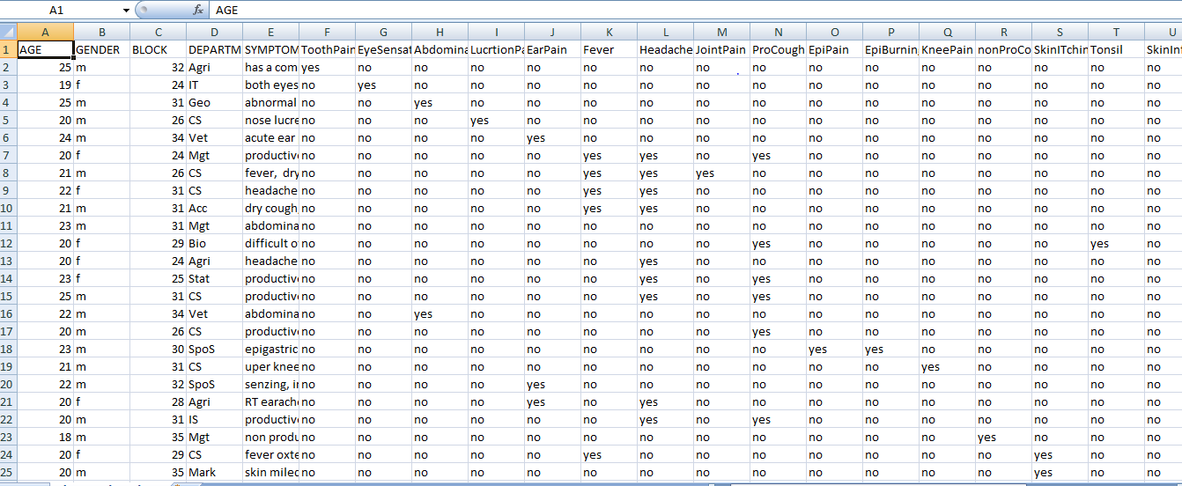

Generated rule from weka using j48 algorithm

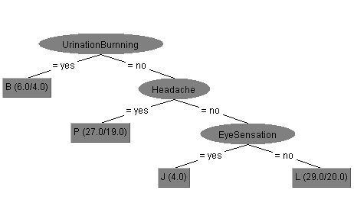

Project home page

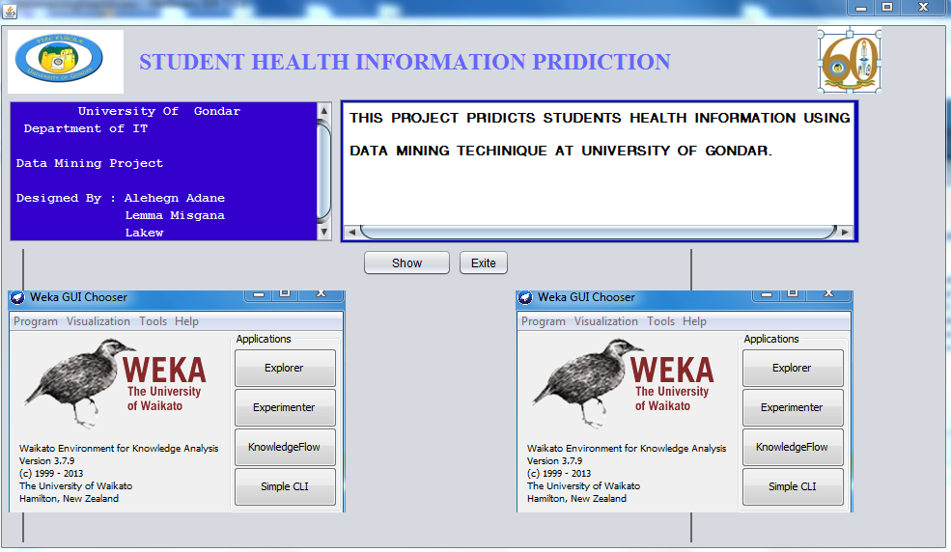

Test the implementation with the generated rule

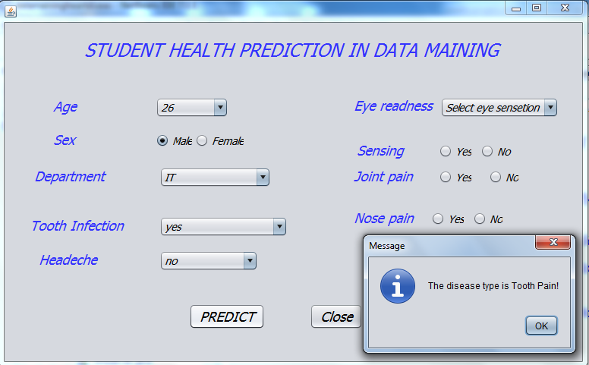

Sample JAVA code

/*

* To change this template, choose Tools | Templates

* and open the template in the editor.

*/

package datamainingheartdiseas;

import javax.swing.JOptionPane;

/**

*

* @author HP

*/

public class studentdata extends javax.swing.JFrame {

/**

* Creates new form studentdata

*/

public studentdata() {

initComponents();

}

/**

* This method is called from within the constructor to initialize the form.

* WARNING: Do NOT modify this code. The content of this method is always

* regenerated by the Form Editor.

*/

@SuppressWarnings("unchecked")

// <editor-fold defaultstate="collapsed" desc="Generated Code">

private void initComponents() {

jLabel1 = new javax.swing.JLabel();

jLabel2 = new javax.swing.JLabel();

jLabel3 = new javax.swing.JLabel();

jLabel4 = new javax.swing.JLabel();

jLabel5 = new javax.swing.JLabel();

jLabel6 = new javax.swing.JLabel();

jLabel7 = new javax.swing.JLabel();

jLabel8 = new javax.swing.JLabel();

jLabel9 = new javax.swing.JLabel();

jLabel10 = new javax.swing.JLabel();

age = new javax.swing.JComboBox();

jRadioButton1 = new javax.swing.JRadioButton();

jRadioButton2 = new javax.swing.JRadioButton();

dep = new javax.swing.JComboBox();

unb = new javax.swing.JComboBox();

hd = new javax.swing.JComboBox();

ey = new javax.swing.JComboBox();

jRadioButton3 = new javax.swing.JRadioButton();

jRadioButton4 = new javax.swing.JRadioButton();

jRadioButton5 = new javax.swing.JRadioButton();

jRadioButton6 = new javax.swing.JRadioButton();

jRadioButton7 = new javax.swing.JRadioButton();

jRadioButton8 = new javax.swing.JRadioButton();

jButton1 = new javax.swing.JButton();

jButton2 = new javax.swing.JButton();

setDefaultCloseOperation(javax.swing.WindowConstants.EXIT_ON_CLOSE);

jLabel1.setFont(new java.awt.Font("Tahoma", 2, 24)); // NOI18N

jLabel1.setForeground(new java.awt.Color(51, 51, 255));

jLabel1.setText("STUDENT HEALTH PREDICTION IN DATA MAINING ");

jLabel2.setFont(new java.awt.Font("Tahoma", 2, 18)); // NOI18N

jLabel2.setForeground(new java.awt.Color(51, 51, 255));

jLabel2.setText("Age");

jLabel3.setFont(new java.awt.Font("Tahoma", 2, 18)); // NOI18N

jLabel3.setForeground(new java.awt.Color(51, 51, 255));

jLabel3.setText("Sex");

jLabel4.setFont(new java.awt.Font("Tahoma", 2, 18)); // NOI18N

jLabel4.setForeground(new java.awt.Color(51, 51, 255));

jLabel4.setText("Sensing");

jLabel5.setFont(new java.awt.Font("Tahoma", 2, 18)); // NOI18N

jLabel5.setForeground(new java.awt.Color(51, 51, 255));

jLabel5.setText("Headeche");

jLabel6.setFont(new java.awt.Font("Tahoma", 2, 18)); // NOI18N

jLabel6.setForeground(new java.awt.Color(51, 51, 255));

jLabel6.setText("Department");

jLabel7.setFont(new java.awt.Font("Tahoma", 2, 18)); // NOI18N

jLabel7.setForeground(new java.awt.Color(51, 51, 255));

jLabel7.setText("Eye readness");

jLabel8.setFont(new java.awt.Font("Tahoma", 2, 18)); // NOI18N

jLabel8.setForeground(new java.awt.Color(51, 51, 255));

jLabel8.setText("Tooth Infection");

jLabel9.setFont(new java.awt.Font("Tahoma", 2, 18)); // NOI18N

jLabel9.setForeground(new java.awt.Color(51, 51, 255));

jLabel9.setText("Nose pain");

jLabel10.setFont(new java.awt.Font("Tahoma", 2, 18)); // NOI18N

jLabel10.setForeground(new java.awt.Color(51, 51, 255));

jLabel10.setText("Joint pain");

age.setFont(new java.awt.Font("Tahoma", 2, 14)); // NOI18N

age.setModel(new javax.swing.DefaultComboBoxModel(new String[] { "Select Age", "25", "26", "27", "28", "29", "30", "31", "32", "33", "34", "35", "36", "37", "38", "39", "40" }));

jRadioButton1.setFont(new java.awt.Font("Tahoma", 2, 14)); // NOI18N

jRadioButton1.setText("Male");

jRadioButton2.setFont(new java.awt.Font("Tahoma", 2, 14)); // NOI18N

jRadioButton2.setText("Female");

dep.setFont(new java.awt.Font("Tahoma", 2, 14)); // NOI18N

dep.setModel(new javax.swing.DefaultComboBoxModel(new String[] { "Select Department", "IT", "IS", "CS", "Bio", "Geo", "CHE" }));

unb.setFont(new java.awt.Font("Tahoma", 2, 14)); // NOI18N

unb.setModel(new javax.swing.DefaultComboBoxModel(new String[] { "Select Disease syptom", "yes", "no" }));

unb.addActionListener(new java.awt.event.ActionListener() {

public void actionPerformed(java.awt.event.ActionEvent evt) {

unbActionPerformed(evt);

}

});

hd.setFont(new java.awt.Font("Tahoma", 2, 14)); // NOI18N

hd.setModel(new javax.swing.DefaultComboBoxModel(new String[] { "Select Headche ", "yes", "no" }));

ey.setFont(new java.awt.Font("Tahoma", 2, 14)); // NOI18N

ey.setModel(new javax.swing.DefaultComboBoxModel(new String[] { "Select eye sensetion", "yes", "no" }));

jRadioButton3.setFont(new java.awt.Font("Tahoma", 2, 14)); // NOI18N

jRadioButton3.setText("Yes");

jRadioButton4.setFont(new java.awt.Font("Tahoma", 2, 14)); // NOI18N

jRadioButton4.setText("No");

jRadioButton5.setFont(new java.awt.Font("Tahoma", 2, 14)); // NOI18N

jRadioButton5.setText("Yes");

jRadioButton6.setFont(new java.awt.Font("Tahoma", 2, 14)); // NOI18N

jRadioButton6.setText("No");

jRadioButton7.setFont(new java.awt.Font("Tahoma", 2, 14)); // NOI18N

jRadioButton7.setText("Yes");

jRadioButton8.setFont(new java.awt.Font("Tahoma", 2, 14)); // NOI18N

jRadioButton8.setText("No");

jButton1.setFont(new java.awt.Font("Tahoma", 2, 18)); // NOI18N

jButton1.setText("PREDICT");

jButton1.addActionListener(new java.awt.event.ActionListener() {

public void actionPerformed(java.awt.event.ActionEvent evt) {

jButton1ActionPerformed(evt);

}

});

jButton2.setFont(new java.awt.Font("Tahoma", 2, 18)); // NOI18N

jButton2.setText("Close");

jButton2.addActionListener(new java.awt.event.ActionListener() {

public void actionPerformed(java.awt.event.ActionEvent evt) {

jButton2ActionPerformed(evt);

}

});

javax.swing.GroupLayout layout = new javax.swing.GroupLayout(getContentPane());

getContentPane().setLayout(layout);

layout.setHorizontalGroup(

layout.createParallelGroup(javax.swing.GroupLayout.Alignment.LEADING)

.addGroup(javax.swing.GroupLayout.Alignment.TRAILING, layout.createSequentialGroup()

.addContainerGap(88, Short.MAX_VALUE)

.addComponent(jLabel1)

.addGap(103, 103, 103))

.addGroup(layout.createSequentialGroup()

.addGap(33, 33, 33)

.addGroup(layout.createParallelGroup(javax.swing.GroupLayout.Alignment.LEADING)

.addGroup(layout.createSequentialGroup()

.addGroup(layout.createParallelGroup(javax.swing.GroupLayout.Alignment.LEADING)

.addGroup(layout.createSequentialGroup()

.addGap(31, 31, 31)

.addGroup(layout.createParallelGroup(javax.swing.GroupLayout.Alignment.LEADING, false)

.addComponent(jLabel2, javax.swing.GroupLayout.DEFAULT_SIZE, javax.swing.GroupLayout.DEFAULT_SIZE, Short.MAX_VALUE)

.addComponent(jLabel3, javax.swing.GroupLayout.PREFERRED_SIZE, 48, javax.swing.GroupLayout.PREFERRED_SIZE))

.addGap(87, 87, 87)

.addGroup(layout.createParallelGroup(javax.swing.GroupLayout.Alignment.LEADING)

.addGroup(layout.createSequentialGroup()

.addComponent(jRadioButton1)

.addGap(4, 4, 4)

.addComponent(jRadioButton2))

.addComponent(age, javax.swing.GroupLayout.PREFERRED_SIZE, javax.swing.GroupLayout.DEFAULT_SIZE, javax.swing.GroupLayout.PREFERRED_SIZE)))

.addGroup(layout.createSequentialGroup()

.addGroup(layout.createParallelGroup(javax.swing.GroupLayout.Alignment.LEADING)

.addGroup(layout.createSequentialGroup()

.addGap(6, 6, 6)

.addComponent(jLabel6, javax.swing.GroupLayout.PREFERRED_SIZE, 108, javax.swing.GroupLayout.PREFERRED_SIZE))

.addComponent(jLabel8, javax.swing.GroupLayout.PREFERRED_SIZE, 149, javax.swing.GroupLayout.PREFERRED_SIZE)

.addGroup(layout.createSequentialGroup()

.addGap(12, 12, 12)

.addComponent(jLabel5, javax.swing.GroupLayout.PREFERRED_SIZE, 93, javax.swing.GroupLayout.PREFERRED_SIZE)))

.addGap(22, 22, 22)

.addGroup(layout.createParallelGroup(javax.swing.GroupLayout.Alignment.LEADING)

.addComponent(unb, javax.swing.GroupLayout.PREFERRED_SIZE, javax.swing.GroupLayout.DEFAULT_SIZE, javax.swing.GroupLayout.PREFERRED_SIZE)

.addComponent(dep, javax.swing.GroupLayout.PREFERRED_SIZE, javax.swing.GroupLayout.DEFAULT_SIZE, javax.swing.GroupLayout.PREFERRED_SIZE)

.addComponent(hd, javax.swing.GroupLayout.PREFERRED_SIZE, javax.swing.GroupLayout.DEFAULT_SIZE, javax.swing.GroupLayout.PREFERRED_SIZE))))

.addPreferredGap(javax.swing.LayoutStyle.ComponentPlacement.RELATED, 87, Short.MAX_VALUE)

.addGroup(layout.createParallelGroup(javax.swing.GroupLayout.Alignment.LEADING)

.addGroup(layout.createSequentialGroup()

.addComponent(jLabel7, javax.swing.GroupLayout.PREFERRED_SIZE, 108, javax.swing.GroupLayout.PREFERRED_SIZE)

.addPreferredGap(javax.swing.LayoutStyle.ComponentPlacement.RELATED)

.addComponent(ey, javax.swing.GroupLayout.PREFERRED_SIZE, javax.swing.GroupLayout.DEFAULT_SIZE, javax.swing.GroupLayout.PREFERRED_SIZE))

.addGroup(layout.createSequentialGroup()

.addGroup(layout.createParallelGroup(javax.swing.GroupLayout.Alignment.LEADING, false)

.addGroup(layout.createSequentialGroup()

.addGap(4, 4, 4)

.addComponent(jLabel4, javax.swing.GroupLayout.PREFERRED_SIZE, 76, javax.swing.GroupLayout.PREFERRED_SIZE)

.addGap(32, 32, 32))

.addGroup(layout.createSequentialGroup()

.addComponent(jLabel10, javax.swing.GroupLayout.DEFAULT_SIZE, javax.swing.GroupLayout.DEFAULT_SIZE, Short.MAX_VALUE)

.addGap(22, 22, 22)))

.addGroup(layout.createParallelGroup(javax.swing.GroupLayout.Alignment.LEADING)

.addComponent(jRadioButton3)

.addComponent(jRadioButton5, javax.swing.GroupLayout.Alignment.TRAILING))

.addGroup(layout.createParallelGroup(javax.swing.GroupLayout.Alignment.LEADING)

.addGroup(layout.createSequentialGroup()

.addGap(23, 23, 23)

.addComponent(jRadioButton6))

.addGroup(layout.createSequentialGroup()

.addPreferredGap(javax.swing.LayoutStyle.ComponentPlacement.UNRELATED)

.addComponent(jRadioButton4, javax.swing.GroupLayout.PREFERRED_SIZE, 51, javax.swing.GroupLayout.PREFERRED_SIZE))))

.addGroup(layout.createSequentialGroup()

.addComponent(jLabel9, javax.swing.GroupLayout.PREFERRED_SIZE, 90, javax.swing.GroupLayout.PREFERRED_SIZE)

.addPreferredGap(javax.swing.LayoutStyle.ComponentPlacement.UNRELATED)

.addComponent(jRadioButton7)

.addPreferredGap(javax.swing.LayoutStyle.ComponentPlacement.UNRELATED)

.addComponent(jRadioButton8))))

.addGroup(javax.swing.GroupLayout.Alignment.TRAILING, layout.createSequentialGroup()

.addGap(0, 0, Short.MAX_VALUE)

.addComponent(jButton1)

.addGap(59, 59, 59)

.addComponent(jButton2)

.addGap(258, 258, 258)))

.addContainerGap(31, javax.swing.GroupLayout.PREFERRED_SIZE))

);

layout.setVerticalGroup(

layout.createParallelGroup(javax.swing.GroupLayout.Alignment.LEADING)

.addGroup(layout.createSequentialGroup()

.addContainerGap()

.addComponent(jLabel1, javax.swing.GroupLayout.PREFERRED_SIZE, 58, javax.swing.GroupLayout.PREFERRED_SIZE)

.addGap(34, 34, 34)

.addGroup(layout.createParallelGroup(javax.swing.GroupLayout.Alignment.LEADING)

.addGroup(layout.createSequentialGroup()

.addGroup(layout.createParallelGroup(javax.swing.GroupLayout.Alignment.LEADING)

.addComponent(jLabel7)

.addComponent(ey, javax.swing.GroupLayout.PREFERRED_SIZE, javax.swing.GroupLayout.DEFAULT_SIZE, javax.swing.GroupLayout.PREFERRED_SIZE))

.addGap(32, 32, 32)

.addGroup(layout.createParallelGroup(javax.swing.GroupLayout.Alignment.BASELINE)

.addComponent(jLabel4)

.addComponent(jRadioButton3)

.addComponent(jRadioButton4))

.addGap(12, 12, 12)

.addGroup(layout.createParallelGroup(javax.swing.GroupLayout.Alignment.BASELINE)

.addComponent(jLabel10)

.addComponent(jRadioButton5)

.addComponent(jRadioButton6))

.addGap(33, 33, 33)

.addGroup(layout.createParallelGroup(javax.swing.GroupLayout.Alignment.BASELINE)

.addComponent(jLabel9)

.addComponent(jRadioButton7)

.addComponent(jRadioButton8)))

.addGroup(layout.createSequentialGroup()

.addGroup(layout.createParallelGroup(javax.swing.GroupLayout.Alignment.BASELINE)

.addComponent(jLabel2)

.addComponent(age, javax.swing.GroupLayout.PREFERRED_SIZE, javax.swing.GroupLayout.DEFAULT_SIZE, javax.swing.GroupLayout.PREFERRED_SIZE))

.addGap(18, 18, 18)

.addGroup(layout.createParallelGroup(javax.swing.GroupLayout.Alignment.BASELINE)

.addComponent(jLabel3)

.addComponent(jRadioButton1)

.addComponent(jRadioButton2))

.addGap(25, 25, 25)

.addGroup(layout.createParallelGroup(javax.swing.GroupLayout.Alignment.BASELINE)

.addComponent(jLabel6)

.addComponent(dep, javax.swing.GroupLayout.PREFERRED_SIZE, javax.swing.GroupLayout.DEFAULT_SIZE, javax.swing.GroupLayout.PREFERRED_SIZE))

.addGap(38, 38, 38)

.addGroup(layout.createParallelGroup(javax.swing.GroupLayout.Alignment.BASELINE)

.addComponent(jLabel8)

.addComponent(unb, javax.swing.GroupLayout.PREFERRED_SIZE, javax.swing.GroupLayout.DEFAULT_SIZE, javax.swing.GroupLayout.PREFERRED_SIZE))

.addGap(18, 18, 18)

.addGroup(layout.createParallelGroup(javax.swing.GroupLayout.Alignment.BASELINE)

.addComponent(hd, javax.swing.GroupLayout.PREFERRED_SIZE, javax.swing.GroupLayout.DEFAULT_SIZE, javax.swing.GroupLayout.PREFERRED_SIZE)

.addComponent(jLabel5))))

.addGap(43, 43, 43)

.addGroup(layout.createParallelGroup(javax.swing.GroupLayout.Alignment.BASELINE)

.addComponent(jButton1)

.addComponent(jButton2))

.addContainerGap(42, Short.MAX_VALUE))

);

pack();

}// </editor-fold>

private void jButton2ActionPerformed(java.awt.event.ActionEvent evt) {

// TODO add your handling code here:

dispose();

}

private void jButton1ActionPerformed(java.awt.event.ActionEvent evt) {

// TODO add your handling code here:

String ages=age.getSelectedItem().toString();

String dept=dep.getSelectedItem().toString();;

String unbr=unb.getSelectedItem().toString();

String hed=hd.getSelectedItem().toString();

String eyes=ey.getSelectedItem().toString();

if(unbr!="yes"&& hed!="yes" && eyes!="yes")

{

JOptionPane.showMessageDialog(this, "The student disease is KneePain!");

}

else if(unbr!="yes"&& hed!="yes" && eyes!="no")

{

JOptionPane.showMessageDialog(this, "The disease type is Eye Sensation!");

}

else if(unbr!="yes"&& hed!="no")

{

JOptionPane.showMessageDialog(this, "The disease type is SkinInfect!");

}

else if(unbr!="no")

{

JOptionPane.showMessageDialog(this, "The disease type is Tooth Pain!");

}

}

private void unbActionPerformed(java.awt.event.ActionEvent evt) {

// TODO add your handling code here:

}

/**

* @param args the command line arguments

*/

public static void main(String args[]) {

/*

* Set the Nimbus look and feel

*/

//<editor-fold defaultstate="collapsed" desc=" Look and feel setting code (optional) ">

/*

* If Nimbus (introduced in Java SE 6) is not available, stay with the

* default look and feel. For details see

* http://download.oracle.com/javase/tutorial/uiswing/lookandfeel/plaf.html

*/

try {

for (javax.swing.UIManager.LookAndFeelInfo info : javax.swing.UIManager.getInstalledLookAndFeels()) {

if ("Nimbus".equals(info.getName())) {

javax.swing.UIManager.setLookAndFeel(info.getClassName());

break;

}

}

} catch (ClassNotFoundException ex) {

java.util.logging.Logger.getLogger(studentdata.class.getName()).log(java.util.logging.Level.SEVERE, null, ex);

} catch (InstantiationException ex) {

java.util.logging.Logger.getLogger(studentdata.class.getName()).log(java.util.logging.Level.SEVERE, null, ex);

} catch (IllegalAccessException ex) {

java.util.logging.Logger.getLogger(studentdata.class.getName()).log(java.util.logging.Level.SEVERE, null, ex);

} catch (javax.swing.UnsupportedLookAndFeelException ex) {

java.util.logging.Logger.getLogger(studentdata.class.getName()).log(java.util.logging.Level.SEVERE, null, ex);

}

//</editor-fold>

/*

* Create and display the form

*/

java.awt.EventQueue.invokeLater(new Runnable() {

public void run() {

new studentdata().setVisible(true);

}

});

}

// Variables declaration - do not modify

private javax.swing.JComboBox age;

private javax.swing.JComboBox dep;

private javax.swing.JComboBox ey;

private javax.swing.JComboBox hd;

private javax.swing.JButton jButton1;

private javax.swing.JButton jButton2;

private javax.swing.JLabel jLabel1;

private javax.swing.JLabel jLabel10;

private javax.swing.JLabel jLabel2;

private javax.swing.JLabel jLabel3;

private javax.swing.JLabel jLabel4;

private javax.swing.JLabel jLabel5;

private javax.swing.JLabel jLabel6;

private javax.swing.JLabel jLabel7;

private javax.swing.JLabel jLabel8;

private javax.swing.JLabel jLabel9;

private javax.swing.JRadioButton jRadioButton1;

private javax.swing.JRadioButton jRadioButton2;

private javax.swing.JRadioButton jRadioButton3;

private javax.swing.JRadioButton jRadioButton4;

private javax.swing.JRadioButton jRadioButton5;

private javax.swing.JRadioButton jRadioButton6;

private javax.swing.JRadioButton jRadioButton7;

private javax.swing.JRadioButton jRadioButton8;

private javax.swing.JComboBox unb;

// End of variables declaration

}