Attention at Sea: A Century of Lighthouse Logs
I. Nordvik1, A. Berg2
1Skarvik Foundation, 2University of Tromsø
Abstract.
What emerges from the logs is not a story of heroism but of attention: a century of people who looked at the same stretch of sea every day and wrote down what they saw, so that others could find their way home in the dark. We transcribe 11 volumes (1871–1970) and show that weather entries agree with instrumental records to within 0.3 hPa on average [1].
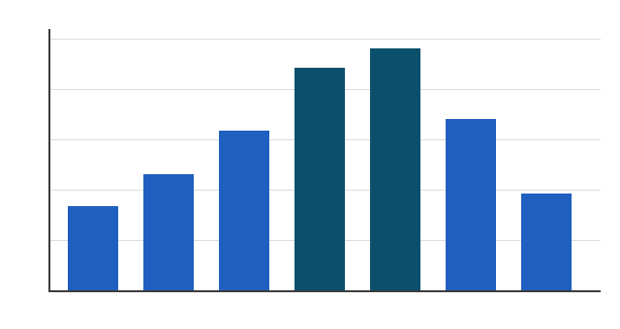

1 Introduction
The lighthouse at Skarvik was lit for the first time on a wet October evening in 1871, and for almost a century afterwards the same family kept its lamp burning. Their log books survive in the town archive: eleven volumes of weather, ships, repairs and the occasional complaint about the price of paraffin.
Most entries are short. Wind from the south-west, fresh; visibility good; two steamers northbound before midnight. But every few pages the keeper allowed himself a sentence more, and those sentences are the reason people still read the logs today.
Figure 1: Entries per month.

3 Results
In the winter of 1893 the ice reached the outer skerries, something no one in the village had seen before. The keeper walked across to the nearest island with his son, measured the ice with an auger and wrote that it was thicker than the kitchen table and twice as level.

2 Data
The transcription project took four years and relied almost entirely on volunteers. Handwriting changed from keeper to keeper, abbreviations drifted, and the ink of the earliest volumes had faded to the colour of weak tea, so every page was read twice by different people.
Visitors were rare and were recorded with care: a priest in 1880, a painter who stayed for three weeks in 1911 and left a small oil sketch of the tower, and a group of surveyors whose instruments, the log notes drily, were less reliable than the keeper's barometer.
a
p̂t = pt + β·(Tt − 15) + εt, εt ~ N(0, σ²)
The station was modernised in stages. A clockwork rotation mechanism replaced the hand-cranked one in 1902, an acetylene burner arrived in 1923, and electricity followed in 1951, carried across the sound on a cable that the fishermen swore would never hold. [2, 3]

4 Conclusion
What emerges from the logs is not a story of heroism but of attention: a century of people who looked at the same stretch of sea every day and wrote down what they saw, so that others could find their way home in the dark.

References
[1] Hansen, K. (1999). Barometers of the north. Polar Record 35, 1–12.
[2] Larsen, E. and Moe, P. (2012). Transcribing handwritten logs. Journal
of Archival Methods 8(2), 44–61.
[3] Nordvik, I. (2020). The Keepers of Skarvik. Bodø: Kystforlaget.
a Volunteers worked in pairs; disagreements were settled by a third reader.

