

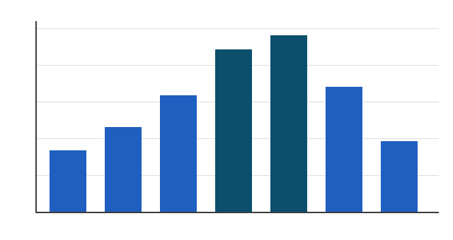
Visitor numbers
Today the tower belongs to a foundation that opens it to the public in summer. The log books have been scanned, transcribed and indexed, and a small exhibition in the old oil store shows the lamp, the auger and a page from the winter of 1893. The lighthouse at Skarvik was lit for the first time on a wet October evening in 1871, and for almost a century afterwards the same family kept its lamp burning. Their log books survive in the town archive: eleven volumes of weather, ships, repairs and the occasional complaint about the price of paraffin.
Figure 1. Visitors per month, 2026 season.
What emerges from the logs is not a story of heroism but of attention: a century of people who looked at the same stretch of sea every day and wrote down what they saw, so that others could find their way home in the dark.

