reference_docx: template1.docx

# Agriculture (CRF Sector 3)

## Source categories and methodological issues

### Enteric fermentation (CRF Source Category 3A)

<http://rmarkdown.rstudio.com/word_document_format.html>

CH4 emissions from source category 3.A Enteric Fermentation are 4.1% of total EU28 GHG emissions and 40% of total EU28 CH4 emissions. They make 42.7% of total agricultural emissions. It is thus the largest GHG source in agriculture and the largest source of CH4 emissions. The main sub-categories are 3.A.1 (Cattle) and 3.A.2 (Sheep) as shown in Figure 1.1.

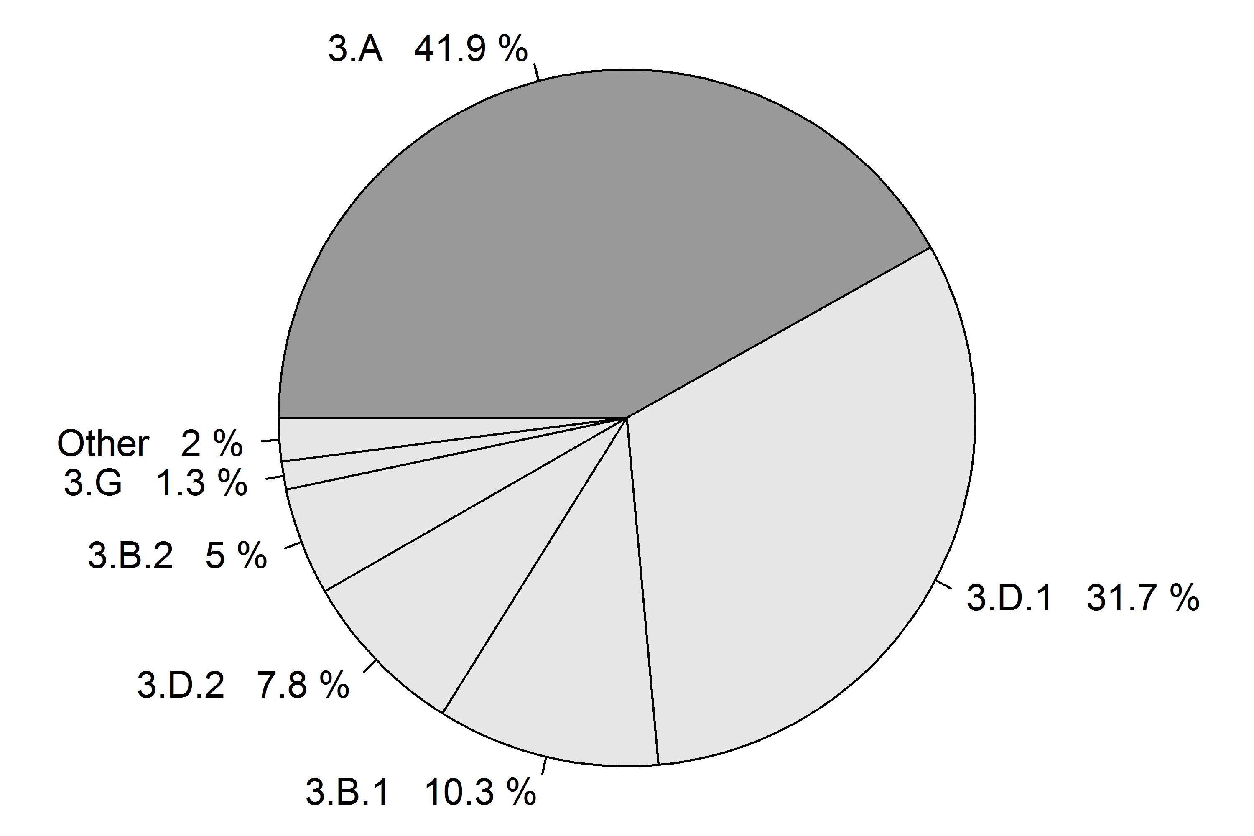 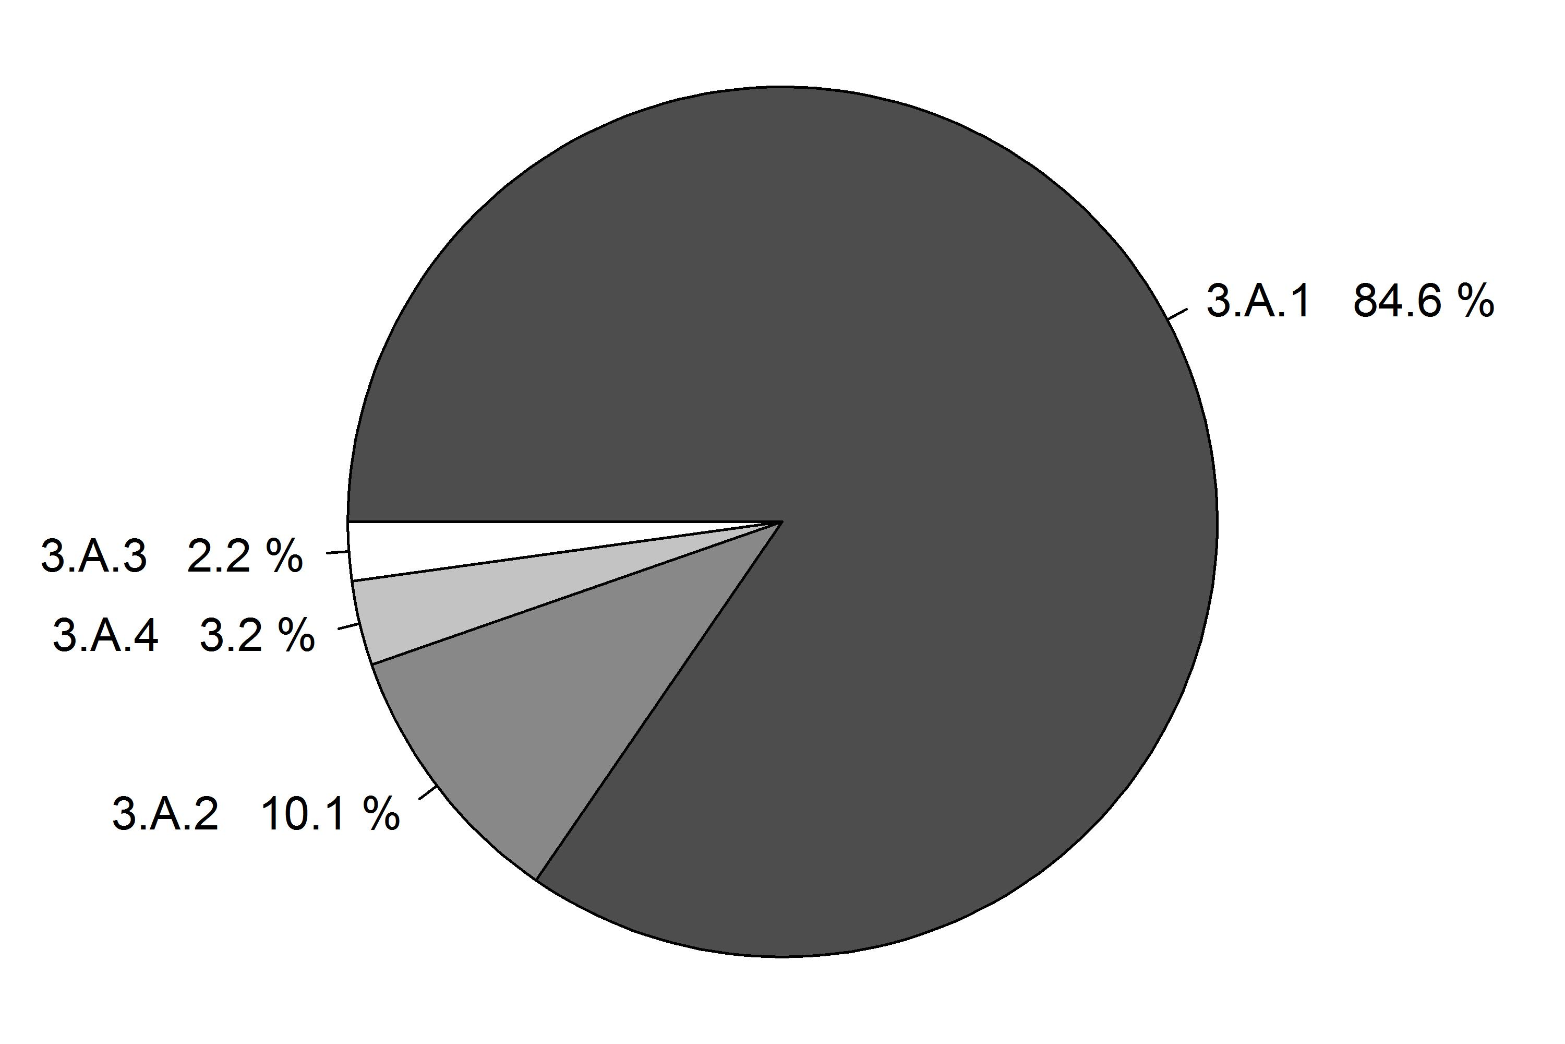 Figure 1.1: Share of source category 3.A on total EU28 agricultural emissions (left panel) and decomposition into its sub-categories (right panel). The percentages refer to the emission in the year 2013.

Total GHG and CH4 emissions by Member States from 3.A Enteric Fermentation are shown in Table 1.1. Between 1990 and 2013, CH4 emission from 4A Enteric fermentation decreased by 25%. The decrease was largest in Croatia in relative terms (66%) and in Germany in absolute terms (29% or 9939 kt CO2-eq). From 2012 to 2013 emissions increased by 0.3%.

Table 1.1: 3A Enteric Fermentation: Member States’ contributions to total GHG and CH4 emissions

Total GHG and CH4 emissions by Member States from 3.A.1 - Cattle Enteric Fermentation are shown in Table 1.3. Between 1990 and 2013, CH4 emission from 4A Enteric fermentation decreased by 26%. The decrease was largest in Croatia in relative terms (71%) and in Poland in absolute terms (43% or 16789 kt CO2-eq). From 2012 to 2013 emissions increased by 0.1%.

Table 1.2: 3A1 Cattle: Member States’ contributions to CH4 emissions

Total GHG and CH4 emissions by Member States from 3.A.2 - Sheep Enteric Fermentation are shown in Table 1.5. Between 1990 and 2013, CH4 emission from 4A Enteric fermentation decreased by 33%. The decrease was largest in Poland in relative terms (95%) and in Romania in absolute terms (36% or 2375 kt CO2-eq). From 2012 to 2013 emissions increased by 0.4%.

Table 1.4: 3A2 Sheep: Member States’ contributions to CH4 emissions

### Manure Management - CH4 (CRF Source Category 3B1)

CH4 emissions from source category 3.B.1 Manure Management are 1% of total EU28 GHG emissions and 10% of total EU28 CH4 emissions. They make 10.5% of total agricultural emissions. The main sub-categories are 3.B.1.1 (Cattle) and 3.B.1.3 (Swine) as shown in Figure 1.2.

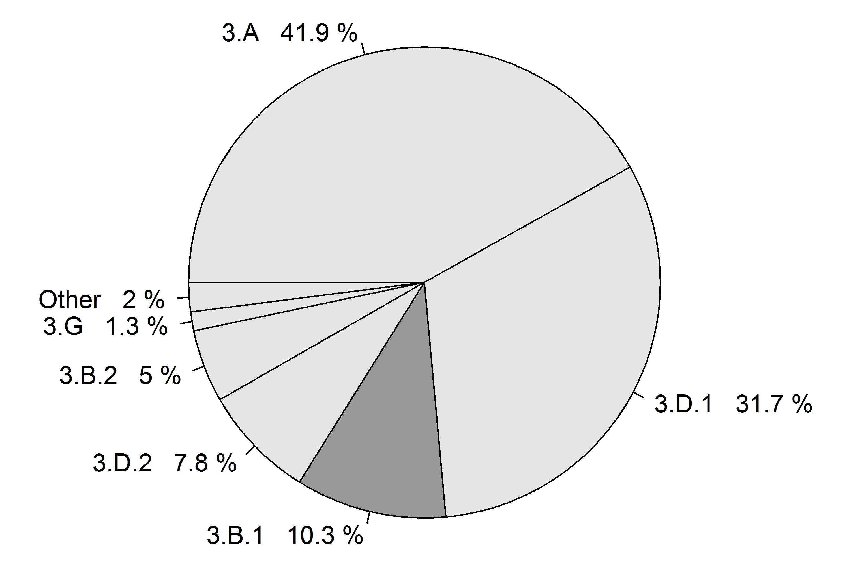 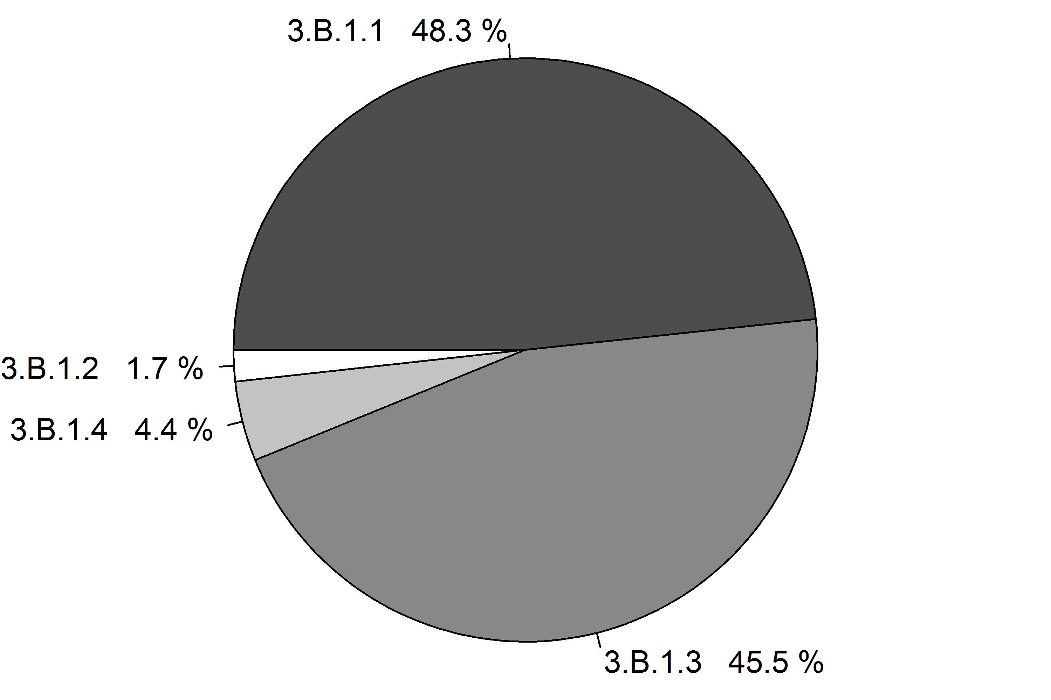 Figure 1.2: Share of source category 3.B.1 on total EU28 agricultural emissions (left panel) and decomposition into its sub-categories (right panel). The percentages refer to the emission in the year 2013.

Total GHG and CH4 emissions by Member States from 3.B.1 Manure Management are shown in Table 1.6. Between 1990 and 2013, CH4 emission from 4A Enteric fermentation decreased by 23%. The decrease was largest in Bulgaria in relative terms (87%) and in Bulgaria in absolute terms (87% or 3357 kt CO2-eq). From 2012 to 2013 emissions decreased by 1.9%.

Table 1.6: 3B1 Manure Management: Member States’ contributions to total GHG and CH4 emissions

### Manure Management - N2O (CRF Source Category 3B2)

N2O emissions from source category 3.B.2 Manure Management are 0.5% of total EU28 GHG emissions and 9% of total EU28 N2O emissions. They make 5.1% of total agricultural emissions. The main sub-categories are 3.B.2.1 (Cattle) and 3.B.2.5 (Farming) as shown in Figure 1.3.

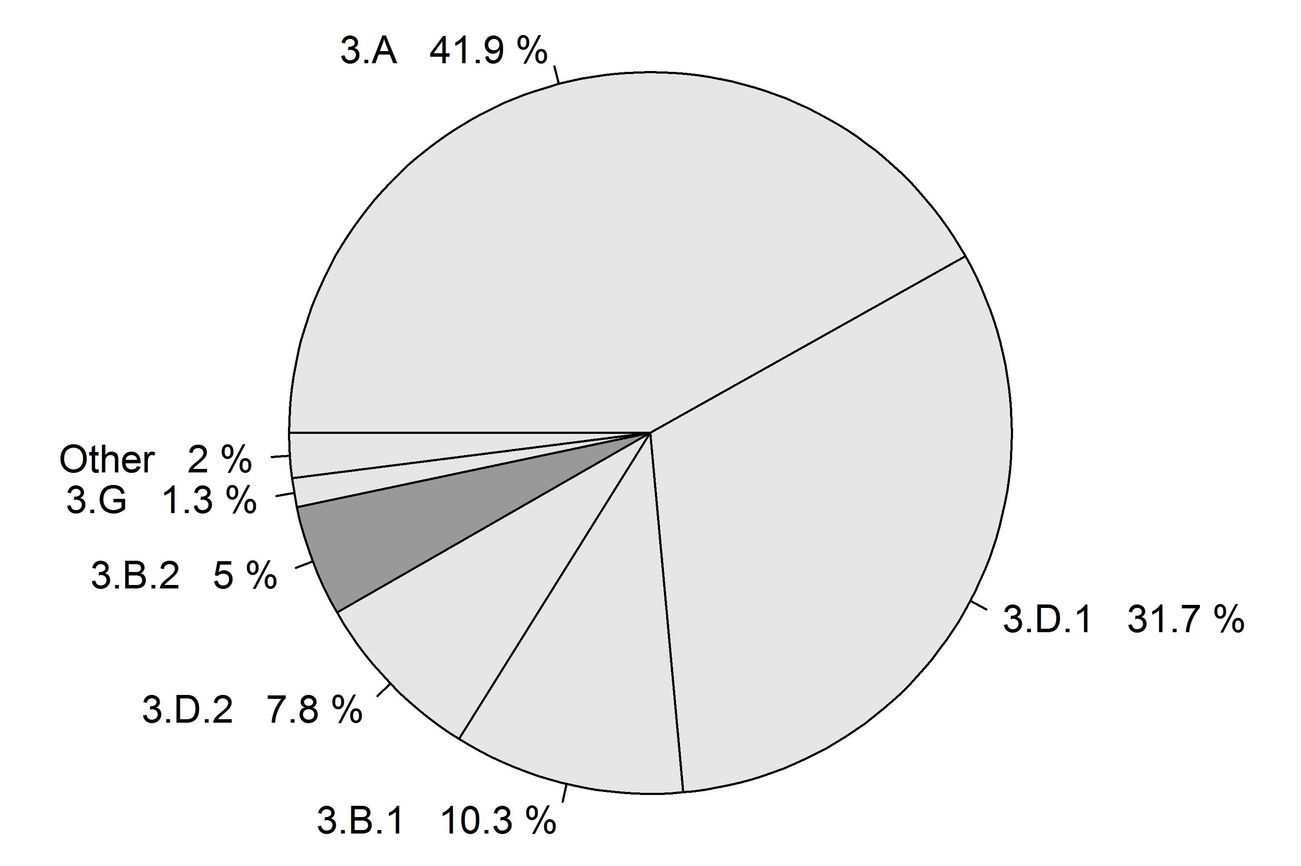 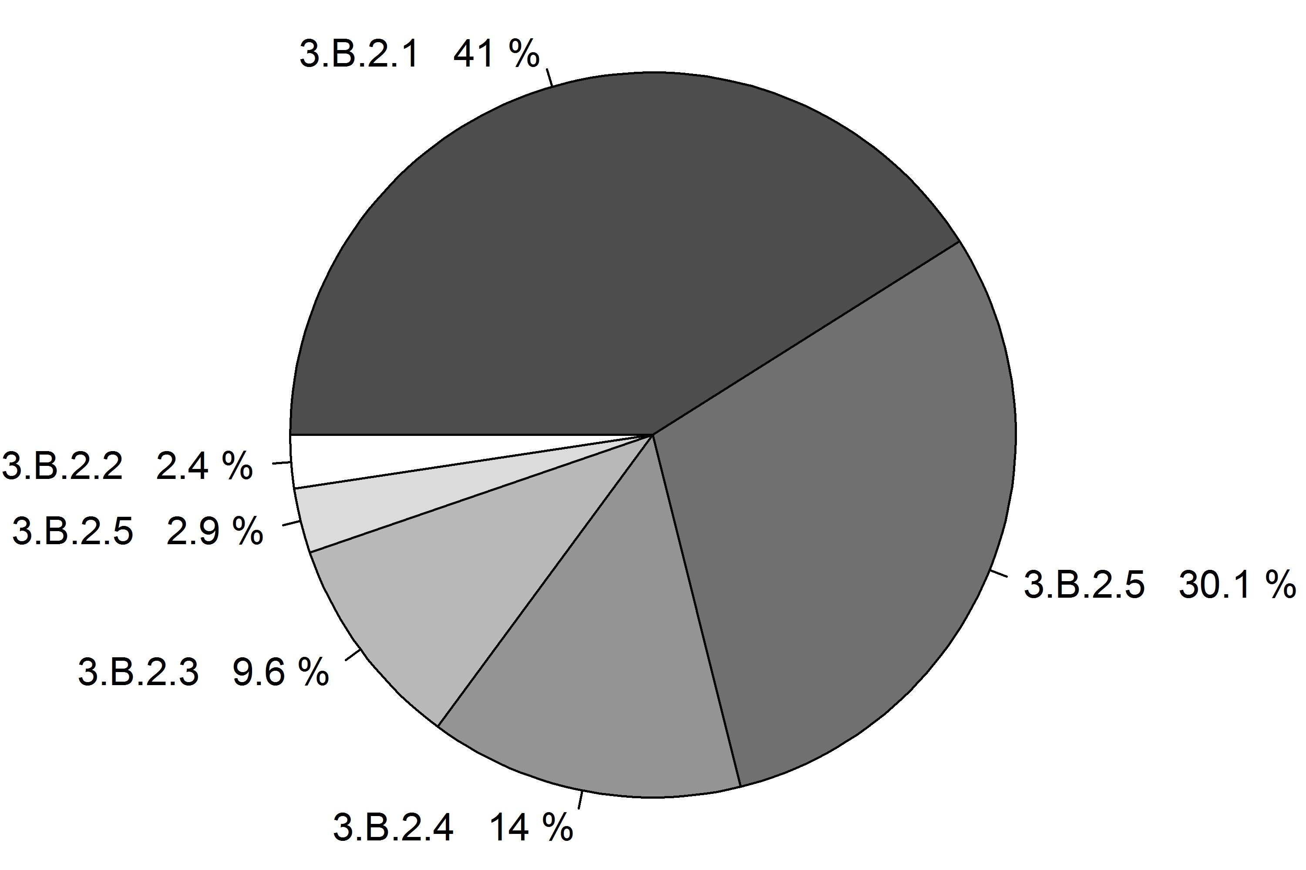 Figure 1.3: Share of source category 3.B.2 on total EU28 agricultural emissions (left panel) and decomposition into its sub-categories (right panel). The percentages refer to the emission in the year 2013.

Total GHG and CH4 emissions by Member States from 3.B.2 Manure Management are shown in Table 1.7. Between 1990 and 2013, CH4 emission from 4A Enteric fermentation decreased by 30%. The decrease was largest in Lithuania in relative terms (69%) and in Czech Republic in absolute terms (60% or 1786 kt CO2-eq). From 2012 to 2013 emissions decreased by 0.4%.

Table 1.7: 3B2 Manure Management: Member States’ contributions to total GHG and CH4 emissions

#### Test of various kinds

Test list

* eins
* zwei
* drei

Anotyher test list

1. eins
2. zwei
3. drei [1]

plot(years)

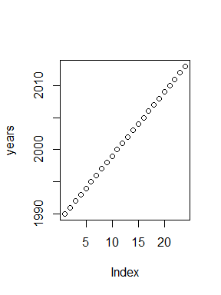

hallo",capt,"ok

# http://www.rdocumentation.org/packages/knitr/functions/kable  
kable(alltotals[alltotals$party=="EU28" & alltotals$type==seltype &  
 alltotals$classification==selclass,lastyear],  
 caption="Table ctopaion test")

## Warning in max(nchar(z), na.rm = TRUE): no non-missing arguments to max;  
## returning -Inf

Table: Table ctopaion test

# http://www.rdocumentation.org/packages/knitr/functions/kable  
kt<-kable(alltotals[alltotals$party=="EU28" & alltotals$type==seltype &  
 alltotals$classification==selclass,lastyear],  
 caption="Table ctopaion test")

## Warning in max(nchar(z), na.rm = TRUE): no non-missing arguments to max;  
## returning -Inf

cat("Figure")

cat("Figure")

Enteric fermentation is the largest[2],[3] 100*agrigeneu[agrigeneu$sector_number=="3.A",lastyear] of emissions.

1. This is one footnite
2. This is one footnite
3. data from lastyear