reference_docx: template.docx

# Agricutlure (CRF Sector 3)

## Source categories and methodological issues

### Enteric fermentation (CRF Source Category 3A)

<http://rmarkdown.rstudio.com/word_document_format.html>

#### Test of various kinds

Test list

* eins
* zwei
* drei

Anotyher test list

1. eins
2. zwei
3. drei

source("curplot.r")

## Warning: package 'reshape2' was built under R version 3.1.3

## Warning: package 'data.table' was built under R version 3.1.3

## Warning: package 'compare' was built under R version 3.1.3

##   
## Attaching package: 'compare'  
##   
## The following object is masked from 'package:base':  
##   
## isTRUE

## [1] "Load existing file ../2015/eealocator/eealocator_20150903_clean.RData"

seltype<-"Total (with LULUCF)"  
seltype<-"" #with indirect  
# selclass<-"Total (with LULUCF with indirect) " #with indirect  
selclass<-"Total (without LULUCF with indirect) " #with indirect  
  
selclass<-"Sectors/Totals" #without indirect  
seltype<-"Total (without LULUCF)" #without indirect  
lastyear<-years[length(years)]  
  
mytotal<-alltotals[alltotals$party=="EU28" & alltotals$type==seltype &  
 alltotals$classification==selclass &  
 alltotals$gas=="Aggregate GHGs",lastyear]  
capt<-"nein"

plot(years)

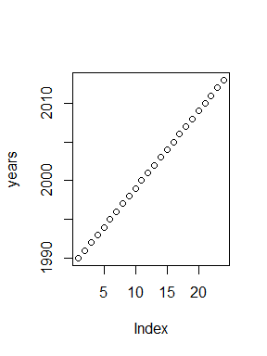

hallo",capt,"ok

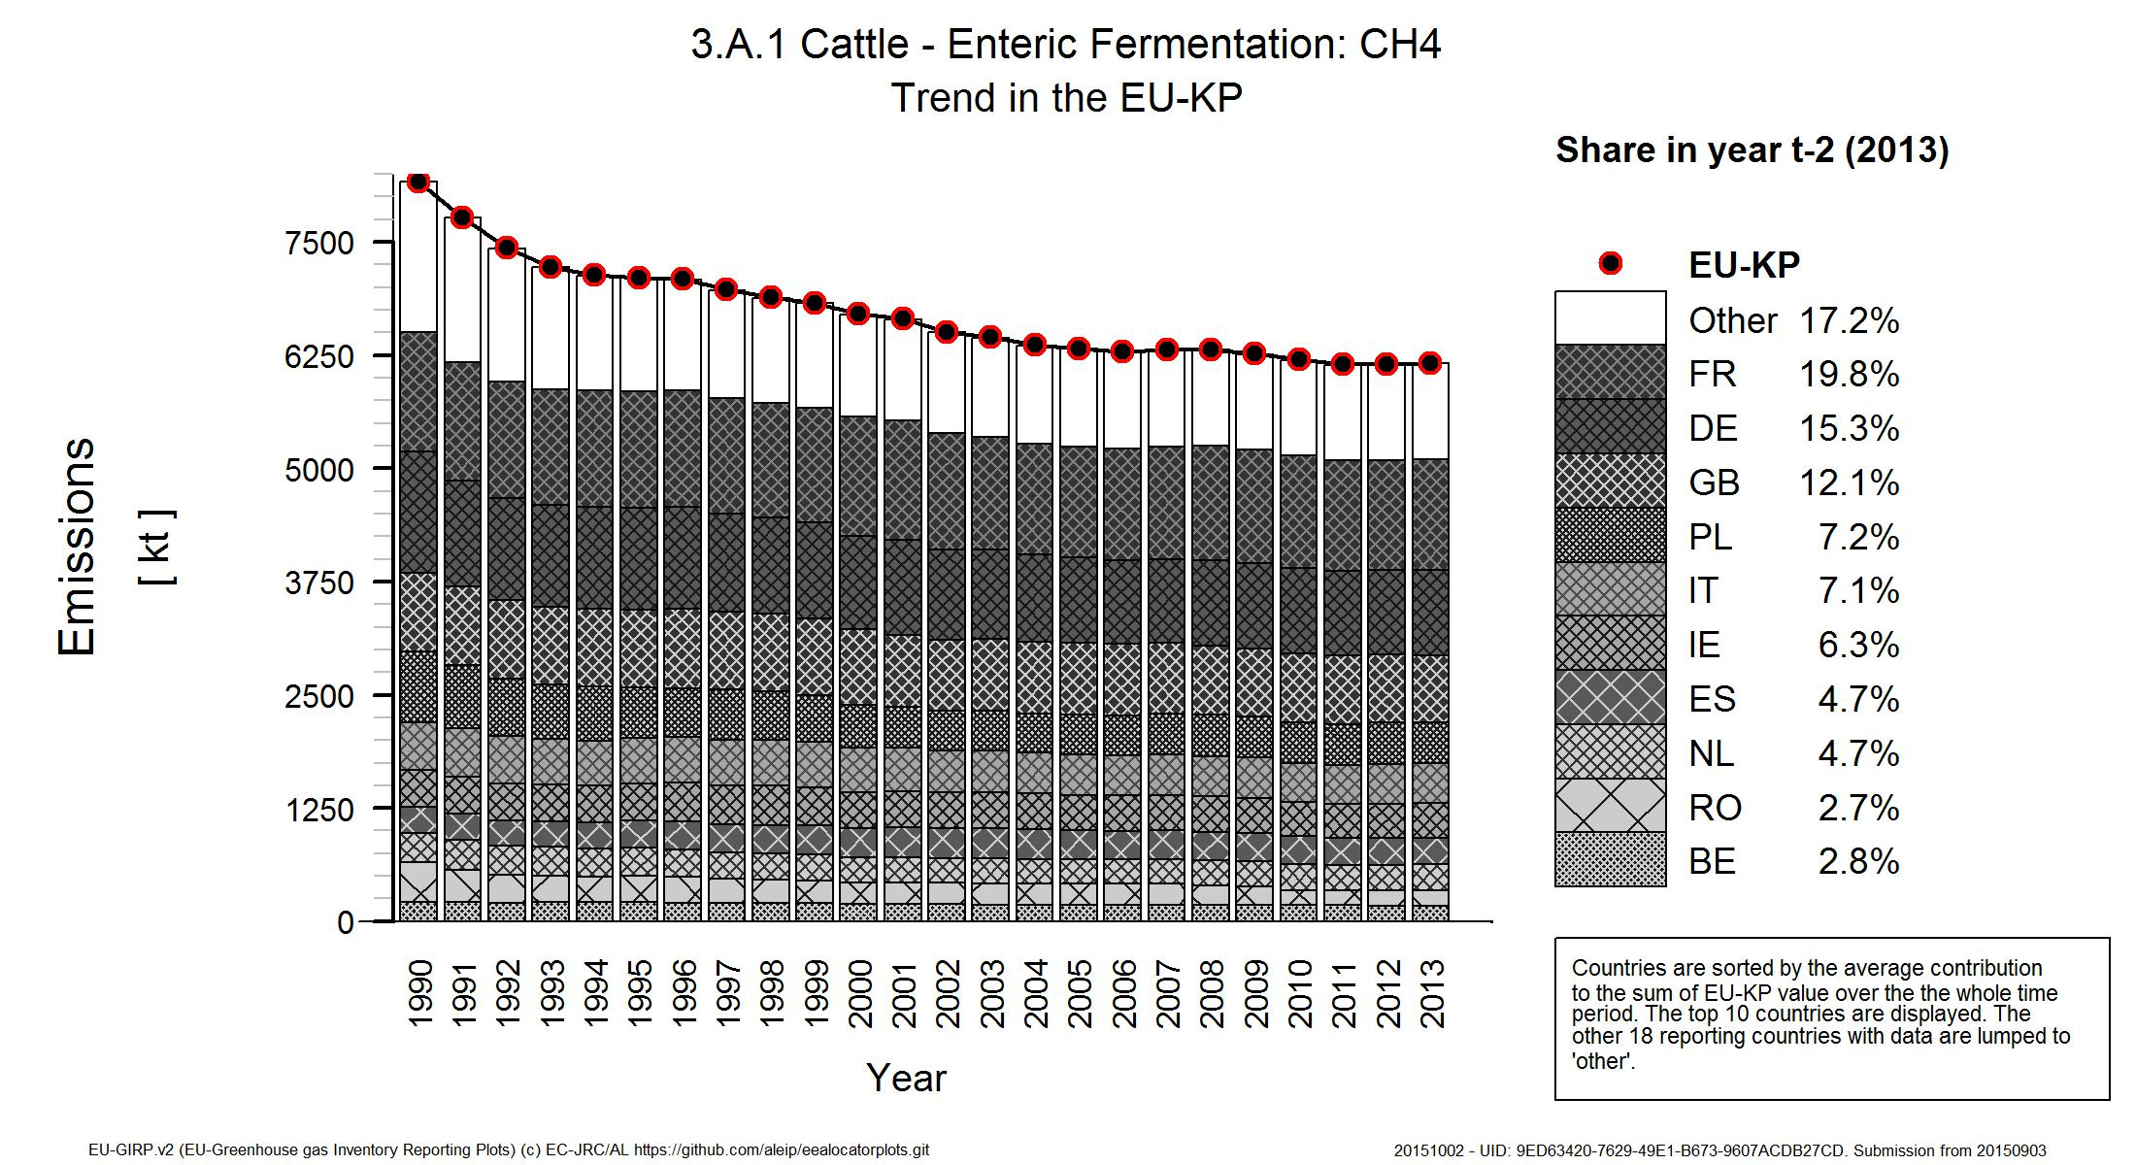

"title"

Enteric fermentation is the largest 100*agrigeneu[agrigeneu$sector_number=="3.A",lastyear]/mytotal of emissions.

1.115511910^{7} of emissions