## Using Skype Call Park Features

The Call Park feature within Skype for Business allows a user to put a call on hold, and then retrieve the call from any phone by using a temporary unique number.

The temporary unique number is created whenever a call is parked. The temporary unique number can then be given to any other user to retrieve the call from parking.

**To park a call in Skype:**

1. Click **“Transfer**”

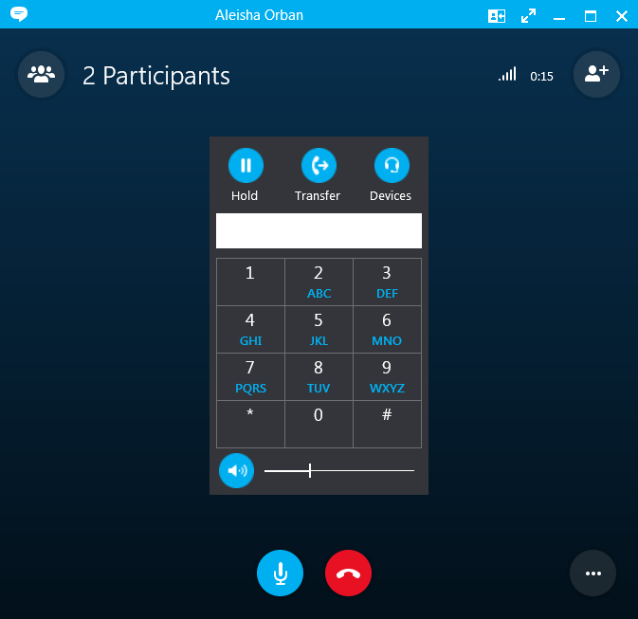

2. Select **“Park the call.”** *(lower-left of transfer window)*

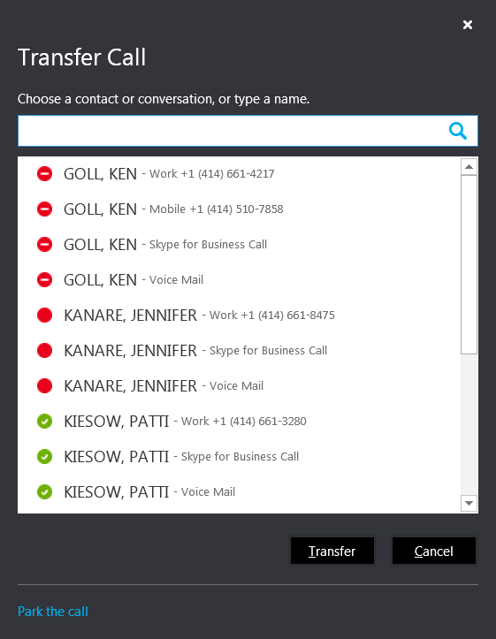

3. The ‘temporary unique number’ is listed in the conversation window. Provide this number to person who   
will pick-up the parked call. (via IM, two-way radio, in-person, etc.)

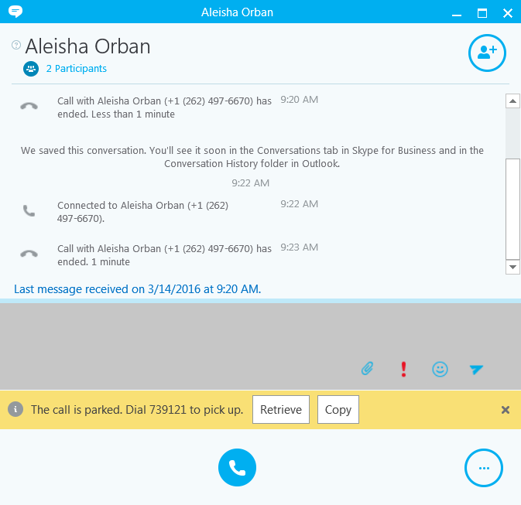

To resume the call, click the Retrieve button.

Dial the number listed to retrieve the call.

4. Person picking up the call will key in this number (in Skype dial pad) and click the Enter button on keyboard.

List steps for VVX here.

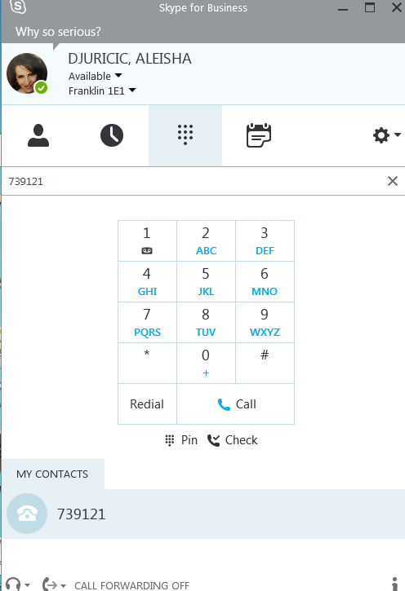

5. Original person (who parked the call) sees when the call was picked up by second person.

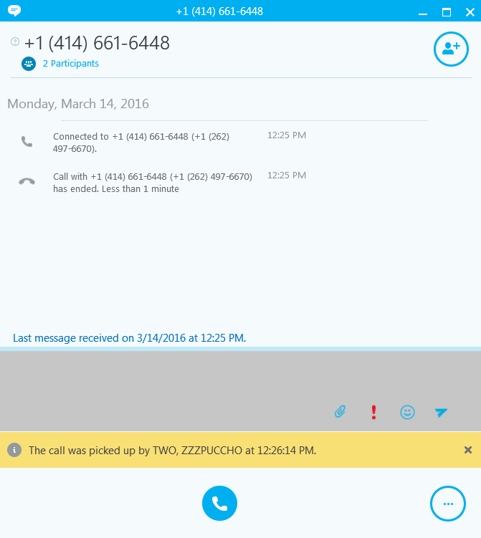

See that the call was picked up.