Reinterventions exploration

# Controling Variables

cat(controlling_vars %>% as.yaml())

- Age  
- Gender  
- Site  
- Prior Spine Surgery  
- ASA classification  
- 3CO  
- SPOs  
- BMI_First Visit  
- Tobacco use_First Visit  
- Osteoporosis / osteopenia  
- LGap  
- Global Tilt  
- ideal LL  
- Lordosis (top of L1-S1)  
- RLL  
- ODI - Score (%)_First Visit  
- SRS22 - SRS Total score_First Visit  
- SF36 - PCS_First Visit  
- SF36 - MCS_First Visit  
- Major curve Cobb angle

# Proportion of reinterventions by year

year N prop  
1: 1 59 35.8  
2: 2 27 16.4  
3: 3 19 11.5  
4: 4 20 12.1  
5: 5 15 9.1  
6: 6 10 6.1  
7: 7 7 4.2  
8: 8 7 4.2  
9: 9 1 0.6

# Reinterventions Impact

## odi

outcome_year

Estimate

StdError

p_value

np_p.val

2.5 %

97.5 %

mean_outcome

relative impact %

1

4.966709

1.522584

0.0012865

0.0009990

1.965606

7.967813

-12.077

41.12562

2

4.879255

1.437928

0.0008178

0.0039960

2.045519

7.712992

-10.109

48.26790

3

5.259115

1.633384

0.0016508

0.0039960

2.025128

8.493102

-11.542

45.56634

4

2.507754

1.811864

0.1695450

0.1938062

-1.088767

6.104275

-9.094

27.57530

5

4.695476

1.334178

0.0005680

0.0009990

2.059958

7.330994

-9.428

49.80426

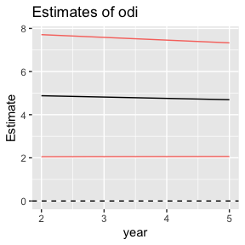

## srss

outcome_year

Estimate

StdError

p_value

np_p.val

2.5 %

97.5 %

mean_outcome

relative impact %

1

-0.1475420

0.0684007

0.0321183

0.0309690

-0.2823675

-0.0127166

0.709

20.80516

2

-0.1576276

0.0578103

0.0069071

0.0079920

-0.2715519

-0.0437033

0.659

23.91921

3

-0.1410390

0.0618450

0.0242700

0.0179820

-0.2634380

-0.0186400

0.700

20.14843

4

-0.0696183

0.0663575

0.2967481

0.1658342

-0.2013370

0.0621004

0.585

11.89252

5

-0.1859493

0.0577773

0.0015645

0.0019980

-0.3000648

-0.0718339

0.615

30.24039

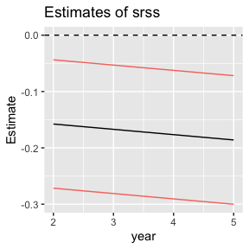

## pcs

outcome_year

Estimate

StdError

p_value

np_p.val

2.5 %

97.5 %

mean_outcome

relative impact %

1

-1.7676473

0.8975770

0.0502088

0.0769231

-3.536919

0.0016241

5.852

30.20672

2

-1.1040904

0.7827849

0.1598278

0.0849151

-2.646885

0.4387048

5.778

19.10928

3

-2.1127379

0.8669075

0.0162731

0.0279720

-3.829155

-0.3963213

6.717

31.45252

4

-0.9788755

0.9684080

0.3147306

0.4275724

-2.901942

0.9441909

5.958

16.42947

5

-1.6663084

0.7203007

0.0220439

0.0279720

-3.089402

-0.2432148

5.349

31.15334

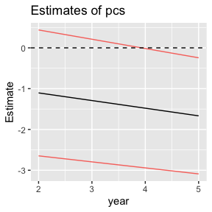

## mcs

outcome_year

Estimate

StdError

p_value

np_p.val

2.5 %

97.5 %

mean_outcome

relative impact %

1

-3.0182627

1.2249097

0.0145290

0.0089910

-5.432760

-0.6037649

4.342

69.51583

2

-2.2263823

0.9185224

0.0161714

0.0119880

-4.036703

-0.4160614

3.786

58.80762

3

-0.7191905

0.9831568

0.4658929

0.3236763

-2.665773

1.2273917

4.073

17.65824

4

-1.1672607

1.0062184

0.2489991

0.2287712

-3.165411

0.8308897

0.954

122.36594

5

-2.3149951

0.8009945

0.0044106

0.0099900

-3.897432

-0.7325581

3.504

66.07312

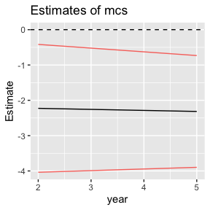

# Time Last Operation Impact

## odi

outcome_year

Estimate

StdError

p_value

np_p.val

2.5 %

97.5 %

mean_outcome

relative impact %

1

-18.4545256

8.426678

0.0296039

0.0419580

-35.064446

-1.844605

-12.077

152.8081736

2

-3.3701729

3.229806

0.2978754

0.6863137

-9.735333

2.994987

-10.109

33.3393450

3

-1.6234546

2.646735

0.5407957

0.4655345

-6.864255

3.617346

-11.542

14.0660325

4

-0.0910887

2.470613

0.9706669

0.4575425

-4.995875

4.813697

-9.094

1.0016131

5

-0.0897263

1.249195

0.9428325

0.7182817

-2.557497

2.378044

-9.428

0.9517147

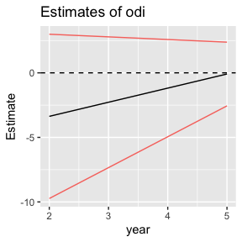

## srss

outcome_year

Estimate

StdError

p_value

np_p.val

2.5 %

97.5 %

mean_outcome

relative impact %

1

0.8410495

0.3628505

0.0214041

0.0109890

0.1258117

1.5562873

0.709

118.597894

2

0.2340668

0.1308823

0.0750789

0.0769231

-0.0238639

0.4919976

0.659

35.518489

3

0.0799069

0.0991638

0.4218968

0.3196803

-0.1163661

0.2761798

0.700

11.415268

4

0.0795924

0.0898932

0.3781706

0.2017982

-0.0988681

0.2580529

0.585

13.596343

5

0.0404435

0.0533910

0.4498873

0.6463536

-0.0650138

0.1459009

0.615

6.577214

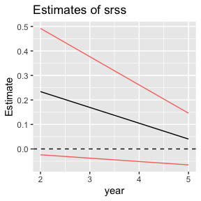

## pcs

outcome_year

Estimate

StdError

p_value

np_p.val

2.5 %

97.5 %

mean_outcome

relative impact %

1

0.7004176

4.8226962

0.8846644

0.8071928

-8.806163

10.2069985

5.852

11.969195

2

-0.4698833

1.7734790

0.7912995

0.6333666

-3.965333

3.0255664

5.778

8.132607

3

0.7891533

1.4000044

0.5740332

0.4325674

-1.982995

3.5613018

6.717

11.748197

4

0.2082904

1.3601548

0.8786254

0.3906094

-2.493094

2.9096753

5.958

3.495953

5

-0.5757842

0.6628848

0.3864423

0.7082917

-1.885511

0.7339428

5.349

10.764876

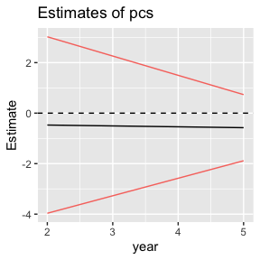

## mcs

outcome_year

Estimate

StdError

p_value

np_p.val

2.5 %

97.5 %

mean_outcome

relative impact %

1

-1.4591341

6.5810246

0.8247465

0.8851149

-14.4317617

11.513493

4.342

33.606391

2

4.8969766

2.0546237

0.0180159

0.0249750

0.8474030

8.946550

3.786

129.348655

3

-0.1812165

1.5897716

0.9094386

0.8481518

-3.3291230

2.966690

4.073

4.449398

4

0.5410499

1.4123146

0.7025335

0.3296703

-2.2639287

3.346029

0.954

56.719191

5

0.9442100

0.7349755

0.2008577

0.1648352

-0.5078766

2.396297

3.504

26.949040

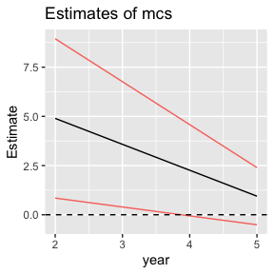

# Diagnosis

## odi

Variable

Estimate

StdError

p_value

2.5 %

97.5 %

outcome_year

diagnosisIdiopathic

-4.7768988

2.637286

0.0715175

-9.975704

0.4219064

1

diagnosisothers

-1.3016234

3.210386

0.6855638

-7.630162

5.0269156

1

diagnosisIdiopathic:reint_n

2.6880729

4.041815

0.5067347

-5.279438

10.6555836

1

diagnosisothers:reint_n

7.5647326

3.250462

0.0208983

1.157193

13.9722720

1

diagnosisIdiopathic

-4.7006098

3.113030

0.1324968

-10.836097

1.4348774

2

diagnosisothers

-2.8280969

3.690179

0.4442764

-10.101090

4.4448966

2

diagnosisIdiopathic:reint_n

-2.1097390

3.608844

0.5594196

-9.222429

5.0029512

2

diagnosisothers:reint_n

-4.3615388

3.139207

0.1661360

-10.548621

1.8255430

2

diagnosisIdiopathic

-4.6128870

4.250375

0.2800438

-13.031289

3.8055152

3

diagnosisothers

-3.3137987

5.908664

0.5759902

-15.016652

8.3890546

3

diagnosisIdiopathic:reint_n

1.1546313

3.926077

0.7692125

-6.621460

8.9307225

3

diagnosisothers:reint_n

-5.7816405

3.943363

0.1453076

-13.591969

2.0286875

3

diagnosisIdiopathic

-7.7638888

5.706909

0.1770156

-19.098302

3.5705242

4

diagnosisothers

-15.6058112

8.386525

0.0659636

-32.262174

1.0505514

4

diagnosisIdiopathic:reint_n

-1.7895980

4.145937

0.6670050

-10.023787

6.4445914

4

diagnosisothers:reint_n

-2.7609548

4.117511

0.5041936

-10.938688

5.4167782

4

diagnosisIdiopathic

-6.9751429

4.239232

0.1019717

-15.351013

1.4007270

5

diagnosisothers

-3.3872933

5.500526

0.5389454

-14.255227

7.4806409

5

diagnosisIdiopathic:reint_n

0.8567426

3.026314

0.7774897

-5.122646

6.8361309

5

diagnosisothers:reint_n

1.4862313

4.114925

0.7184692

-6.644033

9.6164958

5

## srss

Variable

Estimate

StdError

p_value

2.5 %

97.5 %

outcome_year

diagnosisIdiopathic

0.1183727

0.1127642

0.2950461

-0.1039223

0.3406676

1

diagnosisothers

-0.2594879

0.1372700

0.0600886

-0.5300916

0.0111158

1

diagnosisIdiopathic:reint_n

-0.0157359

0.1729409

0.9275870

-0.3566586

0.3251867

1

diagnosisothers:reint_n

-0.1871029

0.1521594

0.2202037

-0.4870585

0.1128526

1

diagnosisIdiopathic

0.0297843

0.1268945

0.8146478

-0.2203064

0.2798750

2

diagnosisothers

0.0711369

0.1505571

0.6370469

-0.2255894

0.3678631

2

diagnosisIdiopathic:reint_n

-0.0285680

0.1459887

0.8450370

-0.3162906

0.2591545

2

diagnosisothers:reint_n

0.0803585

0.1304535

0.5385388

-0.1767465

0.3374635

2

diagnosisIdiopathic

0.2678233

0.1673943

0.1122165

-0.0635779

0.5992245

3

diagnosisothers

0.1628663

0.2317265

0.4835063

-0.2958973

0.6216300

3

diagnosisIdiopathic:reint_n

-0.0590406

0.1567861

0.7071541

-0.3694400

0.2513587

3

diagnosisothers:reint_n

0.1357569

0.1387736

0.3298969

-0.1389821

0.4104959

3

diagnosisIdiopathic

0.2174152

0.2120700

0.3079547

-0.2037742

0.6386046

4

diagnosisothers

0.2959111

0.3137686

0.3481063

-0.3272603

0.9190826

4

diagnosisIdiopathic:reint_n

0.0390993

0.1538103

0.7999047

-0.2663812

0.3445798

4

diagnosisothers:reint_n

0.1415058

0.1534517

0.3588613

-0.1632625

0.4462740

4

diagnosisIdiopathic

0.1482120

0.1834799

0.4204615

-0.2142505

0.5106744

5

diagnosisothers

0.1266735

0.2400531

0.5984744

-0.3475486

0.6008955

5

diagnosisIdiopathic:reint_n

-0.0391501

0.1293108

0.7624814

-0.2946021

0.2163018

5

diagnosisothers:reint_n

-0.0028664

0.1817145

0.9874349

-0.3618412

0.3561084

5

## pcs

Variable

Estimate

StdError

p_value

2.5 %

97.5 %

outcome_year

diagnosisIdiopathic

1.6267881

1.510206

0.2826342

-1.3503999

4.603976

1

diagnosisothers

-1.3662832

1.836755

0.4577984

-4.9872244

2.254658

1

diagnosisIdiopathic:reint_n

-2.6227533

2.317499

0.2590502

-7.1914227

1.945916

1

diagnosisothers:reint_n

-1.1718317

2.033712

0.5650977

-5.1810492

2.837386

1

diagnosisIdiopathic

1.9242723

1.731881

0.2677772

-1.4894579

5.338003

2

diagnosisothers

0.5062420

2.012857

0.8016657

-3.4613229

4.473807

2

diagnosisIdiopathic:reint_n

2.1682821

1.983248

0.2754919

-1.7409199

6.077484

2

diagnosisothers:reint_n

1.9311241

1.712830

0.2608165

-1.4450555

5.307304

2

diagnosisIdiopathic

2.3331179

2.323025

0.3173030

-2.2679266

6.934162

3

diagnosisothers

1.9371529

3.225265

0.5492660

-4.4508905

8.325196

3

diagnosisIdiopathic:reint_n

0.8138135

2.147269

0.7053812

-3.4391234

5.066750

3

diagnosisothers:reint_n

4.1697137

1.954521

0.0350014

0.2985392

8.040888

3

diagnosisIdiopathic

4.9307094

3.019108

0.1059667

-1.0681932

10.929612

4

diagnosisothers

7.2596317

4.488724

0.1093517

-1.6593678

16.178631

4

diagnosisIdiopathic:reint_n

-1.4802205

2.260312

0.5142376

-5.9714130

3.010972

4

diagnosisothers:reint_n

1.3917621

2.243072

0.5365331

-3.0651748

5.848699

4

diagnosisIdiopathic

2.6132583

2.320918

0.2620053

-1.9731590

7.199676

5

diagnosisothers

2.2611324

2.985520

0.4500345

-3.6386202

8.160885

5

diagnosisIdiopathic:reint_n

-0.9121481

1.616583

0.5734418

-4.1067137

2.282418

5

diagnosisothers:reint_n

-2.1264892

2.270065

0.3504119

-6.6124152

2.359437

5

## mcs

Variable

Estimate

StdError

p_value

2.5 %

97.5 %

outcome_year

diagnosisIdiopathic

-2.0487101

2.026950

0.3133119

-6.044599

1.9471785

1

diagnosisothers

-3.0684515

2.465235

0.2146399

-7.928365

1.7914624

1

diagnosisIdiopathic:reint_n

4.0352419

3.110474

0.1959556

-2.096683

10.1671670

1

diagnosisothers:reint_n

-5.2582207

2.729584

0.0554132

-10.639267

0.1228257

1

diagnosisIdiopathic

-2.8298226

2.039804

0.1667929

-6.850503

1.1908577

2

diagnosisothers

-2.2328032

2.370736

0.3473475

-6.905788

2.4401816

2

diagnosisIdiopathic:reint_n

-1.0915211

2.335863

0.6407691

-5.695767

3.5127243

2

diagnosisothers:reint_n

0.6075111

2.017366

0.7635996

-3.368942

4.5839643

2

diagnosisIdiopathic

1.0611957

2.702356

0.6952671

-4.291161

6.4135521

3

diagnosisothers

-2.3506155

3.751923

0.5322118

-9.781773

5.0805416

3

diagnosisIdiopathic:reint_n

-1.2428596

2.497900

0.6197348

-6.190265

3.7045461

3

diagnosisothers:reint_n

-1.8945177

2.273677

0.4064221

-6.397823

2.6087871

3

diagnosisIdiopathic

1.0555426

3.211524

0.7431747

-5.325687

7.4367725

4

diagnosisothers

-2.2656397

4.774804

0.6363063

-11.753073

7.2217934

4

diagnosisIdiopathic:reint_n

-0.6281485

2.404369

0.7945010

-5.405578

4.1492806

4

diagnosisothers:reint_n

-2.2184135

2.386030

0.3550150

-6.959404

2.5225768

4

diagnosisIdiopathic

1.2352520

2.577182

0.6324256

-3.857294

6.3277982

5

diagnosisothers

2.7150731

3.320498

0.4148509

-3.846274

9.2764200

5

diagnosisIdiopathic:reint_n

-0.5445932

1.792972

0.7617514

-4.087529

2.9983425

5

diagnosisothers:reint_n

1.2565135

2.523822

0.6193158

-3.730592

6.2436193

5

# Hospitalization Time Impact

## odi

outcome_year

Estimate

StdError

p_value

np_p.val

2.5 %

97.5 %

mean_outcome

relative impact %

1

0.1296905

0.1143905

0.2581670

0.5374625

-0.0957860

0.3551669

-12.077

1.0738703

2

0.0326514

0.1036273

0.7529944

0.6993007

-0.1715727

0.2368755

-10.109

0.3230031

3

-0.1418101

0.2305270

0.5396262

0.5144855

-0.5982765

0.3146563

-11.542

1.2286794

4

0.0358988

0.2319921

0.8773535

0.7432567

-0.4246637

0.4964612

-9.094

0.3947436

5

0.0934964

0.1356732

0.4917789

0.6313686

-0.1745244

0.3615172

-9.428

0.9917032

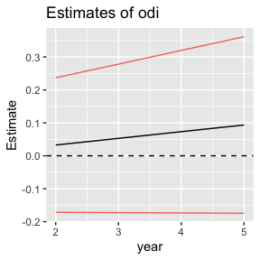

## srss

outcome_year

Estimate

StdError

p_value

np_p.val

2.5 %

97.5 %

mean_outcome

relative impact %

1

-0.0057484

0.0049971

0.2512894

0.6323676

-0.0155984

0.0041016

0.709

0.8105868

2

-0.0016989

0.0047859

0.7229369

0.8721279

-0.0111305

0.0077326

0.659

0.2578030

3

0.0073799

0.0058977

0.2131748

0.0939061

-0.0042933

0.0190530

0.700

1.0542668

4

0.0047246

0.0084843

0.5789269

0.5134865

-0.0121188

0.0215681

0.585

0.8070861

5

-0.0034662

0.0058818

0.5564981

0.5204795

-0.0150839

0.0081515

0.615

0.5637029

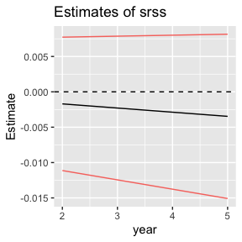

## pcs

outcome_year

Estimate

StdError

p_value

np_p.val

2.5 %

97.5 %

mean_outcome

relative impact %

1

-0.1196534

0.0709034

0.0929674

0.2667333

-0.2594194

0.0201126

5.852

2.044716

2

-0.1453296

0.0582782

0.0133878

0.1638362

-0.2601935

-0.0304658

5.778

2.515324

3

0.1017795

0.1212521

0.4029258

0.4485514

-0.1383118

0.3418708

6.717

1.515201

4

-0.2765079

0.1390987

0.0498006

0.0509491

-0.5527698

-0.0002459

5.958

4.640916

5

-0.1543573

0.0725049

0.0348828

0.0479520

-0.2976124

-0.0111023

5.349

2.885868

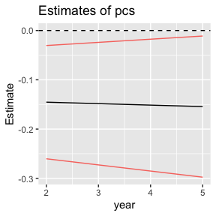

## mcs

outcome_year

Estimate

StdError

p_value

np_p.val

2.5 %

97.5 %

mean_outcome

relative impact %

1

-0.1547463

0.0968270

0.1114938

0.2017982

-0.3456134

0.0361207

4.342

3.5640766

2

-0.0012089

0.0693568

0.9861090

0.9120879

-0.1379081

0.1354902

3.786

0.0319330

3

-0.1401774

0.1373182

0.3094096

0.3966034

-0.4120811

0.1317263

4.073

3.4417680

4

0.1209338

0.1470614

0.4130124

0.7832168

-0.1711429

0.4130104

0.954

12.6776929

5

0.0052834

0.0818260

0.9486021

0.8931069

-0.1563797

0.1669465

3.504

0.1507959

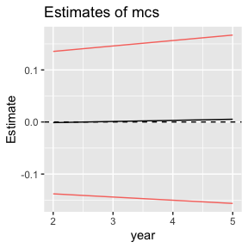

# Blood Loss Impact

## odi

outcome_year

Estimate

StdError

p_value

np_p.val

2.5 %

97.5 %

mean_outcome

relative impact %

1

0.0006639

0.0009404

0.4813122

0.1888112

-0.0011944

0.0025221

-12.077

0.0054970

2

0.0018922

0.0009744

0.0539843

0.1048951

-0.0000328

0.0038172

-10.109

0.0187184

3

0.0009724

0.0012545

0.4400911

0.3446553

-0.0015165

0.0034612

-11.542

0.0084250

4

-0.0007565

0.0018738

0.6874774

0.7082917

-0.0044847

0.0029717

-9.094

0.0083184

5

0.0005107

0.0013737

0.7108261

0.4525475

-0.0022132

0.0032345

-9.428

0.0054168

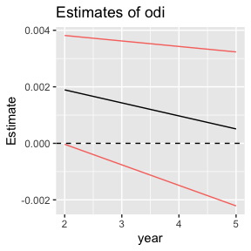

## srss

outcome_year

Estimate

StdError

p_value

np_p.val

2.5 %

97.5 %

mean_outcome

relative impact %

1

-8.00e-07

4.13e-05

0.9845694

0.3246753

-0.0000824

0.0000808

0.709

0.0001129

2

1.82e-05

4.18e-05

0.6638271

0.3396603

-0.0000644

0.0001009

0.659

0.0027653

3

-1.50e-05

5.09e-05

0.7690034

0.1808192

-0.0001159

0.0000859

0.700

0.0021411

4

6.99e-05

6.79e-05

0.3065481

0.6933067

-0.0000652

0.0002050

0.585

0.0119358

5

-7.49e-05

6.39e-05

0.2432638

0.2327672

-0.0002016

0.0000517

0.615

0.0121889

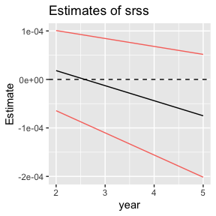

## pcs

outcome_year

Estimate

StdError

p_value

np_p.val

2.5 %

97.5 %

mean_outcome

relative impact %

1

-0.0006810

0.0005392

0.2085675

0.1428571

-0.0017465

0.0003845

5.852

0.0116371

2

0.0000379

0.0005772

0.9476857

0.9750250

-0.0011024

0.0011782

5.778

0.0006566

3

-0.0006783

0.0006965

0.3324706

0.4395604

-0.0020599

0.0007034

6.717

0.0100973

4

-0.0006160

0.0009823

0.5323703

0.3546454

-0.0025710

0.0013389

5.958

0.0103396

5

-0.0004230

0.0007866

0.5919314

0.2987013

-0.0019834

0.0011374

5.349

0.0079083

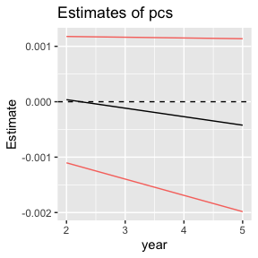

## mcs

outcome_year

Estimate

StdError

p_value

np_p.val

2.5 %

97.5 %

mean_outcome

relative impact %

1

0.0007334

0.0007673

0.3407160

0.4335664

-0.0007830

0.0022498

4.342

0.0168924

2

0.0002154

0.0006746

0.7498826

0.4345654

-0.0011172

0.0015481

3.786

0.0056905

3

-0.0001335

0.0008347

0.8732094

0.4745255

-0.0017893

0.0015222

4.073

0.0032788

4

0.0027518

0.0010013

0.0073999

0.1158841

0.0007593

0.0047444

0.954

0.2884764

5

-0.0005542

0.0009080

0.5429868

0.7292707

-0.0023552

0.0012468

3.504

0.0158174

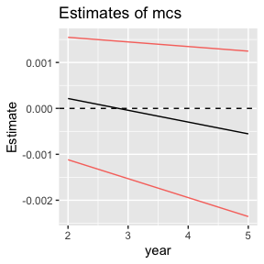

# Surgical Time Impact

## odi

outcome_year

Estimate

StdError

p_value

np_p.val

2.5 %

97.5 %

mean_outcome

relative impact %

1

-0.0041438

0.0075046

0.5814198

0.6933067

-0.0189374

0.0106498

-12.077

0.0343115

2

-0.0058234

0.0084428

0.4910916

0.7112887

-0.0224634

0.0108167

-10.109

0.0576073

3

-0.0046719

0.0109040

0.6690966

0.3796204

-0.0262649

0.0169210

-11.542

0.0404789

4

-0.0019872

0.0155043

0.8982867

0.4315684

-0.0327672

0.0287928

-9.094

0.0218509

5

-0.0088570

0.0105549

0.4026996

0.0869131

-0.0297091

0.0119951

-9.428

0.0939453

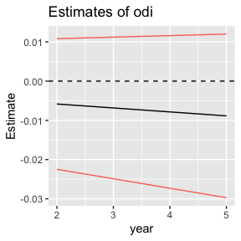

## srss

outcome_year

Estimate

StdError

p_value

np_p.val

2.5 %

97.5 %

mean_outcome

relative impact %

1

0.0004430

0.0003251

0.1743657

0.3886114

-0.0001978

0.0010839

0.709

0.0624740

2

0.0007407

0.0003365

0.0287796

0.3256743

0.0000775

0.0014039

0.659

0.1123947

3

0.0003996

0.0004285

0.3528825

0.0729271

-0.0004486

0.0012478

0.700

0.0570849

4

0.0006127

0.0005634

0.2795699

0.2147852

-0.0005058

0.0017311

0.585

0.1046599

5

0.0003456

0.0004633

0.4568706

0.1378621

-0.0005697

0.0012609

0.615

0.0562022

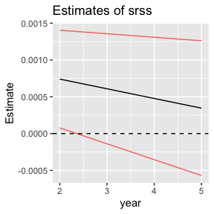

## pcs

outcome_year

Estimate

StdError

p_value

np_p.val

2.5 %

97.5 %

mean_outcome

relative impact %

1

-0.0001948

0.0045381

0.9657986

0.6953047

-0.0091411

0.0087515

5.852

0.0033292

2

0.0033032

0.0048720

0.4985042

0.8251748

-0.0063000

0.0129064

5.778

0.0571707

3

0.0045149

0.0059612

0.4503263

0.3776224

-0.0072898

0.0163196

6.717

0.0672139

4

-0.0097383

0.0086618

0.2638203

0.6133866

-0.0269414

0.0074648

5.958

0.1634478

5

-0.0026636

0.0058996

0.6522955

0.6003996

-0.0143213

0.0089941

5.349

0.0497987

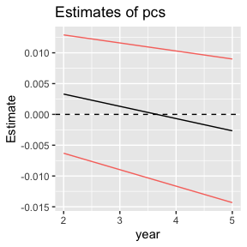

## mcs

outcome_year

Estimate

StdError

p_value

np_p.val

2.5 %

97.5 %

mean_outcome

relative impact %

1

0.0049520

0.0062102

0.4261180

0.7082917

-0.0072905

0.0171946

4.342

0.1140541

2

0.0009533

0.0057508

0.8685021

0.3966034

-0.0103822

0.0122888

3.786

0.0251793

3

-0.0017942

0.0067805

0.7917673

0.9240759

-0.0152214

0.0116329

4.073

0.0440533

4

0.0231139

0.0087353

0.0095793

0.1128871

0.0057648

0.0404631

0.954

2.4230745

5

-0.0006105

0.0065441

0.9257956

0.7132867

-0.0135411

0.0123200

3.504

0.0174250

