Complementary statistics

data_ %>%   
 .[followup_2y ==TRUE] %>%   
 .[Study=='Op'] %>%   
 .[Site != 'ANK Op'] %>%   
 .[Age < 100] %>%   
 .[`Vital status` == 'Alive'] ->  
 data_

Initial Patients: 985

data_ %<>%   
 .[`Posterior Instrumented Fusion` == 'Yes'] %>%   
 .[`Number of Posterior Instrumented Levels` > 3]

With Posterior Instrumented Fusion & Number of Posterior Instrumented Levels > 3: 805

# Survival Curve

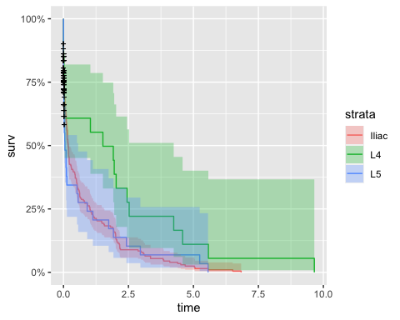

## Risk factors

Among those who are instrumented until L5, which are the risk factors that make them end up instrumented until Iliac.

revision <- read_excel(xls_path, sheet="Revision surgery") %>%   
 as.data.table()   
  
revision[, `Posterior Instrumented Fusion: Upper / Lower Levels`] %>%   
 sapply(. %>% strsplit('-') %>% .[[1]] %>% .[2]) ->  
 post_intr_fusion  
  
reint_iliac <- revision[post_intr_fusion=='Iliac', `Code of the patient`]  
  
data_l5 <- data_[type == 'L5']  
data_l5[, until_iliac := 0]  
data_l5[`Code of the patient` %in% reint_iliac, until_iliac := 1]  
  
data_l5[, .N, until_iliac]

until_iliac N  
1: 1 15  
2: 0 67

### Risk Controls

| Variable | Estimate | Std. Error | Pr(>|z|) |
| --- | --- | --- | --- |
| (Intercept) | -18.913410628 | 1,856.11415070 | 0.9918699 |
| Age | 0.009218199 | 0.02452129 | 0.7069717 |
| BMI_First Visit | -0.015334323 | 0.06692194 | 0.8187621 |
| ASA classification2 | 17.251452548 | 1,856.11323861 | 0.9925843 |
| ASA classification3 | 16.781740615 | 1,856.11336226 | 0.9927862 |
| Prior Spine SurgeryYes | 0.776429218 | 0.66782344 | 0.2449811 |

### Risk Radiology

| Variable | Estimate | Std. Error | Pr(>|z|) |
| --- | --- | --- | --- |
| Pelvic Incidence | 0.03315937 | 0.06389312 | 0.603773423 |
| Global Tilt | 0.35085886 | 0.11919896 | 0.003245526 |
| Pelvic Tilt | -0.45166808 | 0.16223115 | 0.005367614 |
| Pelvic Incidence Change | 0.05277462 | 0.06122904 | 0.388730755 |
| Global Tilt Change | 0.14280203 | 0.11303732 | 0.206475056 |
| Pelvic Tilt Change | -0.24233965 | 0.13106754 | 0.064462477 |