# Experiment

We’ll try to analyze the Reactance and Resistance when the permittivity is 81, conductivity is 0, and the relaxation time is also 0 seg.

Goal

The objective is to verify if the HFSS correctly interprets the dependence of the medium with the frequency

# Results

## Reactance Water (MATLAB)

## Resistance Water (MATLAB)

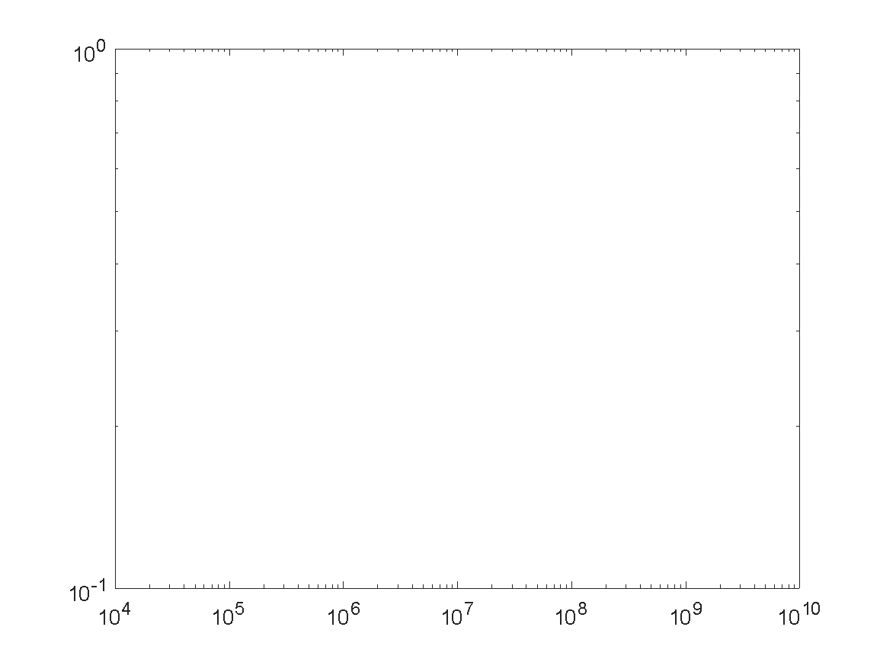

## Reactance Water (HFSS)

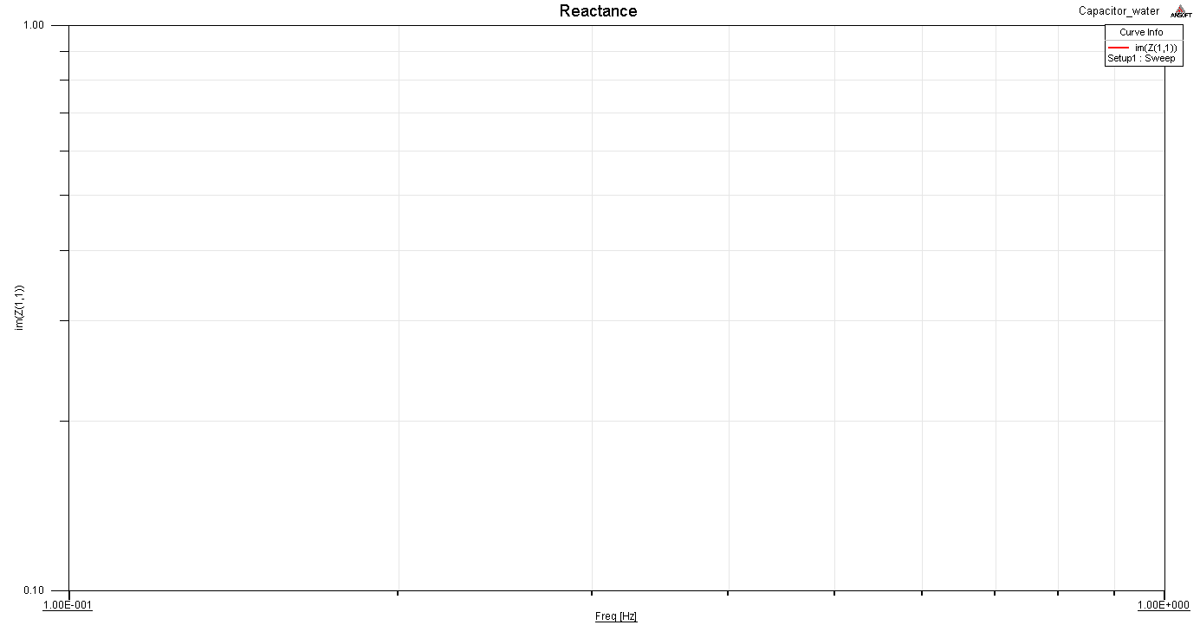

## Resistance Water (HFSS)

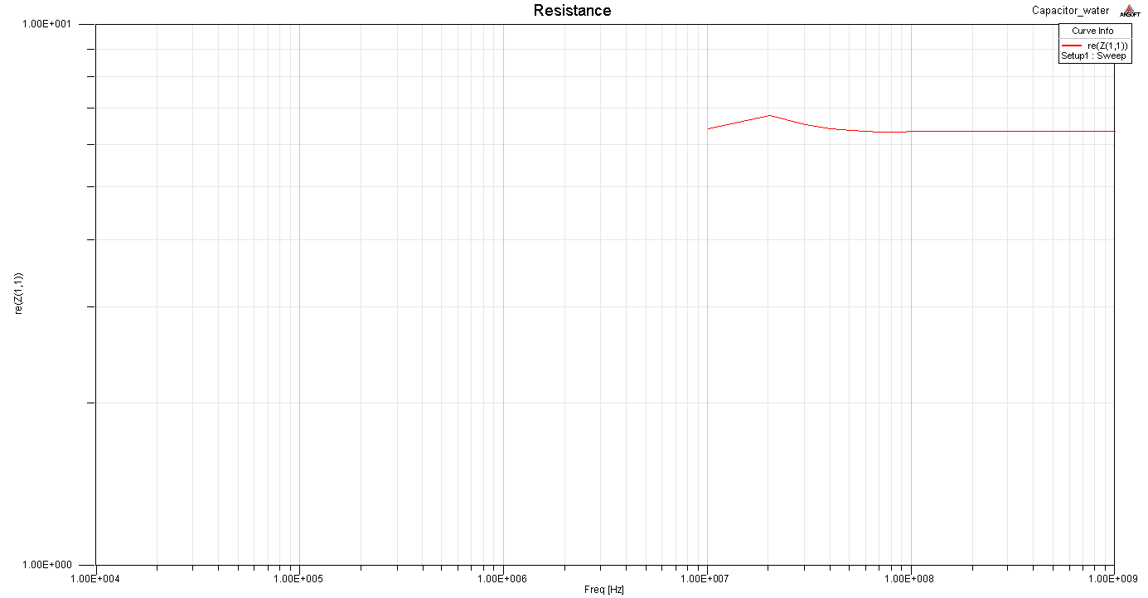

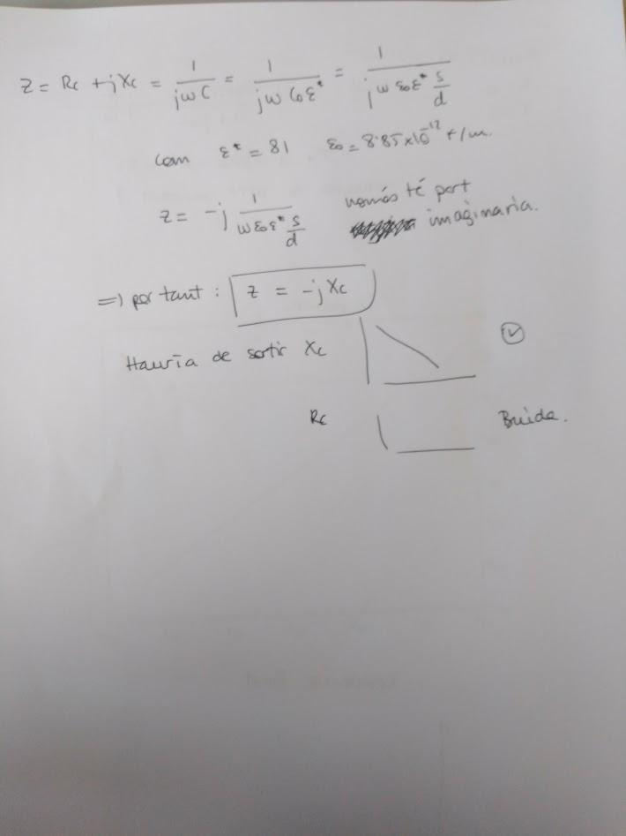

# Conclusions

It is observed that the results of the simulation do not match the analytical results. 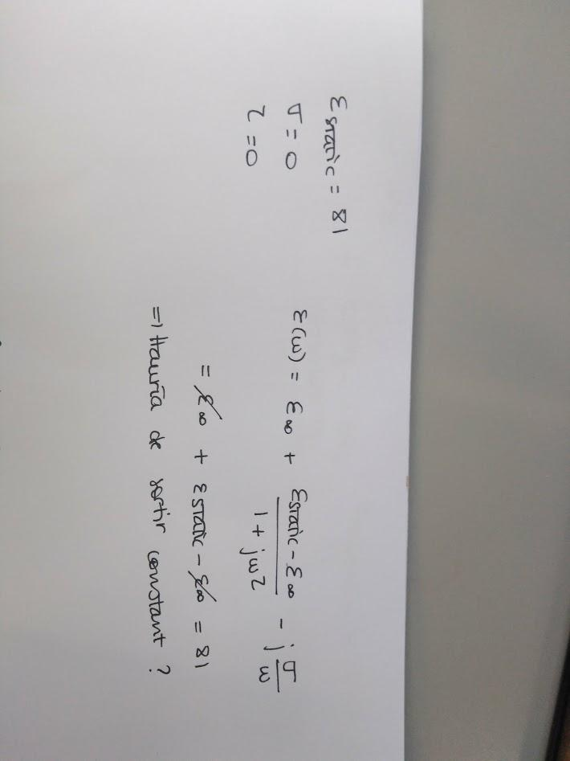

I modified the simulation instead of drawing im (Z (1,1)), that was negative and in logarithmic scale I did not draw anything, now draw -im (Z (1,1)).



