Electromagnetic modeling of water medium

# Experiment Description

In this experiment, the permittivity of watery media at low frequencies (10-2 to 30 MHz) has been investigated. To be able to validate that the results are consistent we have replicated the study elaborated in the role of F. Batalioto.  
For this reason, Matlab has simulated a parallel plates capacitor in suspension in water. The plate’s surface of 0.5 cm2 separated 5mm.  
The electrical impedance and the permittivity in this range of frequencies were measured when an AC voltage of 20mV was applied.

# Goal

The main objective of this experiment was to obtain an analytical expression of the variation of permittivity and impedance depending on the frequency. With the results obtained, it is expected to be able to analyze whether the HFSS correctly introduces the dependence of the environment with the frequency.

# Theory

The impedance of a capacitor is characterized by the following formula:

$$Z= \frac{1}{iωC}$$

Where C is the capacitance of the capacitor that is characterized:

$$C=ε\left(ω\right)\frac{S}{d}$$

The Debye model was used to characterize permittivity:

$${ε\left(ω\right)=ε}_{∞}+\frac{ε_{∞}-ε_{s}}{1+iωτ}-i\frac{σ}{ω}$$

$$σ=15\frac{μS}{m}$$

$$τ=0.9 s$$

$$ε_{∞}=80*ε_{0}$$

$$ε_{s}=1.9x{10}^{7}*ε_{0}$$

# Results

The real part and the imaginary part of the electrical impedance and the permittivity have been represented:

# 

*f(Hz)*

X(f)

R(f)

1. Water Impedance

* It is observed how the real part increases as the frequency decreases, and that during a range of frequencies from 10 Hz to ${10}^{5}Hz$ it stays constant.
* On the contrary, the imaginary part of the impedance has a local maximum of ${10}^{5}Hz.$
* There is a phrase in the paper that I don’t understand: ***“ for frequencies larger tan 1 kHz, the frquency dependencies of R and X are the usual ones. R presents a large plateau up to the frequency Deby, and X has a large maximum for a frequency that depends on the thickness of the simple, as 1/sqrt(d) and a narrow mínimum for a frequency independent of d”***

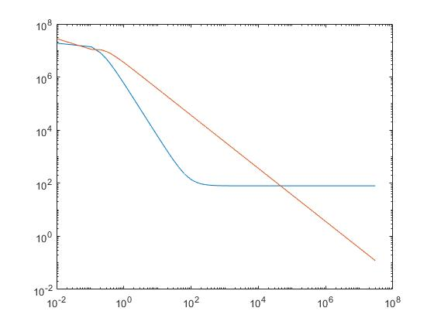

*f(Hz)*

2. Water Permittivity

• The blue line is the real part, as shown in the paper, when the frequency is usually DC, it tends to have a constant value of $3x{10}^{7}$. And for frequencies greater than 1 kHz it tends to vacuum permissibility of $80xε_{0}$. Therefore, it is known perfectly.  
  
• The red line is the imaginary part, it is observed that it is inversely proportional to the frequency.

# Conclusions and future work

From these analytical results, a capacitor will be simulated with HFSS under the same conditions. The material with the Debye model will be modeled and based on the conclusions obtained when comparing the results, the coaxial cable will be designed.