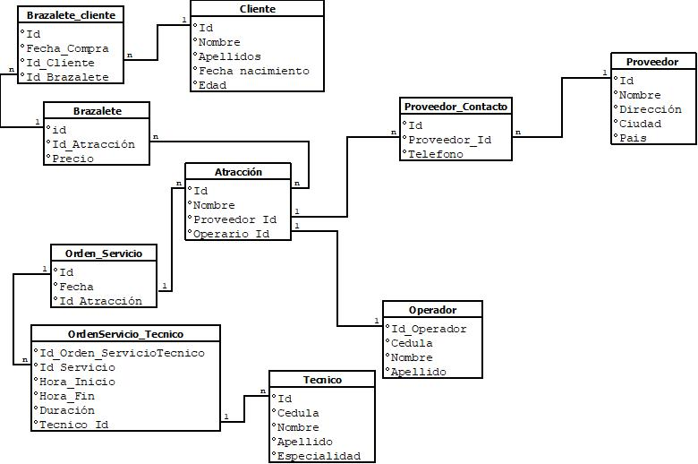

Tablas

|  |  |  |  |
| --- | --- | --- | --- |
| Atracción |  |  |  |
| Id | Nombre | Proveedor Id | Operario Id |
| 1 | Montaña rusa | 1 | 1 |
| 2 | Carrusel | 1 | 2 |
| 3 | Escaleras | 2 | 3 |

|  |  |  |  |
| --- | --- | --- | --- |
| operador |  |  |  |
| id | cedula | nombre | Apellido |
| 1 | 123345 | Juan | Cano |
| 2 | 23334 | Luisa | Paz |
|  |  |  |  |

|  |  |  |  |  |
| --- | --- | --- | --- | --- |
| Proveedor | |  |  |  |
| id | nombre | dirección | ciudad | Pais |
| 1 | atracciones sa | cra 2-34 | Cali | Colombia |
| 2 | Diversiones | cra 2-35 | Bogotá | Colombia |
|  |  |  |  |  |

|  |  |  |
| --- | --- | --- |
| Proveedor contacto | |  |
| Id | Proveedor_Id | Telefono |
| 1 | 1 | 34456 |
| 2 | 2 | 45567 |

|  |  |  |
| --- | --- | --- |
| Orden servicio | |  |
| Id | Fecha | Id Atraccion |
| 1 | 22/01/2023 | 1 |
| 2 | 22/01/2023 | 2 |

|  |  |  |  |  |  |
| --- | --- | --- | --- | --- | --- |
| orderServicio_Tecnico | | |  |  |  |
| id | id_Orden_Servicio | Hora_inicio | Hora_fin | Duración | Tecnico id |
| 1 | 1 | 04:00 | 04:25 | 25 | 1 |
| 2 | 2 | 02:30 | 03:00 | 30 | 2 |
|  |  |  |  |  |  |

|  |  |  |  |
| --- | --- | --- | --- |
| Técnico |  |  |  |
| id | nombre | Apellido | Especialidad |
| 1 | Luisa | Paz | Mecanica |
| 2 | Ana | Rueda | Electrico |

|  |  |  |
| --- | --- | --- |
| brazalete |  |  |
| id | Id Atracción | Precio |
| 1 | 1 | 30000 |
| 2 | 2 | 19000 |

|  |  |  |  |
| --- | --- | --- | --- |
| cliente _brazalete | |  |  |
| id | Fecha_Compra | Id_Cliente | Id_ Brazalete |
| 1 | 22/01/2023 | 1 | 2 |
| 2 | 10/02/2023 | 2 | 2 |

|  |  |  |  |  |
| --- | --- | --- | --- | --- |
| cliente |  |  |  |  |
| id | nombre | Apellidos | Fecha Nacimiento | Edad |
| 1 | Julio | Arcos | 22/01/2000 | 23 |
| 2 | Mary | Rios | 23/01/2000 | 23 |