Alejandra Vouga Aguilera
Kathryn Montovan, Tim Schroeder
Spring 2026 | PFOA Group Research Tutorial | Senior Work
ENV 4696: Group Tutorial: Advanced Work in PFAS Groundwater Contamination II
May 28, 2026

Document Description: This final document contains the work I have done during Spring 2026 in a sequence of coding and explanations along with the code. It shows the progress through cleaning the datasets, merging them to create the first “master dataset,” then checking and acknowledging duplicates, understanding the reasons behind those arrangements, and making decisions upon those findings. After revision, Professor Katie Montovan made a new master dataset so we could use it in our exploratory visualizations of the data. Therefore, this document contains several attempts until finally having a stable dataset we could work with. Then, visualizations were made in order to explore each of the factors that could influence the PFOA concentrations. Bearing and aspect were the topics I researched different visualization methods to experiment with; therefore, all graphs in this document are exploratory and should not be considered final.
____________________________________________________________________________

- Making and Cleaning Datasets:

```{r}
library(dplyr)

#dataset: DEC_dt_1_original

DEC_dt_1_original <- read.csv("~/Desktop/PFAS Project 2026/DEC Original Data/Cleaned_Data_Oct31-2025 (1).csv")
View(DEC_dt_1_original)

DEC_dt_1_cleaned <- DEC_dt_1_original %>%
mutate(SiteSampleDate = as.Date(SiteSampleDate, format = "%m/%d/%y")) %>%
filter(SampleCollection %in% c("Raw", "POET Influent", "raw", "influent")) %>%
mutate(SampleCollection = recode(SampleCollection,"raw" = "Raw"))%>%
mutate(SiteID = as.character(SiteID))%>%
mutate(dataset="DEC_dt_1")%>%
select(
site_ID = SiteID,
address = SiteLocationID,
dataset,
sample_date = SiteSampleDate,
sample_collection = SampleCollection,
PFOA
)

#adding bearing:
bearings_distances_DEC_dt_1 <- read.csv("~/Desktop/PFAS Project 2026/DEC Original Data/bearings_distances_Initial_DEC_Dataset (1).csv") %>%
select(
site_ID = SiteID,
lat = SiteLatitude,
long = SiteLongitude,
distance_to_chemfab = Distance.to.ChemFab..m.,
bearing = Bearing.correct
)

#cutting bearing:
merged_DEC_1 <- merge (bearings_distances_DEC_dt_1, DEC_dt_1_cleaned, by = "site_ID") %>%
mutate(bearing_cat = cut(bearing, breaks= c(22.5,67.5,112.5,157.5,202.1,247.5,292.5,337.5, 360,0),labels=c(1,2,3,4,5,6,7,8,1))) %>%
mutate(bearing_cat = as.numeric (bearing_cat))

#adding slope:
slope_aspect_DEC <- read.csv("~/Desktop/PFAS Project 2026/DEC Original Data/DECwells_slope&aspect.csv") %>%
select(
site_ID = SiteID,
aspect = aspect_reclass1,
slope = slope1
)

#adding BA difference:
merged_DEC_1_2 <- merge (merged_DEC_1, slope_aspect_DEC, by = "site_ID") %>%
mutate(BA_difference = aspect - bearing_cat) %>%
mutate(merged_DEC_1_2, slope_direction = case_when(BA_difference== 0 ~ "Away", BA_difference== 4 ~"Towards", BA_difference== -4 ~"Towards", BA_difference==1|2|3|-1|-2|-3 ~ "NA"))

DEC_dt_1 <- merged_DEC_1_2 #Here I got DEC_dt_1 dataset done!

write.csv(DEC_dt_1, "~/Desktop/PFAS Project 2026/DEC_dt_1.csv", row.names = FALSE)

#dataset: DEC_dt_2

DEC_dt_2 <- read.csv("~/Desktop/PFAS Project 2026/SGPP_Merged.csv") %>%
rename(
address = Address,
dataset = Dataset,
lat = Latitude,
long = Longitude,
distance_to_chemfab = Distance.to.ChemFab..m.,
bearing = Bearing.correct,
aspect = Aspect,
sample_date = Sampledate,
PFOA = PFOA2,
slope = Slope,
BA_difference = BA_diff,
slope_direction = Slope_Direction,
) %>%
mutate(site_ID = as.character(site_ID))%>%
mutate(sample_date = as.Date(sample_date, format = "%m/%d/%Y")) %>%
select()

#main join: DEC_dt_1 + DEC_dt_2
DEC_masterdataset <- bind_rows(DEC_dt_1, DEC_dt_2) %>% #got the DEC masterdataset!
arrange(site_ID)

write.csv(DEC_masterdataset, "~/Desktop/PFAS Project 2026/DEC_masterdataset.csv", row.names = FALSE)
View(DEC_masterdataset)

#DEC_masterdataset %>% group_by(site_ID, address) %>% summarise(count= n()) %>% filter(count >1) #me just trying to see the duplicates!

site_counts <- merged_fixed_data %>%
group_by(site_ID, lat, long) %>%
summarise(count = n(), .groups = "drop")
```
____________________________________________________________________________

```{r}
#Tim's dataset: DataRaw_DEC_untreated.water
DataRaw_DEC_untreated.water <- read.csv("~/Desktop/PFAS Project 2026/Tim Fixed Data 03:24/DataRaw_DEC_untreated-water.csv")%>%
filter(if_any(everything(), ~ !is.na(.) & . != "")) %>% #to delete any rows that migth be empty or contain any empty space and NAs
mutate(SiteSampleDate = as.Date(SiteSampleDate, format = "%m/%d/%y")) %>%
select(
site_ID = SiteID,
address = Address,
site_location_ID = SiteLocationID,
sample_date = SiteSampleDate,
lat = SiteLatitude,
long = SiteLongitude,
sample_collection = SampleCollection,
PFOA,
)

#Tim's data with bearing:
BearingandDistance_fixedDECdata <- read.csv("~/Desktop/PFAS Project 2026/BearingandDistance_fixedDECdata.csv") %>%
select(
site_ID = Site.ID,
distance_chemfab = Distance.from.ChemFab,
bearing_chemfab = BearingFromChemFab,
)

#bearing categories:
merged_fixed_data <- merge (DataRaw_DEC_untreated.water, BearingandDistance_fixedDECdata, by = "site_ID") %>%
mutate(bearing_cat = cut(bearing_chemfab, breaks= c(22.5,67.5,112.5,157.5,202.1,247.5,292.5,337.5, 360,0),labels=c(1,2,3,4,5,6,7,8,1))) %>%
mutate(bearing_cat = as.numeric (bearing_cat))

#Tim's data with aspect and slope:
Sites_with_slope.and.aspect <- read.csv("~/Desktop/PFAS Project 2026/3:30:2026/Sites_with_slope-and-aspect.csv")%>%
select(
fid,
site_ID = Site.ID,
slope = Slope1,
aspect = Aspect1
)
#Adding BA difference for Tim's dataset:
merged_timsdataset <- merge (merged_fixed_data, Sites_with_slope.and.aspect, by = "site_ID") %>%
mutate(BA_difference = aspect - bearing_cat) %>%
mutate(merged_timsdataset, slope_direction = case_when(BA_difference== 0 ~ "Away", BA_difference== 4 ~"Towards", BA_difference== -4 ~"Towards", BA_difference==1|2|3|-1|-2|-3 ~ "NA"))

write.csv(merged_timsdataset, "~/Desktop/PFAS Project 2026/merged_timsdataset.csv", row.names = FALSE)
```
____________________________________________________________________________

```{r}
#Katie's Full Fixed Dataset:
library(dplyr)
library(ggplot2)

FullData_April4_2026 <- read.csv("~/Desktop/PFAS Project 2026/FullData_April4_2026.csv") %>%
select(-X) %>%
mutate(
Date = as.Date(Date),
Month = as.numeric(format(Date, "%m")),

Season = case_when(
Month %in% c(12, 1, 2) ~ "Winter",
Month %in% c(3, 4, 5) ~ "Spring",
Month %in% c(6, 7, 8) ~ "Summer",
Month %in% c(9, 10, 11) ~ "Fall",
TRUE ~ "Unknown"
),
Season = factor(Season, levels = c("Spring", "Summer", "Fall", "Winter", "Unknown"))
)

#finding duplicates:
duplicate_counts <- FullData_April4_2026 %>% #this is the duplicated counts I have!
count(dataset, SiteID, Latitude, Longitude, Date, Month, Year, DOY, Distance, Bearing, Aspect_cat, Slope, StreamDischarge_10d, StreamDischarge_15d, Bearing_cat, BA_difference, Slope_direction) %>%
filter(n > 1) #Here I found a duplicate that is identical! We can delete this!

#SiteID:S107, 2018-03-20, PFOA:920 n:2

library(stringr)
full_data_clean <- FullData_April4_2026 %>%
distinct(dataset, SiteID, Latitude, Longitude, Date, Month, Year, DOY, WellType, WellDepth, Distance, Bearing, Aspect_cat, Slope, StreamDischarge_10d, StreamDischarge_15d, Bearing_cat, BA_difference, Slope_direction, PFOA, .keep_all = TRUE)%>%
mutate(WellType = str_to_title(WellType))

well_check <- full_data_clean %>% distinct(WellType) %>%
arrange(desc(WellType))

#We want to prepare our data better in order to look at the time series test: Auggie suggested Kendall test seasonal/no seasonal

#Now, we just wanna put them in maximum date and minimum date, finding the time span

#this is what Auggie did!(I wanna learn about this as well but it might not be very useful of my time as of now!)
dates_trial <-full_data_april4_2026%>%
group_by(SiteID)%>%
summarize(n(),FirstDate= min(Date),LastDate= max(Date),SampleCount= n_distinct(Date,na.rm = TRUE))%>%
mutate(NumberDays=LastDate-FirstDate)%>%
filter(NumberDays>2190&SampleCount>=8)%>%
filter(FirstDate>=2016-01-01)

#this is my trial:
dates_trial_2 <- full_data_april4_2026 %>%
mutate(Date = as.Date(Date)) %>%
filter(Date >= as.Date("2016-01-01")) %>% #set up to just be this!
group_by(SiteID) %>%
mutate(Years_Count = n_distinct(Year),
Samples_in_2016 = sum(Year == 2016, na.rm = TRUE),
Samples_in_2017 = sum(Year ==2017, na.rm = TRUE),
Samples_in_2018 = sum(Year == 2018, na.rm = TRUE),
Samples_in_2019 = sum(Year ==2019, na.rm = TRUE),
Samples_in_2020 = sum(Year == 2020, na.rm = TRUE),
Samples_in_2021 = sum(Year ==2021, na.rm = TRUE)
) %>%
filter(Years_Count >= 5 & Samples_in_2016 >= 5) %>%
ungroup()

#Goals:
#make some graphs for bearings + aspect: Alecita
#active trees + discharge: Kasha
#distance + time: Auggie
```
____________________________________________________________________________

- Exploratory Visualization: FullData_April_2026

```{r}
#month, season vs PFOA levels:
ggplot(FullData_April4_2026, aes(x = factor(Month), y = PFOA)) +
geom_boxplot(aes(fill = Season), outlier.shape = NA, alpha = 0.5) +
geom_jitter(aes(color = Season), width = 0.2, alpha = 0.6, size = 1.5) +
scale_y_log10() +
theme_light() +
scale_fill_manual(values = c("Spring" = "blue",
"Summer" = "green",
"Fall" = "pink",
"Winter" = "yellow",
"Unknown" = "gray")) +
scale_color_manual(values = c("Spring" = "#707070",
"Summer" = "#707070",
"Fall" = "#707070",
"Winter" = "#707070",
"Unknown" = "#FF0000")) + #unknown is if the code is finding something else!
labs(title = "PFOA Concentration by Month",
x = "Month",
y = "PFOA (log scale)")
```

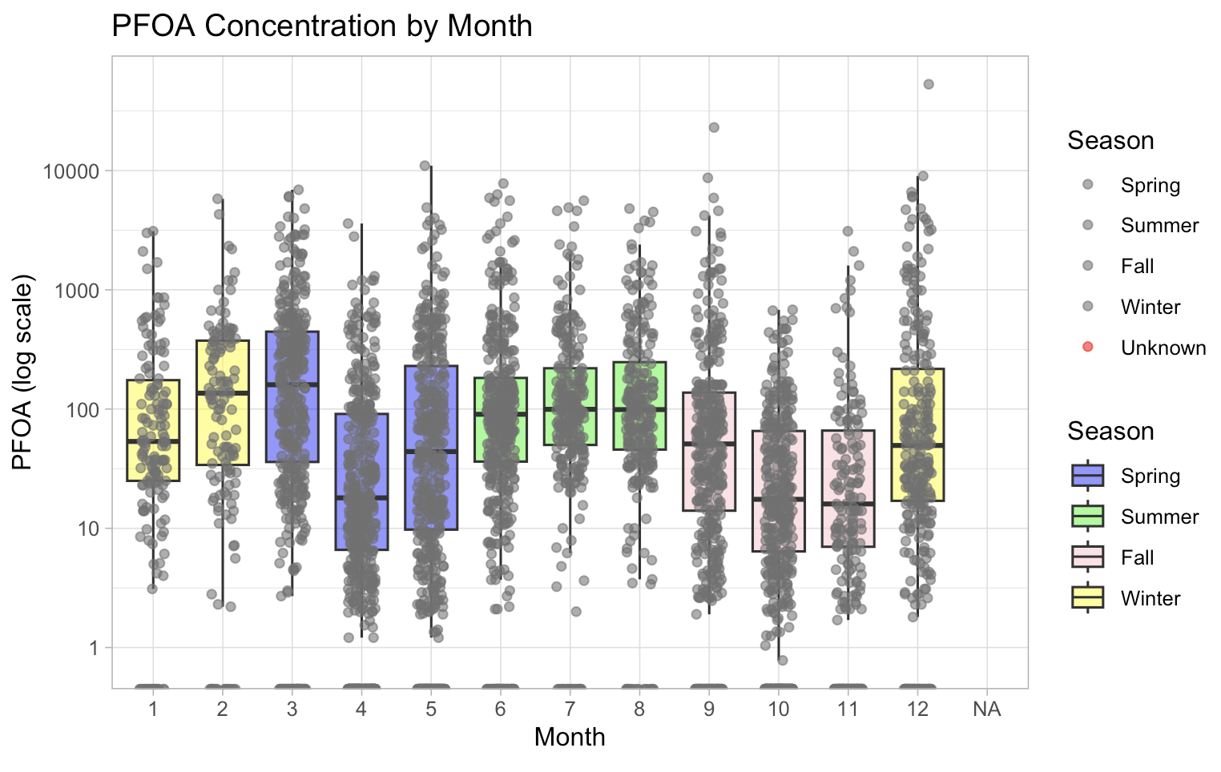

- Katie’s Full Masterdataset ready for all visualizations:
- Restricted: Samples from 2016/01/01, 2190 days in between, 8 sample counts

```{r}
#graphs with new dataset: FullData_April29_2026.csv
#cleaning it! checking everything!
#2194 rows after filtering the dates with Auggie's dataset!

FullData_April29_2026 <- read.csv("~/Desktop/PFAS Project 2026/FullData_April29_2026.csv") %>%
select(-X) %>%
mutate(Date = as.Date(Date))

str(FullData_April29_2026) #4956 obs. of 20 variables #This is unfiltered!

#this is to take the one row that was a duplicate nearby chemfab! PFOA: 920!
FullData_April29_2026 <- distinct(FullData_April29_2026,dataset, SiteID, Latitude, Longitude, Date, Month, Year, DOY, Distance, Bearing, Aspect_cat, Slope, StreamDischarge_10d, StreamDischarge_15d, Bearing_cat, PFOA, BA_diff, .keep_all=TRUE)

str(FullData_April29_2026) #4955 obs. of 20 variables #This is filtered!

duplicate_counts <- FullData_April29_2026 %>% #this is the duplicated counts I have!
count(dataset, SiteID, Latitude, Longitude, Date, Month, Year, DOY, Distance, Bearing, Aspect_cat, Slope, StreamDischarge_10d, StreamDischarge_15d, Bearing_cat, PFOA, BA_diff) %>%
filter(n > 1) #Here I found a duplicate that is identical! We can delete this!

#SiteID:S107, 2018-03-20, PFOA:920 n:2
#now is zero duplicates!

#this shows ONLY the rows with NA in "Aspect_cat" and "Bearing_cat"
FullData_April29_2026 %>%
filter(is.na(Aspect_cat)) %>%
filter(is.na(Bearing_cat))
#decided to take all the rows that appear to have NAs in Aspect_cat and Bearing_cat! just because Tim said let's not worry about them anymore and just do the ones that have a value!

ManySampleSites <- FullData_April29_2026%>%
group_by(SiteID)%>%
summarize(n(),FirstDate= min(Date),LastDate= max(Date),SampleCount= n_distinct(Date,na.rm = TRUE))%>%
mutate(NumberDays=LastDate-FirstDate)%>%
filter(NumberDays>2190&SampleCount>=8)%>%
filter(FirstDate>=2016-01-01)

View(ManySampleSites)
str(FullData_April29_2026)

FullData_April29_2026 %>% left_join(ManySampleSites) %>%
group_by(SiteID)
```
____________________________________________________________________________

- Exploratory Visualizations: FullData_April29_2026
```{r}
#graphs using Katie's dataset: full_data_april29_2026
#goal: make some graphs for bearings + aspect, Alecita

#all libraries for graphs:
install.packages("ggcorrplot")
install.packages("patchwork")
library(tidyverse)
library(ggplot2)
library(dplyr)
library(patchwork) #library for combining plots
library(ggcorrplot) #this is for correlation matrix
```
____________________________________________________________________________

```{r}
#1) PFOA rose map (Bearing): shows which compass direction from the source has the highest average contamination!
ggplot(FullData_April29_2026 %>%
filter(Distance>2000), aes(x = factor(Bearing_cat), y = PFOA, fill = factor(Bearing_cat))) +
geom_bar(stat = "summary", fun = "mean", width = 1, color = "white") +
coord_polar(start = 0) +
theme_minimal() +
labs(title = "Mean PFOA Concentration by Bearing Category", x = "Bearing Category", fill = "Category")
```

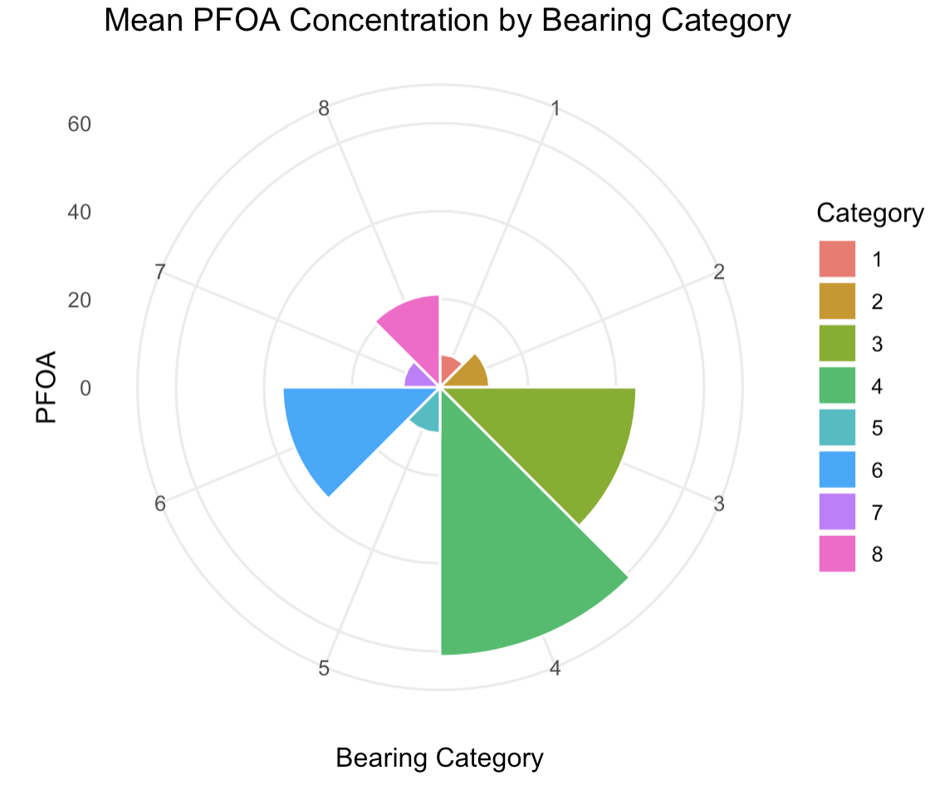

____________________________________________________________________________

```{r}
#3) sampling freq rose: is there any bias towards the frequency of samples in a specific bearing category?
ggplot(FullData_April29_2026 %>%
filter (Distance>2000), aes(x = factor(Bearing_cat))) +
geom_bar(width = 1, fill = "steelblue", color = "white") +
coord_polar(start = 0) +
theme_minimal() +
labs(title = "Frequency of Samples by Bearing")
```

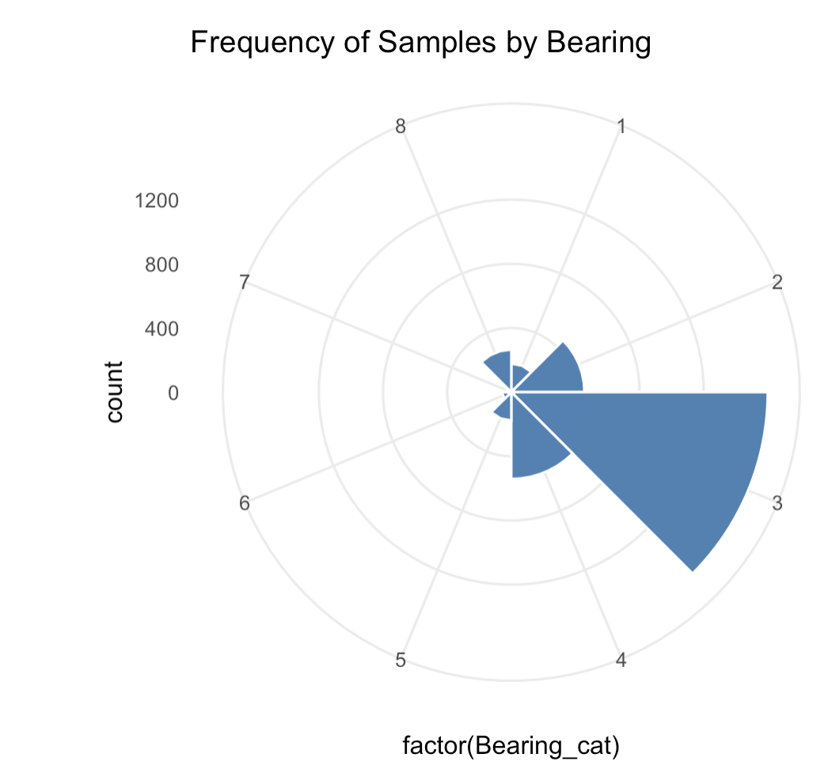

____________________________________________________________________________

```{r}
#4) bearing and aspect interaction as I think: again something might be wrong in the code because it is detecting NAs! - I need further exploration, personally, topographical approaches and spatial understanding are needed
ggplot(FullData_April4_2026 %>%
filter(Distance>2000), aes(x = factor(BA_difference), y = PFOA, fill = factor(BA_difference))) +
geom_boxplot() +
scale_y_log10() +
theme_minimal() +
labs(title = "PFOA Levels vs. Bearing-Aspect Difference",
x = "BA Difference (0 = Slope faces source)", y = "PFOA (log scale)")
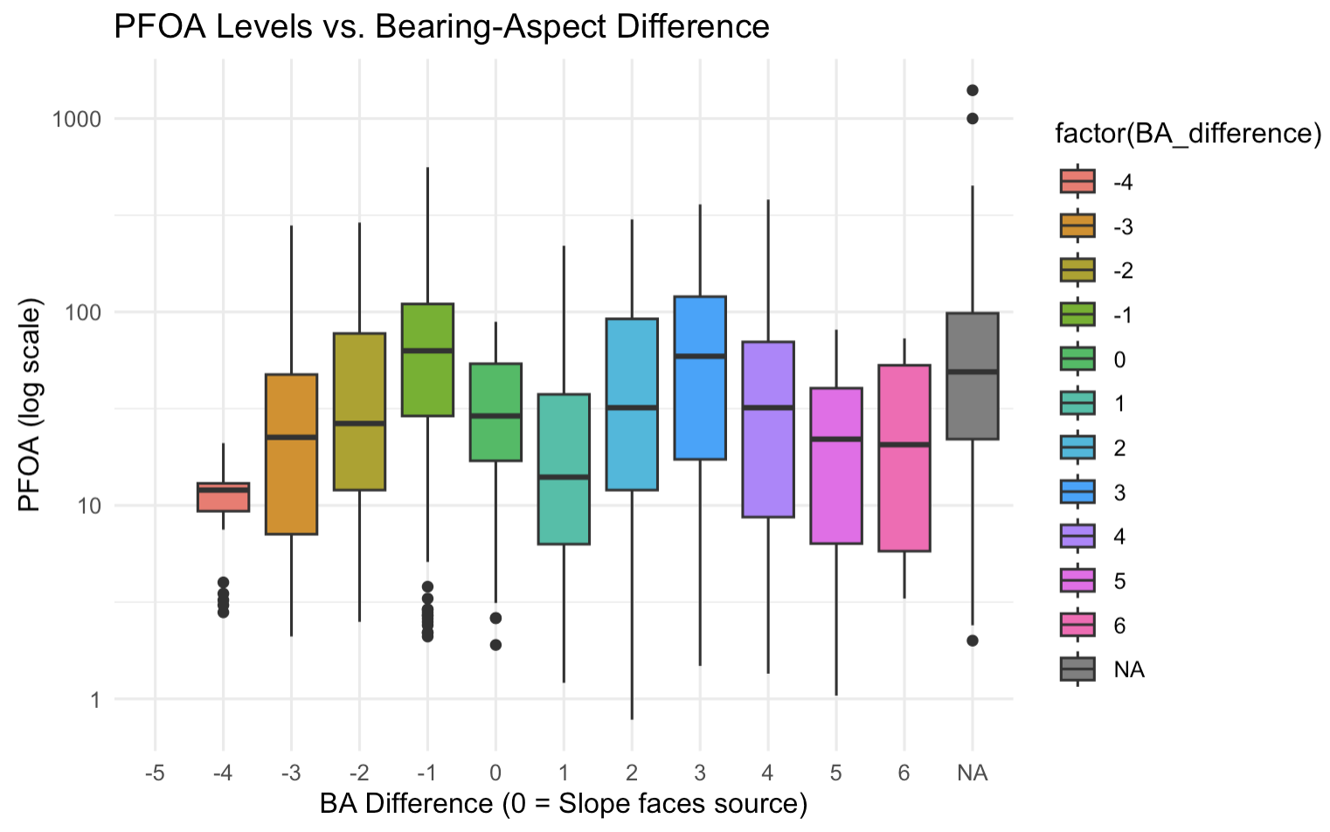
```

____________________________________________________________________________

```{r}
#5) faceted rose plots for possible seasonal changes depending on bearing:
ggplot(FullData_April4_2026 %>%
filter(Distance>500), aes(x = factor(Bearing_cat), y = PFOA, fill = factor(Season))) +
geom_bar(stat = "summary", fun = "mean", width = 1) +
coord_polar() +
facet_wrap(~Season) +
theme_bw() +
labs(title = "Seasonal shift in PFOA bearing")
```

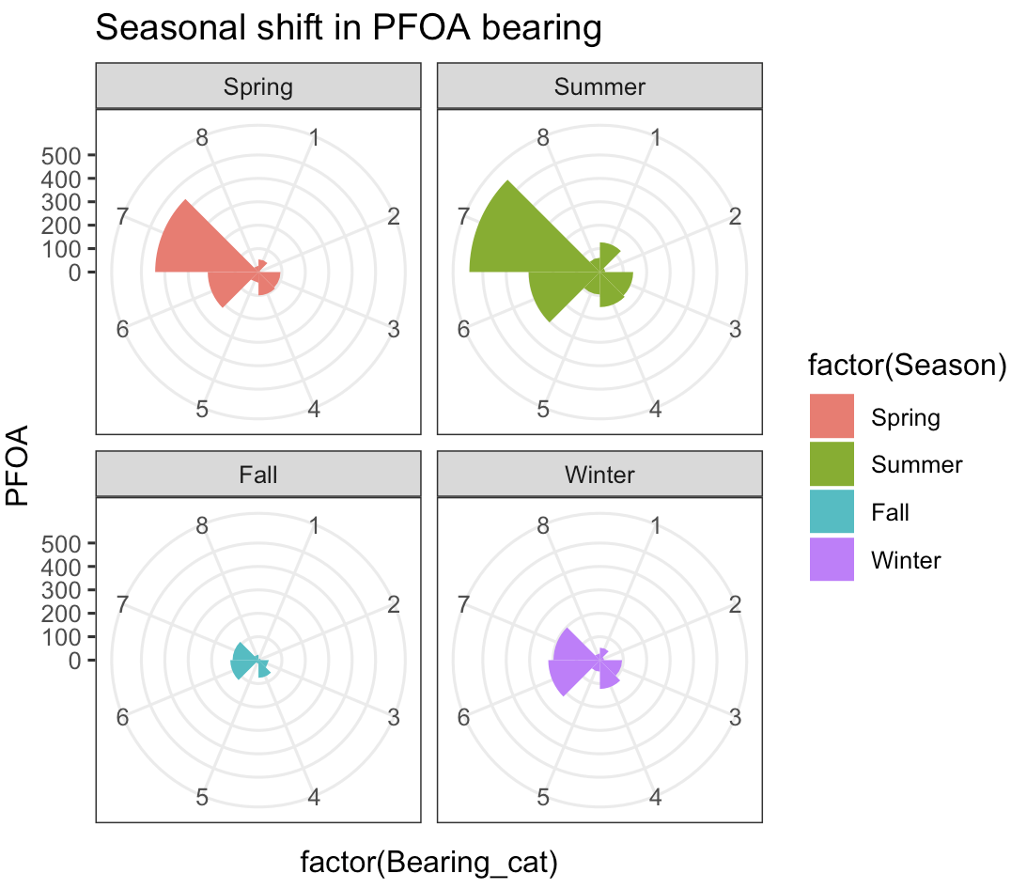
____________________________________________________________________________

```{r}
#6) PFOA dispersion and bearing (directional transport)
ggplot(FullData_April4_2026 %>%
filter(Distance>500), aes(x = Distance, y = PFOA, color = factor(Bearing_cat))) +
geom_point(alpha = 0.3) +
geom_smooth(method = "lm", se = FALSE) +
facet_wrap(~Bearing_cat) +
labs(title = "PFOA Decay by Distance per Bearing Category")
```

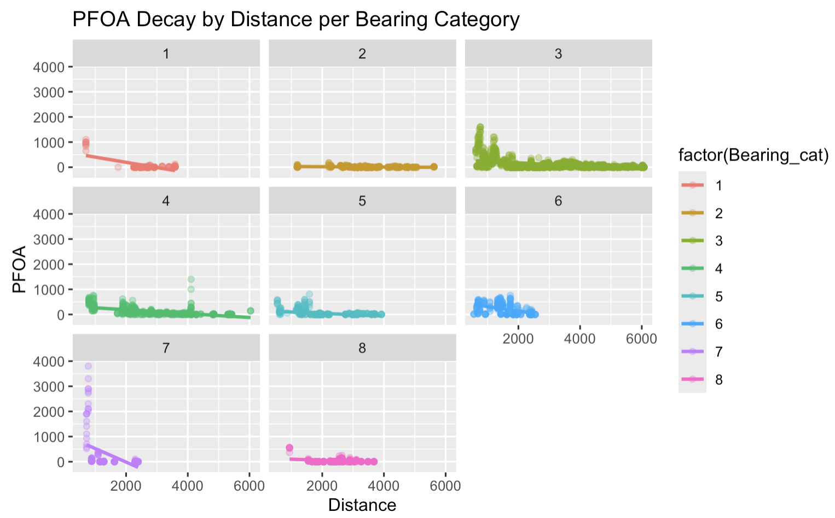
____________________________________________________________________________

```{r}
#7) slope and PFOA: I'd expect to have more with a lower slope value?
ggplot(FullData_April29_2026 %>%
filter(Distance>2000), aes(x = Slope, y = PFOA)) +
geom_point(alpha = 0.5, color = "darkgreen") +
geom_smooth(method = "loess") +

#LOESS local regression line (which stands for Locally Estimated Scatterplot Smoothing).
#Instead of forcing a straight, rigid line through your data (like a standard linear trend line)
#a LOESS curve is adaptive. It moves across your data in small geographic windows, calculating a localized average.

scale_y_log10() +
labs(title = "Slope impact on PFOA")
```

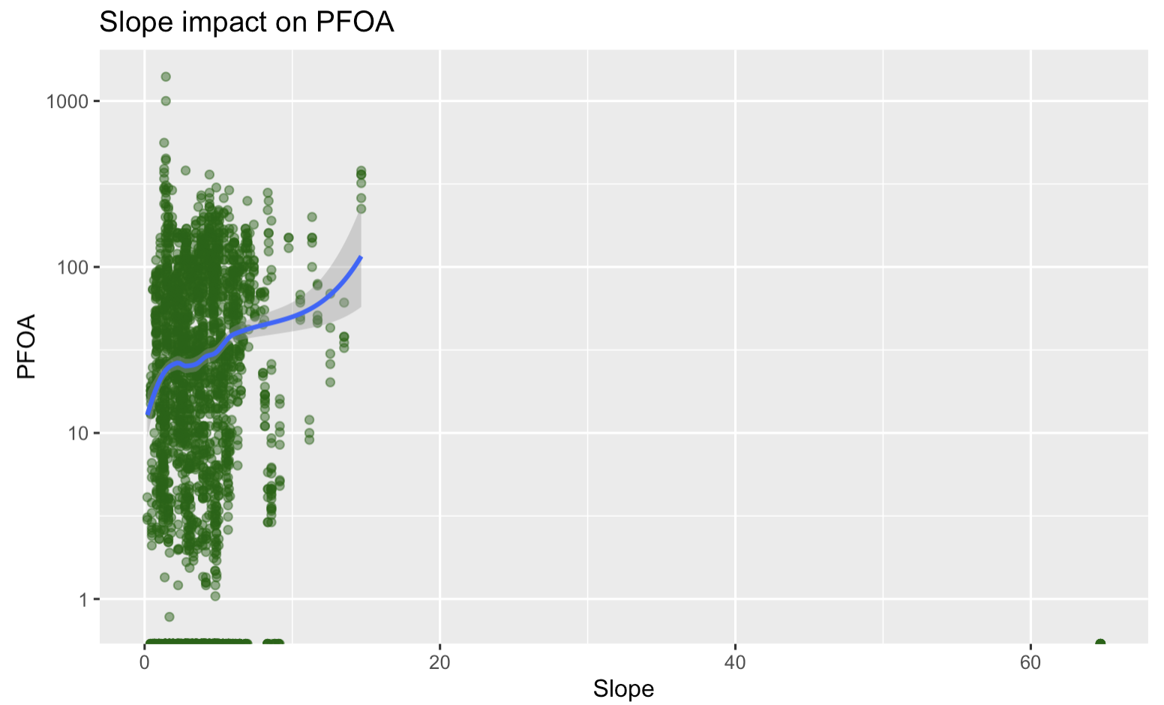

__

__________________________________________________________________________

```{r}
#8) Does distance matter more in certain slope faces? AGAIN NAs! why do we have NAs here? Code error probably!
ggplot(FullData_April4_2026 %>%
filter(Distance>2000), aes(x = Distance, y = PFOA)) +
geom_point(alpha = 0.2) +
geom_smooth() +
facet_wrap(~Aspect_cat) +
labs(title = "PFOA vs Distance Faceted by Aspect Category")
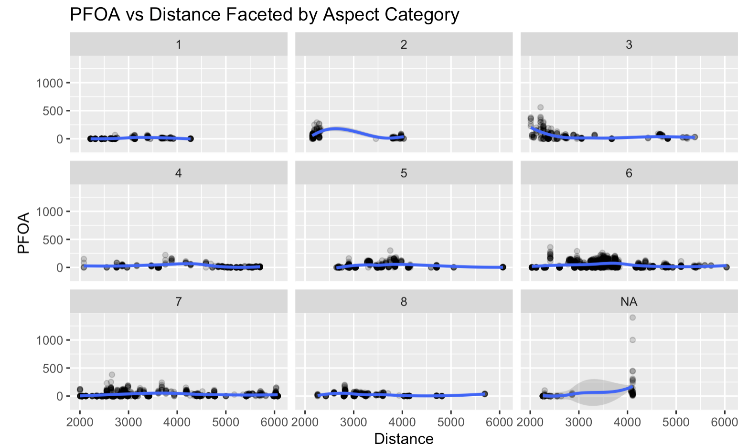
```

__________________________________________________________________________
```{r}
#9) numeric columns for correlation: I don't quite understand the logic of the function but it seems that distance has a "stronger" correlation with bearing, how so? I'm not quite sure yet!

corr_data <- FullData_April29_2026 %>%
select(PFOA, Distance, Bearing, Slope, Aspect_cat, StreamDischarge_10d) %>%
na.omit() %>%
cor()

ggcorrplot(corr_data, lab = TRUE, title = "Correlation of PFOA with all the variables")



