Given the provided data, what are three conclusions that we can draw about crowdfunding campaigns?

- We can safely determine Theater projects have the highest success rates among the list of categories given. Theater projects stand out with a significantly high number of successful campaigns, 187 throughout a decade. This suggests that backers are more willing to support theater projects, potentially due to the unique and tangible experiences that live theater productions offer. Within Theater projects, Plays has the highest number of campaigns. Emphasizing that the theater community actively utilizes crowdfunding platforms to support their productions and creative endeavors.

- February has a relatively high number of failed campaigns; February exhibits a higher count of failed campaigns compared to other periods compared year by year basis. This indicates that February might present challenges or difficulties for crowdfunding campaigns, potentially due to various factors such as increased competition, economic conditions, or reduced consumer spending after the holiday season. Creators planning campaigns during this month may need to consider additional strategies to overcome these challenges. One idea that comes to mind is that February is known as the start of tax return season. One way the Theatre organizer can overcome this slump is by targeting families and individuals receiving tax refunds.

- Journalism, although having only 4 crowdfunding campaigns between 2010 and 2020, is the only category with a 100% success rate in raising capital goals.

What are some limitations of this dataset?

- The dataset includes campaigns from different countries with various currencies. However, the dataset does not clarify if the pledge amount or goal amount has been converted to a common currency i.e., apples to apples. The absence of standardized currency conversion may introduce inconsistencies or inaccuracies when company the pledged amounts or percent funded across campaigns.

- Different regions may have distinct crowdfunding dynamics, cultural factors, or legal regulations that can impact campaign outcomes. Therefore, the findings from this dataset may not be applicable to crowdfunding campaigns in other countries, regions, provinces, states or cities.

What are some other possible tables and/or graphs that we could create, and what additional value would they provide?

- Funding progress over time, a line graph showing the funding progress over time for each campaign can illustrate how the pledge amount evolves throughout the campaign duration. This graph can provide insights into the momentum and success trajectory of campaigns, allowing creators to identify critical periods for securing funding and backers to gauge the popularity and growth potential of projects. This may help each campaign identify weak periods throughout the year and help avoid them and focus on periods that promise success.

- Funding goal distribution histogram or bar graph displaying the distribution of funding goals can provide insights into the range and concentration of campaign goals within the dataset. It allows creators to benchmark their goals against the overall distribution and assess whether their goals are aligned with industry standards or if adjustments may be needed to optimize their chances of success.

Use your data to determine whether the mean or the median better summarizes the data.

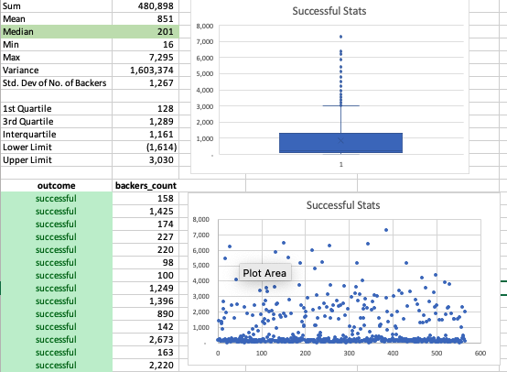

- We can see that the mean is significantly larger than the median, which suggests that the data may be positively skewed. Additionally, the maximum value of 7,295 is much larger than both the mean and the median, indicating multiple outliers, as proven in "Successful Stats" chart.
- In this case, it would be more appropriate to use the median as a summary statistic because it is less affected by outliers and it is less influenced by extreme values.

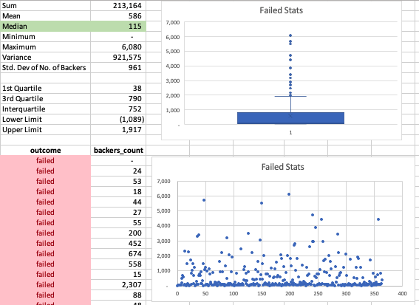

- It would be more appropriate to utilize the median as a summary statistic.

Use your data to determine if there is more variability with successful or unsuccessful campaigns. Does this make sense? Why or why not?

- I believe this does not make sense. The sample size is a big factor with having more successful points compared to failed points.

