Pacrial-1

Esquema 3 (Rojo - Gris - Azul)  
Link Figma: <https://www.figma.com/design/drumtbgrlM6G1gx6fvfvpw/Untitled?node-id=0-1&p=f&t=za0QglPZkPbCWsHc-0>

Pantalla 1:

* 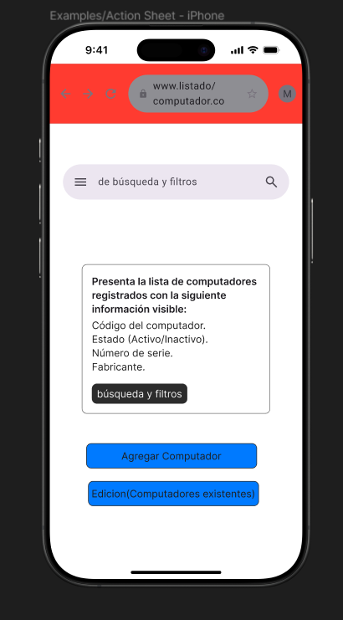

Pantalla 2:

* 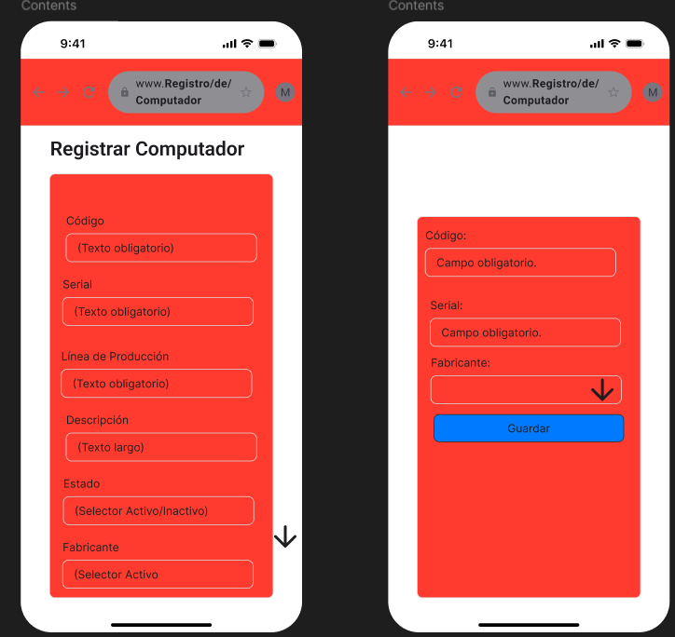

Pantalla 3:

* 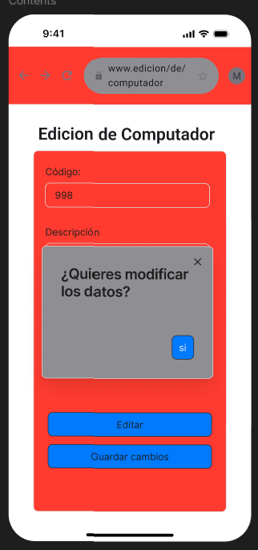

Pantalla 4:

* 