Abercrombie & Fitch Co.  NYSE: ANF Equity Research • Consumer Discretionary / Apparel Retail | 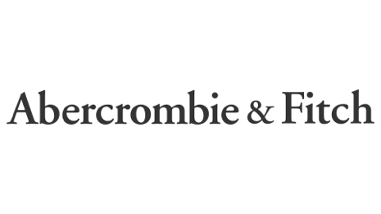
Report Date: 31 October 2025 Exchange: NYSE • Currency: USD
STRONG BUY | Current Price $70.90 | Target Price $109 (+53.74%) | Risk Medium | 12-mo. target

MARKET DATA  Market Cap $3.36 B  Revenue (FY24) $4,948 M  Revenue (LTM) $5,181 M  Net Income (FY24) $566 M  Net Income (LTM) $522 M  LTM EPS $10.74  P/E 6.6x  EV / EBITDA (LTM) 3.07x  EV / EBIT (LTM) 3.70x  Beta 1.35  All figures in USD; $ in millions unless noted. |  | SHARE PRICE — TRAILING 12 MONTHS  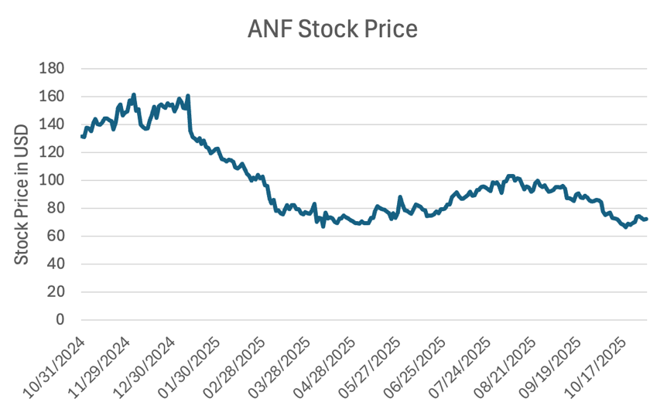
INVESTMENT SUMMARY
I believe Abercrombie & Fitch remains fundamentally strong with solid long-term growth potential despite its recent share-price decline. The sell-off looks overdone and largely driven by temporary concerns around the Abercrombie brand and a short-term deceleration. I remain confident in management's strategy, the brand portfolio, and the company's growth opportunities, which support the view that the stock is undervalued even under conservative growth assumptions. We rate the shares STRONG BUY with a 12-month target of $109.
Recent Results & Outlook
Second-Quarter FY2025 Results
Abercrombie & Fitch delivered another strong quarter, marking its 11th consecutive quarter of growth with record 2Q net sales of $1.2 billion, up 7% year over year and ahead of management's prior outlook. Growth was driven primarily by Hollister, which posted 19% net sales growth, alongside continued strength in the Americas (+8% YoY) and APAC (+12% YoY), partially offset by a modest 1% decline in EMEA. Profitability was also strong, with a reported operating margin of 17.1% and an adjusted operating margin of 13.9% (excluding a $39M pre-tax litigation-settlement benefit), both exceeding expectations. Adjusted EPS of $2.32 compared favorably to prior guidance, underscoring effective cost control and operational discipline. Reflecting this momentum, management raised full-year net sales growth guidance to 5–7% and reaffirmed its long-term outlook, while incorporating an estimated $90M tariff impact (~170 bps of sales).
Full-Year Guidance
For fiscal 2025, the company now expects net sales growth of 5–7%, supported by continued store expansion and steady underlying demand. Operating margin is projected at 13.0–13.5%, reflecting disciplined cost control despite ongoing tariff pressures, with an effective tax rate of approximately 30%. Diluted EPS is guided to $10.00–$10.50, assuming a diluted share count of approximately 49 million. Capital allocation remains shareholder-friendly, with approximately $400 million in share repurchases planned and capital expenditures of approximately $225 million, primarily to support store growth and maintenance. Real-estate activity includes approximately 40 net new store openings (60 openings and 20 closures), alongside around 40 remodels and right-sizing initiatives.
Company Overview
Abercrombie & Fitch Co. is an American apparel retailer founded in Delaware in 1996. The company operates as a digitally led, omnichannel retailer offering apparel, accessories, and personal-care products for men, women, and children, sold through a portfolio of brands: Hollister, Gilly Hicks, Social Tourist, Abercrombie & Fitch, and Abercrombie Kids.
Each brand targets a distinct customer demographic. Hollister primarily focuses on teenagers; Gilly Hicks and Social Tourist — the latter co-created with influencers Charli and Dixie D'Amelio — target Generation Z; the Abercrombie & Fitch brand targets young adults, primarily millennials; and Abercrombie Kids is designed for children. The company operates globally across the Americas, Europe, Asia-Pacific, the Middle East, and Africa.
Strategy
Abercrombie & Fitch's long-term strategy is centered on becoming a digitally led, omnichannel global apparel retailer while maintaining flexibility amid near-term macroeconomic and geopolitical uncertainty. The company's “Always Forward Plan,” announced in fiscal 2022, outlines a multi-year roadmap aimed at delivering sustainable growth and long-term shareholder value, anchored on three core pillars: brand growth, digital acceleration, and financial discipline.
Under this framework, management is focused on brand-specific growth initiatives — targeted marketing and store investment for the Abercrombie brand, refinement of Hollister's assortment and positioning to support renewed growth, and continued expansion of Social Tourist through an evolved merchandise mix. In parallel, the company is executing an enterprise-wide digital transformation, including modernization of key data platforms, a multi-year ERP and cloud migration, and enhancements to the digital and mobile customer experience.
Financial discipline remains a key priority, with management emphasizing lean inventory management, flexible inventory-chase capabilities, and a balanced approach to investment, cost control, and efficiency. Collectively, these efforts position the company to pursue profitable, long-term growth while maintaining operational agility in a dynamic retail environment.
Company History
Abercrombie & Fitch traces its origins to 1892, when David T. Abercrombie opened the company's first store — originally David T. Abercrombie Co. — specializing in hunting and fishing equipment. In 1900, lawyer Ezra Fitch purchased a stake, and by 1904 the business was renamed Abercrombie & Fitch. During its early years the company catered to notable figures, including President Theodore Roosevelt, and in the 1940s became a major supplier of military uniforms across all branches of the U.S. armed forces. By 1968 it reported approximately $28 million in sales.
Performance deteriorated in the 1970s, and the company filed for bankruptcy in 1976. In 1978 Oshman's Sporting Goods acquired the brand, and in 1988 The Limited acquired Abercrombie & Fitch for $47 million. In 1992, Michael Jeffries was hired and later reshaped the company's marketing around a provocative image. In 1996 the company went public on the NYSE under the ticker ANF, was spun off from Limited Brands in 1998, and launched Abercrombie Kids that year and Hollister in 2000. Later brand extensions included Ruehl No. 925 (2004–2010) and Gilly Hicks (2008).
Brand Controversy & Turnaround
Abercrombie became widely known for controversial marketing under Michael Jeffries' leadership; a 2006 interview in which he emphasized exclusivity and sex appeal drew lasting criticism, and the company faced class-action lawsuits alleging discriminatory hiring practices. Jeffries stepped down as CEO in 2014. In 2017, Fran Horowitz was appointed CEO and led a significant brand turnaround that culminated in record sales performance in 2024.
Industry Overview
The fundamental outlook for the U.S. specialty-apparel retail sub-industry is neutral, reflecting a structurally mature sector that has become increasingly bifurcated between well-positioned operators and underperforming peers. While select best-in-class and value-oriented retailers continue to outperform, broader fundamentals remain constrained by macroeconomic headwinds, muted consumer confidence, and limited pricing power.
- Equity performance has been resilient at times. As of November 17, 2025, the S&P Composite 1500 Apparel Retail Index was up approximately 12% year-to-date, modestly trailing the broader index's 13.2% gain. Over five years the apparel-retail index delivered a 14.4% CAGR, outpacing the broader market's 12.1%, underscoring the outperformance of dominant off-price and operationally efficient retailers.
- Industry growth is expected to remain modest. Inforum and the Interindustry Economic Research Fund project U.S. clothing-store industry growth of a 2.6% CAGR from 2025 to 2029, below the broader economy, constrained by elevated rates and limited real-income expansion (projected up 1.8% in 2025 and 1.6% in 2026).
- Consumer behavior continues to favor value-oriented retailers. The University of Michigan Consumer Sentiment Index registered 51.0 in November 2025, near multi-year lows, disproportionately affecting discretionary categories such as apparel, particularly among lower- and middle-income consumers.
- Inflation is mixed: core CPI rose 3.0% year-over-year in September, but apparel CPI declined marginally, signaling continued promotional activity and limited pass-through pricing power.
- Cost and labor pressures remain elevated, driven by higher tariff rates and rising Asian production costs. U.S. unemployment rose to 4.3% by August 2025 (from 3.7% in January 2024), and seasonal retail hiring is projected to fall below 500,000 positions in Q4 2025, the lowest since 2009, as retailers emphasize cost discipline.
Overall, the U.S. specialty-apparel sub-industry at the end of November 2025 is characterized by low growth, heightened competition, and ongoing structural change. While macro pressures and shifting preferences continue to challenge discretionary demand, value-oriented, off-price, and digitally capable retailers remain positioned to outperform within a mature, increasingly polarized market.
Competitive Landscape
- American Eagle Outfitters — a U.S. specialty retailer focused on casual, everyday clothing for teens and young adults, with a strong emphasis on denim and lifestyle basics. Operates primarily through its American Eagle and Aerie brands and leverages an omnichannel model integrating stores and e-commerce.
- Gap Inc. — a global apparel retailer with a diversified portfolio including Gap, Old Navy, Banana Republic, and Athleta. Serves a wide range of demographics, from value-oriented families to more premium consumers, emphasizing brand segmentation, scale efficiencies, and a balanced store-and-digital mix across international markets.
- Uniqlo — a subsidiary of Fast Retailing centered on functional, high-quality basics under its “LifeWear” philosophy. Targets a broad demographic with timeless, minimalist designs and emphasizes operational efficiency, fabric innovation, and large-format stores to support global expansion.
- H&M — a global fast-fashion retailer offering trend-driven apparel at accessible price points. Targets a broad, fashion-conscious base across an extensive international store network supported by e-commerce, emphasizing rapid product turnover and scale-driven sourcing.
- Zara — Inditex's flagship, a vertically integrated fast-fashion retailer known for its rapid design-to-shelf cycle. Targets style-conscious consumers and benefits from a highly responsive supply chain enabling limited production runs, fast inventory turnover, and reduced markdown risk.

Financial Statements
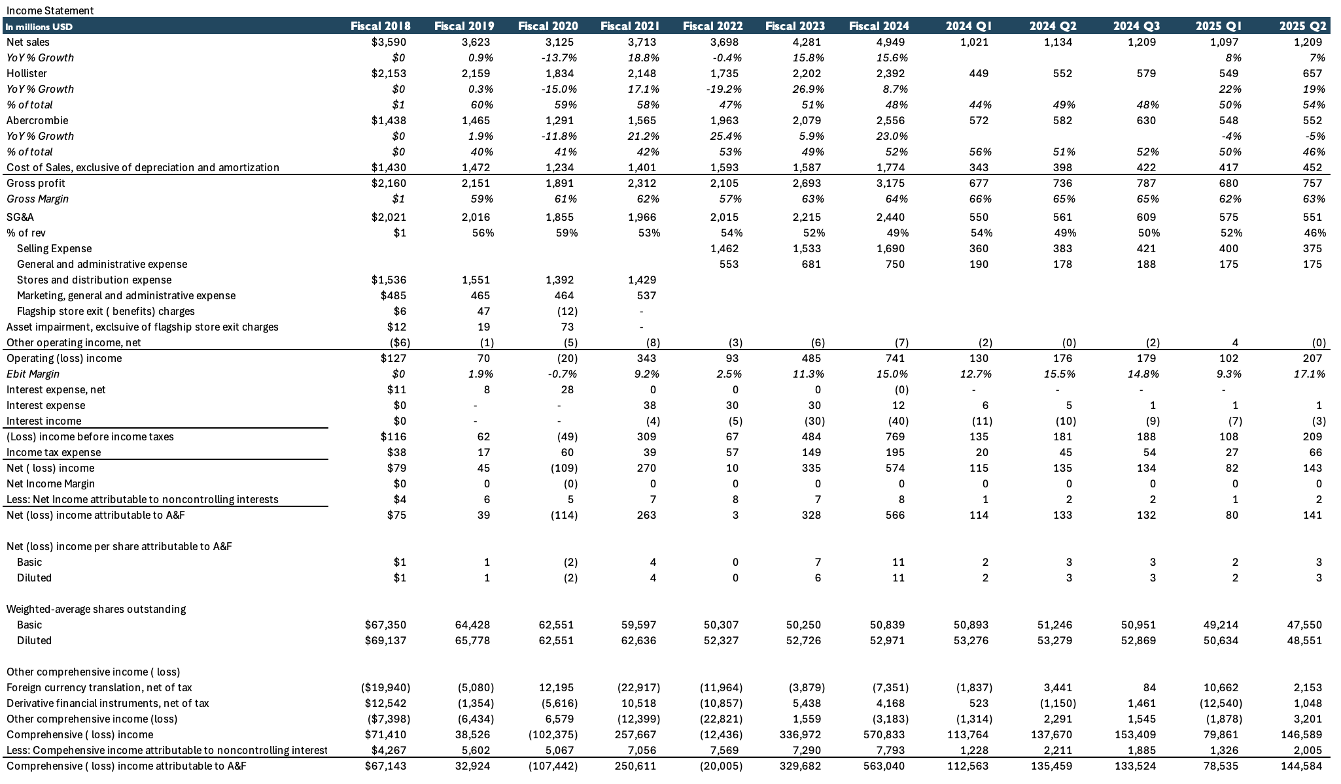
Figure 1 — Income Statement
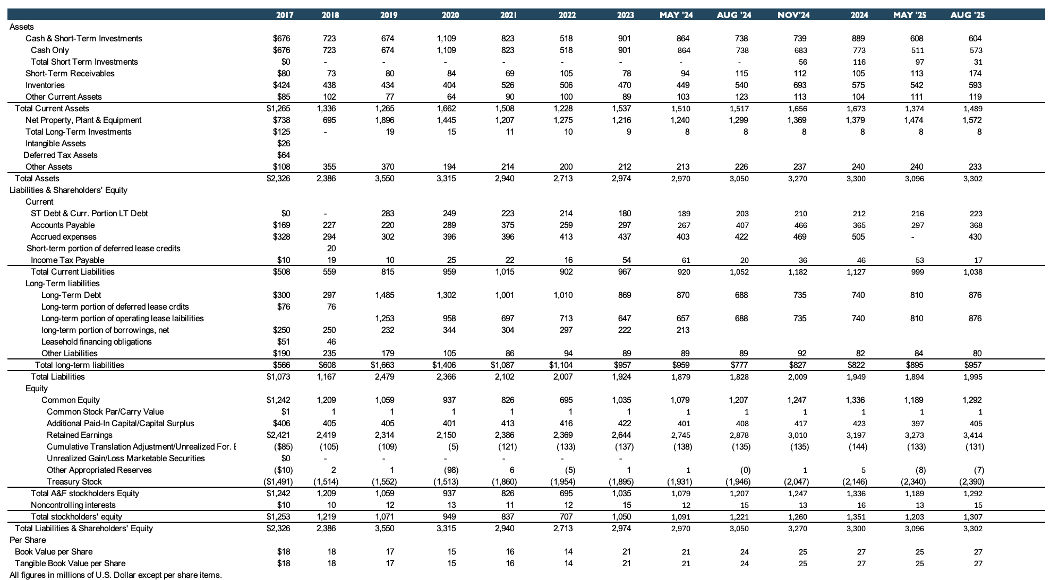
Figure 2 — Balance Sheet
Sales Analysis
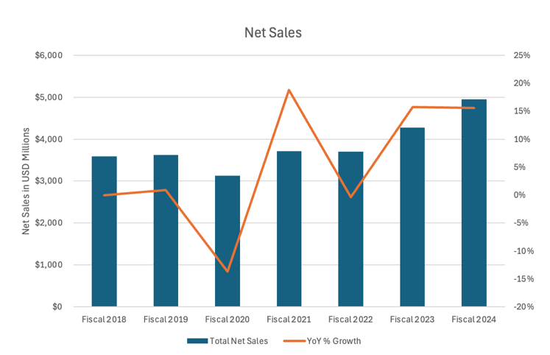  Figure 3 — Net Sales & YoY Growth | 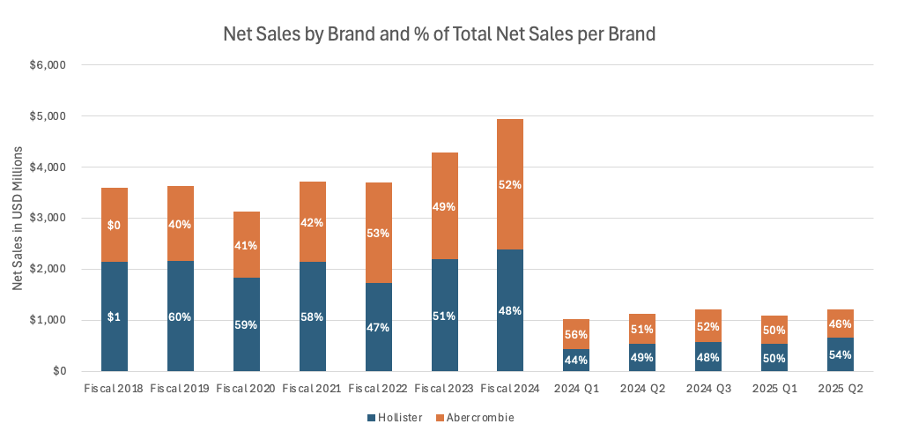  Figure 4 — Net Sales by Brand & % of Total

Since 2018, Abercrombie has delivered solid growth — a CAGR of 5.1% — taking a hit during COVID but recovering quickly the following year. Growth has been led by the Abercrombie brand (CAGR of 10.1%), while Hollister grew at 1.8% over the same period. In 2025 this trend shifted: Hollister became the biggest driver of growth, rising 22% and 19% in Q1 and Q2 respectively, while the Abercrombie brand declined 4% and 5%. Hollister's growth was driven mainly by existing stores, with comparable sales up 23% and 19%, whereas Abercrombie's comparable sales fell 10% and 11%.
Abercrombie's weak Q2 comparable sales were primarily driven by excess carryover inventory from the prior year, which forced increased promotions and markdowns. This lowered average unit retail (AUR) — which management identified as the main reason for the sales miss, not a lack of demand or traffic. In fact, traffic remained strong across both stores and digital channels.
Management explained that clearing higher-cost, excess inventory compressed both AUR and gross margin. Inventory at quarter-end was up 10% at cost and 7% in units year-over-year, indicating significantly more unsold merchandise than the prior year. As a result, even though units were selling and engagement was healthy, revenue per customer fell, pulling Abercrombie-brand comparable sales down 11%; selling through this inventory also pressured cost of sales.
Importantly, management emphasized that this was a temporary, self-inflicted issue, not a demand problem. By the end of Q2, inventory was described as “clean and current,” positioning the brand to reduce promotions and stabilize AUR going forward.
Margins & Profitability
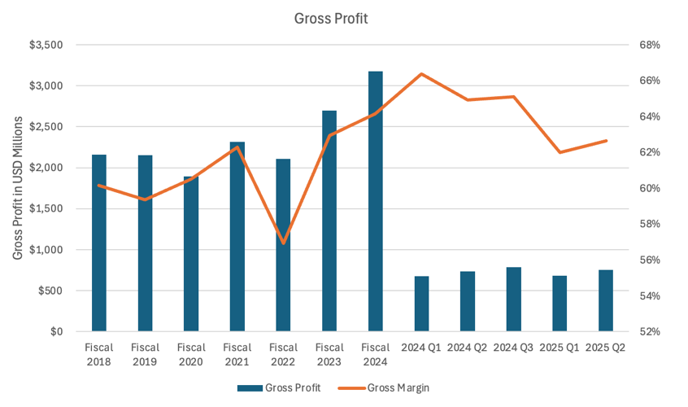  Figure 5 — Gross Profit & Gross Margin | 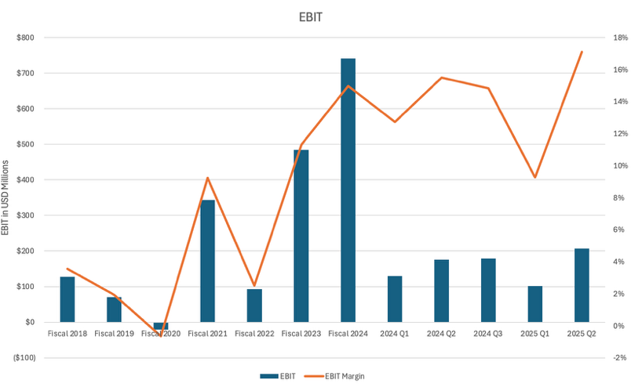  Figure 6 — EBIT & EBIT Margin

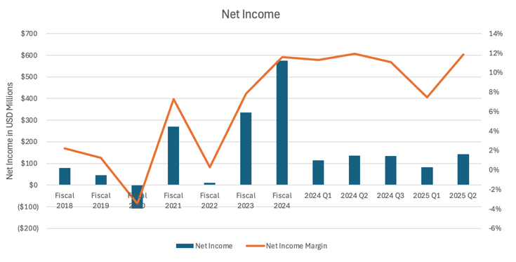
Figure 7 — Net Income & Net Income Margin
Over time, the company has demonstrated a clear improvement in profitability, with gross margins expanding structurally as pricing discipline, merchandising optimization, and supply-chain efficiencies improved following pandemic-related volatility. Gross margin recovered meaningfully after fiscal 2022 and has remained elevated, reflecting better inventory management and reduced promotional intensity.
Operating margins have followed a similar trajectory, with EBIT margins expanding steadily as SG&A leverage improved alongside revenue growth. While margins experienced short-term volatility on a quarterly basis due to seasonality and investment spending, the overall trend remains positive.
Net income margins have also strengthened over the long term, supported by higher operating profitability and improved cost control. Most recently, margins remain healthy — gross margin in the low-to-mid 60% range and EBIT margin in the mid-teens — indicating sustained pricing power and a structurally more profitable business than historically. The sharp margin decline in Q1 2025 is largely seasonal, driven by post-holiday demand normalization, higher promotional activity, and front-loaded investment spending.
Returns on Capital
Methodology
- ROTCE = EBIT / (NWC + NFA)
- NWC = current assets (excl. cash) − current liabilities (excl. short-term debt)
- ROIC = EBIT × (1 − tax rate) / [(assets − cash) − non-interest-bearing current liabilities]
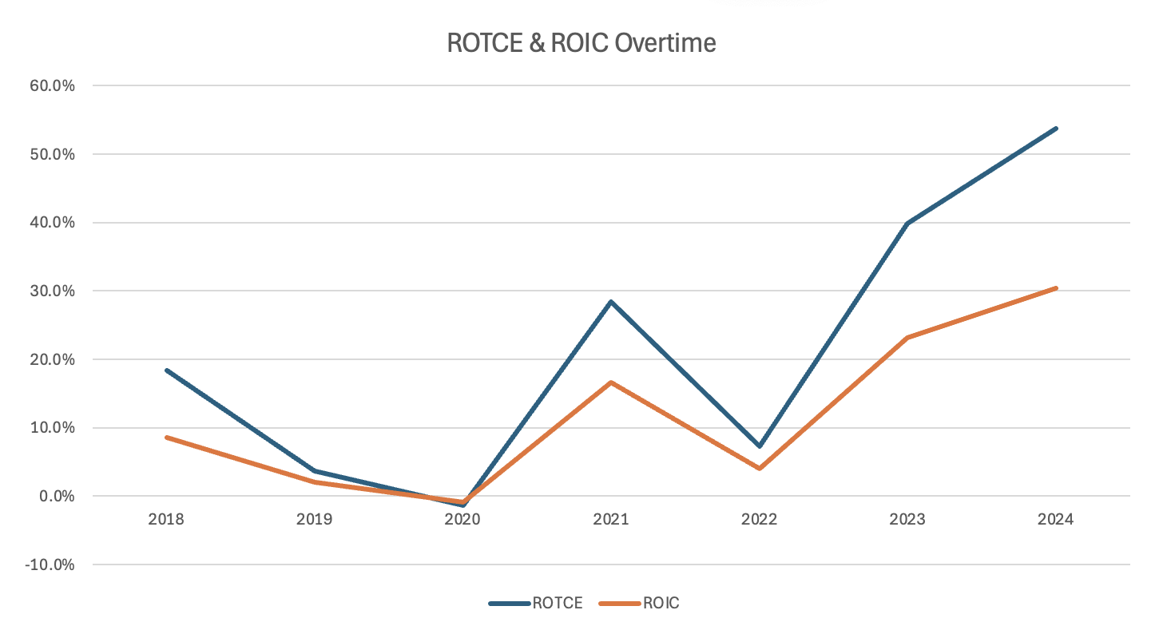
Figure 8 — ROTCE & ROIC Over Time
Abercrombie's returns on capital deteriorated significantly between 2019 and 2020, reflecting weak operating performance, store rationalization, and pandemic-related disruptions. During this period both ROTCE and ROIC reached trough levels as profitability declined and the capital base remained elevated.
From 2021 onward, returns rebounded sharply, driven by a meaningful recovery in EBIT, improved inventory discipline, and a structurally more efficient store footprint. The acceleration in 2023 and 2024 highlights strong operating leverage and improved capital allocation, as incremental investments generated significantly higher returns.
At current levels, both ROTCE and ROIC are well above historical averages, indicating that Abercrombie has successfully repositioned its business and is now generating returns meaningfully above its cost of capital.

Valuation
Target price per share
- Public Company Comparables: $153
- Discounted Cash Flow: $109
- Assumed acquisition price: $109
- The target price is primarily based on the DCF analysis, with a slight uplift reflecting the comparables.
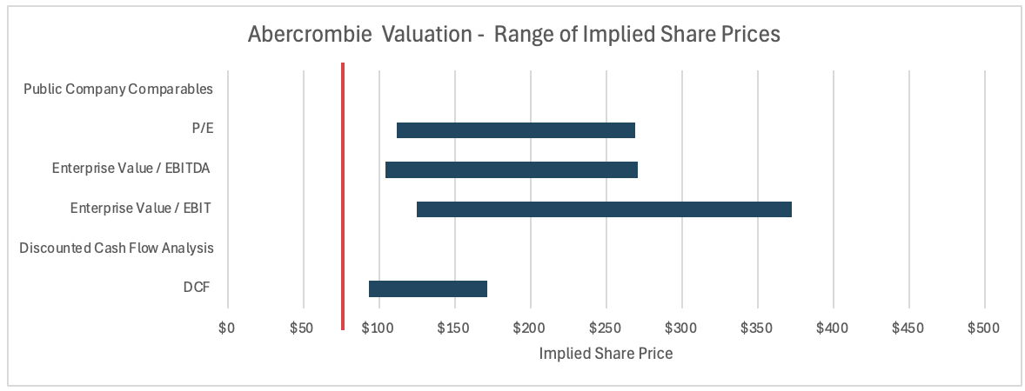
Figure 9 — Valuation Football Field — Range of Implied Share Prices
Public Company Comparables
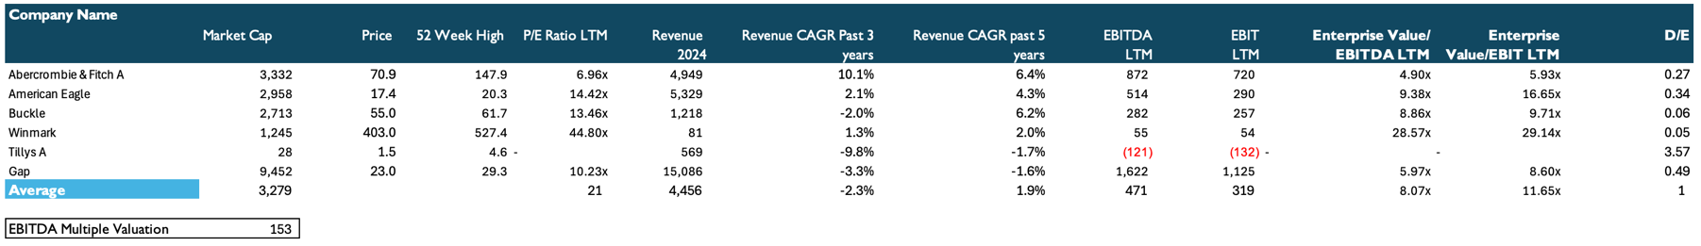
Figure 10 — Comparable Public Companies
The public-company comparables analysis implies a target price of approximately $153, derived using average valuation multiples, with Winmark excluded from the peer set due to its materially different business model and valuation profile. While this implied valuation is modestly higher than the DCF-derived target, it provides additional support for upside potential and suggests the stock could perform slightly better than the DCF-only valuation would imply.

Discounted Cash Flow Analysis

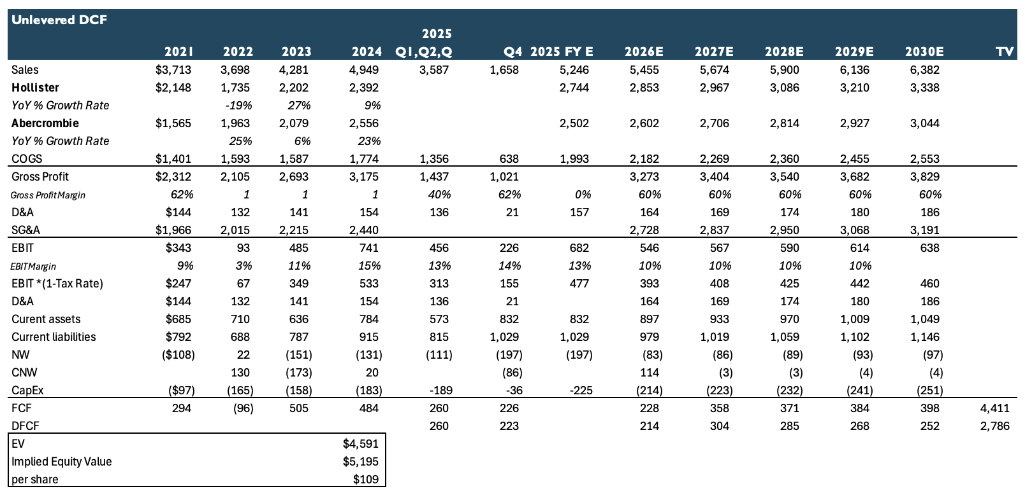
Figure 11 — Unlevered DCF
Figure 12 — Revenue & Operating Assumptions | 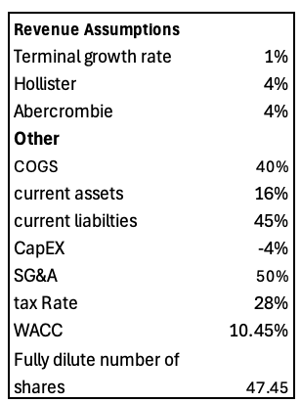

Over the past three years, the Hollister brand has grown at an average of 5% per year, while the Abercrombie brand has grown at an average of 18%. This year Hollister is growing strongly, revenue up 22% and 21% in Q1 and Q2, supported by similar comparable-sales growth. However, fashion brands tend to experience significant growth fluctuations due to changing consumer trends, which makes revenue less predictable. I therefore project a slowdown in Hollister's growth to 4% next year, moderating to 3% in the final two forecast years, closer to its historical average.
Abercrombie has seen flat sales and declining comparable sales this year. Management has explained that although store traffic remains strong, poor inventory management last year drove increased promotions and lower average revenue per customer. I view the recent comparable-sales decline as largely a one-year inventory misstep rather than a structural issue, and expect growth to resume next year, supported by a strong brand, loyal customers, improved marketing, and opportunities such as the NFL partnership. I also reduce long-term growth assumptions to 3% given intense competition from American Eagle, Uniqlo, and Gap.
Based on these assumptions, the DCF analysis yields a target price of approximately $109 per share.
Sensitivity Analysis
DCF output is most sensitive to the assumed cost of capital and brand-level growth rates. The tables below show implied per-share value across a range of assumptions for medium-term Abercrombie and Hollister growth and for the terminal growth rate, holding other inputs constant.
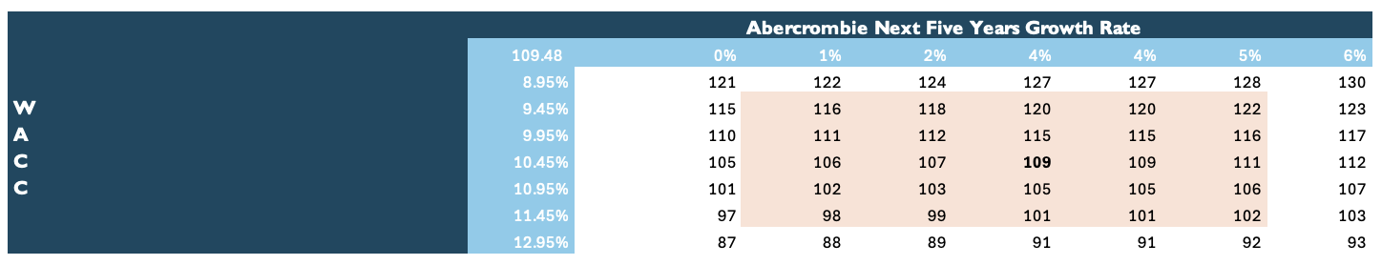  Figure 14 — Sensitivity — Abercrombie Growth vs. WACC | Figure 15 — Sensitivity — Hollister Growth vs. WACC
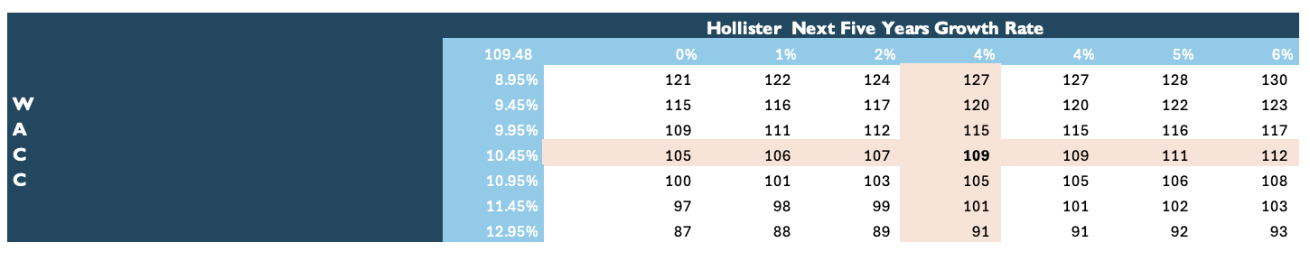
Figure 15 — Sensitivity — Hollister Growth vs. WACC
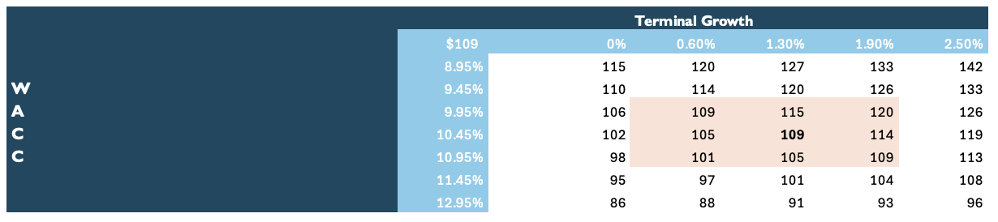

Figure 16 — Sensitivity — Terminal Growth Rate vs. WACC
Investment Thesis
Over the past few years, the company has demonstrated a strong capacity to keep growing and capturing the interest of its target customers. I have confidence in its operational structure, which supports attractive margins and disciplined capital allocation. I believe the recent stock decline has been taken out of proportion, largely driven by investor concerns surrounding the Abercrombie brand and its transition from strong growth last year to a recent slowdown.
I remain confident that Abercrombie will continue to grow, even if it is currently experiencing a few weaker quarters. The company has meaningful growth opportunities through marketing initiatives - including its official partnership with the NFL - and is one of the longest-standing American brands in the sector, demonstrating its ability to endure challenges and return to growth over multiple business cycles.
Management has indicated that the decline in comparable sales was primarily driven by lower average revenue per customer rather than reduced traffic, largely due to increased promotional activity stemming from weaker inventory management in the prior year. Hollister, meanwhile, has shown strong growth this year, and I expect this momentum to continue through the final two quarters.
Lastly, my target price is not based on aggressive assumptions but on low single-digit growth expectations, which increases my confidence that the stock is currently undervalued.
Catalysts
- Q3 results. Continued strong growth at Hollister offsetting the Abercrombie brand's weaker performance could serve as a significant catalyst. A clearer explanation of the factors driving Abercrombie's decline, demonstrating they are cyclical rather than structural, would further support the stock.
- New marketing initiatives. Collaborations with other companies or celebrities could meaningfully influence broader fashion trends and strengthen Abercrombie's positioning within the industry.
Investment Risks
- Loss of sector leadership. Failure to maintain leadership by effectively aligning products with evolving customer wants and needs could pressure growth and brand relevance.
- Macroeconomic sensitivity. Abercrombie is not positioned as a low-cost brand; any slowdown in the U.S. economy, particularly a significant event such as a recession, could materially impact demand and overall performance.
- Increased competition. While Abercrombie has performed well in core basic-apparel categories, these segments are relatively easy to enter, and heightened competition could pressure margins and market share.
- Operational inefficiencies. Renewed challenges in inventory management could negatively affect both financial performance and stock valuation.

