Lululemon Athletica Inc.  NASDAQ: LULU Equity Research • Consumer / Apparel | 
Report Date: 01 February 2026 Exchange: NASDAQ • Currency: USD
HOLD | Current Price $210 | Target Price $205 (-2.4%) | Risk Medium | 12–24 months

MARKET DATA  Market Cap $25.6 B  Revenue (FY24) $10,588 M  Revenue (LTM) $11,073 M  Net Income (FY24) $1,814 M  Net Income (LTM) $1,740 M  LTM EPS $14.35  P/E 14.6x  EV / EBITDA (LTM) 8.33x  EV / EBIT (LTM) 9.98x  Beta 1.01  All figures in USD; $ in millions unless noted. |  | SHARE PRICE — TRAILING 12 MONTHS  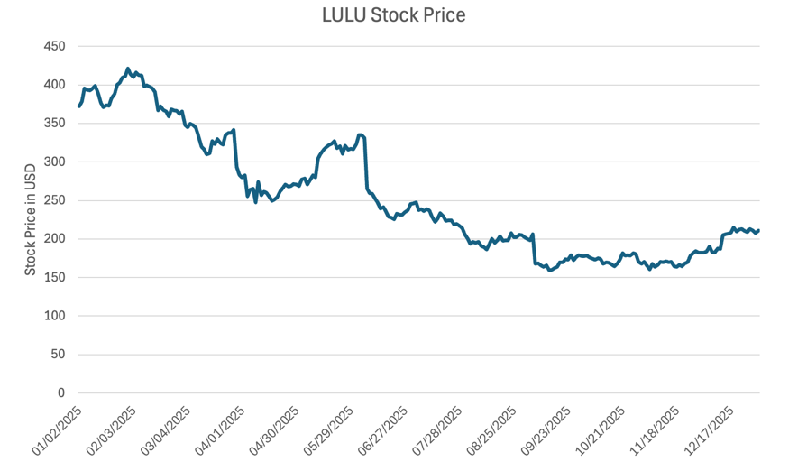
INVESTMENT SUMMARY
Lululemon’s recent share-price decline reflects near-term weakness in an otherwise strong business. The premium athleisure market is expected to continue expanding in both the United States and internationally, with markets such as Mainland China offering particularly attractive growth opportunities. Lululemon remains a leader in premium athletic apparel and is well positioned to benefit from these long-term industry trends. However, the company has recently faced weaker performance in its largest market, the Americas, due to intensifying competition and slower product innovation. We view this as a temporary product-cycle challenge rather than a structural deterioration, given Lululemon’s established market position, strong brand recognition, and loyal customer base. Based on the current risk-reward profile, we rate the shares HOLD with a $203 price target.

Recent Results & Outlook
Third-Quarter FY2025 Results
The company reported Q3 FY2025 net revenue growth of 7% year over year to $2.6 billion, driven entirely by strong international performance, which increased 33%, while Americas revenue declined 2%. Comparable sales rose 1% (2% on a constant-currency basis), reflecting a 5% decline in the Americas offset by 18% growth internationally. Despite top-line growth, profitability weakened: gross profit increased 2% to $1.4 billion, but gross margin contracted 290 basis points to 55.6%. Operating income declined 11% to $435.9 million, with operating margin compressing 350 basis points to 17.0%. The effective tax rate rose modestly to 30.5%, and diluted EPS declined to $2.59 from $2.87 a year earlier. During the quarter the company opened 12 net new company-operated stores, bringing the total store count to 796.
Full-Year Guidance
For full-year fiscal 2025, the company expects net revenue of $10.96–$11.05 billion, representing reported growth of approximately 4%, or 5–6% excluding the 53rd week in FY2024. Diluted EPS is guided to $12.92–$13.02, based on an assumed effective tax rate of approximately 30%. Guidance incorporates an estimated $210 million reduction in operating income, net of mitigation, reflecting management's assumptions around higher U.S. import tariffs and the elimination of the de minimis exemption. Mitigation initiatives include vendor savings and pricing actions, though results remain sensitive to tariff levels, sourcing savings, consumer demand, and the timing of regulatory changes. The outlook excludes any potential future share repurchases.
Company Overview
Lululemon Athletica Inc. is principally a designer, distributor, and retailer of technical athletic apparel, footwear, and accessories marketed under the lululemon brand. Its assortment includes pants, shorts, tops, and jackets designed to support a healthy lifestyle and activities such as yoga, running, and training, as well as apparel for being on the move and fitness-inspired everyday use.
The company operates an integrated omnichannel model that connects online and in-store operations. Customers can purchase online or through a digital app and pick up in store, and store educators can access inventory across locations and arrange for products to be shipped directly to a customer's home or another store. E-commerce orders can be fulfilled from both distribution centers and retail locations, and all inventory is managed through a single, unified pool, allowing efficient allocation across distribution centers, stores, and online demand.
Lululemon operates in over 25 countries and organizes its operations into four regional markets - Americas, Mainland China, Asia Pacific (APAC), and Europe and the Middle East (EMEA). For reporting purposes it reports three operating segments: Americas, Mainland China, and Rest of World (APAC and EMEA combined). The Americas segment represents the company's core business, accounting for approximately 75% of net revenue, while Mainland China has grown at a sales CAGR of 37.8% over the past three years.
Strategy & Operating Model
Lululemon's strategy focuses on premium product innovation, brand-led demand, and international expansion, supported by an omnichannel retail model and an asset-light operating structure. The company differentiates itself through technically advanced fabrics, functional design, and a strong connection with its customer community, which together support premium pricing and brand loyalty. Product innovation remains central to maintaining relevance and driving repeat purchases in core categories.
Geographically, Lululemon is prioritizing international growth, with Mainland China identified as a key long-term growth engine; management expects a significant share of future store openings and revenue growth to come from international markets, while the Americas remain the primary profit base. The company also highlights the men's category as a meaningful growth opportunity, alongside expansion into adjacent categories such as accessories and footwear to enlarge its addressable market.
Lululemon operates an outsourced manufacturing model, retaining control over design and quality while limiting capital intensity, a structure that supports high margins and strong returns on invested capital as the business scales globally.
Industry Overview
United States Market
Lululemon operates in the premium athletic-apparel (athleisure) sector, which has grown significantly in recent years. The company faces competitive pressure from two directions: established athletic brands offering similar-quality products at lower price points, such as Nike and adidas; and newer premium competitors offering comparable products at similar price levels, including Vuori, Alo Yoga, and Athleta. (Source: CNN)
The global athleisure market was estimated at USD 393.7 billion in 2024 and is expected to reach USD 902.4 billion by 2033. (Source: Yahoo Finance) In the United States, the market generated USD 93.5 billion in 2022 and is projected to reach USD 176.5 billion by 2030, growing at a CAGR of 8.3% from 2023 to 2030, with premium athleisure representing a significant portion of that growth. (Source: Grand View Research)
U.S. Macroeconomic Backdrop
- Cost pressures remain elevated across the apparel industry due to higher 2025 tariff rates and continued labor and input-cost inflation in major Asian sourcing regions. For Lululemon this is a near-term margin headwind, though the company has historically mitigated such pressure through selective pricing, product mix, and supply-chain efficiencies.
- Labor markets softened into year-end: U.S. unemployment reached approximately 4.2% in December 2025, up from 3.7% in early 2024, with long-term unemployment elevated at roughly 1.9 million — a trend pointing to slower discretionary-spending growth into 2026.
- Consumer spending stayed under pressure late in 2025, unevenly across income groups. The University of Michigan Consumer Sentiment Index stood at 52.9 in December 2025, signaling ongoing caution. Lower- and middle-income households remain most affected, while higher-income consumers, Lululemon's core demographic, have shown greater resilience.
- Inflation improved modestly into year-end, with core CPI for November 2025 at 2.6% (U.S. Bureau of Labor Statistics).
Chinese Market
China's athleisure market has expanded rapidly, supported by urbanization, rising disposable incomes, and an increasing focus on health and wellbeing. The broader Chinese sportswear market was projected to reach approximately USD 82.8 billion by 2024, while the yoga-apparel segment alone is expected to reach USD 3 billion by 2028, growing at a CAGR of over 9%.
- Consumer behavior & preferences. Chinese consumers typically purchase athleisure every three to six months and exhibit notable price sensitivity, with most spending under USD 55 per purchase. Comfort is the most important purchase factor, followed by price and design. Demand for premium athleisure nonetheless continues to grow in Tier 1 and Tier 2 cities, and over two-thirds of consumers wear athleisure regularly beyond exercise, with a strong preference for domestic brands.
- Channels & omnichannel retail. Physical stores remain the primary purchasing channel, followed closely by e-commerce. Successful brands operate strong direct-to-consumer models that integrate offline stores, brand websites, and major Chinese platforms such as Tmall and JD.com.
- Product & design trends. Consumers favor simple, modern designs with bright or bold colors alongside functional, sport-specific features. Fabric performance is critical — softness, elasticity, breathability, moisture-wicking, and body-enhancing fits tailored to Asian body types.
- Competitive landscape. Lululemon competes in the premium segment via community-based marketing, immersive in-store experiences, and a strong brand identity, and has grown rapidly in China. Domestic brand Maia Active competes through more affordable pricing, Asian-specific fits, and strong social-media engagement, supported by its acquisition by Anta Sports.
- Outlook. China's athleisure market is expected to keep growing, supported by lifestyle changes, rising fitness participation, and ongoing omnichannel development. Brands that balance functionality, comfort, localized design, and community engagement while offering a clear value proposition are best positioned.
Competitive Landscape
- Alo Yoga — a premium activewear and lifestyle brand at the intersection of performance, fashion, and wellness, targeting affluent, style-conscious consumers. Operates ~100+ company-owned stores globally, concentrated in major U.S. metros with a growing international presence, plus a strong DTC digital channel that supports high engagement and margins.
- Vuori — a performance-lifestyle activewear brand focused on versatility, comfort, and sustainability, targeting young professionals and active adults. Operates ~50–60 stores, mainly in U.S. coastal and lifestyle markets, with a rapidly growing DTC business that represents the majority of sales.
- Maia Active — a China-based women's activewear brand focused on fit, functionality, and inclusive sizing for Asian female consumers. Operates dozens of stores across major Chinese cities with a strong domestic e-commerce presence.
- Athleta — a Gap Inc. subsidiary; a women's performance and lifestyle brand emphasizing inclusivity, sustainability, and wellness. Operates ~250 stores, primarily in the U.S., targeting adult women seeking functional yet stylish activewear.
- Nike — a global athletic apparel and footwear leader with unmatched scale, innovation, and marketing reach. Operates ~1,000+ owned retail locations worldwide across North America, Europe, and Asia, supported by a vast wholesale network and digital ecosystem, spanning elite athletes to everyday consumers.

Financial Statements
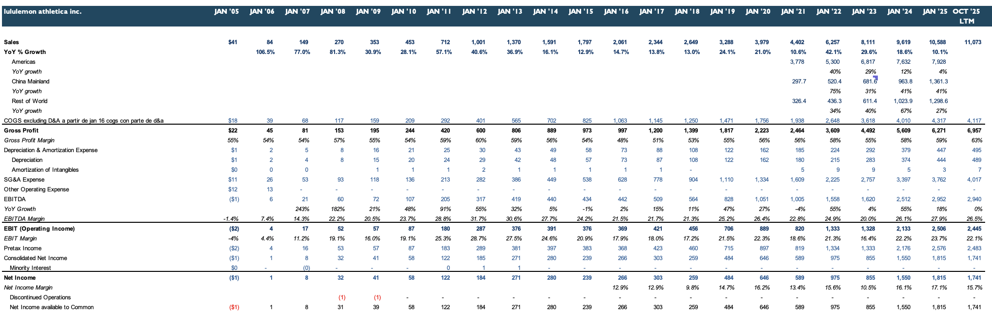
Figure 1 — Income Statement (Annual)
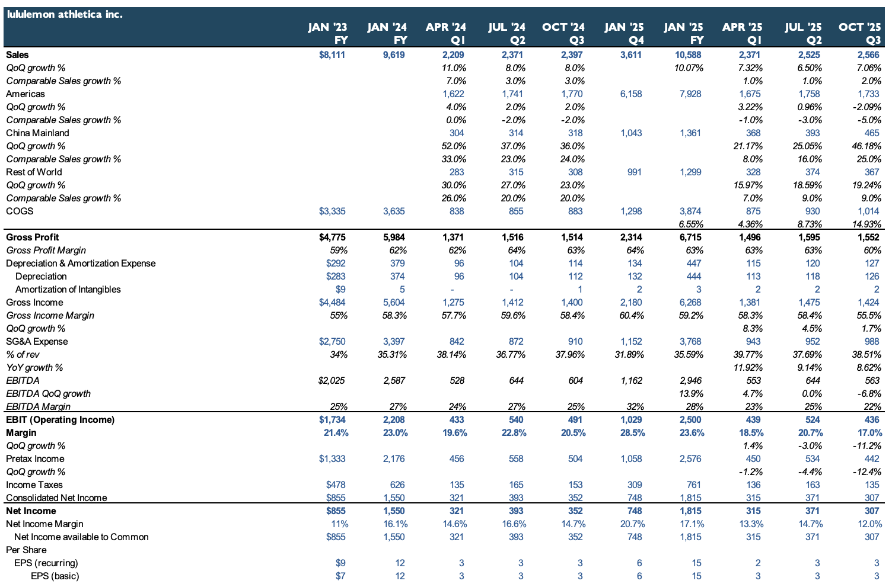
Figure 2 — Income Statement (Quarterly)
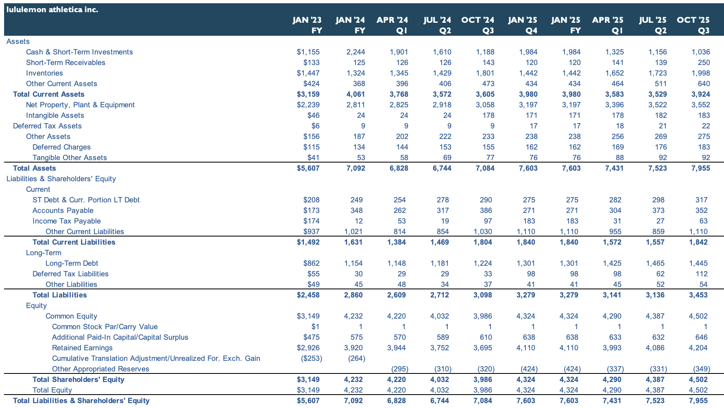
Figure 3 — Balance Sheet (Quarterly)
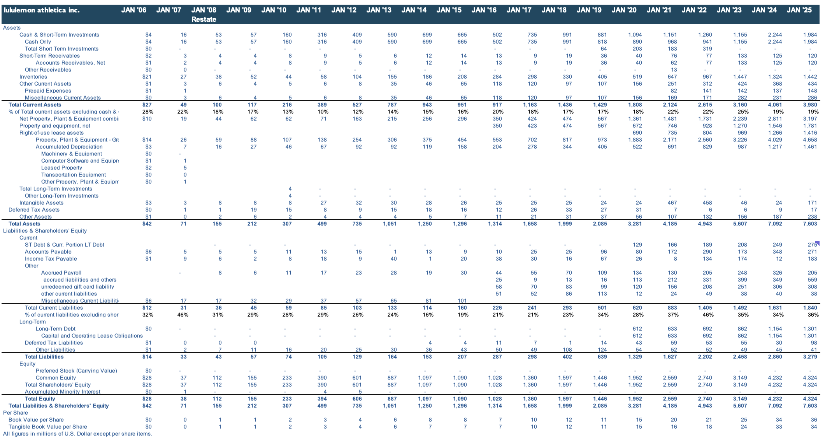
Figure 4 — Balance Sheet (Annual)
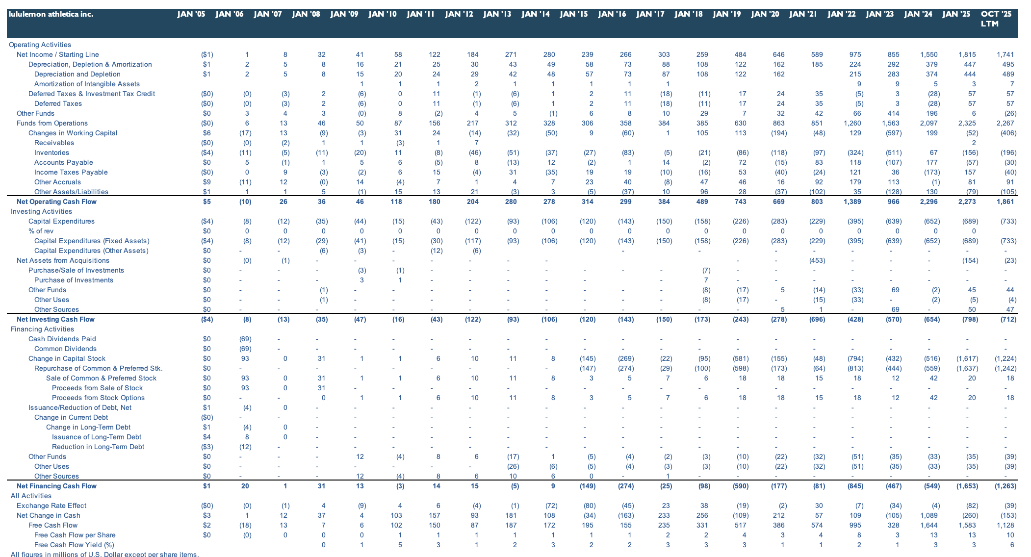
Figure 5 — Cash Flow Statement
Sales Analysis
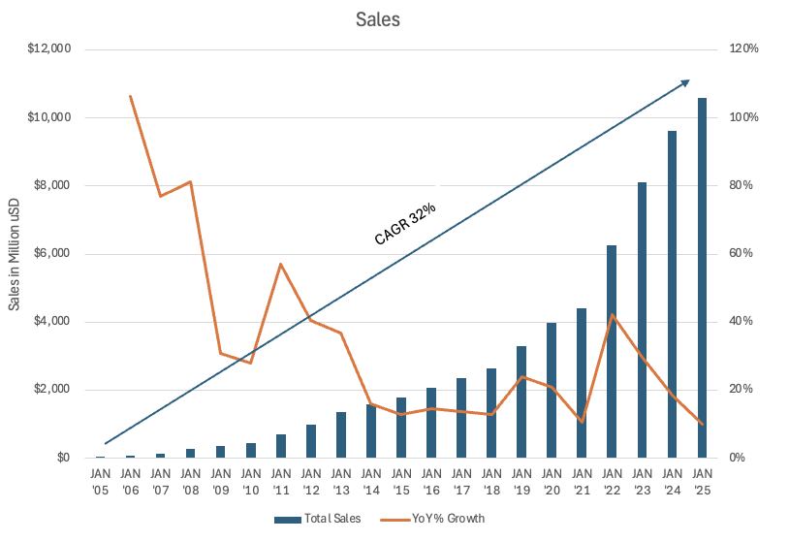
Figure 6 — Net Sales & 20-Year CAGR
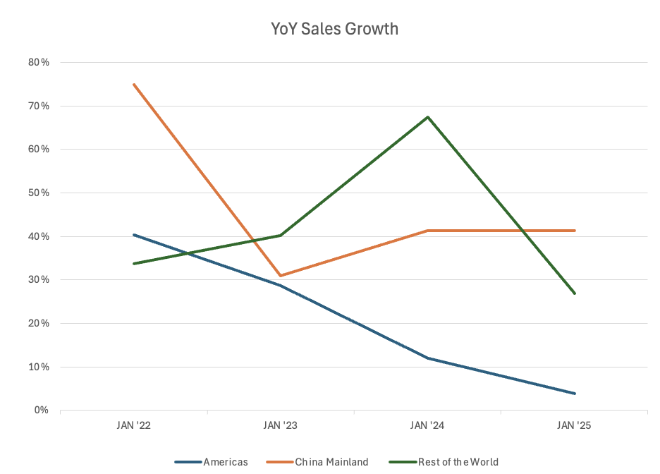  Figure 7 — YoY Sales Growth | 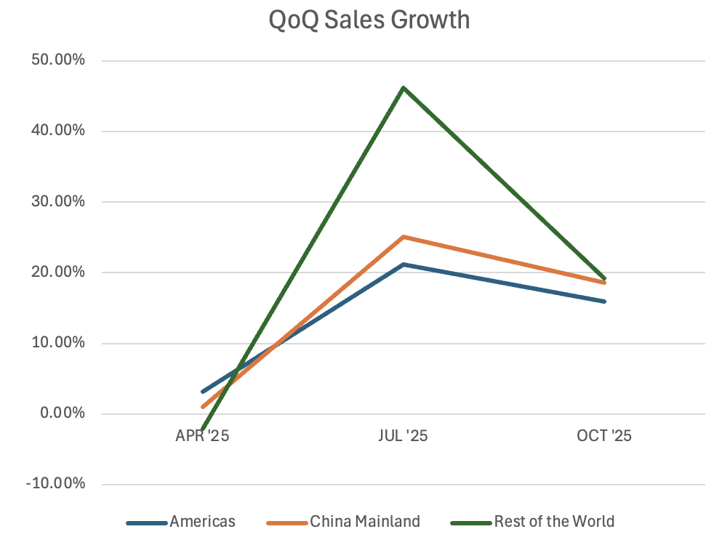  Figure 8 — QoQ Sales Growth

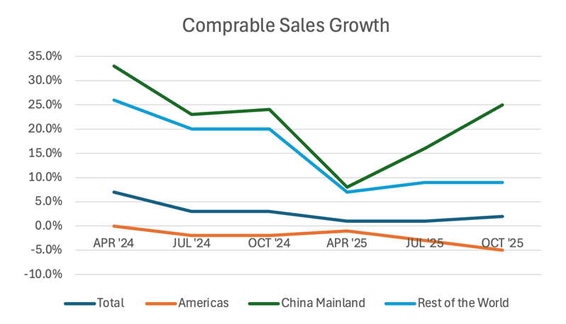  Figure 9 — Comparable Sales Growth | 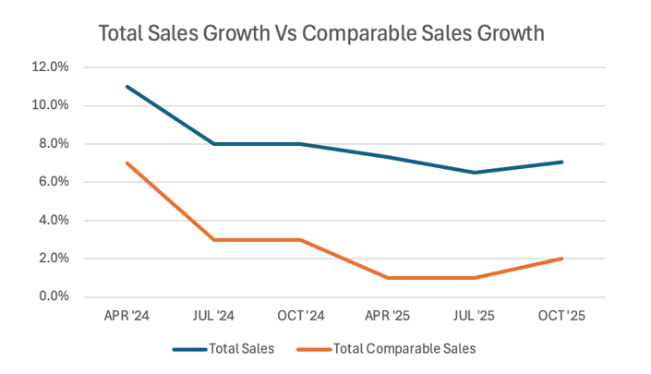  Figure 10 — Total vs. Comparable Sales

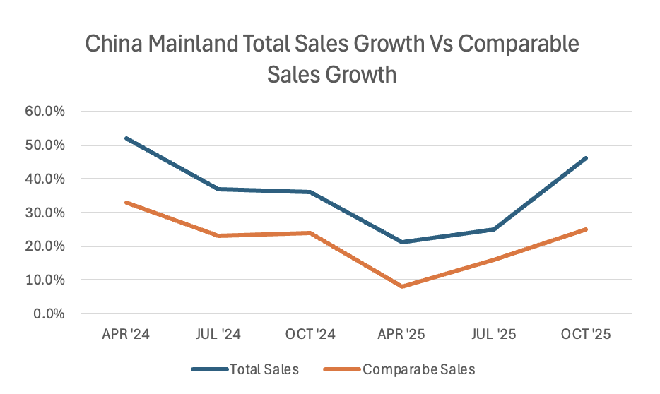  Figure 11 — Mainland China: Total vs. Comparable | 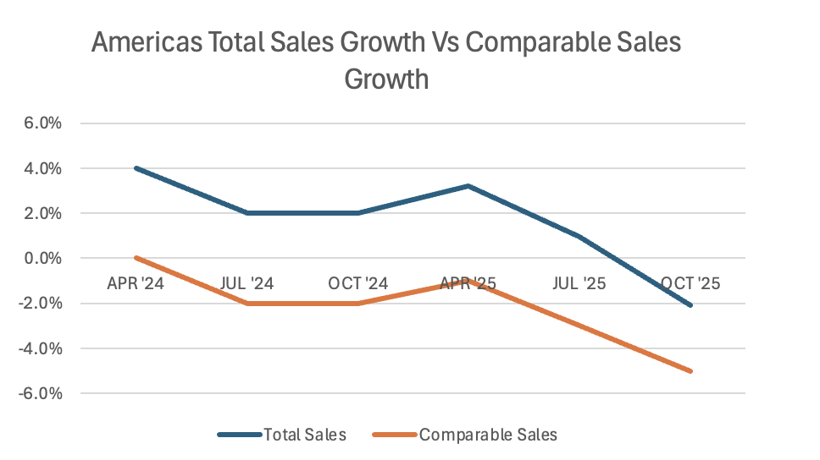  Figure 12 — Americas: Total vs. Comparable

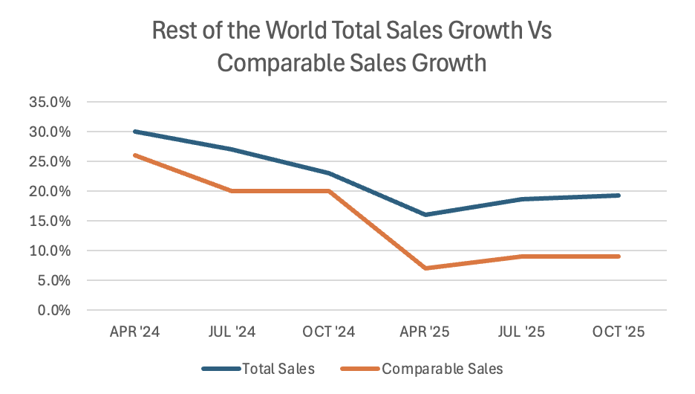
Figure 13 — Rest of World: Total vs. Comparable
Over the past 20 years, the company has delivered a strong sales CAGR of approximately 32%, demonstrating its ability to consistently acquire new customers and drive top-line growth over an extended period.
More recently, growth in the Americas has decelerated. In fiscal 2023 and 2024, regional sales increased approximately 12% and 4% year-over-year, respectively, reflecting a slowdown in the company's largest market. This is also visible in comparable sales, which declined in six of the past seven quarters; the weakest performance came in Q3 2025, when Americas comparable sales fell approximately 5%.
In contrast, international markets continued to deliver robust growth. Mainland China and Rest of World achieved sales CAGRs of approximately 37.8% and 43.8%, respectively, over the past three years. Unlike the Americas, comparable sales growth in these regions tracked closely with total sales over the past six quarters, indicating expansion driven primarily by underlying demand rather than store openings alone.
Overall, the divergence between the Americas and international markets highlights the company's increasing reliance on global growth to offset near-term softness in its core U.S. business.
Revenue Channels & Geography
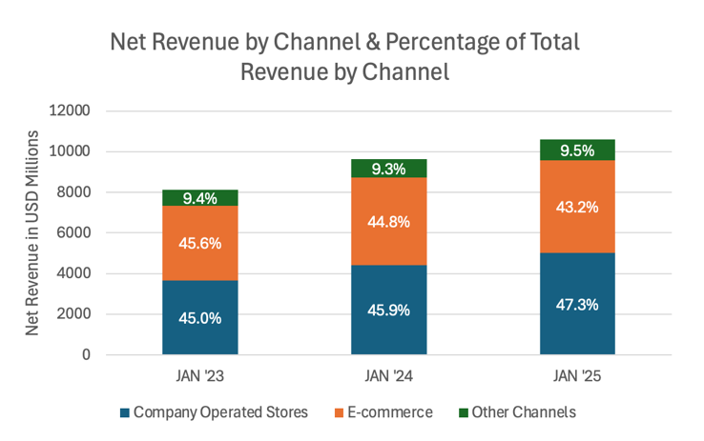  Figure 14 — Net Revenue by Channel (Annual) | 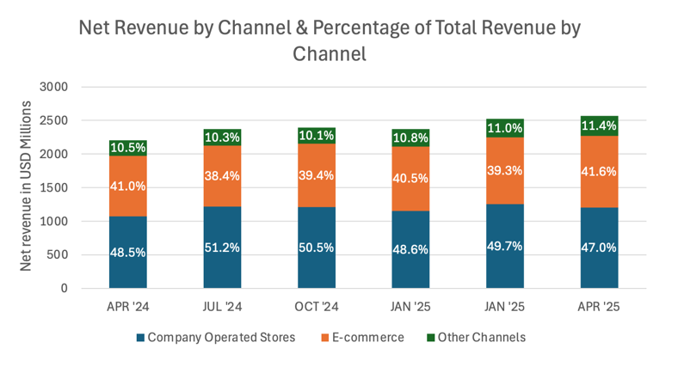  Figure 15 — Net Revenue by Channel (Quarterly)

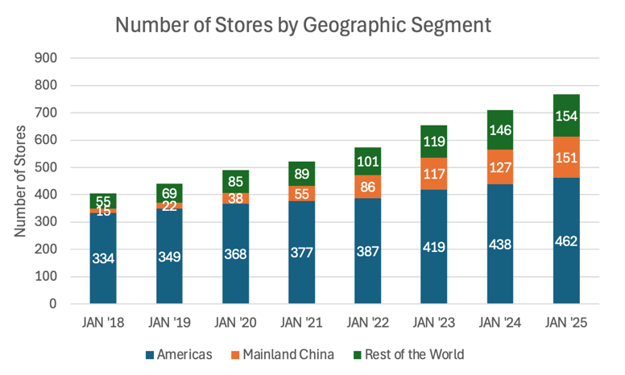
Figure 16 — Stores by Geographic Segment
Revenue remains well diversified across channels, with company-operated stores representing the largest share of total revenue, followed by e-commerce, which remains a meaningful and stable contributor. While e-commerce's share has moderated slightly, absolute revenue across all channels continues to grow, indicating balanced omnichannel demand rather than channel substitution.
Geographically, store expansion has been broad-based: the Americas remain the largest footprint, while Mainland China and Rest of World account for a growing share of total stores. This highlights Lululemon's continued focus on international growth in higher-growth markets while maintaining a strong, stable domestic base.
Margins & Profitability
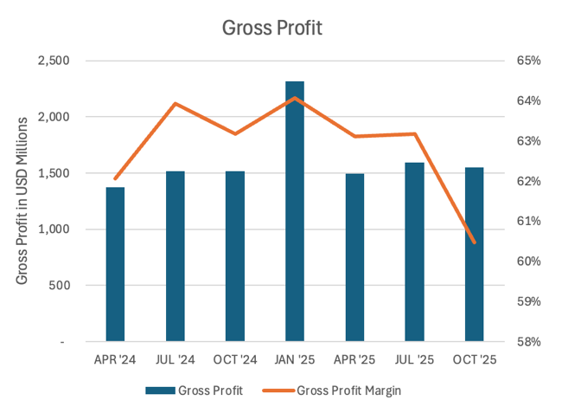  Figure 17 — Gross Profit (Recent Quarters) | 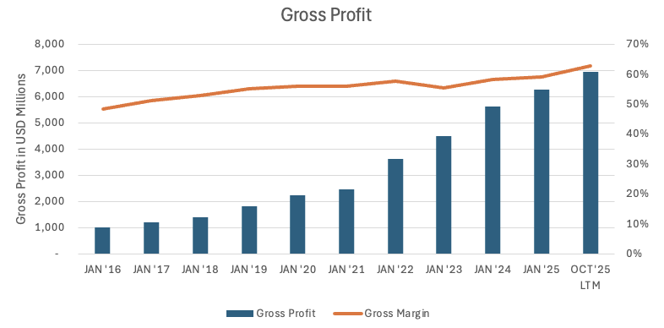  Figure 18 — Gross Profit (Long-Term)

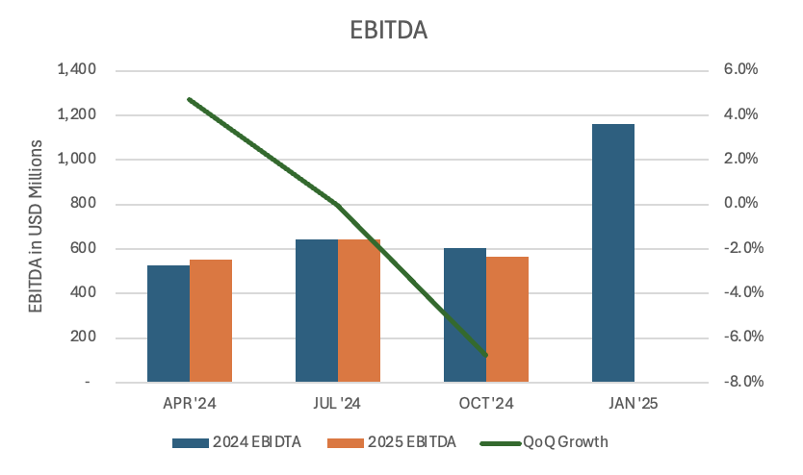  Figure 19 — EBITDA (Recent Quarters) | 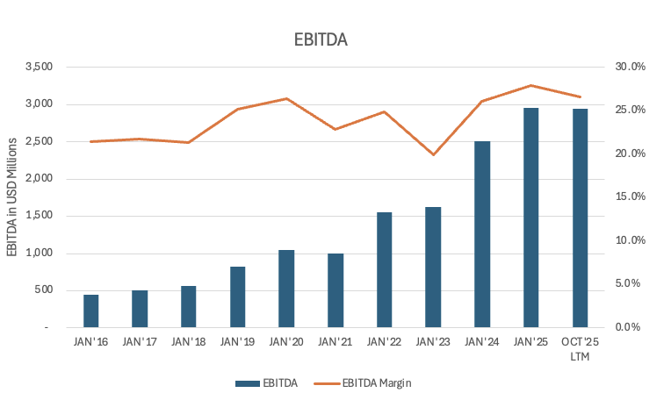  Figure 20 — EBITDA (Long-Term)

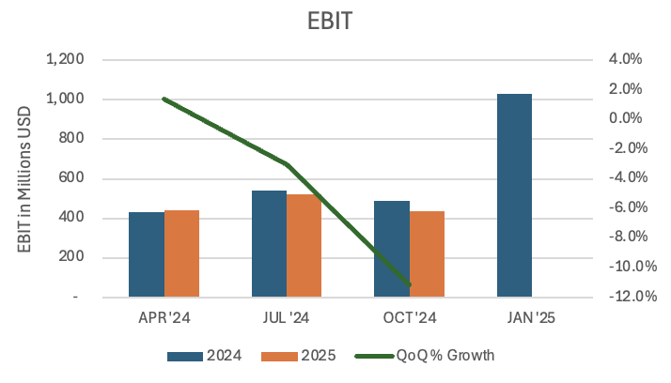  Figure 21 — EBIT (Recent Quarters) | 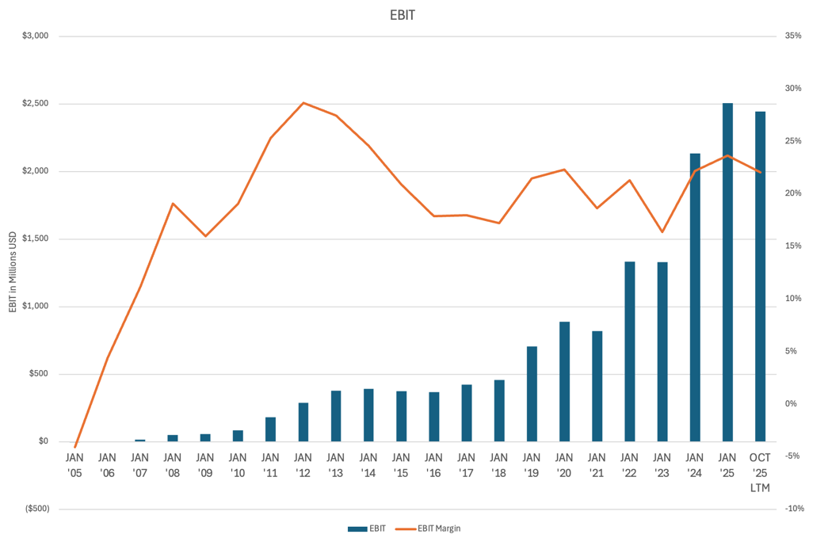  Figure 22 — EBIT (Long-Term)

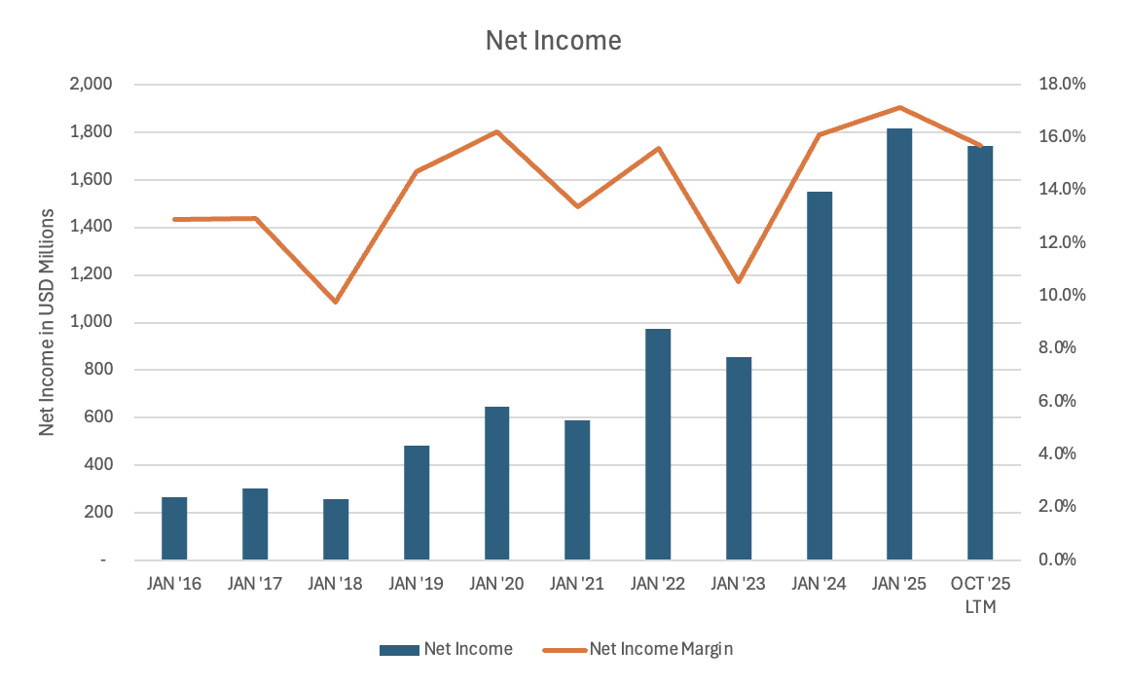  Figure 23 — Net Income (Recent Quarters) | 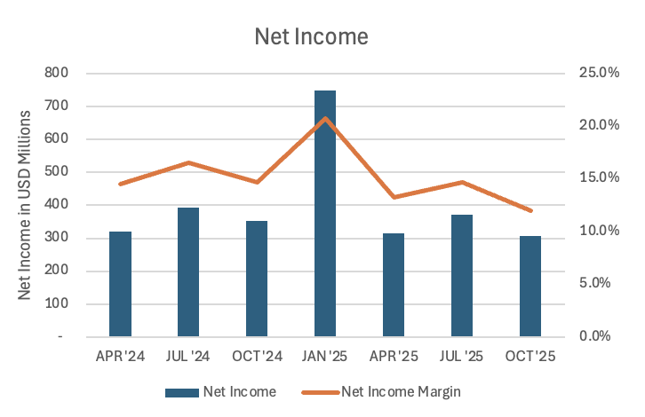  Figure 24 — Net Income (Long-Term)

Lululemon has demonstrated strong long-term profitability expansion, supported by consistent gross-margin improvement and operating leverage. Over the past decade, gross profit has increased steadily, reflecting both sustained revenue growth and the company's ability to maintain premium pricing. Gross margin has trended upward over time, underscoring pricing power, disciplined inventory management, and favorable product mix.
In the most recent quarters, gross-profit growth has moderated alongside slower sales momentum, particularly in the Americas. While gross margin remains structurally elevated, recent quarter-to-quarter fluctuations reflect the impact of tariffs, as COGS has increased faster than sales. Lululemon's suppliers and manufacturers are primarily located in APAC and Mainland China; the tariff hit to income from operations is expected to be approximately $210 million for 2025, net of mitigation efforts. Even so, margins remain well above industry averages.
EBITDA growth over the long term has been robust, highlighting the scalability of the business model. Near-term EBITDA growth has shown increased volatility, with quarter-over-quarter growth turning negative in recent periods, reflecting slower revenue growth combined with higher COGS. Absolute EBITDA nonetheless remains near historical highs, suggesting margin compression is cyclical rather than structural.
EBIT performance mirrors EBITDA, with long-term operating-income expansion driven by revenue growth and operating leverage. Recent quarters show pressure on EBIT growth, particularly quarter-over-quarter, as fixed costs weigh more heavily amid softer top-line growth, though EBIT margins remain healthy relative to history. SG&A expense rose 8.6% year-over-year, from $909.8M to $988.3M, and now represents 38.5% of net revenue, driven by higher employee costs, increased digital-marketing spend, and growth in head-office, brand, community, and technology investments.
Net income has continued to trend upward over the long term, supported by strong operating performance and disciplined cost control. While quarterly growth has fluctuated, margins remain resilient, reflecting Lululemon's ability to convert revenue into earnings despite a more challenging demand environment.
Overall, the profitability profile reinforces the view that Lululemon remains a high-quality, structurally profitable business, with near-term margin volatility driven by cyclical pressures.
Returns on Capital
Methodology
- ROTCE = EBIT / (NWC + NFA)
- NWC = current assets (excl. cash) − current liabilities (excl. short-term debt)
- ROIC = EBIT × (1 − tax rate) / [(assets − cash) − non-interest-bearing current liabilities]
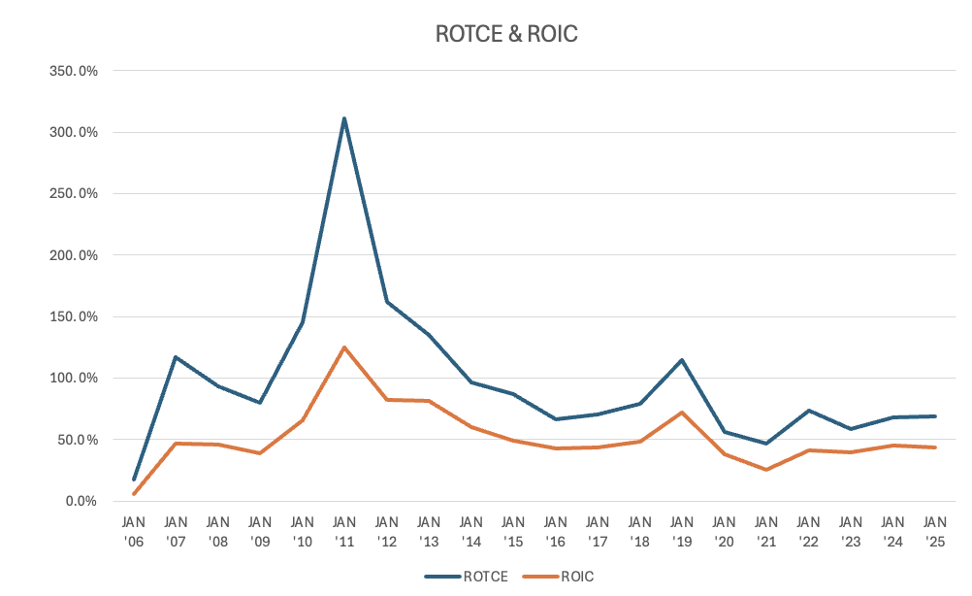
Figure 25 — ROTCE & ROIC Over Time
Lululemon has consistently generated strong returns on capital, highlighting the efficiency of its business model and its ability to convert operating performance into value creation. Returns peaked in the early 2010s and have since normalized as the company scaled its store base and international operations. Despite this moderation, both ROTCE and ROIC remain structurally attractive and well above typical retail benchmarks.
In recent years, returns have stabilized at lower but still-elevated levels, reflecting a more mature growth profile and increased investment to support long-term expansion. Importantly, current return levels remain comfortably above the company's cost of capital, indicating continued value creation despite near-term operational headwinds.
Valuation
Target price per share
- Public Company Comparables: $534
- Discounted Cash Flow: $205
- Assumed acquisition price: $205
- The target price is primarily based on the DCF analysis.
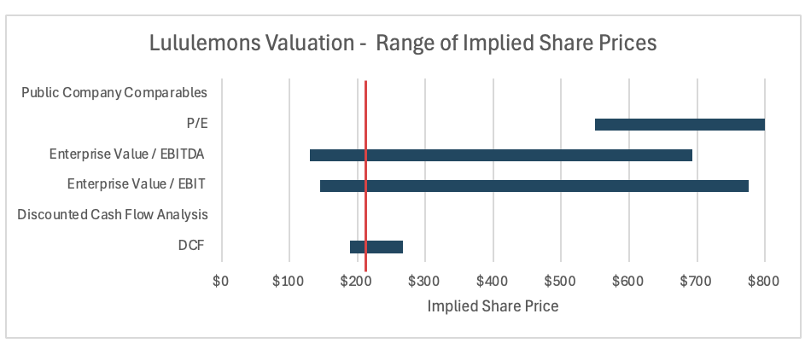
Figure 26 — Valuation Football Field — Range of Implied Share Prices
Public Company Comparables
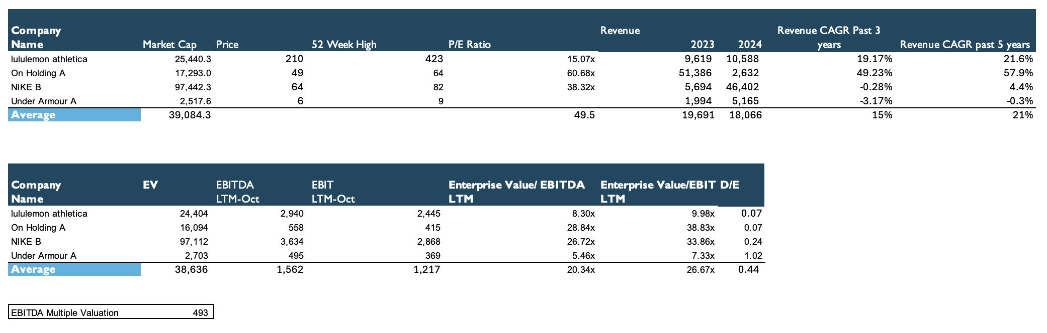
Figure 27 — Public Company Comparables
The public-company comparables analysis implies a target price of approximately $534, calculated using average valuation multiples given the high dispersion across peers and the limited number of comparables (which makes the median less representative). I do not view this as the most appropriate indicator of fair value, given limitations in peer-group selection: several of Lululemon's most direct competitors, such as Alo and Vuori, are privately held and unsuitable for direct comparison.
The publicly traded peers operate within the broader athletic-apparel category but differ meaningfully in positioning and product mix. Nike and Under Armour are more focused on mass-market athletic apparel than premium or luxury athletic wear, limiting comparability to Lululemon's brand positioning and pricing. On Holding, while relevant as a premium performance brand, is more concentrated in footwear and appears earlier in its growth cycle, which likely explains its elevated multiples.
As a result, the implied valuation from the comparables likely overstates fair value and should be interpreted with caution. Accordingly, greater weight is placed on the discounted cash flow analysis, which more directly reflects company-specific fundamentals and long-term growth assumptions.
Discounted Cash Flow Analysis
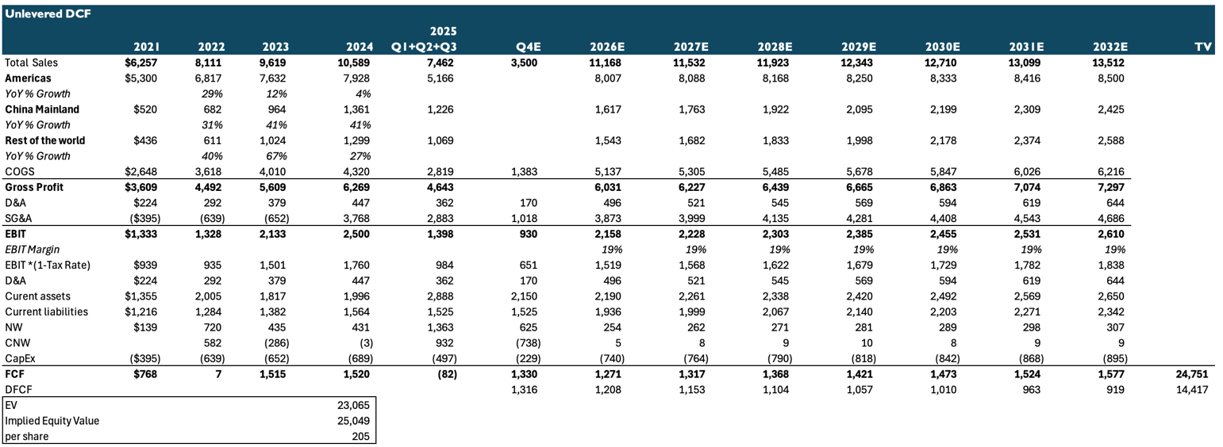
Figure 28 — Unlevered DCF
Figure 29 — Revenue & Operating Assumptions | 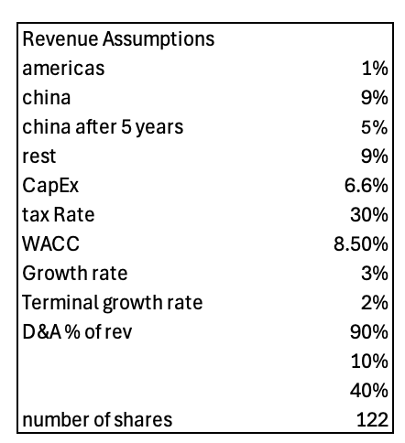

For the DCF, I assume 1% revenue growth in the Americas, reflecting the recent decline in comparable-store sales and ongoing innovation challenges over the past two years. For Mainland China, I model 9% revenue growth over the next five years, followed by 5% growth in years six and seven, capturing continued expansion while allowing for gradual normalization after three years of 30–40% growth driven by both comparable-sales gains and store expansion. For the Rest of World, which has seen similar growth to China but slowed over the past two years, I adopt a more conservative 9% growth rate given current geopolitical tensions and global tariffs.
The valuation applies a WACC of 8.5% and a terminal growth rate of 1%. Based on these assumptions, the DCF yields a target price of approximately $205 per share.
Sensitivity Analysis
DCF output is most sensitive to the assumed cost of capital and long-run growth rates. The tables below show implied per-share value across a range of assumptions for the terminal growth rate and for medium-term Americas and China growth, holding other inputs constant.
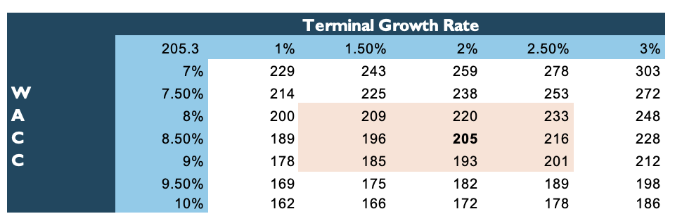
Figure 30 — Sensitivity — Terminal Growth Rate vs. WACC
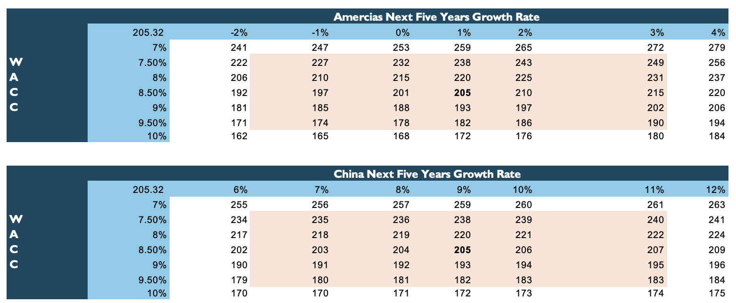
Figure 31 — Sensitivity — Americas & China Growth vs. WACC
Investment Thesis
Lululemon's stock has experienced a significant decline over the past year, driven primarily by a slowdown in comparable sales in the Americas, the company's largest market. While this weakness has weighed on recent share performance, I view the current period as cyclical rather than structural and believe the company is well positioned to reaccelerate growth over the medium term.
Lululemon remains the market leader in premium athletic apparel, having played a central role in shaping and expanding the luxury athleisure category. Despite increased competition and recent concerns around product innovation, the company continues to benefit from a powerful global brand, industry-leading margins, and strong customer loyalty — advantages that position it to defend its leadership and maintain pricing power over time.
International expansion is a key long-term growth driver. The China market has delivered a sales CAGR of 37.8% over the past three years, significantly outpacing the broader company average, and the premium athletic-apparel segment in China continues to exhibit strong secular growth, with forecasts projecting roughly 9% annual growth. Lululemon's Rest of World segment has achieved a three-year CAGR of 43.8%, highlighting substantial growth potential outside North America.
Recent management changes further strengthen the long-term outlook. Management's willingness to acknowledge recent innovation gaps and take decisive action provides confidence in the company's commitment to restoring product leadership and sustaining growth over time.
Finally, the men's apparel segment represents an underpenetrated opportunity with meaningful upside; continued expansion in men's offerings should support incremental revenue growth and further diversify the company's revenue base.
Catalysts
- Management transition. Appointment of a new CEO with a proven track record of driving operational turnarounds could act as a positive sentiment catalyst, particularly if accompanied by a credible strategic roadmap.
- Tariff-headwind normalization. A reduction in market concern around tariffs and their impact on Lululemon's cost structure could support valuation-multiple expansion, especially if input-cost pressures continue to ease.
- Reacceleration of Americas comparable sales. Improvement in Americas comparable sales, driven by successful new product launches and increased penetration in the men's category, would represent a meaningful upside catalyst.
Investment Risks
- Macroeconomic sensitivity. Any deterioration in U.S. economic conditions that negatively impacts consumer spending could materially affect Lululemon, which sells premium apparel at relatively high price points, making demand more sensitive to downturns as consumers cut discretionary spending.
- Product-innovation risk. Recent challenges have been driven in part by intensifying competition and slower product innovation. A failure to consistently introduce compelling new collections or refresh core lines could weaken brand relevance and erode the company's premium positioning.
- Competitive pressure. Competitors such as Alo and Vuori have gained meaningful market share in recent years, increasing pressure on Lululemon. If LULU is unable to defend its leadership in premium athletic apparel, long-term growth and profitability could be negatively impacted.

