Sprouts Farmers Market, Inc.  NASDAQ: SFM Equity Research • Consumer Staples / Grocery Retail | 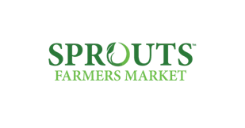
Report Date: 08 January 2026 Exchange: NASDAQ • Currency: USD
STRONG BUY | Current Price $80.30 | Target Price $122 (+52.9%) | Risk Medium | 12–24 mo.

MARKET DATA  Market Cap $7.9 B  Revenue (FY24) $7,719 M  Revenue (LTM) $8,653 M  Net Income (FY24) $380 M  Net Income (LTM) $513 M  LTM EPS $5.22  P/E 15.4x  EV / EBITDA (LTM) 7.79x  EV / EBIT (LTM) 11.18x  Beta 0.68  All figures in USD; $ in millions unless noted. |  | SHARE PRICE — TRAILING 12 MONTHS  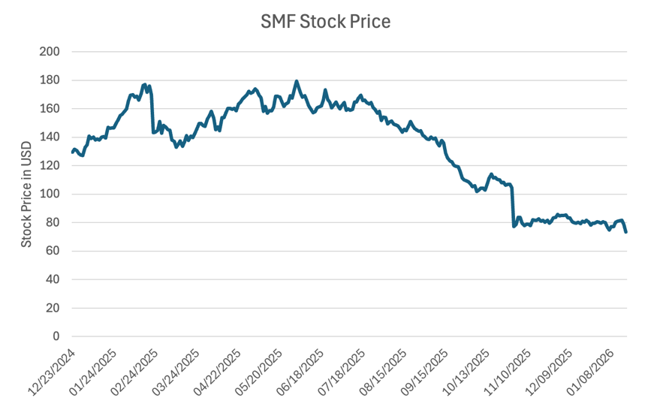
INVESTMENT SUMMARY
Sprouts Farmers Market appears materially undervalued following a sharp 2025 share-price decline driven by a temporary earnings miss and cautious guidance. The company remains well positioned to capture share through continued store expansion and sustained demand for healthy and organic food, and its differentiated farmers-market format supports a resilient long-term growth profile. Under conservative assumptions - roughly 5% revenue growth and normalized capital spending - our DCF implies a target price of approximately $126, suggesting meaningful upside from current levels. We rate the shares STRONG BUY
Recent Results & Outlook
Third-Quarter FY2025 Results
The company delivered a strong third quarter, with net sales increasing 13% year over year to $2.2 billion, supported by comparable-store sales growth of 5.9%. Profitability improved meaningfully, as diluted EPS rose to $1.22 from $0.91 a year earlier, reflecting operating leverage on higher sales. Store expansion continued, with nine new locations opened, bringing the total base to 464 stores across 24 states as of September 28, 2025. The company entered into a new $600 million revolving credit facility on terms largely consistent with its prior agreement, ending the quarter with $322 million in cash and no outstanding borrowings. Capital allocation remained shareholder-friendly, with a new $1 billion share-repurchase authorization and $50 million deployed to buybacks during the quarter. Year-to-date, the company generated $577 million in operating cash flow and invested $194 million in capital expenditures, net of landlord reimbursements.
Full-Year Guidance
For full-year fiscal 2025, management expects net sales growth of approximately 14%, supported by comparable-store sales growth of roughly 7% and continued unit expansion. EBIT is guided to $675–$680 million, reflecting sustained operating leverage, and diluted EPS is projected at $5.24–$5.28. The company plans to open approximately 37 net new stores during the year. Capital investment remains elevated, with capital expenditures (net of landlord reimbursements) expected to range from $230–$250 million, supporting new openings and ongoing infrastructure investment.
Company Overview
Sprouts Farmers Market is a health-focused grocery retailer founded in 2002 in Arizona. Since its founding it has expanded to more than 464 stores across over 24 states. Sprouts designs its stores to resemble a traditional farmers market while maintaining operational efficiency, focusing on healthy food options with an emphasis on organic products, items with minimal chemical processing, and specialty offerings such as gluten-free and plant-based products. The company generally avoids many traditional grocery items associated with less healthy consumption, such as conventional sodas; its founding objective was to create a grocery store where customers could purchase healthy food without needing to be highly affluent.
Sprouts targets health enthusiasts and selective shoppers who prioritize better-for-you, organic, and high-quality food and who value how food fits into a healthy lifestyle. This customer base spans a wide range of ages and income levels, and the company sees significant growth opportunities by expanding share of wallet through differentiated products and a strong in-store experience.
Store Format & Merchandising
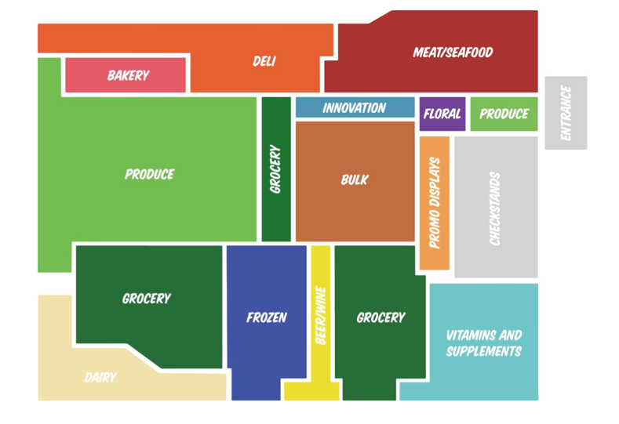
Figure 1 — Sprouts Store Design (FY2024 Form 10-K)
Sprouts' stores follow a “flipped” conventional grocery model, positioning fresh produce at the center of the store and surrounding it with a complete grocery assortment. Approximately 20% of selling square footage is dedicated to produce — up from 15% in 2018 and a level the company states is significantly higher than many peers.
Stores are designed with open layouts and low displays so customers can view most of the store from a single vantage point, reinforcing the farmers-market atmosphere. As of 2024, stores averaged approximately 28,000 square feet, while newer formats introduced from 2021 onward are smaller — ranging from 21,000 to 25,000 square feet — less expensive to build and generally operating at lower cost.
Supply Chain & Distribution
Product Mix
For fiscal 2024, 57.3% of product mix consisted of perishable items — produce, meat, seafood, deli, bakery, floral, dairy, and dairy alternatives — with the remaining 42.7% non-perishable (grocery, vitamins, bulk, frozen, beer and wine, and natural and body-care products).
The company operates six produce distribution centers — two in California and one each in Arizona, Texas, Colorado, and Florida. Approximately 80% of stores sit within 250 miles of a distribution center, supporting supply-chain efficiency, product freshness, and service levels.
Growth Strategy
Sprouts' long-term strategy focuses on driving profitable, sustainable growth by deepening engagement with its core health-conscious and selective-shopper customer base, supported by a differentiated assortment of fresh and better-for-you products and a full omnichannel offering.
Growth is expected to be driven by disciplined market expansion, with an emphasis on smaller, higher-return store formats and geographic expansion aligned with supply-chain capabilities. The company targets approximately 10% annual unit growth over the long term. Additional initiatives include strengthening supply-chain infrastructure, enhancing customer engagement and personalization through data analytics and digital tools, and continued investment in technology to improve inventory management, decision-making, and scalability. Management also emphasizes financial discipline and margin expansion, supported by talent-development initiatives and ongoing measurement against key long-term financial and operational metrics.
Industry Overview
U.S. Macroeconomic Backdrop
- Consumer spending remained under pressure toward the end of 2025, though unevenly across income groups. The University of Michigan Consumer Sentiment Index stood at 52.9 in December 2025, signaling ongoing caution. Lower- and middle-income households remain most affected, while higher-income consumers have shown greater resilience.
- Inflation improved modestly into year-end, with core CPI of 2.7% for December 2025 and food CPI of 3.1% (U.S. Bureau of Labor Statistics).
- Labor markets softened further by year-end: U.S. unemployment reached approximately 4.2% in December 2025, up from 3.7% in early 2024, with long-term unemployment elevated at roughly 1.9 million — a trend pointing to slower discretionary-spending growth into 2026.
Organic Food Market
The organic food market has expanded steadily over the past decade. According to the Organic Trade Association (OTA), organic food sales totaled $38.6 billion in 2012 and increased to $65.4 billion in 2024. Fresh fruits and vegetables represent the largest category, with produce accounting for approximately 33% of total organic food sales in 2024.
Consumer awareness of organic products has risen, particularly among younger generations: as of 2024, more than 30% of Gen Z and millennial consumers in the United States reported that they primarily purchase organic food or prefer to do so. Looking ahead, the OTA projects the organic food market will expand at a compound annual growth rate of approximately 5.1% through 2029.
Competitive Landscape
- Whole Foods Market — a premium natural and organic grocery retailer focused on high-quality fresh, prepared, and private-label products. Owned by Amazon, the chain operates ~520 stores, primarily in the U.S. with a smaller presence in Canada and the U.K., targeting higher-income, health-conscious consumers and benefiting from Amazon's scale, logistics, and digital ecosystem.
- Trader Joe's — a value-oriented specialty grocer known for a curated, predominantly private-label assortment at accessible price points. Operates ~560 stores, almost entirely in the U.S., typically in urban and suburban high-traffic areas, and generates industry-leading sales per square foot.
- Natural Grocers — a specialty natural and organic chain catering to health-focused consumers, with a strong emphasis on organic produce, supplements, and nutrition education. Operates approximately 165 stores across roughly 20 U.S. states, mainly in the Western and Central U.S.; its footprint and assortment overlap meaningfully with Sprouts, though with greater emphasis on supplements.
- The Fresh Market — a specialty grocer targeting more affluent, food-focused consumers with premium fresh foods, prepared meals, and specialty grocery items. Operates approximately 160 smaller-format stores across the U.S., primarily in suburban markets in the Southeast, Midwest, and East Coast, emphasizing a curated, high-touch experience.

Financial Statements
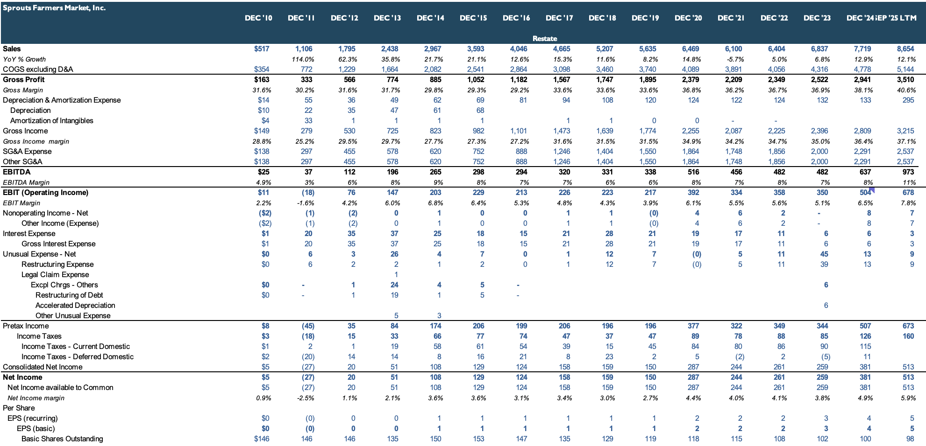
Figure 2 — Income Statement (Annual)
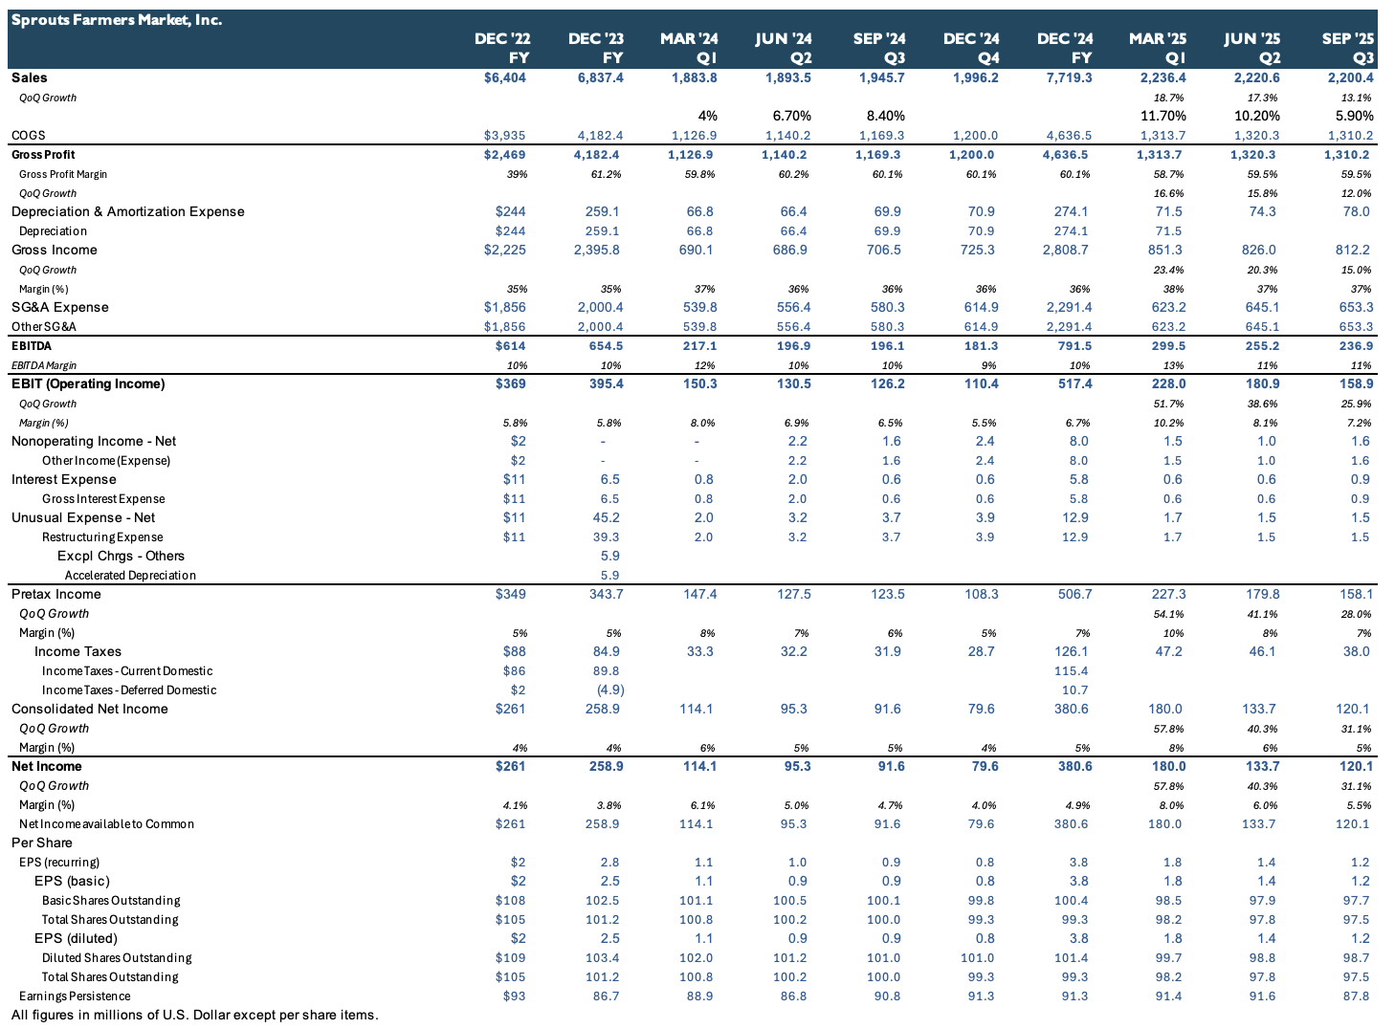
Figure 3 — Income Statement (Quarterly)
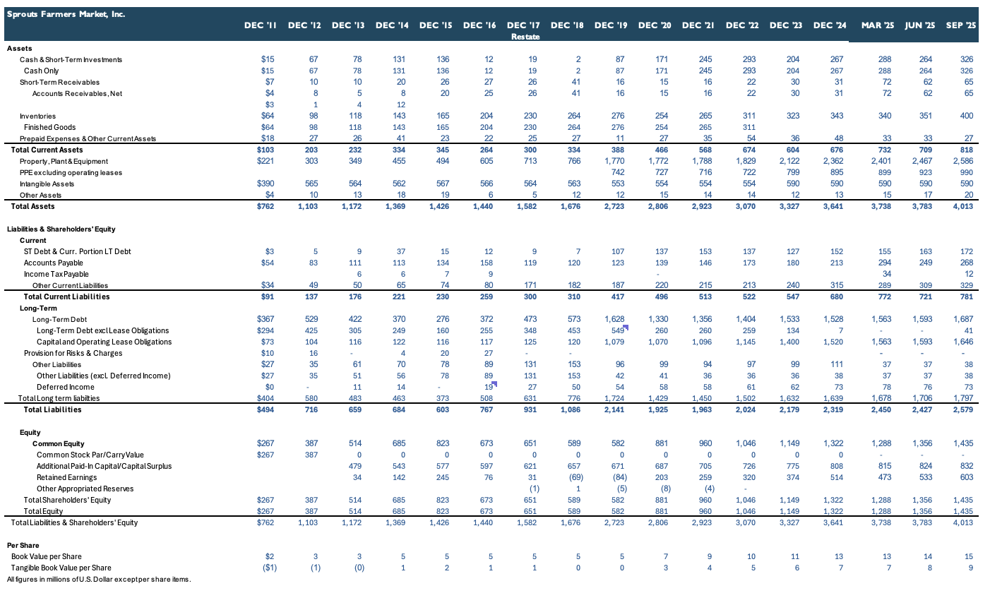
Figure 4 — Balance Sheet
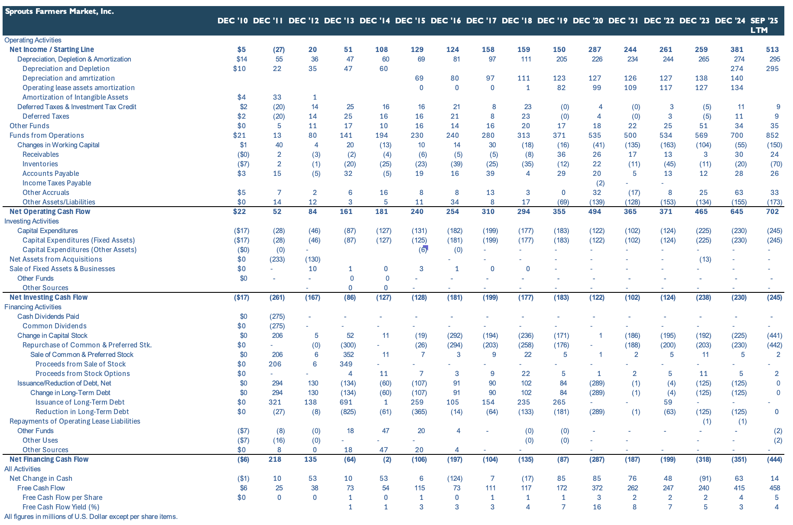
Figure 5 — Cash Flow Statement
Sales Analysis
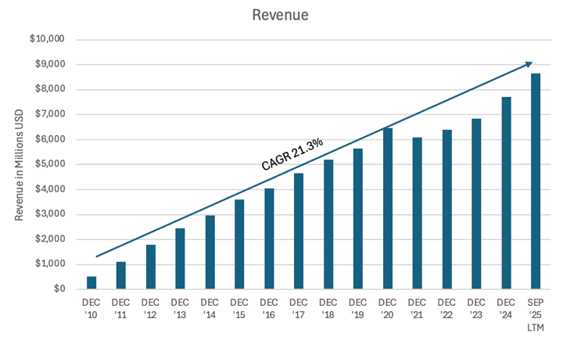
Figure 6 — Revenue & 15-Year CAGR
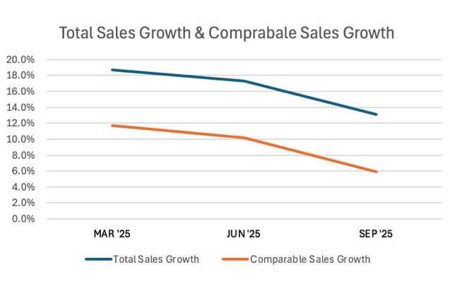
Figure 7 — Total vs. Comparable Sales Growth (2025 Quarters)
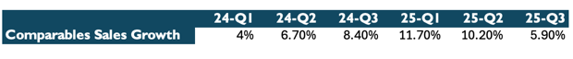
Figure 8 — Comparable Sales Growth by Quarter
Sprouts has delivered strong growth over the past 15 years, generating a sales CAGR of approximately 21.3%, driven by broader market expansion, increased consumer awareness around food quality, improving brand competitiveness, and consistent store expansion across multiple U.S. states.
In 2025, revenue growth has remained robust, with sales increasing approximately 19%, 17%, and 13% in the first three quarters, respectively. Comparable-store sales have generally tracked total revenue growth; however, in Q3 comparable sales growth moderated to 5.9%. This deceleration has raised investor concerns and contributed meaningfully to the recent decline in the stock price.
Margins & Profitability
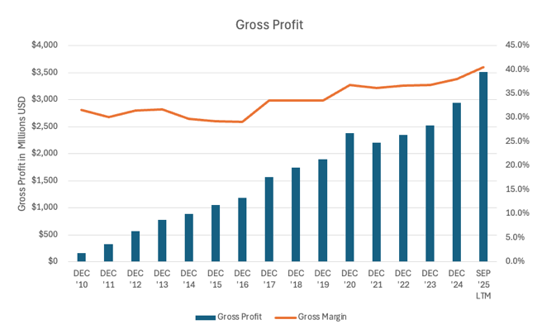  Figure 9 — Gross Profit Over Time | 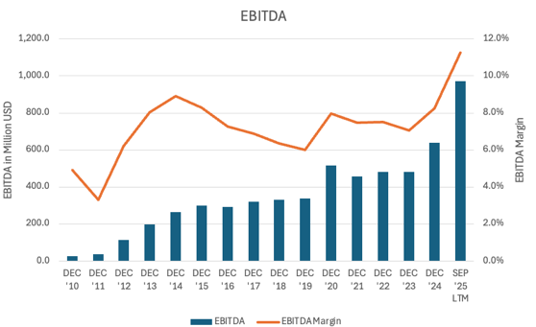  Figure 10 — EBITDA Over Time

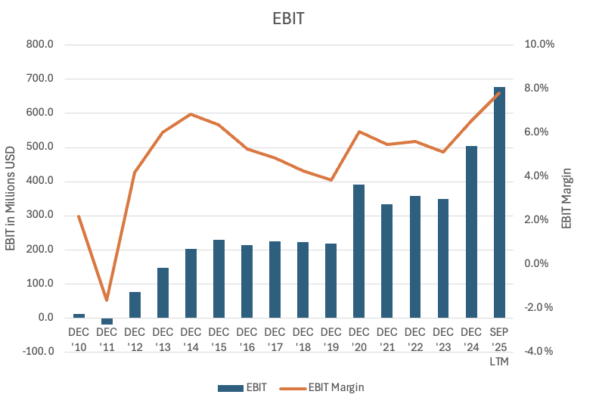  Figure 11 — EBIT Over Time | 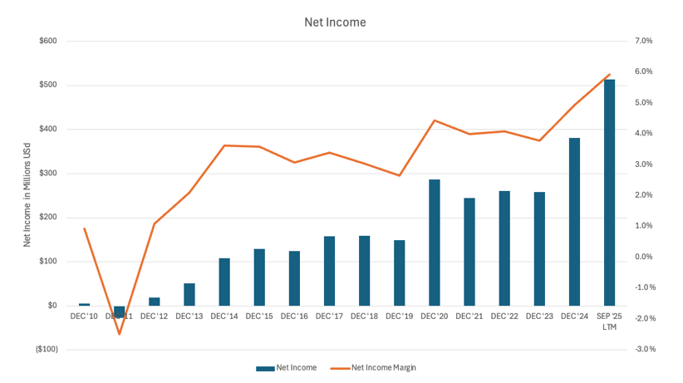  Figure 12 — Net Income Over Time

- Gross profit increased from approximately $163 million in 2010 to over $3.5 billion in 2025, reflecting significant scale expansion. Gross margin improved from roughly 32% to above 40%, driven by improved merchandising, pricing discipline, and cost management.
- EBITDA grew from approximately $25 million in 2010 to nearly $1.0 billion in 2025 LTM, with margins expanding from around 5% in the early 2010s to approximately 11–12% recently — substantial operating leverage as the business scaled.
- EBIT increased from roughly $11 million in 2010 to approximately $680 million in 2025 LTM, with margins expanding from about 2% to nearly 8%, reflecting disciplined SG&A control and stronger store-level profitability.
- Net income rose from $5 million in 2010 to over $500 million in 2025 LTM, while net margin improved from below 1% to nearly 6% — underscoring the company's ability to convert revenue growth into sustainable bottom-line earnings.
Overall, Sprouts has transformed from a small, low-margin retailer into a scaled, highly profitable operator. The steady expansion in revenue, margins, and earnings demonstrates a durable business model and strong execution, positioning the company well for continued long-term growth.
Returns on Capital
Methodology
- ROTCE = EBIT / (NWC + NFA)
- NWC = current assets (excl. cash) − current liabilities (excl. short-term debt)
- ROIC = EBIT × (1 − tax rate) / [(assets − cash) − non-interest-bearing current liabilities]
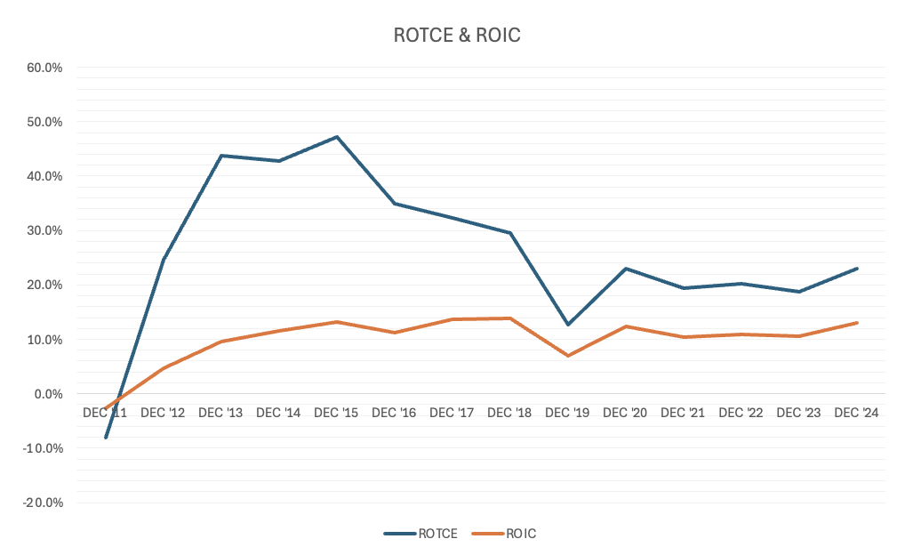
Figure 13 — ROTCE & ROIC Over Time
ROTCE increased sharply between 2012 and 2015, peaking at approximately 45–47%, driven by rapid EBIT growth combined with a relatively low capital base during the company's early expansion phase. As Sprouts continued to invest in new stores and infrastructure, ROTCE normalized to the 20–25% range in recent years — still well above typical retail averages and reflecting strong underlying unit economics.
ROIC has followed a more stable trajectory, improving from low single digits in the early 2010s to a sustained 10–13% in recent years, reflecting higher operating profitability and more disciplined capital deployment. The temporary decline in both metrics around 2019 coincided with increased investment and margin pressure, followed by a recovery driven by improved operating performance.
Overall, the sustained elevation of both ROTCE and ROIC suggests Sprouts has been effective in converting incremental investment into profitable growth, supporting the view that it operates with a high-quality capital structure and generates returns well in excess of its cost of capital over time.
CapEx & Store Expansion
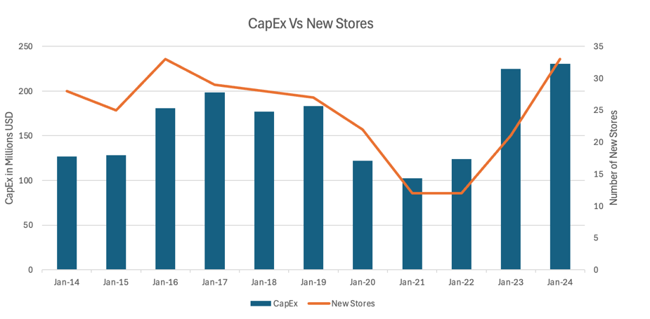  Figure 14 — CapEx vs. New Stores | 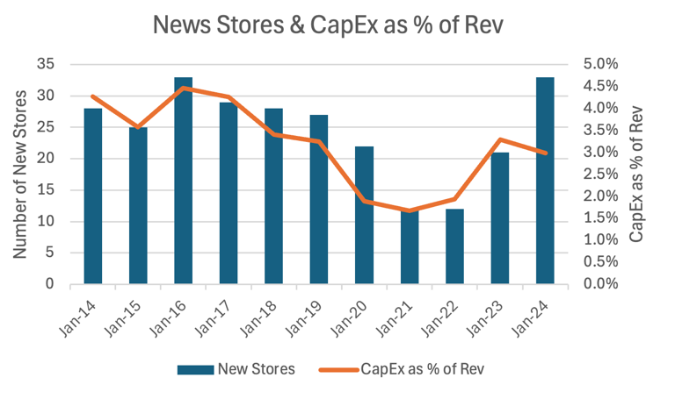  Figure 15 — New Stores & CapEx as % of Revenue

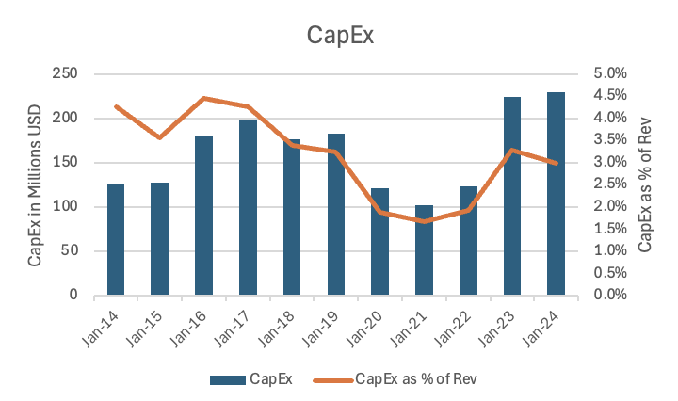
Figure 16 — CapEx & CapEx as % of Revenue
Sprouts has pursued a consistent, disciplined store-expansion strategy over the past decade, steadily increasing its footprint while maintaining prudent capital allocation. Total store count grew from approximately 170 locations in 2013 to 440 in 2024, while geographic presence expanded from 12 to 25 states. In 2025 the company has already reached 464 stores and expects to finish the year having opened 37 — underscoring its commitment to a long-term objective of 1,000 stores nationwide.
Recent expansion has concentrated in high-growth, underpenetrated markets. From 2022 to 2024 the company added 66 net new stores, led by California (+21), Florida (+18), Texas (+7), and Arizona (+4), and has increasingly pursued opportunities in the Northeast.
Capital expenditures have closely tracked store growth but become more efficient over time, rising from roughly $125–180 million in the mid-2010s to approximately $225–230 million in 2024. Importantly, CapEx as a percentage of revenue has trended down, from over 4% earlier in the decade to closer to 3% recently, indicating improved capital efficiency as the business scaled.
The temporary reduction in openings and CapEx during 2020–2021 reflected heightened uncertainty and capital discipline, followed by a clear reacceleration beginning in 2023. The increase to over 30 new stores in 2024 suggests renewed confidence in demand and the company's ability to generate attractive returns on incremental investment. Overall, Sprouts' approach balances expansion with discipline, reinvesting in growth while improving capital efficiency and reinforcing the sustainability of its long-term model.
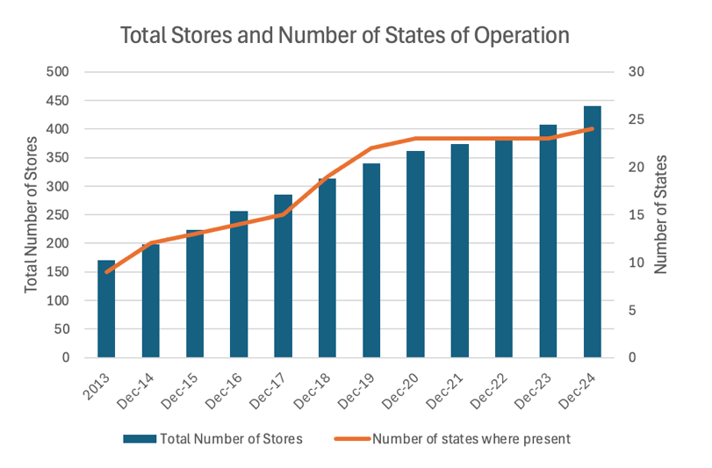
Figure 17 — Total Stores & Number of States of Operation
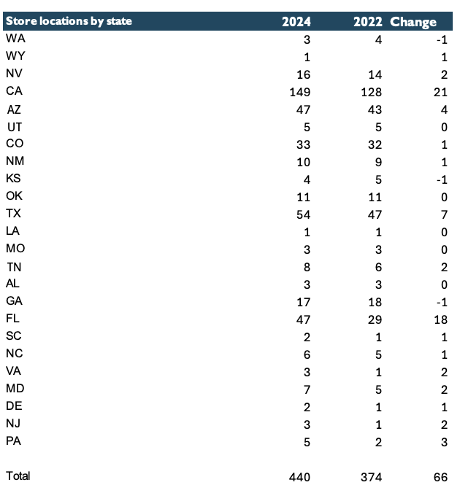
Figure 18 — Store Locations by State

Valuation
Target price per share
- Public Company Comparables: $56
- Discounted Cash Flow: $122
- Assumed acquisition price: $80.30
- The investment decision is based primarily on the DCF analysis, with less reliance on comparables; precedent transactions were not considered.
- The target price is, in my view, conservative, as it assumes growth rates meaningfully below the company's historical levels.
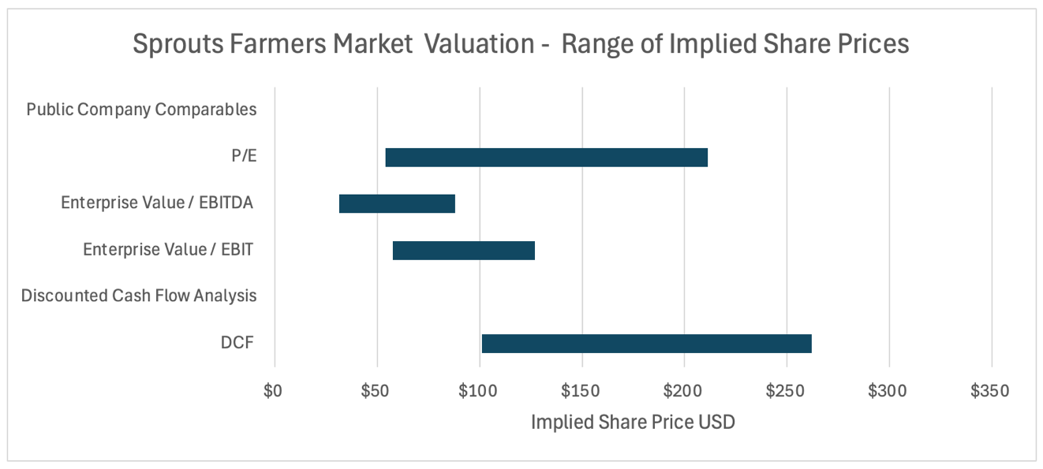
Figure 19 — Valuation Football Field — Range of Implied Share Prices
Public Company Comparables
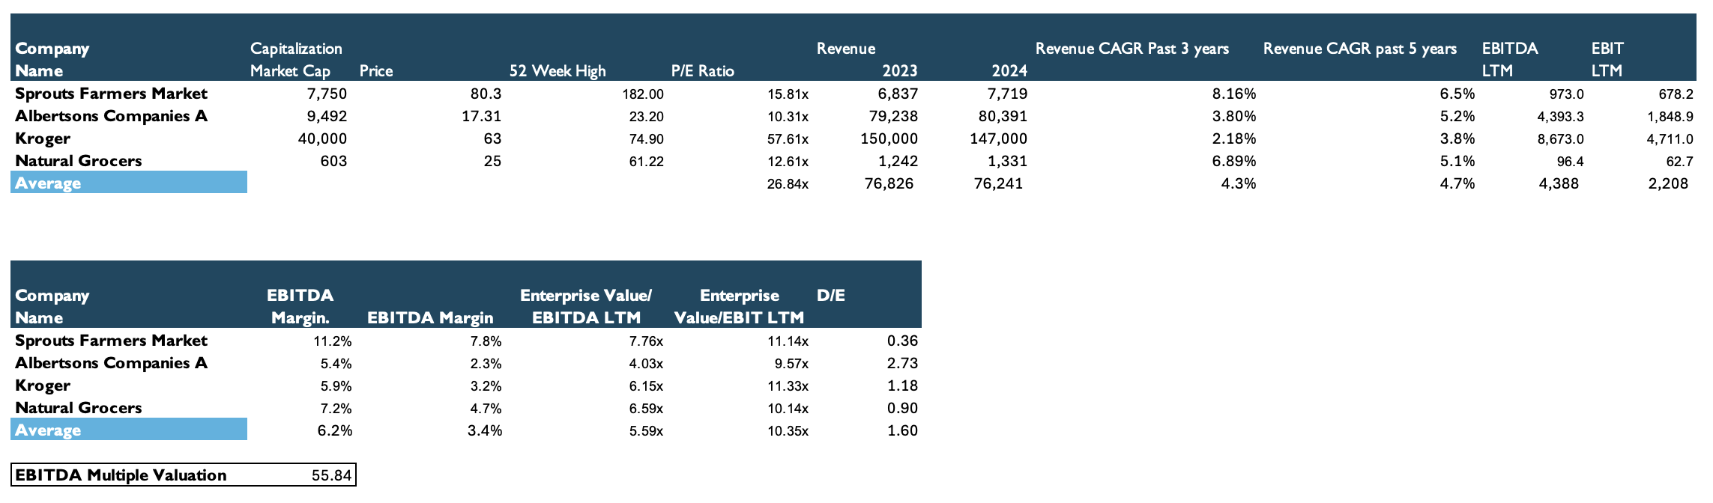
Figure 20 — Comparable Public Companies
The public-company comparables analysis implies a target price of approximately $56, based on average valuation multiples. However, I place limited weight on this, as the selected peer group consists primarily of traditional grocery retailers whose business models differ meaningfully from Sprouts'; with the exception of Natural Grocers, these companies are less focused on organic and specialty offerings.
In addition, the peer group exhibits materially lower revenue growth than Sprouts, and I do not expect these companies to match Sprouts' expected growth trajectory over the next several years. As a result, the comparable analysis may understate Sprouts' intrinsic value and should be interpreted with caution.
Discounted Cash Flow Analysis
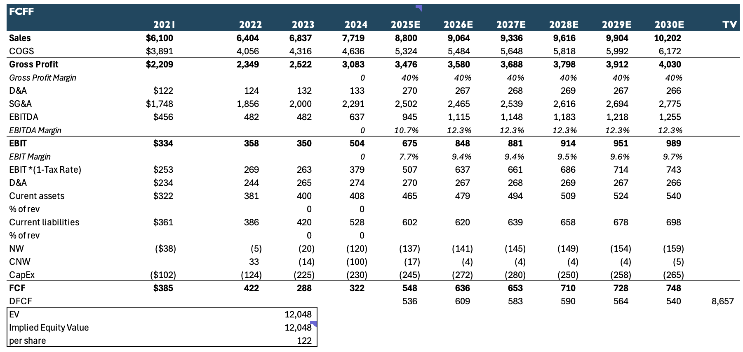
Figure 21 — Unlevered DCF
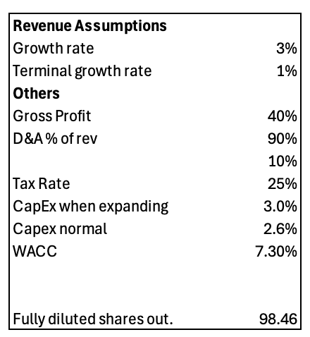
Figure 22 — Revenue & Operating Assumptions

For the DCF, I assume a 5% revenue growth rate over the next five years — below the company's historical rate — reflecting continued comparable-store sales growth driven by sustained demand in the healthy and organic segment, plus ongoing nationwide store expansion.
Growth is supported by new-store openings, with capital expenditures of approximately 3.0% of revenue for the first three years (roughly 36 stores per year). Thereafter I assume a moderation in expansion, with openings declining to approximately 22 stores per year and CapEx easing to 2.6% of revenue, consistent with historical periods of slower expansion. Operating leases are not capitalized, in line with the company's own reporting treatment; lease costs are reflected as rent expense within operating expenses.
Based on these assumptions, the DCF yields a target price of approximately $126 per share.
Sensitivity Analysis
DCF output is most sensitive to the assumed cost of capital and long-run growth rates. The tables below show implied per-share value across a range of assumptions for medium-term revenue growth and the terminal growth rate, holding other inputs constant.
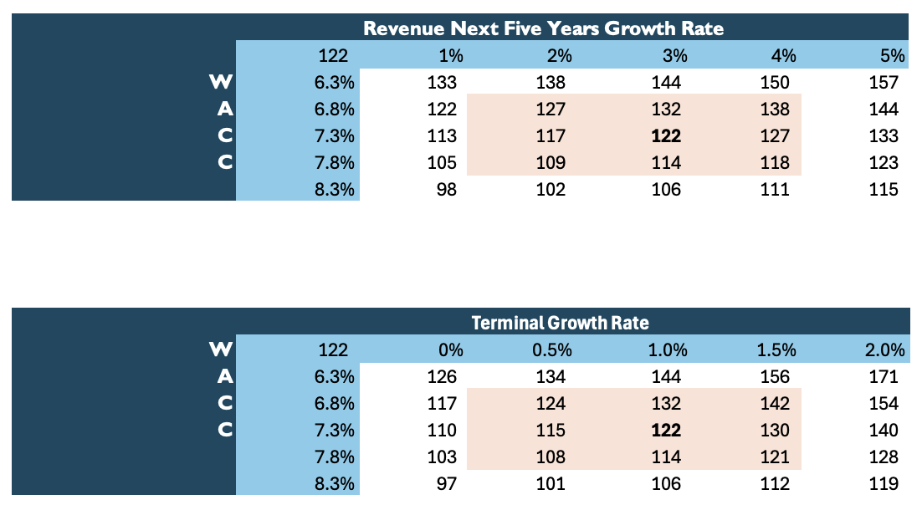
Figure 23 — Sensitivity — Revenue Growth & Terminal Growth vs. WACC
Investment Thesis
I believe Sprouts Farmers Market is materially undervalued at current levels. The stock declined sharply in 2025, driven in part by a miss versus consensus and more cautious forward guidance, falling from approximately $173 in 2024 to around $80 currently.
Despite this pullback, I expect Sprouts to continue expanding its footprint and capturing incremental market share. The company is well positioned to benefit from sustained consumer demand for healthy and organic food, supported by a differentiated product offering and a strong brand identity centered on a farmers-market-style format. Growth should be driven by a combination of improving comparable-store sales and continued nationwide expansion.
Sprouts' strategy of offering high-quality, premium products at competitive prices allows it to compete effectively across a broad range of grocery retailers while maintaining a differentiated value proposition.
My valuation framework is deliberately conservative, assuming only 3% revenue growth over the next several years while modeling capital expenditures and operating costs consistent with the company's historical expansion period. Even under these cautious assumptions, the analysis implies a target price of approximately $122, highlighting the extent to which the stock appears undervalued.
Catalysts
- Reacceleration in comparable-store sales. A recovery in comparable-store sales growth would alleviate concerns around demand softness and support a re-rating of the stock.
- Positive guidance or store-expansion updates. More constructive management guidance, or evidence of strong unit economics from new stores, would reinforce confidence in the long-term growth strategy.
Investment Risks
- Macroeconomic sensitivity. Any deterioration in U.S. economic conditions that negatively affects consumer spending could materially impact Sprouts. Organic food is typically priced at a premium to conventional food, and demand may decline during slowdowns as consumers trade down to lower-cost alternatives.
- Slower new-store expansion. If management reduces its focus on new openings, the company's forecasted long-term growth could fall significantly. Underperformance of newly opened stores relative to expectations would also weigh on revenue growth and profitability.
- Competitive pressure. As organic and health-focused food becomes more mainstream, competition is likely to intensify — both from existing chains expanding organic offerings and from new entrants. Whole Foods' recent price reductions erode one of Sprouts' historical advantages; while Sprouts' exclusive health-oriented focus may partially offset this, intensified competition remains a key risk.
- Securities-fraud lawsuit. A class-action complaint alleges that Sprouts and certain executives made false or misleading statements about growth prospects and sales performance, harming investors who purchased the stock. Investors who acquired Sprouts securities between June 4, 2025 and October 29, 2025 may be eligible to join.

